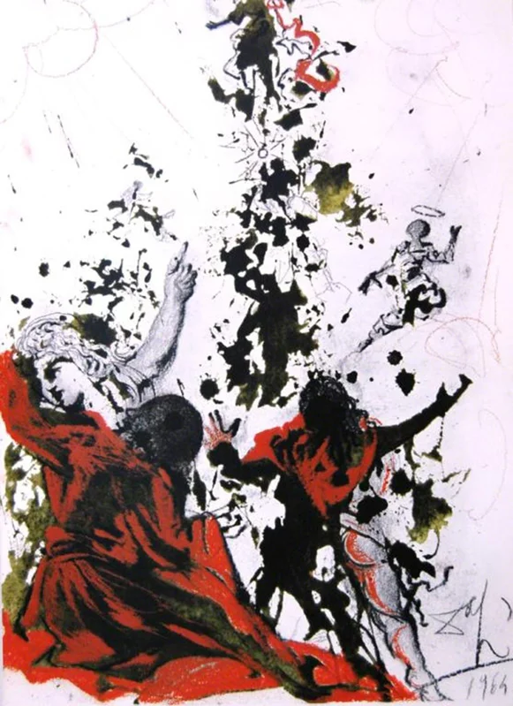

Last Sunday after Epiphany
Holy Eucharist
February 11, 2024

WELCOME!
You are invited to be a part of this community whether you’re arriving
for the first time or returning. This bulletin is intended to encourage
and enable your enthusiastic participation.

There is Children’s Time during worship this morning.
The staffed Nursery and the Narthex Nursery are available for little ones.

St. David’s Welcomes You
St. David’s Episcopal Church is committed to following Jesus’ example of practicing radical hospitality, seeking to find God in all people because they are of sacred worth. We respect the dignity of all persons, regardless of gender, race, ethnicity, age, physical or mental capacity, education, sexual orientation, gender identity, socioeconomic or marital status. All are invited as full participants in the life and ministries of our community of faith.
Loving God. Loving One Another

St. David’s Mission Statement
We at St. David’s Episcopal Church are devoted to loving and serving God, one another and the world. Honoring the dignity and freedom of all to seek God at their own pace, we connect our life stories with the teachings of Jesus. Inspired by the Holy Spirit, we believe our actions transform the world and ourselves.
______________________________________________________

Please note, this service is livestreamed and recorded on Facebook and YouTube.

Cover art: The Transfiguration of Jesus, by Salvadore Dali, 1967
Music reprinted under OneLicense.net #A-729358
Liturgy comes from Enriching our Worship
______________________________________________________

THE HOLY EUCHARIST

We Gather in God’s Name

Prelude Reflections on Aberystwyth arr. Linker and McFadden

Opening Hymn Be Thou My Vision Hymnal #488

Opening Acclamation
Celebrant Blessed be the one, holy, and living God.
People Glory to God for ever and ever. Amen.

Collect for Purity
Almighty God, to you all hearts are open, all desires known, and from you no secrets are hid: Cleanse the thoughts of our hearts by the inspiration of your Holy Spirit, that we may perfectly love you, and worthily magnify your Holy name; through Christ our Lord. Amen.

Song of Praise My Soul Rejoices (Magnificat)
Children ages 3 – grade 5 are invited to process out during the
Song of Praise for Children’s Time, returning for communion.
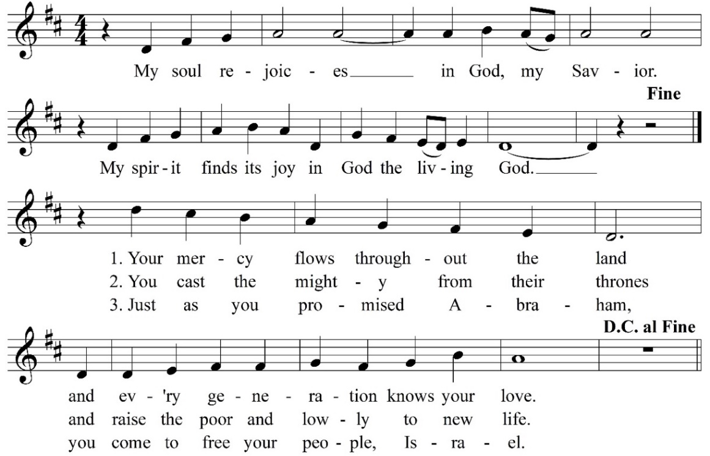

Collect of the Day
Celebrant The Lord be with you.
People And also with you.
Celebrant Let us pray.

O God, who before the passion of your only-begotten Son revealed his glory upon the holy mountain: Grant to us that we, beholding by faith the light of his countenance, may be strengthened to bear our cross, and be changed into his likeness from glory to glory; through Jesus Christ our Lord, who lives and reigns with you and the Holy Spirit, one God, for ever and ever. Amen.

We Hear and Respond to God’s Word

First Reading 2 Kings 2:1 – 12
When the Lord was about to take Elijah up to heaven by a whirlwind, Elijah and Elisha were on their way from Gilgal. Elijah said to Elisha, “Stay here; for the Lord has sent me as far as Bethel.” But Elisha said, “As the Lord lives, and as you yourself live, I will not leave you.” So they went down to Bethel. The company of prophets who were in Bethel came out to Elisha, and said to him, “Do you know that today the Lord will take your master away from you?” And he said, “Yes, I know; keep silent.”
Elijah said to him, “Elisha, stay here; for the Lord has sent me to Jericho.” But he said, “As the Lord lives, and as you yourself live, I will not leave you.” So they came to Jericho. The company of prophets who were at Jericho drew near to Elisha, and said to him, “Do you know that today the Lord will take your master away from you?” And he answered, “Yes, I know; be silent.”
Then Elijah said to him, “Stay here; for the Lord has sent me to the Jordan.” But he said, “As the Lord lives, and as you yourself live, I will not leave you.” So the two of them went on. Fifty men of the company of prophets also went, and stood at some distance from them, as they both were standing by the Jordan. Then Elijah took his mantle and rolled it up, and struck the water; the water was parted to the one side and to the other, until the two of them crossed on dry ground.

When they had crossed, Elijah said to Elisha, “Tell me what I may do for you, before I am taken from you.” Elisha said, “Please let me inherit a double share of your spirit.” He responded, “You have asked a hard thing; yet, if you see me as I am being taken from you, it will be granted you; if not, it will not.” As they continued walking and talking, a chariot of fire and horses of fire separated the two of them, and Elijah ascended in a whirlwind into heaven. Elisha kept watching and crying out, “Father, father! The chariots of Israel and its horsemen!” But when he could no longer see him, he grasped his own clothes and tore them in two pieces.

Reader The Word of the Lord.
People Thanks be to God.

Psalm 50:1 – 6
1 The God of gods has spoken; *
God has called the earth from the rising of the sun to its setting.
2 Out of Zion, perfect in its beauty, *
God is revealed in glory.
3 O God, you will come and will not keep silence; *
before you there is a consuming flame,
and round about you a raging storm.
4 You call the heavens and the earth from above *
to witness the judgment of your people.
5 “Gather before me my loyal followers, *
those who have made a covenant with me
and sealed it with sacrifice.”
6 Let the heavens declare the rightness of your cause, *
for you alone are judge.

Second Reading 1 Corinthians 4:3 - 6
Even if our gospel is veiled, it is veiled to those who are perishing. In their case the god of this world has blinded the minds of the unbelievers, to keep them from seeing the light of the gospel of the glory of Christ, who is the image of God. For we do not proclaim ourselves; we proclaim Jesus Christ as Lord and ourselves as your slaves for Jesus’ sake. For it is the God who said, “Let light shine out of darkness,” who has shone in our hearts to give the light of the knowledge of the glory of God in the face of Jesus Christ.

Reader The Word of the Lord.
People Thanks be to God.

Gospel Hymn God of Mercy, God of Grace Hymnal #538

The Gospel Mark 9:2 – 9
Deacon The Holy Gospel of our Lord Jesus Christ according to Mark.
People Glory to you, Lord Christ.
Deacon Jesus took with him Peter and James and John, and led them up a high mountain apart, by themselves. And he was transfigured before them, and his clothes became dazzling white, such as no one on earth could bleach them. And there appeared to them Elijah with Moses, who were talking with Jesus. Then Peter said to Jesus, “Rabbi, it is good for us to be here; let us make three dwellings, one for you, one for Moses, and one for Elijah.” He did not know what to say, for they were terrified. Then a cloud overshadowed them, and from the cloud there came a voice, “This is my Son, the Beloved; listen to him!” Suddenly when they looked around, they saw no one with them any more, but only Jesus.

As they were coming down the mountain, he ordered them to tell no one about what they had seen, until after the Son of Man had risen from the dead.

Deacon The Gospel of the Lord
People Praise to you, Lord Christ.

The Sermon Marilyn Clark

The Nicene Creed
We believe in one God, the Father, the Almighty, maker of heaven and earth, of all that is, seen and unseen.
We believe in one Lord, Jesus Christ, the only Son of God, eternally begotten of the Father, God from God, Light from Light, true God from true God, begotten, not made, of one Being with the Father. Through him all things were made.
For us and for our salvation he came down from heaven: by the power of the Holy Spirit he became incarnate from the Virgin Mary, and was made man.
For our sake he was crucified under Pontius Pilate; he suffered death and was buried. On the third day he rose again in accordance with the Scriptures; he ascended into heaven and is seated at the right hand of the Father.
He will come again in glory to judge the living and the dead, and his kingdom will have no end.
We believe in the Holy Spirit, the Lord, the giver of life, who proceeds from the Father and the Son. With the Father and the Son he is worshiped and glorified. He has spoken through the Prophets.
We believe in one holy catholic and apostolic Church. We acknowledge one baptism for the forgiveness of sins. We look for the resurrection of the dead, and the life of the world to come. Amen.
Leader

Prayers of the People
The Leader and People pray responsively. Please join in reading the bold text.

In peace, we pray to you, Lord God.

Silence

For all people in their daily life and work;
For our families, friends, and neighbors, and for those who are alone.

For this community, the nation, and the world.
For all who work for justice, freedom, and peace.

For the just and proper use of your creation;
For the victims of hunger, fear, injustice, and oppression.

We pray for... and for all who are in danger, sorrow, or any kind of trouble;
For those who minister to the sick, the friendless, and the needy.

For the peace and unity of the Church of God;
For all who proclaim the Gospel, and all who seek the Truth.

For Michael, our Presiding Bishop, and Craig, our Bishop; and for all clergy and lay ministers;
For all who serve God in God’s Church.

For the special needs and concerns of this congregation.

Please offer your own petitions, silently or aloud.

Hear us, Lord;
For your mercy is great.

We thank you, Lord, for all the blessings of this life.

Please offer your own thanksgivings, silently or aloud.

We will exalt you, O God our Creator;
And praise your Name for ever and ever.

We pray for … and all who have died, that they may have a place in your eternal kingdom.

Please offer your own petitions, silently or aloud.

Lord, let your loving-kindness be upon them;
Who put their trust in you.

We pray to you also for the forgiveness of our sins.

Silence

You are invited to be seated, to kneel or to remain standing.

God of all mercy, we confess that we have sinned against you, opposing your will in our lives. We have denied your goodness in each other, in ourselves, and in the world you have created. We repent of the evil that enslaves us, the evil we have done, and the evil done on our behalf. Forgive, restore, and strengthen us through our Savior Jesus Christ, that we may abide in your love and serve only your will. Amen.

Absolution
Almighty God have mercy on you, forgive you all your sins through the grace of Jesus Christ, strengthen you in all goodness, and by the power of the Holy Spirit keep you in eternal life. Amen.

The Peace
Celebrant The peace of the Lord be always with you.
People And also with you.

We Share in Holy Communion
Please stand, as you are able, while the offerings of bread and wine are presented. You may be seated until the singing of the Doxology, when we ask that you stand once more.

Offertory Go Not Far from Me, O God Zingarelli, arr. Thompson

Doxology
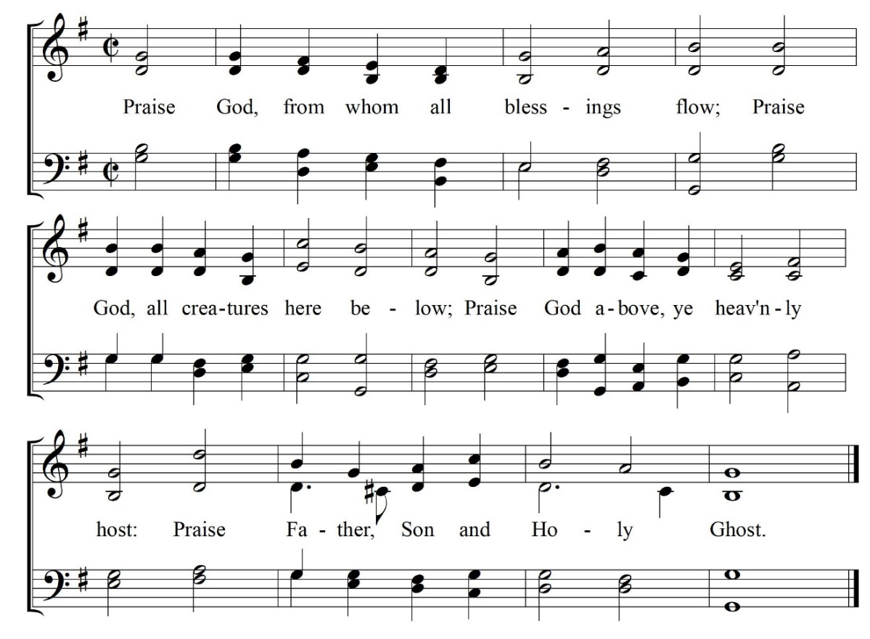

The Great Thanksgiving
The Lord be with you.
And also with you.
Lift up your hearts.
We lift them to the Lord.
Let us give thanks to the Lord our God.
It is right to give our thanks and praise.

We praise you and we bless you, holy and gracious God, source of life abundant. From before time you made ready the creation. Your Spirit moved over the deep and brought all things into being: sun, moon, and stars; earth, winds, and waters; and every living thing. You made us in your image, and taught us to walk in your ways. But we rebelled against you, and wandered far away; and yet, as a mother cares for her children, you would not forget us.
Time and again you called us to live in the fullness of your love. And so this day we join with Saints and Angels in the chorus of praise that rings through eternity, lifting our voices to magnify you as we sing:

Sanctus
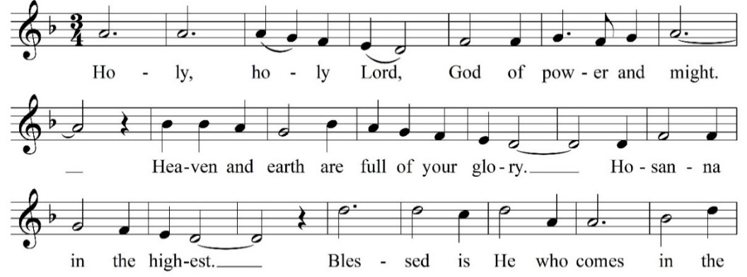
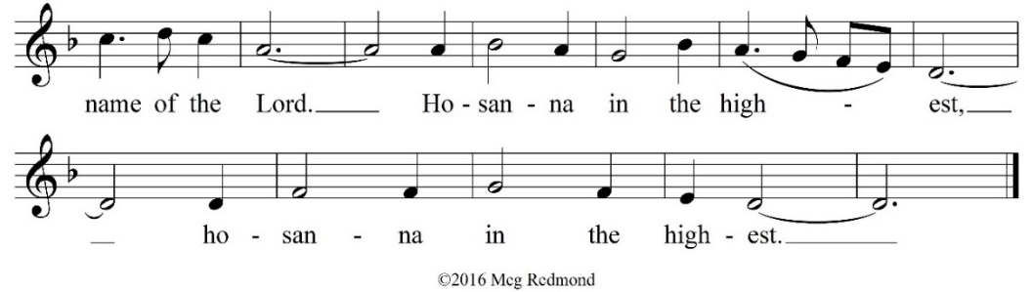

Glory and honor and praise to you, holy and living God. To deliver us from the power of sin and death and to reveal the riches of your grace, you looked with favor upon Mary, your willing servant, that she might conceive and bear a son,
Jesus the holy child of God. Living among us, Jesus loved us. He broke bread with outcasts and sinners, healed the sick, and proclaimed good news to the poor. He yearned to draw all the world to himself yet we were heedless of his call to walk in love. Then, the time came for him to complete upon the cross the sacrifice of his life, and to be glorified by you.
On the night before he died for us, Jesus was at table with his friends. He took bread, gave thanks to you, broke it, and gave it to them, and said: “Take, eat: This is my Body, which is given for you. Do this for the remembrance of me.”
As supper was ending, Jesus took the cup of wine. Again, he gave thanks to you, gave it to them, and said: “Drink this, all of you: This is my Blood of the new Covenant, which is poured out for you and for all for the forgiveness of sins. Whenever you drink it, do this for the remembrance of me.”
Now gathered at your table, O God of all creation, and remembering Christ, crucified and risen, who was and is and is to come, we offer to you our gifts of bread and wine, and ourselves, a living sacrifice. Pour out your Spirit upon these gifts that they may be the Body and Blood of Christ. Breathe your Spirit over the whole earth and make us your new creation, the Body of Christ given for the world you have made. In the fullness of time bring us, with David and all your saints, from every tribe and language and people and nation, to feast at the banquet prepared from the foundation of the world. Through Christ and with Christ and in Christ, in the unity of the Holy Spirit, to you be honor, glory, and praise, for ever and ever.
Amen.
And now, as our Savior Christ has taught us, we now pray,

All Our Father, who art in heaven, hallowed be thy Name, thy kingdom come, thy will be done, on earth as it is in heaven. Give us this day our daily bread. And forgive us our trespasses, as we forgive those who trespass against us. And lead us not into temptation, but deliver us from evil. For thine is the kingdom, and the power, and the glory, for ever and ever. Amen.

The Breaking of the Bread
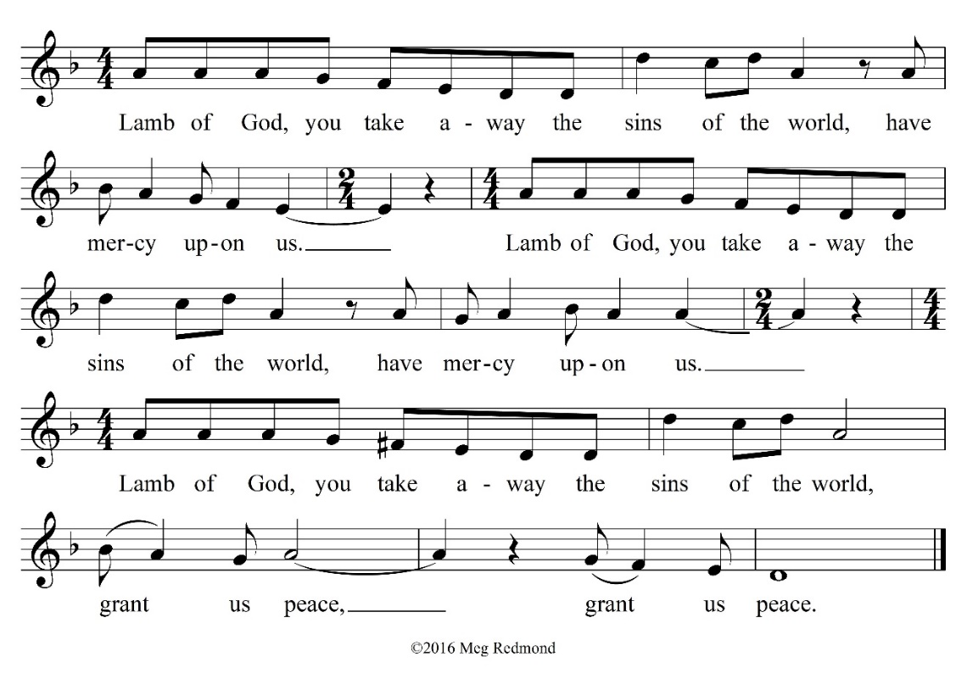

The Communion
We invite all people regardless of age or denomination to share in the Holy Communion at the Lord’s table. Please come forward to receive the bread and wine. When receiving from the common cup, please do not intinct (dip the bread in the wine). If you wish to receive only the bread, you may remain in place at the rail, crossing your arms across your chest when the chalice bearer presents the cup, or return to your seat after receiving the bread. Gluten-free wafers are available. If you do not wish to receive communion you are invited to receive a blessing. Please indicate this desire by crossing your arms over your chest. If you are unable to come forward, please let an usher know and communion will be brought to you.

Communion Hymn Transform Us

Communion Meditation As the Deer arr. Patricia Sanders Cota

Sending Forth of Lay Eucharistic Visitors
On those days when the parish sends out Lay Eucharistic Visitors to those who cannot attend the liturgy, the Bread is presented to the Visitors at the altar, using this form.
Deacon In the name of this congregation, I send you forth bearing these holy gifts that those to whom you go may share with us in the communion of Christ’s body and blood.
People We who are many are one body, because we share the one bread and the one cup.
Prayer after Communion
All Loving God, we give you thanks for restoring us in your image and nourishing us with spiritual food in the Sacrament of Christ’s Body and Blood. Now send us forth a people, forgiven, healed, renewed; that we may proclaim your love to the world and continue in the risen life of Christ our Savior. Amen.

We Go into the World in God’s Name

Announcements

Commissioning of Leaders

Celebrant I present these people as wardens, members of the
vestry, treasurer, clerk, and diocesan convention
delegates.

People The Lord gives wisdom; from God’s mouth comes
knowledge and understanding; God stores up sound wisdom for the upright and is a shield to those who walk in integrity.

Leaders I am your servant; grant me understanding; that I may know your
decrees, O God.

Celebrant Let us pray.

O Eternal God, the foundation of all wisdom and the source of all courage: Enlighten with your grace the Wardens, Vestry Members, Treasurer, Clerk, and Delegates of this congregation, and so rule their minds, and guide their counsels, that in all things they may seek your glory and promote the mission of your Church; through Jesus Christ our Lord.
Amen.

In the name of God and of this congregation, I commission you as Wardens, Members of the Vestry, Treasurer, Clerk, and Convention Delegates of St. David’s.

The Blessing

Departing Jesus, the Light of the World

Dismissal
Deacon Let us go forth into the world, rejoicing in the power of the Spirit.
People Thanks be to God.

Postlude

_____________________________________________________________

Want to read more about what’s going on at St. David’s? Visit our website stdavidsparish.org or check out the weekly email for announcements!

The QR Code below will lead you directly to the website. No app needed! Simply turn on your smartphone camera and select the rear facing camera. Hold your device so that the QR Code appears in the viewfinder. Don’t take a picture, just tap the notification to open the link.



_____________________________________________________________

Our Leadership

Presiding Bishop of the Episcopal Church
The Most Rev. Michael B. Curry ▪ 212-716-6273
Bishop of The Episcopal Church in Minnesota
The Rt. Rev. Craig Loya ▪ 612-870-3301 ▪ craig.l@episcopalmn.org
Wardens
Sr.. Warden ▪ Diane Curley ▪ 612-239-8445 ▪ dcurley@stdavidsparish.org
Jr. Warden ▪ David Niles ▪ 612-799-6808 ▪ dniles@stdavidsparish.org

Rector
The Rev. Katherine Lewis ▪ 612-747-5405l ▪ klewis@stdavidsparish.org
Deacon Emeritus
The Rev. Guy Drake ▪ 612-590-8502 ▪ gdrake@stdavidsparish.org
Adjunct Clergy
The Rev. Leonard Freeman ▪ 952-476-6267 ▪ LandL30@aol.com
The Rev. Lindsay Freeman ▪ 952-476-6267 ▪ lhfreeman25@gmail.com
Office Administrator
Nancy Lilja-Nerheim ▪ 952-935-3336 ▪ office@stdavidsparish.org

Manager for Finance, Communications and Ministry Support
Shea Brendalen ▪ 612-636-6134 ▪ sbrendalen@stdavidsparish.org
Minister of Music
Roger Stratton ▪ 612-819-5247 ▪ rstratton@stdavidsparish.org
Children and Youth Minister
Anna Brock ▪ 612-293-5750 ▪ abrock@stdavidsparish.org
Godly Play Minister
Sara Kuyper ▪ 952-938-2073 ▪ s.kuyper@fastmail.us



