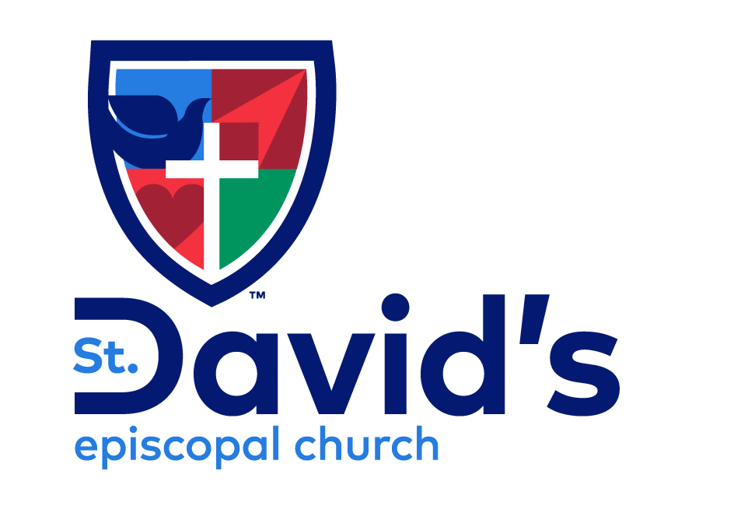

The Last Sunday after Pentecost
November 23, 2025

WELCOME!
You are invited to be a part of this community whether you’re arriving
for the first time or returning. This bulletin is intended to encourage
and enable your enthusiastic participation.

The staffed Nursery is available for little ones
during and following the 9:30 service.

St. David’s Welcomes You
St. David’s Episcopal Church is committed to following Jesus’ example of practicing radical hospitality, seeking to find God in all people because they are of sacred worth. We welcome all persons, regardless of gender, race, ethnicity, age, physical or mental capacity, education, sexual orientation, gender identity, socioeconomic or marital status. All are invited as full participants in the life and ministries of our community of faith.

St. David’s Mission Statement
We at St. David’s Episcopal Church are devoted to loving and serving God, one another and the world. Honoring the dignity and freedom of all to seek God at their own pace, we connect our life stories with the teachings of Jesus. Inspired by the Holy Spirit, we believe our actions transform the world and ourselves.

Please note, this service is livestreamed and recorded on Facebook and YouTube.

Music reprinted under OneLicense.net #A-729358 and CCLI license #A-21881814
}

Liturgy from Enriching Our Worship: Supplemental Liturgical Materials prepared by The Standing Liturgical Commission 1997

THE HOLY EUCHARIST

We Gather in God’s Name

Prelude Christ, of God Unseen the Image

Christ, of God unseen the image, born before creation’s birth;
through whom all things were created, all that live in heav’n and earth—
realms and rulers, thrones, dominions, powers great and forces small
through and for him made and fashioned— he is in and over all.

Christ the firstborn of creation, Christ in whom all things cohere,
all things’ Maker, seen and unseen, low and lofty, far and near.
Christ the head of his dear body, of his Church the living core,
risen from the dead before us— him we gladly now adore.

Christ in whom the very fullness of the living God is found,
Christ who reconciles creation turning earth to holy ground,
Christ the home of God’s good pleasure through whose blood is made our peace,
in whose cross, beyond all measure is our freedom and release.

Glory be to God the Father, glory be to God the Son,
glory to the Holy Spirit, binding humankind as one.
As it was in the beginning, is for now and evermore,
let our voices rise in union as we worship and adore!

Text: Based on Colossians 1:15-20. Stanzas 1-3 ©2005, Leith Fisher. Stanza 4 composite sources.
Music: RAQUEL, © Estate of Skinner Chavez-Melo

Opening Hymn At the Name of Jesus Hymnal #435
verses 1 - 4

Opening Acclamation

Celebrant Blessed be the one, holy, and living God.
People Glory to God for ever and ever. Amen.

Collect for Purity
Almighty God, to you all hearts are open, all desires known, and from you no secrets are hid: Cleanse the thoughts of our hearts by the inspiration of your Holy Spirit, that we may perfectly love you, and worthily magnify your holy Name; through Christ our Lord. Amen.

Song of Praise
Children ages 3-6 are invited to process out for Godly Play, returning at the time of communion distribution.
Collect of the Day
Celebrant The Lord be with you.
People And also with you.
Celebrant Let us pray.

Almighty and everlasting God, whose will it is to restore all things in your well-beloved Son, the King of kings and Lord of lords: Mercifully grant that the peoples of the earth, divided and enslaved by sin, may be freed and brought together under his most gracious rule; who lives and reigns with you and the Holy Spirit, one God, now and for ever. Amen.

We Hear and Respond to God’s Word

Reading Jeremiah 23:1-6

Woe to the shepherds who destroy and scatter the sheep of my pasture! says the Lord. Therefore thus says the Lord, the God of Israel, concerning the shepherds who shepherd my people: It is you who have scattered my flock, and have driven them away, and you have not attended to them. So I will attend to you for your evil doings, says the Lord. Then I myself will gather the remnant of my flock out of all the lands where I have driven them, and I will bring them back to their fold, and they shall be fruitful and multiply. I will raise up shepherds over them who will shepherd them, and they shall not fear any longer, or be dismayed, nor shall any be missing, says the Lord.

The days are surely coming, says the Lord, when I will raise up for David a righteous Branch, and he shall reign as king and deal wisely, and shall execute justice and righteousness in the land. In his days Judah will be saved and Israel will live in safety. And this is the name by which he will be called: "The Lord is our righteousness."
Reader The Word of the Lord.
People Thanks be to God.

Psalm 46
At 8:00, the psalm can be found in the Book of Common Prayer, at p. 649
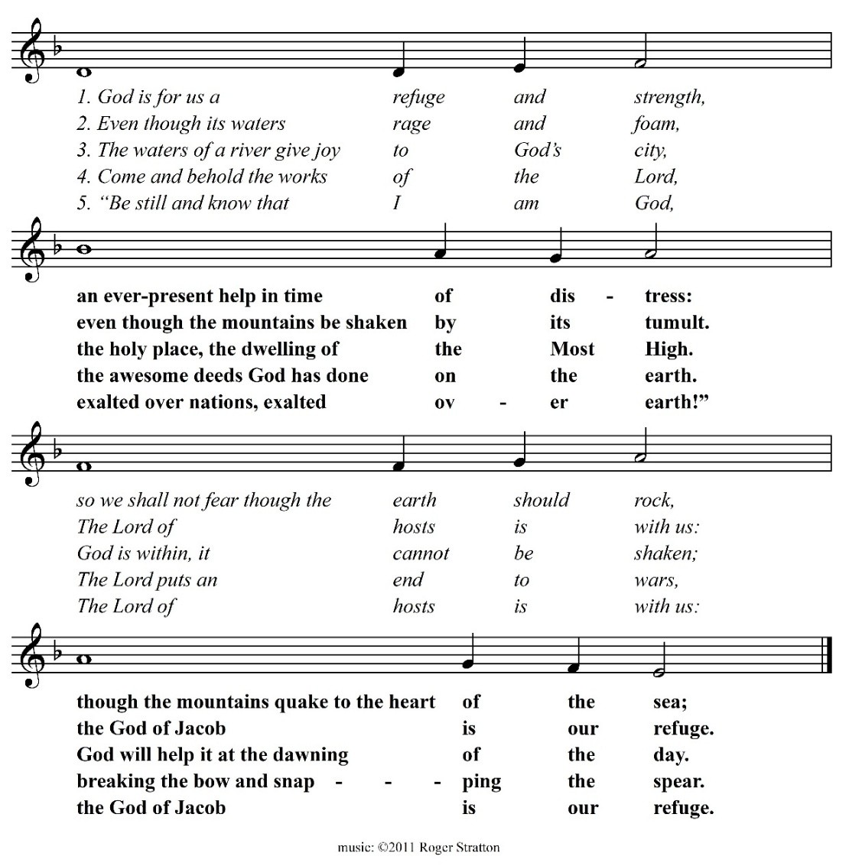

Second Reading Colossians 1:11-20

May you be made strong with all the strength that comes from his glorious power, and may you be prepared to endure everything with patience, while joyfully giving thanks to the Father, who has enabled you to share in the inheritance of the saints in the light. He has rescued us from the power of darkness and transferred us into the kingdom of his beloved Son, in whom we have redemption, the forgiveness of sins.

He is the image of the invisible God, the firstborn of all creation; for in him all things in heaven and on earth were created, things visible and invisible, whether thrones or dominions or rulers or powers-- all things have been created through him and for him. He himself is before all things, and in him all things hold together. He is the head of the body, the church; he is the beginning, the firstborn from the dead, so that he might come to have first place in everything. For in him all the fullness of God was pleased to dwell, and through him God was pleased to reconcile to himself all things, whether on earth or in heaven, by making peace through the blood of his cross.

Reader The Word of the Lord.
People Thanks be to God.

Gospel Acclamation
Please stand as you are able for the Gospel Acclamtion and reading of the Gospel.

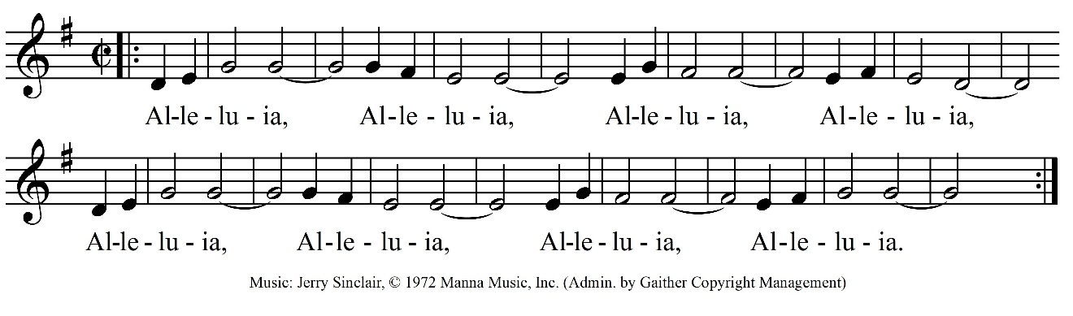

The Gospel Luke 23:33-43

Deacon The Holy Gospel of our Lord Jesus Christ according to Luke.
People Glory to you, Lord Christ.

When they came to the place that is called The Skull, they crucified Jesus there with the criminals, one on his right and one on his left. Then Jesus said, "Father, forgive them; for they do not know what they are doing." And they cast lots to divide his clothing. The people stood by, watching Jesus on the cross; but the leaders scoffed at him, saying, "He saved others; let him save himself if he is the Messiah of God, his chosen one!" The soldiers also mocked him, coming up and offering him sour wine, and saying, "If you are the King of the Jews, save yourself!" There was also an inscription over him, "This is the King of the Jews."

One of the criminals who were hanged there kept deriding him and saying, "Are you not the Messiah? Save yourself and us!" But the other rebuked him, saying, "Do you not fear God, since you are under the same sentence of condemnation? And we indeed have been condemned justly, for we are getting what we deserve for our deeds, but this man has done nothing wrong." Then he said, "Jesus, remember me when you come into your kingdom." He replied, "Truly I tell you, today you will be with me in Paradise."

\
Deacon The Gospel of the Lord
People Praise to you, Lord Christ.

The Sermon The Rev. Lindsay Hardin Freeman

The Nicene Creed
Please stand as you are able.

We believe in one God, the Father, the Almighty, maker of heaven and earth, of all that is, seen and unseen.

We believe in one Lord, Jesus Christ, the only Son of God, eternally begotten of the Father, God from God, Light from Light, true God from true God, begotten, not made, of one Being with the Father; through him all things were made. For us and for our salvation he came down from heaven, was incarnate of the Holy Spirit and the Virgin Mary and became truly human.

For our sake he was crucified under Pontius Pilate; he suffered death and was buried. On the third day he rose again in accordance with the Scriptures; he ascended into heaven and is seated at the right hand of the Father. He will come again in glory to judge the living and the dead, and his kingdom will have no end.

We believe in the Holy Spirit, the Lord, the giver of life, who proceeds from the Father, who with the Father and the Son is worshiped and glorified, who has spoken through the prophets.

We believe in one holy catholic and apostolic Church. We acknowledge one baptism for the forgiveness of sins. We look for the resurrection of the dead, and the life of the world to come. Amen.
The Prayers of the People
The Leader and People pray responsively.

Deacon Gathered as believers in Christ, made one body through baptism, let us offer prayers to God for the living hope of all the world.

We pray for this holy gathering, for Sean, our Presiding Bishop, and Craig, our Bishop, for all clergy and lay leaders, that we might live with courage and in hope.

Lord, in your mercy,
Hear our prayer.

We pray for our all those impacted by systemic inequality, for the courage, grace and strength to participate in works of justice. For God’s peace made manifest in our unity in Christ.

Lord, in your mercy,
Hear our prayer.

We pray for the leaders of the nations and all in authority. We pray especially for the people of Gaza and Israel, Sudan, Ukraine, and Ecuador, for peaceful solutions to war and unrest, and for justice and freedom for all the peoples of the earth.

Lord, in your mercy,
Hear our prayer.

We pray for strength in the face of the challenges and fears that the news of each day brings. For the hope of our faith, that our small acts might be leaven for transformation through the power of the Spirit.

Lord, in your mercy,
Hear our prayer.

We pray for this congregation, for our city and those who live in it, and for our families, companions, and all those we love. We pray in thanksgiving for the birth of Harvey Andrew Hellerman.

Lord, in your mercy,
Hear our prayer.

We pray for the hungry and the oppressed, and for those in prison, for the sick and the suffering, especially…

Please offer your own prayers, silently or aloud.

Lord, in your mercy,
Hear our prayer.

We pray for those who have died due to war, poverty, and gun violence, for all who have died in the hope of the resurrection, and for all who grieve. We pray especially for ...

Please offer your own prayers, silently or aloud.

Lord, in your mercy,
Hear our prayer.

Celebrant Blessed are you, O Lord our God, who gives us eternal peace through Jesus Christ. Hear our prayers which we offer in the hope of glory, and breathe upon us with your Holy Spirit; through Jesus Christ our Lord. Amen .

Confession
Deacon Let us confess our sins to God.

Silence
You are invited to be seated, to kneel or to remain standing.

All God of all mercy,
we confess that we have sinned against you,
opposing your will in our lives.
We have denied your goodness in each other,
in ourselves, and in the world you have created.
We repent of the evil that enslaves us,
the evil we have done,
and the evil done on our behalf.
Forgive, restore, and strengthen us
through our Savior Jesus Christ,
that we may abide in your love and serve only your will. Amen.

Absolution
Celebrant Almighty God have mercy on you, forgive you all your sins through the grace of Jesus Christ, strengthen you in all goodness, and by the power of the Holy Spirit keep you in eternal life.
People Amen.

The Peace
Celebrant The peace of the Lord be always with you.
People And also with you.

We Share in Holy Communion
Please stand, as you are able, while the offerings of bread and wine are presented. You may be seated until the singing of the Doxology, when we ask that you stand once more.

Offertory Bread of the World Richard Shephard

Bread of the world, in mercy broken,
Wine of the soul, in mercy shed,
By Whom the words of life were spoken,
And in Whose death our sins are dead.

Look on the heart by sorrow broken,
Look on the tears by sinners shed;
And be Thy feast to us the token,
That by Thy grace our souls are fed.

Doxology

The Great Thanksgiving
Remain standing as you are able
.
The Lord be with you.
And also with you.
Lift up your hearts.
We lift them to the Lord.
Let us give thanks to the Lord our God.
It is right to give our thanks and praise.

We praise you and we bless you, holy and gracious God, source of life abundant. From before time you made ready the creation. Your Spirit moved over the deep and brought all things into being: sun, moon, and stars; earth, winds, and waters; and every living thing.

You made us in your image, and taught us to walk in your ways. But we rebelled against you, and wandered far away; and yet, as a mother cares for her children, you would not forget us. Time and again you called us to live in the fullness of your love.

And so this day we join with Saints and Angels in the chorus of praise that rings through eternity, lifting our voices to magnify you as we sing:

Glory and honor and praise to you, holy and living God. To deliver us from the power of sin and death and to reveal the riches of your grace, you looked with favor upon Mary, your willing servant, that she might conceive and bear a son, Jesus the holy child of God.

Living among us, Jesus loved us. He broke bread with outcasts and sinners, healed the sick, and proclaimed good news to the poor. He yearned to draw all the world to himself yet we were heedless of his call to walk in love. Then, the time came for him to complete upon the cross the sacrifice of his life, and to be glorified by you.

On the night before he died for us, Jesus was at table with his friends. He took bread, gave thanks to you, broke it, and gave it to them, and said: “Take, eat: This is my Body, which is given for you. Do this for the remembrance of me.” As supper was ending, Jesus took the cup of wine. Again, he gave thanks to you, gave it to them, and said: “Drink this, all of you: This is my Blood of the new Covenant, which is poured out for you and for all for the forgiveness of sins. Whenever you drink it, do this for the remembrance of me.”

Now gathered at your table, O God of all creation, and remembering Christ, crucified and risen, who was and is and is to come, we offer to you our gifts of bread and wine, and ourselves, a living sacrifice.

Pour out your Spirit upon these gifts that they may be the Body and Blood of Christ. Breathe your Spirit over the whole earth and make us your new creation, the Body of Christ given for the world you have made.

In the fullness of time bring us, with David and Non and all your saints, from every tribe and language and people and nation, to feast at the banquet prepared from the foundation of the world.

Through Christ and with Christ and in Christ, in the unity of the Holy Spirit, to you be honor, glory, and praise, for ever and ever. Amen.

And now, as our Savior Christ has taught us, we are bold to say,
Our Father, who art in heaven, hallowed be thy Name, thy kingdom come, thy will be done, on earth as it is in heaven. Give us this day our daily bread. And forgive us our trespasses, as we forgive those who trespass against us. And lead us not into temptation, but deliver us from evil. For thine is the kingdom, and the power, and the glory, for ever and ever. Amen.

The Breaking of the Bread

The Communion
Everyone, without exception and regardless of age or faith tradition, is invited to share in Holy Communion at the Lord’s table. If you wish, please come forward to receive the bread and wine. If you are unable to come forward, please let an usher know and communion will be brought to you.

Gluten-free wafers are available. The wine is shared from a common cup; feel free to receive only the bread if you prefer. (For health reasons, we ask that you do not dip the bread in the wine.) If you would like to receive a blessing instead of communion, you can indicate this desire by crossing your arms over your chest.

Communion Hymns What Wondrous Love Is This? Hymnal #439

Jesus, Remember Me
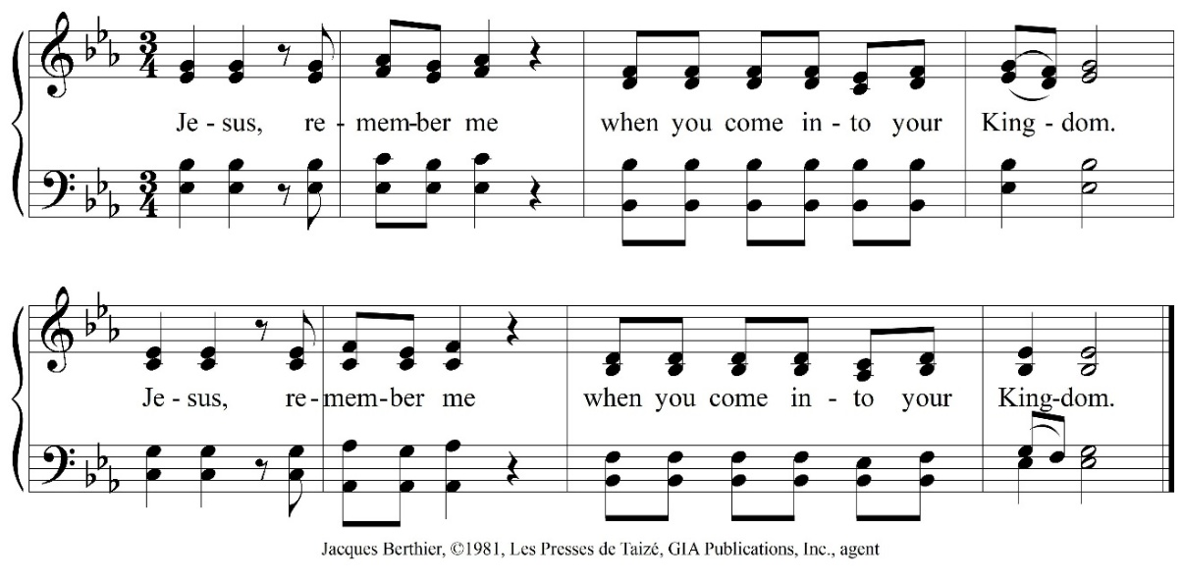

Sending Forth of Lay Eucharistic Visitors
On those days when the parish sends out Lay Eucharistic Visitors to those who cannot attend the liturgy, the Bread is presented to the Visitors at the altar, using this form.

Deacon In the name of this congregation, I send you forth bearing these holy gifts that those to whom you go may share with us in the communion of Christ’s body and blood.
People We who are many are one body, because we share the one bread and the one cup.

Prayer after Communion
All God of abundance,
you have fed us
with the bread of life and cup of salvation;
you have united us
with Christ and one another;
and you have made us one
with all your people in heaven and on earth.
Now send us forth
in the power of your Spirit,
that we may proclaim your redeeming love to the world
and continue for ever
in the risen life of Christ our Savior. Amen.
We Go into the World in God’s Name

Announcements

Blessing of Cambria Bold
Creator God, thank you for calling your servant Cambria into ministry in your church. Guide her with your wisdom, strengthen her with your Spirit, and keep her steadfast in faith as she hears and responds to your voice and call. May her life and work be a witness to your love and grace.
Through Jesus Christ, our Lord. Amen.

The Blessing

Departing Hail to the Lord’s Anointed Hymnal #616

Dismissal
Deacon Let us go forth into the world, rejoicing in the power of the Spirit.
People Thanks be to God.

Postlude

Want to read more about what’s going on at St. David’s? Visit our website stdavidsparish.org or check out the weekly email for announcements!


Our Leadership

Presiding Bishop of the Episcopal Church
The Most Rev. Sean W. Rowe ▪ 212-716-6273
Bishop of The Episcopal Church in Minnesota
The Rt. Rev. Craig Loya ▪ 612-870-3301 ▪ craig.l@episcopalmn.org
Wardens
Sr. Warden ▪ David Niles ▪ 612-799-6808 ▪ dniles@stdavidsparish.org
Jr. Warden ▪ Cathy Schwichtenberg ▪ (612) 710-2203 ▪ cschwichtenberg@stdavidsparish.org
Rector
The Very Rev. Katherine Lewis ▪ 612-747-5405 cell ▪ klewis@stdavidsparish.org
Deacon Emeritus
The Rev. Guy Drake ▪ 612-590-8502 ▪ gdrake@stdavidsparish.org
Adjunct Clergy
The Rev. Leonard Freeman ▪ 952-476-6267 ▪ LandL30@aol.com
The Rev. Lindsay Hardin Freeman ▪ 952-476-6267 ▪ lhfreeman25@gmail.com
Postulant for the Priesthood, Intern
Cambria Bold ▪ office@stdavidsparish.org
Manager for Finance, Communications and Ministry Support
Shea Brendalen ▪ 952-935-3336 ext. 17 ▪ sbrendalen@stdavidsparish.org
Minister of Music
Roger Stratton ▪ 612-819-5247 ▪ rstratton@stdavidsparish.org
Children and Youth Minister
Anna Belz-Brock ▪ 320-221-4075 ▪ abrock@stdavidsparish.org
Minister of Parish Life
Julia Moser-Hardy ▪ 952-935-3336 ▪ office@stdavidsparish.org
Parish Office
952-935-3336 ▪ office@stdavidsparish.org
