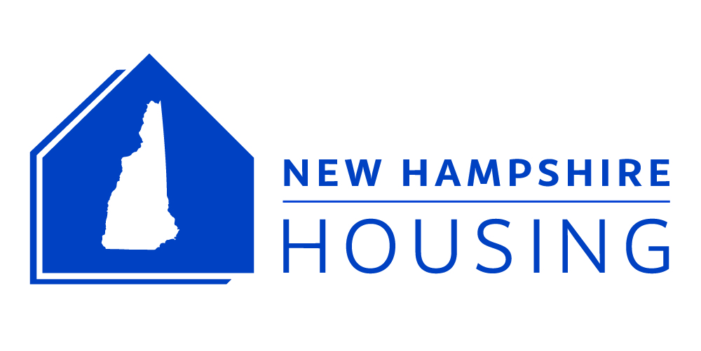

NEWS RELEASE
Grace Lessner
Public Information Manager
603-310-9371 | glessner@nhhfa.org
NHHFA.org/newsroom
STRONG TOWNS FOUNDER CHUCK MAROHN IN
ROCHESTER, CONCORD, CLAREMONT & PORTSMOUTH IN APRIL
— Free Events By Planning Expert on Communities, Growth and Resiliency —
(Bedford, March 22, 2019) – What does it mean to be a “Strong Town”? In April, nationally known planner and engineer Chuck Marohn will speak at community events in Rochester, Concord, Claremont and Portsmouth to discuss the STRONG TOWNS perspective of community economic resilience, citizen involvement, and wise land use.

Marohn will focus on how housing affordability fits with the STRONG TOWNS philosophy during the April 1-2 events presented by New Hampshire Housing Finance Authority. All of the events are free and open to the public. Registration is requested to ensure sufficient seating: www.NHHFA.org/events

Housing Our Communities: A Strong Towns Perspective (presented by New Hampshire Housing)
- April 1 - Rochester Performance & Arts Center 6:30-8:30 PM
- April 2 - Concord, NH Audubon Center McLane Center 7:30-9:00 AM
- April 2 - Claremont Savings Bank Community Center 6:30-8:00 PM
- April 3 - Pennywise Portsmouth: Balancing Costs & Community
(presented by Portsmouth Smart Growth PS21) 6:30 – 8:30 PM, Portsmouth Public Library
Charles Marohn founded Strong Towns in 2008 to support a model of development that encourages America's cities, towns and neighborhoods to become financially strong and resilient. A Professional Engineer and a member of the American Institute of Certified Planners, Marohn has presented Strong Towns concepts across North America, and in 2017 was named one of the 10 Most Influential Urbanists of all time by Planetizen.

The April 1 - 2 events are presented in partnership with:
- City of Rochester NH
- City of Claremont, NH
- Workforce Housing Coalition of the Greater Seacoast
- Vital Communities
- Mount Washington Valley Housing Coalition
- Plan NH
- Rockingham Planning Commission
- Strafford Regional Planning Commission
- Central New Hampshire Regional Planning Commission
- Upper Valley Lake Sunapee Regional Planning Commission
- New Hampshire Planners Association
- Northern New England Chapter of the American Planning Association (offering CM credit)
About New Hampshire Housing: As a self-supporting public corporation, New Hampshire Housing Finance Authority promotes, finances and supports affordable housing. NHHFA operates a number of rental and homeownership programs designed to assist low- and moderate-income persons with obtaining affordable housing. Since its inception, NHHFA has helped more than 45,000 families purchase their own homes and has been instrumental in financing the creation of almost 15,000 multi-family housing units.
NHHFA.org | #NHHFAHousing | Facebook @NewHampshireHousing | Twitter @NHHFA
NHHFA RESOURCES:
- March 2019 Housing Market Report
- NHHFA FY18 Annual Report
- 2018 New Hampshire Residential Rental Cost Survey report
- A New Hampshire Homeowner’s Guide to Accessory Dwelling Units
- Accessory Dwelling Units in New Hampshire: A Guide for Municipalities
- New Hampshire housing economic and demographic data and reports at
NHHFA.org/data-resources-planning

