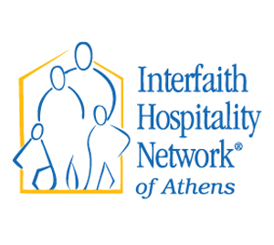
Interfaith Hospitality Network of Athens
2017 Annual Report

Interfaith Hospitality Network of Athens had a very successful year and we are grateful for the tremendous support provided by our congregations, our volunteers, our donors, and most importantly, YOU!
The Mission of IHN Athens is to mobilize our community to help homeless families in crisis situations find support and achieve sustainable independence.

We want to share three stories that demonstrate how we are achieving our mission:

“I just want to let you know that I appreciated the help from the program. Me and my kids are really enjoying our new house. They love it so much they are helping around the house! Also, my other son got to see it. To see my kids be as happy as they are now makes me glad to know that I done something great for them. Thanks a lot for y'all help. Also, we are doing great!”

There are academic studies that show the trauma that homeless children suffer. Recently, we experienced this first hand. We had an elementary school aged boy in our program, who was having serious behavioral problems in school. He was in emotional chaos. The week after we celebrated with the family moving into their own home, our Director, Davin Welter, ran into one of the Vice-Principal from the school who told him that she had never seen such a turnaround in a child. He was now the perfect student; his behavioral problems were gone. Don't ever underestimate the effects of a child having a home of their own, and that is our goal at IHNA. We support these families up to 90 days, work hard to move them into their own homes to get them back on their feet.

This year, a family moved into our shelter on the oldest boy's 12th birthday. Just before moving in, he told his mom he was brave and understood there would be no party. Of course, IHNA learned it was his birthday at intake, and we were prepared. Cake, ice cream, balloons, all with a race car theme. After the party, the birthday boy told his mom, "That was a cool." That is a lot of praise for a twelve-year-old middle schooler. Success!

Once families graduate from our program they are invited to participate in our Extended Network Program. This program provides case management follow up to families for one year after leaving the rotation program to make sure that they continue to thrive.
Impact: IHNA stories are inspiring, and here are the numbers behind the stories:
1,002 people volunteered this year. That is a total of 5,628.6 hours. Which equals a dollar value of $96,755.63 (($17.19/per hour, a number provided non-profits nation-wide by the federal government)
People served in the Network – 40 individuals,
27 children, 13 adults, 13 families
Average stay – 64.1 days
Graduation rate with Housing and Employment:
- Families as of 12/31/2017 that are in stable housing: 8 out of 10 families, 80%
- Total parents that left program with employment: 13 out of 13, 100%

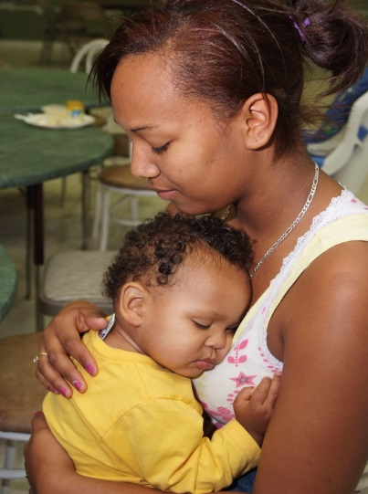
2,650- Total individual beds provided
Number of meals served - 4,112
1,515 - Bus passes distributed

Extended Network Program – 18 individuals,
11 children, 7 adults, 7 families
Individual referrals made to other agencies -92
Families (not in our network) in emergency situations who were assisted with a case plan, 79 referrals and follow up

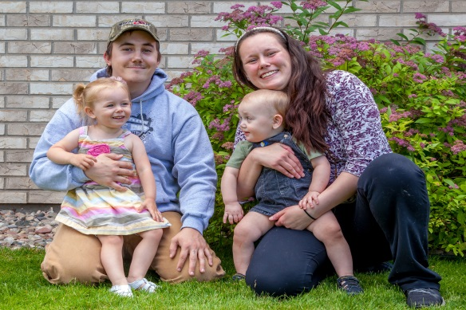
Total Revenue - $221,349.00
Grants - $44,613.56
Congregations – $43,764.05
Individuals – $71,831.20
Fundraising events - $54,751.43 (Includes La Table, Over the Edge, Whole-in-One Golf Tournament)
Miscellaneous - $6,388.76

Total Expenses – $216,727.79
Childcare – $14,143.00
Direct guest expenses – $12,949.39
Salaries and payroll expenses - $118,802.89
Fundraising expenses - $18,973.16
Indirect guest expenses - $8,958.80
Administrative expenses - $22,966.97
Rent – $9,237.00
Insurance - $10,696.58

Brief Financial Report:
Initiative

In the fall of 2016, IHNA helped form the Greater Athens Area Interfaith Clergy Partnership. After one and a half years, this group has had 75 clergy participate in some of the group events and we have a consistent group of around 35 at each event. We hope that our community will be strengthened from a wide range of religious leaders knowing each other, trusting one other and pursuing initiatives together for the betterment of our area.

Congregational Network (New congregations highlighted in red)
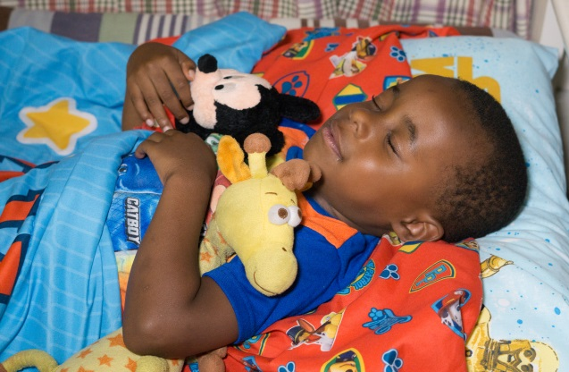
Support Congregations

Al Huda Islamic Center
Ashford Memorial Methodist Church
Athens Church
Athens Religious Society of Friends
The Catholic Center at UGA
Central Presbyterian Church
Chestnut Grove Baptist Church
Christian Science Congregation
Christus Victor Lutheran Church
Congregation Children of Israel
East Friendship Baptist Church
First Christian Church of Athens
Good Shepherd Presbyterian
Oconee Presbyterian Church
Oconee St. UMC
Princeton United Methodist Church
St. Joseph Catholic Church
Trinity Lutheran Church
Unitarian Universalist Fellowship of Athens
Watkinsville First Christian Church
Winterville United Methodist Church
Young Harris United Methodist Church

Host Congregations

Alps Road Presbyterian Church
Bethlehem United Methodist Church
The Church of Jesus Christ of Latter Day Saints (Mormons)
Covenant Presbyterian Church
Emmanuel Episcopal Church
First Baptist Church of Athens
First Presbyterian Church of Athens
First United Methodist Church of Athens
Holy Cross Lutheran Church
Milledge Avenue Baptist Church
St. Gregory’s Episcopal Church
Tuckston UMC
Union Christian Church, Watkinsville
Watkinsville First United Methodist Church

What People Are Saying about IHNA:
Guests
“Thank you so much I appreciate every moment, every talk, every pat on the back, every meal. I just want to say thank you.” IHNA Guest, James

Volunteers
“IHNA is so special because it is community based. It brings all the congregations together and says, ‘This is how we are going to give back to Athens and help our people.’ These kids are in our schools.” – IHNA Volunteer Jodie Anderson, Athens, GA

Staff
“The mission of IHNA is to provide basics to homeless families—shelter, food, transportation—but it goes beyond that. They also need care, compassion, and unconditional love, and our volunteers willingly provide that care.” – IHNA Executive Director, Davin Welter

“Our goal is that our families will never be homeless again.”
–IHNA Executive Director, Davin Welter

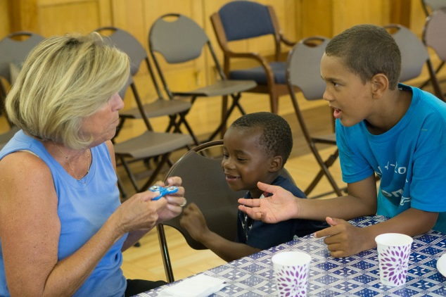
“Studies show the high likelihood of homeless children becoming homeless adults. By shortening the period of homelessness and providing a nurturing home-like environment, we believe we are breaking this cycle for our guest children and affecting future statistics.” – IHNA Assistant Director, Stacy Pardue

Clergy
“There are a lot of people who are really passionate about Interfaith Hospitality Network here in our congregation, so we really get excited and mobilize when we know that there is going to be a group coming to be guests at the church for a week.”
– Rev. Nathan Hilkert, Pastor Holy Cross Lutheran Church Athens, GA

“Our people live out their faith by serving in the community, and by helping folks who are in need, and so I think people really feel like their faith is strengthened and they are able to live out their faith by serving the people who come to stay with us.”
–Rev. Nathan Hilkert, Pastor Holy Cross Lutheran Church Athens, GA

Board
“Without the volunteers there would be no interfaith, it’s just that simple. We only have three paid staff here in Athens which is the same as most Family Promise networks.” – IHNA Board Member, Linda Lacy

“You always think when you do a ministry like this that you are going to be the one who’s providing the help and blessing to those in need. But I have found that it’s been the reverse, that I have been so blessed by the guests who have come.” – IHNA Board Member, Linda Lacy

“When a young Mom with a couple of children walks into your space that you have provided for them and says, “Wow, this really feels like home,” there is just something that says, “Wow, I can do that for this family.” – IHNA Board Member, Linda Lacy

“What sets IHNA apart from another homeless shelter is that it is designed to keep the family together.” – Holly Schramski, former IHNA Board Member

“Being a board member, I was able to take my business, organizational and operations skills and use them to help people.” – Holly Schramski, former IHNA Board Member

Staff and Interns

Executive Director, Davin Welter
Assistant Director, Stacy Pardue
Service Director, Regina Roth-Goldman

UGA Social Work Interns: – Sarah Beth Tankersley, Hannah Mapes, Melanie Norton, Bailey Meyne, Jasey Jones, Michael Whitfield, Ben Gardner, Nick DeVictor

Waddell Fellow: Dray Criswell

UGA Master of Public Administration Students: Carrie Campbell, Haiyan Fan, Patricia Lee, Ryan Moore, Siying Qu, Rebecca Rykard, Darbi Steckman

UGA Master of Business Students: Tony Caucci, Phil Edmondson John-David Morris, Justin Nachsin

Young Dawgs Intern: Olivia Ripps

2018 New Board Members

Tom Rodgers
Stacie Carson
Eric Linder

2017 Board Members:

Duane Bernt
Richard Carswell
Christopher Cole
Rachele Gibson
Justin Ingles
Linda Lacy
Alex McQueen
Don Nelson
Bemene Piaro
Michael Ripps
Harry Shuford
Courtney Tobin

Interfaith Hospitality Network of Athens
Appendix to 2017 Annual Report
Partnership/Collaborations

Shelter

IHNA worked with case managers at the Athens Area Homeless Shelter, the Salvation Army (family units), Project Safe, Peace Place, and Family Promise affiliates to share information, pool resources, and to make and receive referrals for families. Individuals without children were referred to A Bigger Vision and the Salvation Army.

Housing

The majority of our families received services from the Going Home Rapid re-Housing Program, through the Athens Area Homeless Shelter, including rent assistance and case management. A family was eligible for the lease to own program through the Athens Land Trust. Families were referred to housing programs through the Department of Veterans Affairs and Advantage Behavioral Health. In addition, IHNA received referrals from the Division of Family and Children Services in Clarke, and surrounding counties

Childcare and School

IHNA partnered with Bright Beginnings Daycare and Little Angels Daycare to provide fulltime and afterschool childcare for families. IHNA worked with Clarke County School District Homeless Student Services to arrange bus transportation, tutors, school supplies, and uniforms. We also received referrals from the school district.

Employment

Families were referred to the Career Centers at the Department of Labor and Goodwill Industries for job skills, job search, interviewing skills, job fairs, and interview clothes.

Healthcare

Physical and mental health referrals were made, for both adults and children, to Athens Clarke County Health Department, Neighborhood Health Clinic, Athens Nurses Clinic, and Good Samaritan Counseling. We have partnered with Femme(me), a UGA Public Health organization, to provide feminine hygiene products for women and girls in our shelter.

Financial Literacy

Families were referred to VITA (volunteer income tax assistance) through Action Ministries. IHNA referred families to the ASPIRE clinic for financial counseling and credit repair. IHNA uses the financial literacy information, from Family Promise, to assist families with developing a monthly budget.

Clothing

America’s Thrift Store, Re-Blossom, Salvation Army, and Project Safe provided store vouchers for our families to shop for free.

Mainstream Benefits

Information is always provided for SNAP (food stamps), Medicaid, CAPS, TANF (Temporary Assistance for Needy Families), Georgia Child Support Office, SSI (Social Security Insurance) for children, WIC (Women, Infants, and Children – under 5), CAPS (Childcare and Parent Services(federally subsidized program for daycare assistance).

Transportation

IHNA partnered with both Car Craft and Cedar Shoals High School Automotive Department to assist families with car repairs.

