Tufts Medicine Employee Resource Guide

Welcome to Tufts Medicine! This is an employee resource guide to help you navigate through and access the Wellforce systems and resources. You can also visit https://www.tuftsmedicine/careers/employees for additional resources. Please reach out to any of the following individuals if you have questions and/or password reset issues with any of the following systems.
Kronos
Time Management System

Web address: https://wellforce.kronos.net/wfc/logon

- Log in with your Wellforce email
- The first time you log in the password is “password” (all lowercase)
- Non-exempt/Hourly employees must punch in and out daily (VPs and above do not have to punch in)
- Exempt/Salary employees must punch in once a day
- Time off request – follow your department guidelines

If you forget to punch in, you will need to complete a My Time Form (which is he last page of this guide), collect the appropriate signatures and share this form with your department time keeper.

Kronos contact: David Vaida at david.vaida@wellforce.org
OR call 617-636-4668

Employee ID Location
Employee ID location is in Kronos.
- Log into Kronos
- Click My Time Card on the right side of screen
- Click “Print Time Card”. Your employee ID is in the upper left-hand corner of the screen or
It is on your paystubs

Help Desk Phone Numbers
Lowell Circle Health - call - 978-937-6445-State you are a Wellforce employee. Ask to be transferred to Tier 2 Desktop Support (Hours M-F from 8am-6pm EST)
MelroseWakefield - call - 781-306-6330
Tufts Medical Center – call - 617-636-6485

Payroll/Direct Deposit/PTO Accruals

Payroll contact: tuftsmcfinancepayroll@tuftsmedicalcenter.org

Location of Paystub Instructions: https://www.tuftsmedicine/careers/employees

Paid Time Off (PTO)
As new Tufts Medicine employees, you will begin to accrue PTO hours from your first day of employment. However, even though the system is logging and calculating your accruals, you won’t see any change in the number in your TM- Paid Time Off row (see below example), because you are technically under your “probationary period” for the first 90 days from your date of hire.

Once your 90 days are complete, you will see your PTO balance on your paycheck

PTO Accrual Questions: totalrewards@wellforce.org
Another way to view time off accruals after your 90 days, is to go into Lawson Self Service.
Lawson
Employee Self-Service Payroll Information for Paychecks and Time Accruals

You will need to log into Citrix and VIP Access app on your cellphone with a registered SYMC number.
You can find the Lawson icon on your desktop, if you do not have it please call the help desk from which your device laptop was issued.
- You will need to call the Help Desk from the member your laptop is issued from:
- Lowell Circle Health - call - 978-937-6445 Ask to be transferred to Tier 2 Desktop Support (Hours M-F from 8am-6pm EST)
- MelroseWakefield - call - 781-306-6330
- Tufts Medical Center – call - 617-636-6485

- Or John Lally, Tufts Medical Center, email john.lally@wellforce.org OR call 617-636-5646

Employment Verification
For employment verification, please contact: tuftsmcfinancepayroll@tuftsmedicalcenter.org

Tufts Medicine 403(b) Plan
To enroll contact Fidelity at (800) 343-0860 or www.netbenefits.com/atwork
Questions, contact Kara O’Connor, kara.oconnor@wellforce.org

Holidays
Listed below is a list of official Tufts Medicine Holidays
- New Year’s Day
- Memorial Day
- Juneteenth
- Independence Day
- Labor Day
- Thanksgiving Day
- Christmas Day

BSwift Benefits Portal
Contact: Kristin Gibson at Kristin.gibson@wellforce.org or Julio Pizzaro at Julio.Pizarro@wellforce.org
OR call Bswift Service Center 8:00am – 8:00pm EST 1-888-235-1253

Web address:
www.mywellbenefits.bswift.com

Key Contacts:
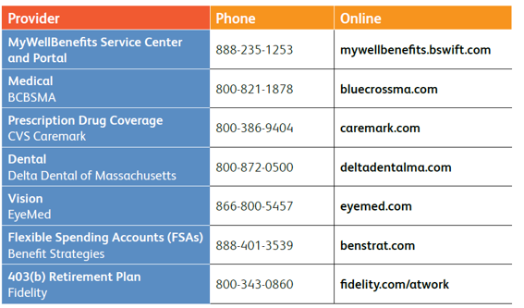

Employee/Occupational Health at Tufts Medical Center

185 Harrison Ave, Boston, MA 02111
Phone: 617-636-5480
Fax: 617-636-6211
employeehealthservices@tuftsmedicalcenter.org

Annual Employee/Occupational Requirements
- Employees will continue to be required to get their annual Flu shot
- TB and any other annual test are still pending review if required annually

Personal Information Changes
To change your personal information, such as address, phone number, please complete and submit an information change form, which can be found here: tuftsmcemployeechanges@tuftsmedicalcenter.org

Performance Manager
To access the Tufts Medicine Performance Management system, please visit: https://pfm.healthcaresource.com/performance/wellforce

To register for the Wellforce Performance Manager platform, follow the below steps:
- Select register below the log in box on the website
- Verify your identity by entering your first name, last name and Wellforce employee
  - If you do not know your Wellforce employee ID, please email HR@Wellforce.org
- Enter a password that meets the requirements as outlined
- Set up security questions
- The next page will confirm your registration and return you to the log in page

From here you will be able to login using your username (which is your Wellforce employee ID) and the password that you selected. If you have questions, please contact HR@Wellforce.org

Performance Manager Requirements
Tufts Medicine requires all employees to sign off on their job description during their first week of employment.
Additionally, employees will be asked the utilize Performance Manager to complete an introductory appraisal at their 90-day mark and an annual appraisal at the designated focal review period.

EVA Link to Corporate Policies

The HR page is listed here: https://www.evaintra.org/Interact/Pages/Section/Default.aspx?Section=7242
The access is typically system login credentials.

Wellforce Email
A Wellforce email account has been created for all employees even if you have or had an MWH, Circle or Tufts MC email account. Your Wellforce email account will be used to grant you access to Lawson, Kronos, and other Wellforce systems, also Wellforce will be using this email to distribute communications. Please check this email account daily.

User name for this email is the FIRST 3 letters of your first name and the FIRST 5 letters of your last name, i.e.,

EXAMPLE: Joseph Smith user name is jossmith
Password will need to be reset every 90 days
This email account is managed by the Circle Health/Lowell General Hospital information services team.

If you need a password, please contact our help desk at 978-937-6445

Adding your Wellforce email to your phone must be approved by your manager-you will need to call the help desk at 978-937-6445

How to access your email-remotely

Click this link https://owa.lowellgeneral.org/owa to log in to your Lowell General (Wellforce) web mail.

For future reference, to change your password without using a
Lowell General provided device.

- Click this link https://owa.lowellgeneral.org/owa to log in to your Lowell General (Wellforce) web mail,
- from the top-right corner, click the gear icon and click Options
- from the left-hand side, click General and My account,
- click Change your password at the bottom right,
- Enter your old password, a new password, and confirm the new password.
- Click Save, and your password is now changed.

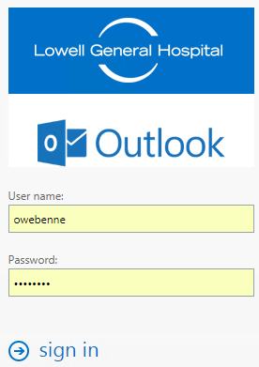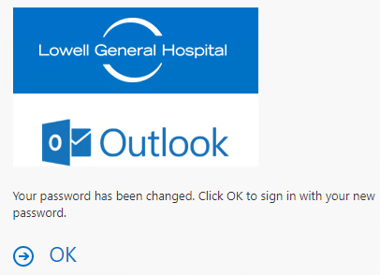

Leave Us A Review!

Want to share your experience working at Tufts Medicine? Leave a review on our company pages:

Glassdoor: https://www.glassdoor.com/Overview/Working-at-Wellforce-EI_IE1880958.11,20.htm
Indeed: https://www.indeed.com/cmp/Wellforce

PM

Tufts Medicine MyTime Missed Punch Form


Name: | Employee ID:

*Please record your missed punches below, sign and return to your supervisor by the end of the week.
*Record the actual time you arrived or left and not your scheduled time.
*Forms will be kept in department records for 3 years.
*Please enter missed punches no later than noon on the Monday of Payroll processing.

Date | In | Out | Date | In | Out


Comments: Employee was not able to log into Kronos, due to being a new hire
*By signing, you certify that you have reviewed the above MyTime punches and agree that it is an
accurate record of the employee's time.
Signed: |  | Date:

