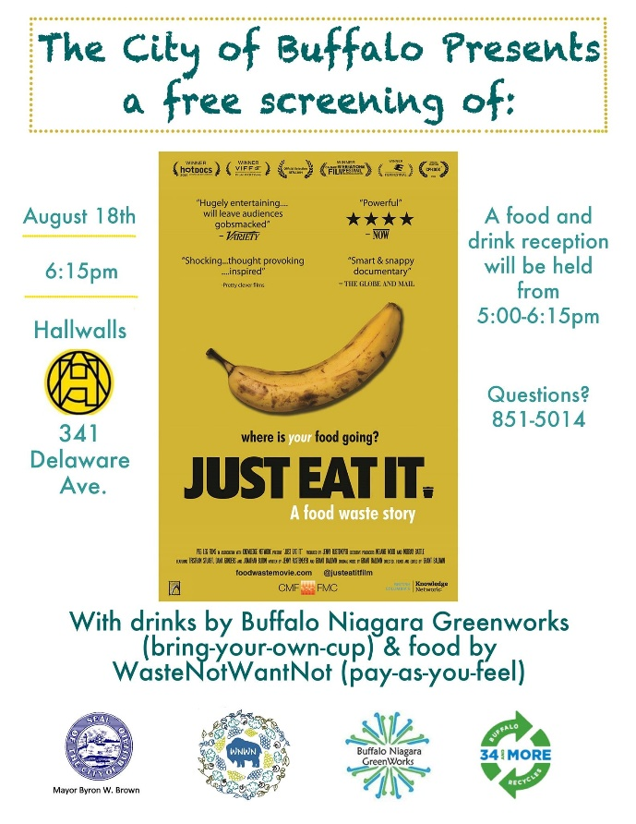
Mayor Byron W. Brown and the City of Buffalo sponsored a free screening of the renowned documentary, “Just Eat It – A food waste story” on Thursday, August 18, 2016. The community outreach event was to draw attention to problem of food waste. In the United States, 40 percent of all food is wasted. In fact, food is the single largest contributor to landfills today. Consumers are responsible for more wasted food than farmers, grocery stores, restaurants or any part of the food supply chain. Most people don’t realize how much food they toss out each year—an average of 1,000 pounds per family of four, resulting in $1,500 lost.
“I encourage city residents to come to this free screening to learn how to waste less food. Wasting less food not only saves consumers money, it helps the environment by conserving landfill space and helps our 34 and More recycling campaign by decreasing our waste disposal,” said Mayor Byron Brown. “I am pleased that the city is working with other community groups to draw attention to this issue.

A food and drink reception was provided by a local community group by WasteNotWantNot and Buffalo Niagara Greenworks. Over 120 people attended this event and the there was a call for a follow up event.

------------------------------------------------------------------------------------------------------------------

The City of Buffalo also stepped up food recycling efforts at Special Events this summer by working with the Taste of Buffalo to add food waste collection to the popular annual event. Fifty-five restaurant vendors were given food waste collection totes as well as five staffed recycling stations for the 450,000 visitors that come to the two day festival. Collection was provided by Natural Upcycling, where the food waste is processed in their food digester located in Pavilion, New York and converted to energy. Natural Upcycling also provides food waste collection to several businesses in the Buffalo area, including two schools and Buffalo City
Hall.

