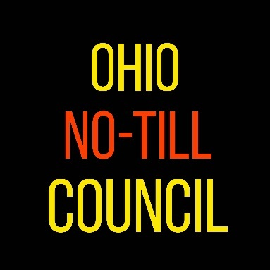
Ohio No-Till Council
College Scholarship Application 2020
The Ohio No-Till Council is offering 5 scholarships ranging from $500-$1000. These scholarships are one year in length and are open to children and grandchildren from a farming background, who are enrolling or are currently enrolled in a two-year or four-year accredited college program. Three $500-dollar scholarships are open to applicants of any college or expected degree. Two $1000-dollar scholarships are as follows: the Howard Doster Memorial Scholarship is open to an applicant fulfilling the above requirements and studying agriculture at The Ohio State University or Purdue University; the other $1000-dollar scholarship (Bill Richards Scholarship) is open to an applicant fulfilling the above requirements and studying agriculture at The Ohio State University. Previous winners and applicants may apply each year they are eligible. All monies awarded will be made payable to the winner’s respective school. Scholarships are open to all incoming freshmen, sophomore, junior and senior students. The selection process will occur in May and winners will be announced by the end of June.
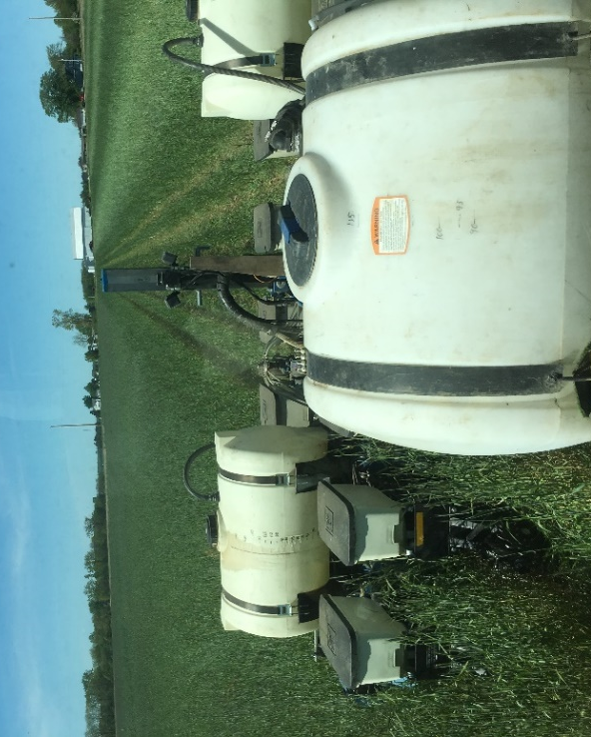
All interested applicants must meet the following requirements, complete the information requested below, and return by May 1st to:

OhioNoTillCouncil@gmail.com
or
Scholarship Chair
419 County Road 106
Fremont, OH 43420

NAME_________________________ CELL PHONE__________________________
ADDRESS____________________________ CITY___________________________ STATE_______ ZIP________ E-MAIL_____________________________________
FARM PARENT OR GRANDPARENT ______________________________________
SCHOOL PRESENTLY ATTENDING________________________________________
GUIDANCE COUNSELOR/ADVISOR: NAME________________________________
SCHOOL ATTENDING NEXT YEAR__________________________________
EXPECTED DEGREE_____________________________________________
Requirements for All Scholarships:
- Applicants must be a child or grandchild of a farming family.
- Applicants must be enrolling/enrolled in an accredited two/four-year college program.
- Applicants must have an accredited 2.5 grade average in your current high school or college (secondary education) curriculum.
- Recipients must attend an Ohio No-Till Council Event in order to receive their scholarship.
- Additional Requirements for Bill Richards Scholarship ($1000)
  - Must be attending The Ohio State University (or ATI)
  - Must be Studying Agriculture
- Additional Requirements for Howard Doster Memorial Scholarship ($1000)
  - Must be attending The Ohio State University (or ATI) or Purdue University
  - Must be Studying Agriculture
Please Include (with this form):
- A one-page essay (500 words) on an agriculturally-related topic. (Preference given to soil & water conservation; no-tillage practices, soil health, etc.)
- Two letters of recommendation from teachers or professors.
- A copy of your most recent grade card or transcript.
All materials must be received by May 1st.
Good Luck!

