Palm Sunday/Sunday of the Passion
Trinity Lutheran Church
Athens, GA

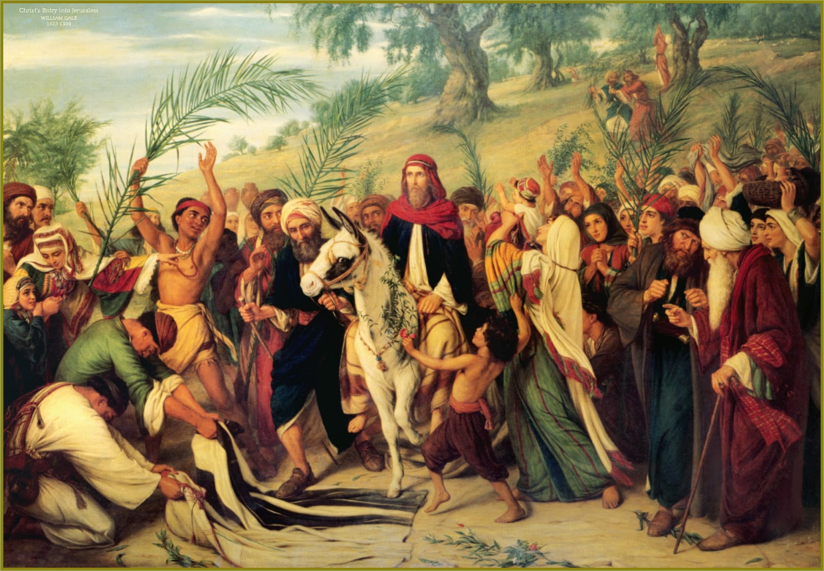

“13So they took branches of palm trees and went out to meet him, crying out, “Hosanna! Blessed is he who comes in the name of the Lord, even the King of Israel!”” (John 12:13)

Welcome!
We rejoice and give thanks that you are here this morning and pray that the message of the cross of Christ brings comfort to you. If this is your first time worshipping with us please read Trinity’s statement regarding the practice of Holy Communion. Please introduce yourself to the pastor and those sitting around you. Thank you for visiting and please join us again. If you have any questions please reach out to Pastor Davis at 970-630-5191(Text or Voice)

Hearing Aids and Cry Room
Those who have a need for hearing assistance, please speak with the usher. Please be assured that the voices of children are received with delight in our midst. The cry room is located at the back of the church if you desire to use it.

Trinity’s Holy Communion Statement
We rejoice in the celebration of the Lord’s Supper as the Lord Jesus comes to us in an intimate manner. In the Lord’s Supper we receive His true Body and true Blood in, with, and under the bread and wine. Our Lord teaches us in 1 Corinthians 11:28-29, “A man ought to examine himself before he eats of the bread and drinks of the cup. For anyone who eats and drinks without recognizing the body of the Lord eats and drinks judgment on himself.” If this is your confession, please join us in the Lord’s Supper. Alcohol-free wine is available for those who are unable or desire not to receive alcohol. The alcohol-free wine is in the center of the tray.

(Stand)

READING John 12:12–19
12The next day the large crowd that had come to the feast heard that Jesus was coming to Jerusalem. 13So they took branches of palm trees and went out to meet him, crying out, “Hosanna! Blessed is he who comes in the name of the Lord, even the King of Israel!” 14And Jesus found a young donkey and sat on it, just as it is written,
15“Fear not, daughter of Zion;
behold, your king is coming,
sitting on a donkey’s colt!”
16His disciples did not understand these things at first, but when Jesus was glorified, then they remembered that these things had been written about him and had been done to him. 17The crowd that had been with him when he called Lazarus out of the tomb and raised him from the dead continued to bear witness. 18The reason why the crowd went to meet him was that they heard he had done this sign. 19So the Pharisees said to one another, “You see that you are gaining nothing. Look, the world has gone after him.”

443 HOSANNA, LOUD HOSANNA

+ CONFESSION AND ABSOLUTION +

(The sign of the cross may be made by all in remembrance of their Baptism.)

INVOCATION

EXHORTATION LSB 184

(Kneel/Stand)

(Silence for reflection on God’s Word and for self-examination.)

CONFESSION OF SINS LSB 184

ABSOLUTION LSB 185

(Stand)

+ SERVICE OF THE WORD +

INTROIT Psalm 24:7–10; antiphon: Psalm 118:26
Blessèd is he who comes in the name of the Lord!
We bless you from the house of the Lord.
Lift up your heads, O gates! And be lifted up, O ancient doors,
that the King of glory may come in.
Who is this King of glory?
The Lord, strong and mighty, the Lord, mighty in battle!
Lift up your heads, O gates! And lift them up, O ancient doors,
that the King of glory may come in.
Who is this King of glory?
The Lord of hosts, he is the King of glory!
Blessèd is he who comes in the name of the Lord!
We bless you from the house of the Lord.

KYRIE LSB 186

SALUTATION AND COLLECT OF THE DAY
P The Lord be with you.
C And with thy spirit.

P Let us pray.
Almighty and everlasting God, You sent Your Son, our Savior Jesus Christ, to take upon Himself our flesh and to suffer death upon the cross. Mercifully grant that we may follow the example of His great humility and patience and be made partakers of His resurrection; through the same Jesus Christ, our Lord, who lives and reigns with You and the Holy Spirit, one God, now and forever.

C Amen.

(Sit)

OLD TESTAMENT READING Deuteronomy 32:36–39
36 The Lord will vindicate his people
and have compassion on his servants,
when he sees that their power is gone
and there is none remaining, bond or free.
37Then he will say, “Where are their gods,
the rock in which they took refuge,
38who ate the fat of their sacrifices
and drank the wine of their drink offering?
Let them rise up and help you;
let them be your protection!
39“See now that I, even I, am he,
and there is no god beside me;
I kill and I make alive;
I wound and I heal;
and there is none that can deliver out of my hand.”

A This is the Word of the Lord.
C Thanks be to God.

EPISTLE Philippians 2:5–11
5Have this mind among yourselves, which is yours in Christ Jesus, 6who, though he was in the form of God, did not count equality with God a thing to be grasped, 7but made himself nothing, taking the form of a servant, being born in the likeness of men. 8And being found in human form, he humbled himself by becoming obedient to the point of death, even death on a cross. 9Therefore God has highly exalted him and bestowed on him the name that is above every name, 10so that at the name of Jesus every knee should bow, in heaven and on earth and under the earth, 11and every tongue confess that Jesus Christ is Lord, to the glory of God the Father.
A This is the Word of the Lord.
C Thanks be to God.

(Stand)
HOLY GOSPEL Luke 23:1–56
P The Holy Gospel according to St. Luke, the twenty-third chapter.

1Then the whole company of them arose and brought him before Pilate. 2And they began to accuse him, saying, “We found this man misleading our nation and forbidding us to give tribute to Caesar, and saying that he himself is Christ, a king.” 3And Pilate asked him, “Are you the King of the Jews?” And he answered him, “You have said so.” 4Then Pilate said to the chief priests and the crowds, “I find no guilt in this man.” 5But they were urgent, saying, “He stirs up the people, teaching throughout all Judea, from Galilee even to this place.”
6When Pilate heard this, he asked whether the man was a Galilean. 7And when he learned that he belonged to Herod’s jurisdiction, he sent him over to Herod, who was himself in Jerusalem at that time. 8When Herod saw Jesus, he was very glad, for he had long desired to see him, because he had heard about him, and he was hoping to see some sign done by him. 9So he questioned him at some length, but he made no answer. 10The chief priests and the scribes stood by, vehemently accusing him. 11And Herod with his soldiers treated him with contempt and mocked him. Then, arraying him in splendid clothing, he sent him back to Pilate. 12And Herod and Pilate became friends with each other that very day, for before this they had been at enmity with each other.
13Pilate then called together the chief priests and the rulers and the people, 14and said to them, “You brought me this man as one who was misleading the people. And after examining him before you, behold, I did not find this man guilty of any of your charges against him. 15Neither did Herod, for he sent him back to us. Look, nothing deserving death has been done by him. 16I will therefore punish and release him.”
18But they all cried out together, “Away with this man, and release to us Barabbas”— 19a man who had been thrown into prison for an insurrection started in the city and for murder. 20Pilate addressed them once more, desiring to release Jesus, 21but they kept shouting, “Crucify, crucify him!” 22A third time he said to them, “Why, what evil has he done? I have found in him no guilt deserving death. I will therefore punish and release him.” 23But they were urgent, demanding with loud cries that he should be crucified. And their voices prevailed. 24So Pilate decided that their demand should be granted. 25He released the man who had been thrown into prison for insurrection and murder, for whom they asked, but he delivered Jesus over to their will.
26And as they led him away, they seized one Simon of Cyrene, who was coming in from the country, and laid on him the cross, to carry it behind Jesus. 27And there followed him a great multitude of the people and of women who were mourning and lamenting for him. 28But turning to them Jesus said, “Daughters of Jerusalem, do not weep for me, but weep for yourselves and for your children. 29For behold, the days are coming when they will say, ‘Blessed are the barren and the wombs that never bore and the breasts that never nursed!’ 30Then they will begin to say to the mountains, ‘Fall on us,’ and to the hills, ‘Cover us.’ 31For if they do these things when the wood is green, what will happen when it is dry?”
32Two others, who were criminals, were led away to be put to death with him. 33And when they came to the place that is called The Skull, there they crucified him, and the criminals, one on his right and one on his left. 34And Jesus said, “Father, forgive them, for they know not what they do.” And they cast lots to divide his garments. 35And the people stood by, watching, but the rulers scoffed at him, saying, “He saved others; let him save himself, if he is the Christ of God, his Chosen One!” 36The soldiers also mocked him, coming up and offering him sour wine 37and saying, “If you are the King of the Jews, save yourself!” 38There was also an inscription over him, “This is the King of the Jews.”
39One of the criminals who were hanged railed at him, saying, “Are you not the Christ? Save yourself and us!” 40But the other rebuked him, saying, “Do you not fear God, since you are under the same sentence of condemnation? 41And we indeed justly, for we are receiving the due reward of our deeds; but this man has done nothing wrong.” 42And he said, “Jesus, remember me when you come into your kingdom.” 43And he said to him, “Truly, I say to you, today you will be with me in Paradise.”
44It was now about the sixth hour, and there was darkness over the whole land until the ninth hour, 45while the sun’s light failed. And the curtain of the temple was torn in two. 46Then Jesus, calling out with a loud voice, said, “Father, into your hands I commit my spirit!” And having said this he breathed his last. 47Now when the centurion saw what had taken place, he praised God, saying, “Certainly this man was innocent!” 48And all the crowds that had assembled for this spectacle, when they saw what had taken place, returned home beating their breasts. 49And all his acquaintances and the women who had followed him from Galilee stood at a distance watching these things.
50Now there was a man named Joseph, from the Jewish town of Arimathea. He was a member of the council, a good and righteous man, 51who had not consented to their decision and action; and he was looking for the kingdom of God. 52This man went to Pilate and asked for the body of Jesus. 53Then he took it down and wrapped it in a linen shroud and laid him in a tomb cut in stone, where no one had ever yet been laid. 54It was the day of Preparation, and the Sabbath was beginning. 55The women who had come with him from Galilee followed and saw the tomb and how his body was laid. 56Then they returned and prepared spices and ointments.
On the Sabbath they rested according to the commandment.

P This is the Gospel of the Lord.

NICENE CREED

(Sit)

442 ALL GLORY, LAUD, AND HONOR

CHILDRENS SERMON(10:00 A.M.)
SERMON

(Stand)

OFFERTORY LSB 192

(Sit)

OFFERING

(Stand)

PRAYER OF THE CHURCH

+ SERVICE OF THE SACRAMENT +

PREFACE LSB 194

P It is truly meet, right, and salutary that we should at all times and in all places give thanks to You, holy Lord, almighty Father, everlasting God, through Jesus Christ, our Lord, who accomplished the salvation of mankind by the tree of the cross that, where death arose, there life also might rise again and that the serpent who overcame by the tree of the garden might likewise by the tree of the cross be overcome. Therefore with angels and archangels and with all the company of heaven we laud and magnify Your glorious name, evermore praising You and saying:

SANCTUS LSB 195

LORD’S PRAYER LSB 196

THE WORDS OF OUR LORD LSB 197

PAX DOMINI LSB 197
P The peace of the Lord be with you always.
C Amen.
(Following the PAX DOMINI, the people may greet one another in the name of the Lord, saying, “Peace be with you,” as a sign of reconciliation and of the unity of the Spirit in the bond of peace (Matt. 5:22–24; Eph. 4:1–3).)

AGNUS DEI LSB 198

(Sit)

DISTRIBUTION

622 LORD JESUS CHRIST, YOU HAVE PREPARED

(Stand)
NUNC DIMITTIS LSB 199

THANKSGIVING LSB 200

POST-COMMUNION COLLECT

SALUTATION LSB 201

BENEDICAMUS LSB 202

BENEDICTION LSB 202

441 RIDE ON, RIDE ON IN MAJESTY

ACKNOWLEDGMENTS
Divine Service, Setting Three from Lutheran Service Book
Unless otherwise indicated, Scripture quotations are from the ESV® Bible (The Holy Bible, English Standard Version®), copyright © 2001 by Crossway, a publishing ministry of Good News Publishers. Used by permission. All rights reserved.
Created by Lutheran Service Builder © 2025 Concordia Publishing House.

Holy Week Schedule

*Maundy Thursday-Thursday Evening, 7:00 p.m. with Holy Communion
*Good Friday-Friday Evening, 7:00 p.m. Tenebrae
*Easter Sunday-Early Service-8:00 a.m. with Holy Communion.
*EASTER BREAKFAST: Serving 8:45-9:30 a.m. Board of Christian Service is providing Egg Casserole and Drinks, please bring a dish to share.
*EASTER CELEBRATION SERVICE: 10:00 a.m. with Holy Communion.
*Easter Egg Hunt: Immediately Following the late service. Bring the kids we have lots and lots of eggs!!
Upcoming

Confirmation Public Examination: April 27th, during the 10:00 a.m. service in lieu of the sermon.
Confirmation: May 4th, 10:00 a.m. service. Reception and Dinner following in the Fellowship Hall.
Family Promise Sunday: May 4th, 10:00 a.m. service. Door Offering Collected.

In May

Spiritual First Aid Weekend: April 16th-17th, more details coming regarding registration. ALL are invited to attend this FREE training workshop starting Friday evening and concluding Saturday afternoon.

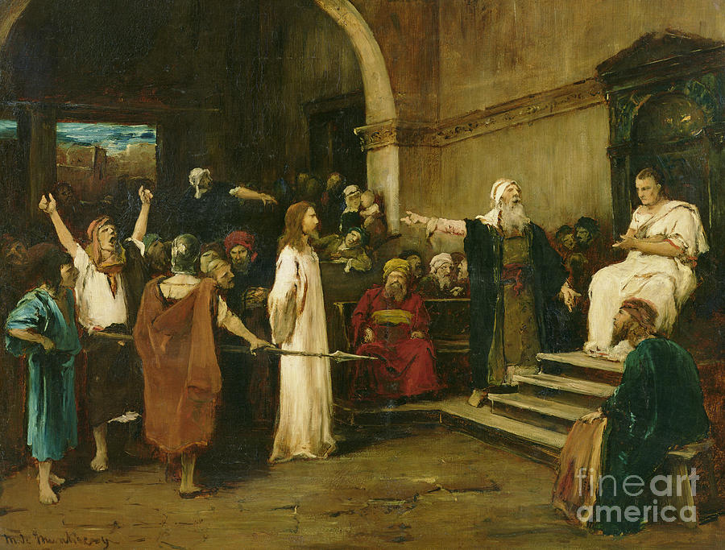

“1Then the whole company of them arose and brought him before Pilate. 2And they began to accuse him, saying, “We found this man misleading our nation and forbidding us to give tribute to Caesar, and saying that he himself is Christ, a king.”” (Luke 23:1-2)

