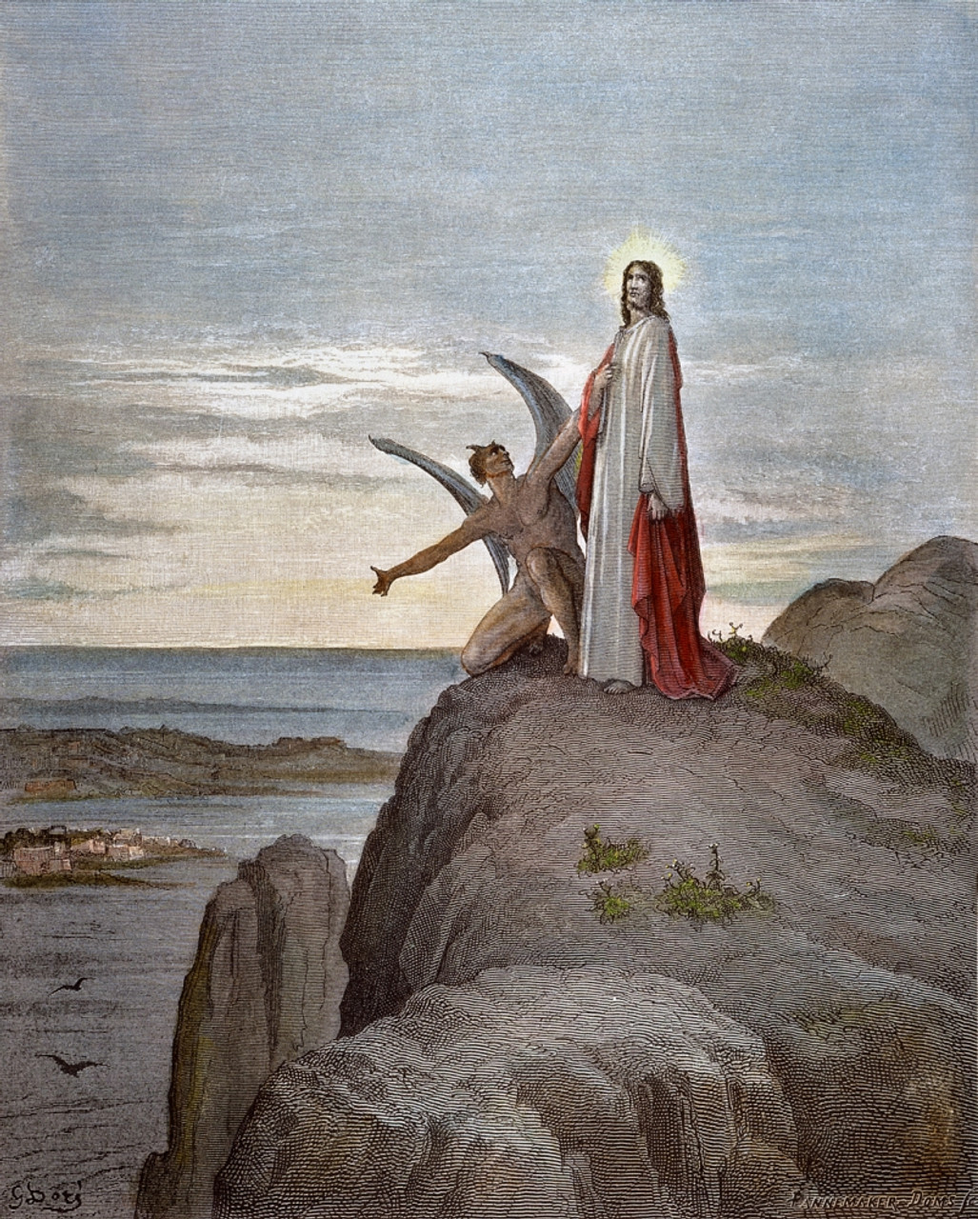
1st Sunday in Lent
March 9th, 2025
Trinity Lutheran Church

2for forty days, being tempted by the devil.
(Luke 4:2a)

Welcome!
We rejoice and give thanks that you are here this morning/evening and pray that the message of the cross of Christ brings comfort to you. If this is your first time worshipping with us please read Trinity’s statement regarding the practice of Holy Communion. Please introduce yourself to the pastor and those sitting around you. Thank you for visiting and please join us again. If you have any questions, please reach out to Pastor Davis at 970-630-5191(Text or Voice)

Hearing Aids and Cry Room
Those who have a need for hearing assistance, please speak with the usher. Please be assured that the voices of children are received with delight in our midst. The cry room is located at the back of the church if you desire to use it.

Trinity’s Holy Communion Statement
We rejoice in the celebration of the Lord’s Supper as the Lord Jesus comes to us in an intimate manner. In the Lord’s Supper we receive His true Body and true Blood in, with, and under the bread and wine. Our Lord teaches us in 1 Corinthians 11:28-29, “A man ought to examine himself before he eats of the bread and drinks of the cup. For anyone who eats and drinks without recognizing the body of the Lord eats and drinks judgment on himself.” If this is your confession, please join us in the Lord’s Supper. Alcohol-free wine is available for those who are unable or desire not to receive alcohol. The alcohol-free wine is in the center of the tray.

+ CONFESSION AND ABSOLUTION +

O LOVE, HOW DEEP LSB 544
(The sign of the cross may be made by all in remembrance of their Baptism.)
INVOCATION
EXHORTATION LSB 184
(Kneel/Stand)
(Silence for reflection on God’s Word and for self-examination.)
CONFESSION OF SINS LSB 184
ABSOLUTION LSB 185
(Stand)

+ SERVICE OF THE WORD +

INTROIT Psalm 91:9–13; antiphon: vv. 15–16

When he calls to me, I will answer him; I will be with him in | trouble;*
I will rescue him and | honor him.
With long life I will sat- | isfy him*
and show him my sal- | vation.
Because you have made the Lord your | dwelling place—*
the Most High, who is my | refuge—
no evil shall be allowed to be- | fall you,*
no plague come | near your tent.
For he will command his angels con- | cerning you*
to guard you in | all your ways.
On their hands they will | bear you up,*
lest you strike your foot a- | gainst a stone.
You will tread on the lion and the | adder;*
the young lion and the serpent you will trample | underfoot.
Glory be to the Father and | to the Son*
and to the Holy | Spirit;
as it was in the be- | ginning,*
is now, and will be forever. | Amen.
When he calls to me, I will answer him; I will be with him in | trouble;*
I will rescue him and | honor him.
With long life I will sat- | isfy him*
and show him my sal- | vation.

KYRIE LSB 186
SALUTATION AND COLLECT OF THE DAY
P The Lord be with you.
C And with thy spirit.
P Let us pray.
O Lord God, You led Your ancient people through the wilderness and brought them to the promised land. Guide the people of Your Church that following our Savior we may walk through the wilderness of this world toward the glory of the world to come; through Jesus Christ, Your Son, our Lord, who lives and reigns with You and the Holy Spirit, one God, now and forever.
C Amen.
(Sit)

OLD TESTAMENT READING Deuteronomy 26:1–11
1“When you come into the land that the Lord your God is giving you for an inheritance and have taken possession of it and live in it, 2you shall take some of the first of all the fruit of the ground, which you harvest from your land that the Lord your God is giving you, and you shall put it in a basket, and you shall go to the place that the Lord your God will choose, to make his name to dwell there. 3And you shall go to the priest who is in office at that time and say to him, ‘I declare today to the Lord your God that I have come into the land that the Lord swore to our fathers to give us.’ 4Then the priest shall take the basket from your hand and set it down before the altar of the Lord your God.
5“And you shall make response before the Lord your God, ‘A wandering Aramean was my father. And he went down into Egypt and sojourned there, few in number, and there he became a nation, great, mighty, and populous. 6And the Egyptians treated us harshly and humiliated us and laid on us hard labor. 7Then we cried to the Lord, the God of our fathers, and the Lord heard our voice and saw our affliction, our toil, and our oppression. 8And the Lord brought us out of Egypt with a mighty hand and an outstretched arm, with great deeds of terror, with signs and wonders. 9And he brought us into this place and gave us this land, a land flowing with milk and honey. 10And behold, now I bring the first of the fruit of the ground, which you, O Lord, have given me.’ And you shall set it down before the Lord your God and worship before the Lord your God. 11And you shall rejoice in all the good that the Lord your God has given to you and to your house, you, and the Levite, and the sojourner who is among you.”

A This is the Word of the Lord.
C Thanks be to God.

EPISTLE Romans 10:8b–13
“The word is near you, in your mouth and in your heart” (that is, the word of faith that we proclaim); 9because, if you confess with your mouth that Jesus is Lord and believe in your heart that God raised him from the dead, you will be saved. 10For with the heart one believes and is justified, and with the mouth one confesses and is saved. 11For the Scripture says, “Everyone who believes in him will not be put to shame.” 12For there is no distinction between Jew and Greek; the same Lord is Lord of all, bestowing his riches on all who call on him. 13For “everyone who calls on the name of the Lord will be saved.”

A This is the Word of the Lord.
C Thanks be to God.
(Stand)

HOLY GOSPEL Luke 4:1–13

P The Holy Gospel according to St. Luke, the fourth chapter.

1Jesus, full of the Holy Spirit, returned from the Jordan and was led by the Spirit in the wilderness 2for forty days, being tempted by the devil. And he ate nothing during those days. And when they were ended, he was hungry. 3The devil said to him, “If you are the Son of God, command this stone to become bread.” 4And Jesus answered him, “It is written, ‘Man shall not live by bread alone.’” 5And the devil took him up and showed him all the kingdoms of the world in a moment of time, 6and said to him, “To you I will give all this authority and their glory, for it has been delivered to me, and I give it to whom I will. 7If you, then, will worship me, it will all be yours.” 8And Jesus answered him, “It is written,
“‘You shall worship the Lord your God,
and him only shall you serve.’”
9And he took him to Jerusalem and set him on the pinnacle of the temple and said to him, “If you are the Son of God, throw yourself down from here, 10for it is written,
“‘He will command his angels concerning you,
to guard you,’
11and
“‘On their hands they will bear you up,
lest you strike your foot against a stone.’”
12And Jesus answered him, “It is said, ‘You shall not put the Lord your God to the test.’” 13And when the devil had ended every temptation, he departed from him until an opportune time.

P This is the Gospel of the Lord.
(Sit)
CHILDRENS SERMON (10:00 AM)
A MIGHTY FORTRESS IS OUR GOD LSB 656

SERMON
(Stand)
OFFERTORY LSB 192
(Sit)
OFFERING
(Stand)
PRAYER OF THE CHURCH

+ SERVICE OF THE SACRAMENT +

PREFACE LSB 194

P It is truly meet, right, and salutary that we should at all times and in all places give thanks to You, holy Lord, almighty Father, everlasting God, through Jesus Christ, our Lord, who overcame the assaults of the devil and gave His life as a ransom for many that with cleansed hearts we might be prepared joyfully to celebrate the paschal feast in sincerity and truth. Therefore with angels and archangels and with all the company of heaven we laud and magnify Your glorious name, evermore praising You and saying:

SANCTUS LSB 195
LORD’S PRAYER LSB 196
THE WORDS OF OUR LORD LSB 197
PAX DOMINI LSB 197
P The peace of the Lord be with you always.
C Amen.
(Following the PAX DOMINI, the people may greet one another in the name of the Lord, saying, “Peace be with you,” as a sign of reconciliation and of the unity of the Spirit in the bond of peace (Matt. 5:22–24; Eph. 4:1–3).)
AGNUS DEI LSB 198
(Sit)
DISTRIBUTION
TO THEE, OMNISCIENT LORD OF ALL LSB 613
O CHRIST, YOU WALKED THE ROAD LSB 424

(Stand)
NUNC DIMITTIS LSB 199
THANKSGIVING LSB 200
POST-COMMUNION COLLECT
SALUTATION LSB 201
BENEDICAMUS LSB 202
BENEDICTION LSB 202

CHRIST IS THE WORLD’S REDEEMER LSB 539

ACKNOWLEDGMENTS
Divine Service, Setting Three from Lutheran Service Book
Unless otherwise indicated, Scripture quotations are from the ESV® Bible (The Holy Bible, English Standard Version®), copyright © 2001 by Crossway, a publishing ministry of Good News Publishers. Used by permission. All rights reserved.
Created by Lutheran Service Builder © 2025 Concordia Publishing House.

*Voters’ Meeting next week, March 16th, 2025, following the late service. Potluck following the voters’ meeting.
*Help us break in our new Smoker! We are having a BBQ (Pork and Brisket) sale on March 29th, to help offset the cost of our Spiritual First Aid Weekend May 16-18. Orders are due by Thursday March 27th, at 12:00 p.m. Orders can be picked up on Saturday March 29th, between 12:45 p.m. and 2:00 p.m.


