The 18th Sunday After Pentecost
(Proper 21)

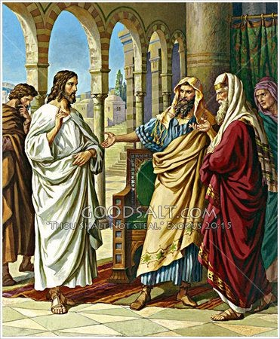
23When [Jesus] entered the temple, the chief priests and the elders of the people came up to him as he was teaching, and said, “By what authority are you doing these things, and who gave you this authority?”
(Matthew 21:23)

Trinity Lutheran Church and Academy
2535 Jefferson Road
Athens, GA 30607
Pastor Timothy P. Davis
706-308-7550
Welcome!
We rejoice and give thanks that you are here this morning and pray that the message of the cross of Christ brings comfort to you. If this is your first time worshipping with us please read Trinity’s statement regarding the practice of Holy Communion. Please introduce yourself to the pastor and those sitting around you. Thank you for visiting and please join us again. If you have any questions please reach out to Pastor Davis at 970-630-5191(Text or Voice)

Hearing Aids and Cry Room

Those who have a need for hearing assistance, please speak with the usher. Please be assured that the voices of children are received with delight in our midst. The cry room is located at the back of the church if you desire to use it.

Trinity’s Holy Communion Statement
We rejoice in the celebration of the Lord’s Supper as the Lord Jesus comes to us in an intimate manner. In the Lord’s Supper we receive His true Body and true Blood in, with, and under the bread and wine. Our Lord teaches us in 1 Corinthians 11:28-29, “A man ought to examine himself before he eats of the bread and drinks of the cup. For anyone who eats and drinks without recognizing the body of the Lord eats and drinks judgment on himself.” If this is your confession, please join us in the Lord’s Supper. Alcohol-free wine is available for those who are unable or desire not to receive alcohol. The alcohol-free wine is in the center of the tray.

+ CONFESSION AND ABSOLUTION +

ALL HAIL THE POWER OF JESUS’ NAME LSB 549
(Stand)
(The sign of the cross may be made by all in remembrance of their Baptism.)
INVOCATION
EXHORTATION LSB 151
(Kneel/Stand)
(Silence for reflection on God’s Word and for self-examination.)
CONFESSION OF SINS LSB 151
ABSOLUTION LSB 151
(Stand)

+ SERVICE OF THE WORD +

INTROIT Psalm 147:1–5; antiphon: v. 6

The Lord lifts up the | humble;*
he casts the wicked | to the ground.
Praise the Lord! For it is good to sing praises | to our God;*
for it is pleasant, and a song of praise is | fitting.
The Lord builds up Je- | rusalem;*
he gathers the outcasts of | Israel.
He heals the broken- | hearted*
and binds | up their wounds.
He determines the number | of the stars;*
he gives to all of | them their names.
Great is our Lord, and abun- | dant in power;*
his understanding is beyond | measure.
Glory be to the Father and | to the Son*
and to the Holy | Spirit;
as it was in the be- | ginning,*
is now, and will be forever. | Amen.
The Lord lifts up the | humble;*
he casts the wicked | to the ground.
KYRIE LSB 152
GLORIA IN EXCELSIS LSB 154
SALUTATION AND COLLECT OF THE DAY
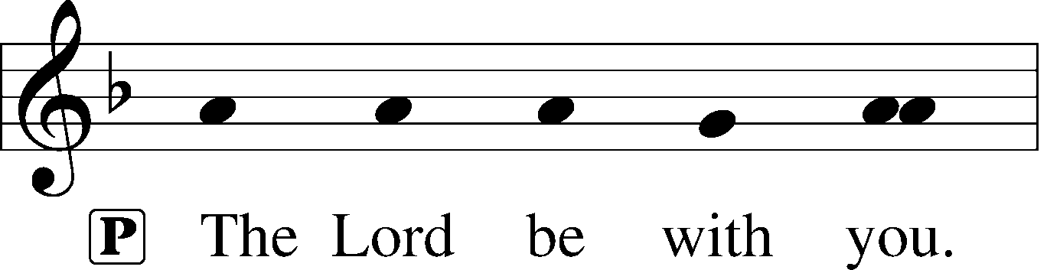
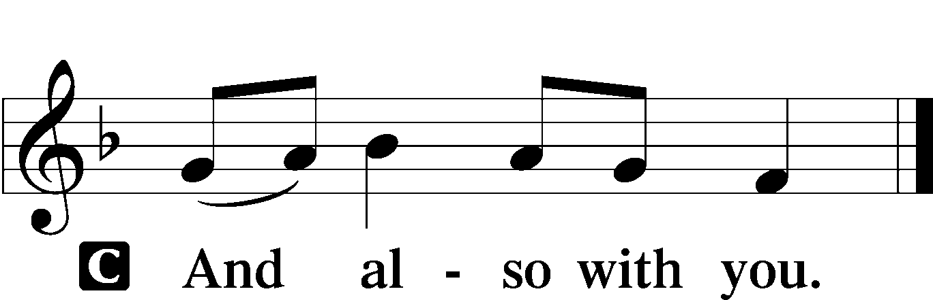

P Let us pray.
Almighty God, You exalted Your Son to the place of all honor and authority. Enlighten our minds by Your Holy Spirit that, confessing Jesus as Lord, we may be led into all truth; through the same Jesus Christ, our Lord, who lives and reigns with You and the Holy Spirit, one God, now and forever.

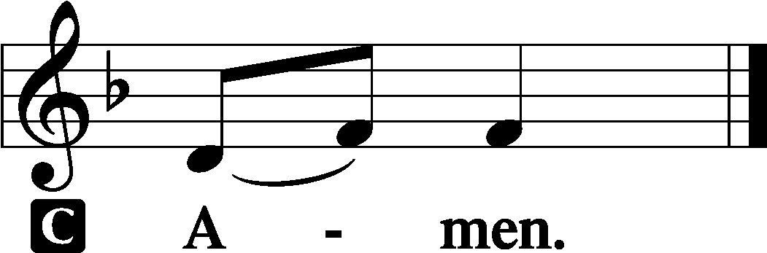

(Sit)

OLD TESTAMENT READING Ezekiel 18:1–4, 25–32
1The word of the Lord came to me: 2“What do you mean by repeating this proverb concerning the land of Israel, ‘The fathers have eaten sour grapes, and the children’s teeth are set on edge’? 3As I live, declares the Lord God, this proverb shall no more be used by you in Israel. 4Behold, all souls are mine; the soul of the father as well as the soul of the son is mine: the soul who sins shall die. . . .
25“Yet you say, ‘The way of the Lord is not just.’ Hear now, O house of Israel: Is my way not just? Is it not your ways that are not just? 26When a righteous person turns away from his righteousness and does injustice, he shall die for it; for the injustice that he has done he shall die. 27Again, when a wicked person turns away from the wickedness he has committed and does what is just and right, he shall save his life. 28Because he considered and turned away from all the transgressions that he had committed, he shall surely live; he shall not die. 29Yet the house of Israel says, ‘The way of the Lord is not just.’ O house of Israel, are my ways not just? Is it not your ways that are not just?
30“Therefore I will judge you, O house of Israel, every one according to his ways, declares the Lord God. Repent and turn from all your transgressions, lest iniquity be your ruin. 31Cast away from you all the transgressions that you have committed, and make yourselves a new heart and a new spirit! Why will you die, O house of Israel? 32For I have no pleasure in the death of anyone, declares the Lord God; so turn, and live.”

A This is the Word of the Lord.
C Thanks be to God.

EPISTLE Philippians 2:1–4, 14–18
1If there is any encouragement in Christ, any comfort from love, any participation in the Spirit, any affection and sympathy, 2complete my joy by being of the same mind, having the same love, being in full accord and of one mind. 3Do nothing from rivalry or conceit, but in humility count others more significant than yourselves. 4Let each of you look not only to his own interests, but also to the interests of others. . . .
14Do all things without grumbling or questioning, 15that you may be blameless and innocent, children of God without blemish in the midst of a crooked and twisted generation, among whom you shine as lights in the world, 16holding fast to the word of life, so that in the day of Christ I may be proud that I did not run in vain or labor in vain. 17Even if I am to be poured out as a drink offering upon the sacrificial offering of your faith, I am glad and rejoice with you all. 18Likewise you also should be glad and rejoice with me.

A This is the Word of the Lord.
C Thanks be to God.
Stand)

ALLELUIA AND VERSE LSB 156
HOLY GOSPEL Matthew 21:23–27
P The Holy Gospel according to St. Matthew, the twenty-first chapter.
C Glory to You, O Lord.

23When [Jesus] entered the temple, the chief priests and the elders of the people came up to him as he was teaching, and said, “By what authority are you doing these things, and who gave you this authority?” 24Jesus answered them, “I also will ask you one question, and if you tell me the answer, then I also will tell you by what authority I do these things. 25The baptism of John, from where did it come? From heaven or from man?” And they discussed it among themselves, saying, “If we say, ‘From heaven,’ he will say to us, ‘Why then did you not believe him?’ 26But if we say, ‘From man,’ we are afraid of the crowd, for they all hold that John was a prophet.” 27So they answered Jesus, “We do not know.” And he said to them, “Neither will I tell you by what authority I do these things.”

P This is the Gospel of the Lord.
C Praise to You, O Christ.
(Sit)

CHILDREN’S MESSAGE (10:00 AM)
LORD, KEEP US STEADFAST IN YOUR WORD LSB 655
SERMON

(Stand)
NICENE CREED
PRAYER OF THE CHURCH
(Sit)

OFFERING
(Stand)
OFFERTORY LSB 159

+ SERVICE OF THE SACRAMENT +

PREFACE LSB 160

P It is truly good, right, and salutary that we should at all times and in all places give thanks to You, holy Lord, almighty Father, everlasting God, through Jesus Christ, our Lord, who on this day overcame death and the grave and by His glorious resurrection opened to us the way of everlasting life. Therefore with angels and archangels and with all the company of heaven we laud and magnify Your glorious name, evermore praising You and saying:

SANCTUS LSB 161

PRAYER OF THANKSGIVING LSB 161

LORD’S PRAYER LSB 162

THE WORDS OF OUR LORD

PAX DOMINI LSB 163
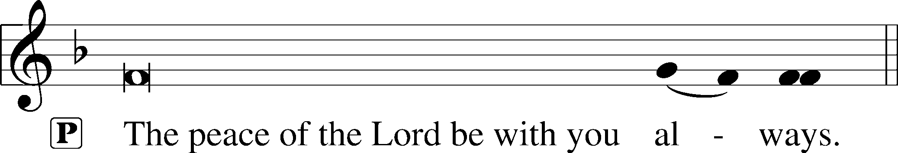


(Following the prayers, the people may greet one another in the name of the Lord, saying, “Peace be with you,” as a sign of reconciliation and of the unity of the Spirit in the bond of peace (Matt. 5:22–24; Eph. 4:1–3).)
AGNUS DEI LSB 163
(Sit)

WHAT WONDROUS LOVE IS THIS LSB 543
O LORD, WE PRAISE THEE LSB 617

(Stand)
NUNC DIMITTIS LSB 165
POST-COMMUNION COLLECT
BENEDICTION LSB 166
WHEN MORNING GILDS THE SKIES LSB 807

ACKNOWLEDGMENTS
Divine Service, Setting One from Lutheran Service Book
Unless otherwise indicated, Scripture quotations are from the ESV® Bible (The Holy Bible, English Standard Version®), copyright © 2001 by Crossway, a publishing ministry of Good News Publishers. Used by permission. All rights reserved.
Created by Lutheran Service Builder © 2026 Concordia Publishing House.

