10th Sunday After Pentecost
August 2nd, 2026
Divine Service Setting One
Trinity Lutheran Church and Academy

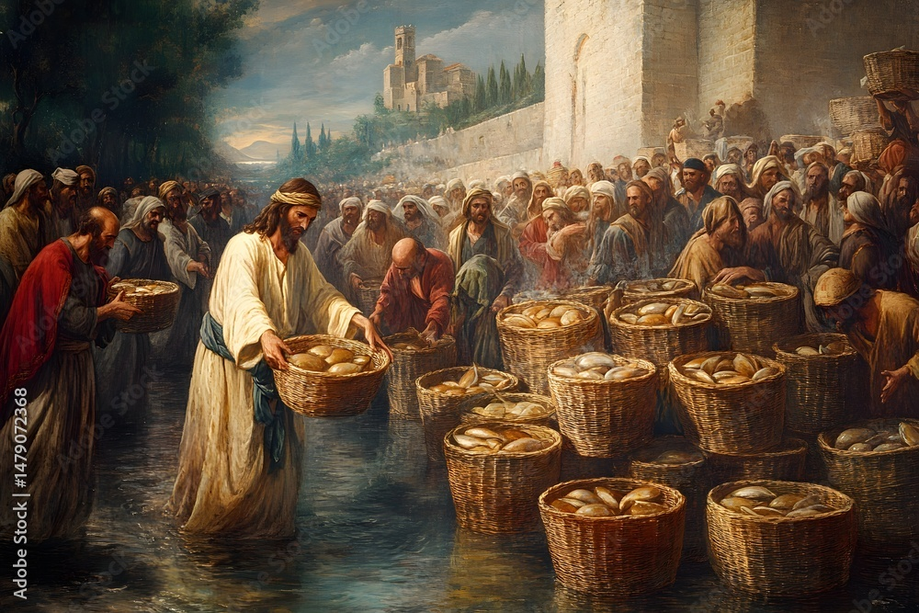
“…and taking the five loaves and the two fish, he looked up to heaven and said a blessing. Then he broke the loaves and gave them to the disciples, and the disciples gave them to the crowds. 20And they all ate and were satisfied. And they took up twelve baskets full of the broken pieces left over. 21And those who ate were about five thousand men, besides women and children.”(Matthew 14:19-21)

Trinity Lutheran Church and Academy
2535 Jefferson Road
Athens, GA 30607
Pastor Timothy P. Davis
706-308-7550
Pastor.davis@trinity-athens.org
Welcome!
We rejoice and give thanks that you are here this morning and pray that the message of the cross of Christ brings comfort to you. If this is your first time worshipping with us please read Trinity’s statement regarding the practice of Holy Communion. Please introduce yourself to the pastor and those sitting around you. Thank you for visiting and please join us again. If you have any questions please reach out to Pastor Davis at 970-630-5191(Text or Voice)

Hearing Aids and Cry Room

Those who have a need for hearing assistance, please speak with the usher. Please be assured that the voices of children are received with delight in our midst. The cry room is located at the back of the church if you desire to use it.

Trinity’s Holy Communion Statement
We rejoice in the celebration of the Lord’s Supper as the Lord Jesus comes to us in an intimate manner. In the Lord’s Supper we receive His true Body and true Blood in, with, and under the bread and wine. Our Lord teaches us in 1 Corinthians 11:28-29, “A man ought to examine himself before he eats of the bread and drinks of the cup. For anyone who eats and drinks without recognizing the body of the Lord eats and drinks judgment on himself.” If this is your confession, please join us in the Lord’s Supper. Alcohol-free wine is available for those who are unable or desire not to receive alcohol. The alcohol-free wine is in the center of the tray.

+ CONFESSION AND ABSOLUTION +

YOU SATISFY THE HUNGRY HEART LSB 641

(Stand)

(The sign of the cross may be made by all in remembrance of their Baptism.)

INVOCATION

EXHORTATION LSB 151

(Kneel/Stand)

(Silence for reflection on God’s Word and for self-examination.)

CONFESSION OF SINS LSB 151

ABSOLUTION LSB 151

(Stand)

+ SERVICE OF THE WORD +

INTROIT Psalm 105:39–43; antiphon: v. 1

Oh give thanks to the Lord; call up- | on his name;*
make known his deeds among the | peoples!
He spread a cloud for a | covering,*
and fire to give | light by night.
They asked, and he | brought quail,*
and gave them bread from heaven in a- | bundance.
He opened the rock, and water | gushed out;*
it flowed through the desert like a | river.
For he remembered his holy | promise,*
and Abraham, his | servant.
So he brought his people | out with joy,*
his chosen ones with | singing.
Glory be to the Father and | to the Son*
and to the Holy | Spirit;
as it was in the be- | ginning,*
is now, and will be forever. | Amen.
Oh give thanks to the Lord; call up- | on his name;*
make known his deeds among the | peoples!

KYRIE LSB 152

GLORIA IN EXCELSIS LSB 154

SALUTATION AND COLLECT OF THE DAY
P The Lord be with you.
C And also with you.

P Let us pray.
Heavenly Father, though we do not deserve Your goodness, still You provide for all our needs of body and soul. Grant us Your Holy Spirit that we may acknowledge Your gifts, give thanks for all Your benefits, and serve You in willing obedience; through Jesus Christ, Your Son, our Lord, who lives and reigns with You and the Holy Spirit, one God, now and forever.

C Amen.

(Sit)

OLD TESTAMENT READING Isaiah 55:1–5
1“Come, everyone who thirsts,
come to the waters;
and he who has no money,
come, buy and eat!
Come, buy wine and milk
without money and without price.
2Why do you spend your money for that which is not bread,
and your labor for that which does not satisfy?
Listen diligently to me, and eat what is good,
and delight yourselves in rich food.
3Incline your ear, and come to me;
hear, that your soul may live;
and I will make with you an everlasting covenant,
my steadfast, sure love for David.
4Behold, I made him a witness to the peoples,
a leader and commander for the peoples.
5Behold, you shall call a nation that you do not know,
and a nation that did not know you shall run to you,
because of the Lord your God, and of the Holy One of Israel,
for he has glorified you.”

A This is the Word of the Lord.
C Thanks be to God.

Solo-(10:00 A.M.)-Goodness of God Courtney Johnson

EPISTLE Romans 9:1–13
1I am speaking the truth in Christ—I am not lying; my conscience bears me witness in the Holy Spirit— 2that I have great sorrow and unceasing anguish in my heart. 3For I could wish that I myself were accursed and cut off from Christ for the sake of my brothers, my kinsmen according to the flesh. 4They are Israelites, and to them belong the adoption, the glory, the covenants, the giving of the law, the worship, and the promises. 5To them belong the patriarchs, and from their race, according to the flesh, is the Christ who is God over all, blessed forever. Amen.
6But it is not as though the word of God has failed. For not all who are descended from Israel belong to Israel, 7and not all are children of Abraham because they are his offspring, but “Through Isaac shall your offspring be named.” 8This means that it is not the children of the flesh who are the children of God, but the children of the promise are counted as offspring. 9For this is what the promise said: “About this time next year I will return and Sarah shall have a son.” 10And not only so, but also when Rebecca had conceived children by one man, our forefather Isaac, 11though they were not yet born and had done nothing either good or bad—in order that God’s purpose of election might continue, not because of works but because of his call— 12she was told, “The older will serve the younger.” 13As it is written, “Jacob I loved, but Esau I hated.”

A This is the Word of the Lord.
C Thanks be to God.

(Stand)

ALLELUIA AND VERSE LSB 156

HOLY GOSPEL Matthew 14:13–21
P The Holy Gospel according to St. Matthew, the fourteenth chapter.
C Glory to You, O Lord.

13Now when Jesus heard [about the death of John], he withdrew from there in a boat to a desolate place by himself. But when the crowds heard it, they followed him on foot from the towns. 14When he went ashore he saw a great crowd, and he had compassion on them and healed their sick. 15Now when it was evening, the disciples came to him and said, “This is a desolate place, and the day is now over; send the crowds away to go into the villages and buy food for themselves.” 16But Jesus said, “They need not go away; you give them something to eat.” 17They said to him, “We have only five loaves here and two fish.” 18And he said, “Bring them here to me.” 19Then he ordered the crowds to sit down on the grass, and taking the five loaves and the two fish, he looked up to heaven and said a blessing. Then he broke the loaves and gave them to the disciples, and the disciples gave them to the crowds. 20And they all ate and were satisfied. And they took up twelve baskets full of the broken pieces left over. 21And those who ate were about five thousand men, besides women and children.

P This is the Gospel of the Lord.
C Praise to You, O Christ.

(Sit)

O LIVING BREAD FROM HEAVEN LSB 642

SERMON

(Stand)

NICENE CREED

PRAYER OF THE CHURCH

(Sit)

OFFERING
DUET-(10:00 A.M.)-Shepherd of Tender Youth LSB-866
Janet Rodekohr & Joan Watson
OFFERTORY LSB 159

+ SERVICE OF THE SACRAMENT +

PREFACE LSB 160

P It is truly good, right, and salutary that we should at all times and in all places give thanks to You, holy Lord, almighty Father, everlasting God, through Jesus Christ, our Lord. Therefore with angels and archangels and with all the company of heaven we laud and magnify Your glorious name, evermore praising You and saying:

SANCTUS LSB 161

PRAYER OF THANKSGIVING LSB 161

LORD’S PRAYER LSB 162

THE WORDS OF OUR LORD

PAX DOMINI LSB 163
P The peace of the Lord be with you always.
C Amen.

(Following the prayers, the people may greet one another in the name of the Lord, saying, “Peace be with you,” as a sign of reconciliation and of the unity of the Spirit in the bond of peace (Matt. 5:22–24; Eph. 4:1–3).)

AGNUS DEI LSB 163

(Sit)

DUET-(8:00 A.M.)-Shepherd of Tender Youth LSB-866
Janet Rodekohr & Joan Watson

WATER, BLOOD, AND SPIRIT CRYING LSB 597

THE KING OF LOVE MY SHEPHERD IS LSB 709

(Stand)

NUNC DIMITTIS LSB 165

POST-COMMUNION COLLECT

BENEDICTION LSB 166

LORD JESUS CHRIST, THE CHILDREN’S FRIEND LSB 866

ACKNOWLEDGMENTS
Divine Service, Setting One from Lutheran Service Book
Unless otherwise indicated, Scripture quotations are from the ESV® Bible (The Holy Bible, English Standard Version®), copyright © 2001 by Crossway, a publishing ministry of Good News Publishers. Used by permission. All rights reserved.
Created by Lutheran Service Builder © 2026 Concordia Publishing House.

