Easter Divine Service
10:00 AM
April 5, 2026
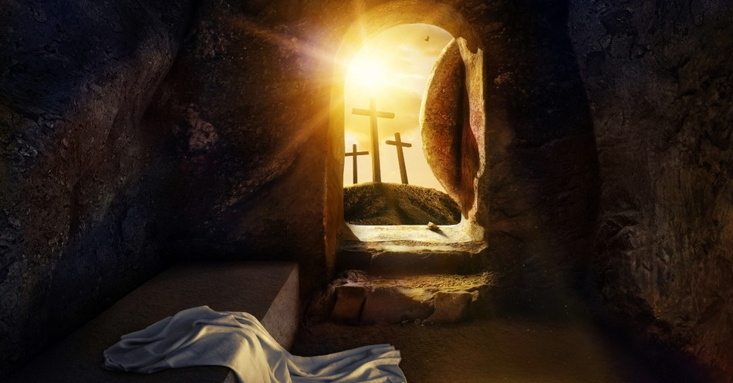
“6He is not here, for he has risen, as he said. Come, see the place where he lay.” Matt 28:6

Trinity Lutheran Church
2535 Jefferson Road
Athens, GA 30605

Pastor Timothy P. Davis
Pastor.davis@trinity-athens.org
706-308-7550

Welcome!
We rejoice and give thanks that you are here and pray that the message of the cross of Christ brings comfort to you. If this is your first time worshipping with us, please read Trinity’s statement regarding the practice of Holy Communion. Please introduce yourself to the pastor and those sitting around you. Thank you for visiting and please join us again. If you have any questions, please reach out to Pastor Davis at 970-630-5191(Text or Voice)

Hearing Aids and Cry Room

Those who have a need for hearing assistance, please speak with the usher. Please be assured that the voices of children are received with delight in our midst. The cry room is located at the back of the church if you desire to use it.

Trinity’s Holy Communion Statement
We rejoice in the celebration of the Lord’s Supper as the Lord Jesus comes to us in an intimate manner. In the Lord’s Supper we receive His true Body and true Blood in, with, and under the bread and wine. Our Lord teaches us in 1 Corinthians 11:28-29, “A man ought to examine himself before he eats of the bread and drinks of the cup. For anyone who eats and drinks without recognizing the body of the Lord eats and drinks judgment on himself.” If this is your confession, please join us in the Lord’s Supper. Alcohol-free wine is available for those who are unable or desire not to receive alcohol. The alcohol-free wine is in the center of the tray

EASTER DIVINE SERVICE CELEBRATION
Duet Janet Rodekohr and Joan Watson Were You There
HANDBELL CHIOR Chimes of Great Joy
Hymn of Invocation
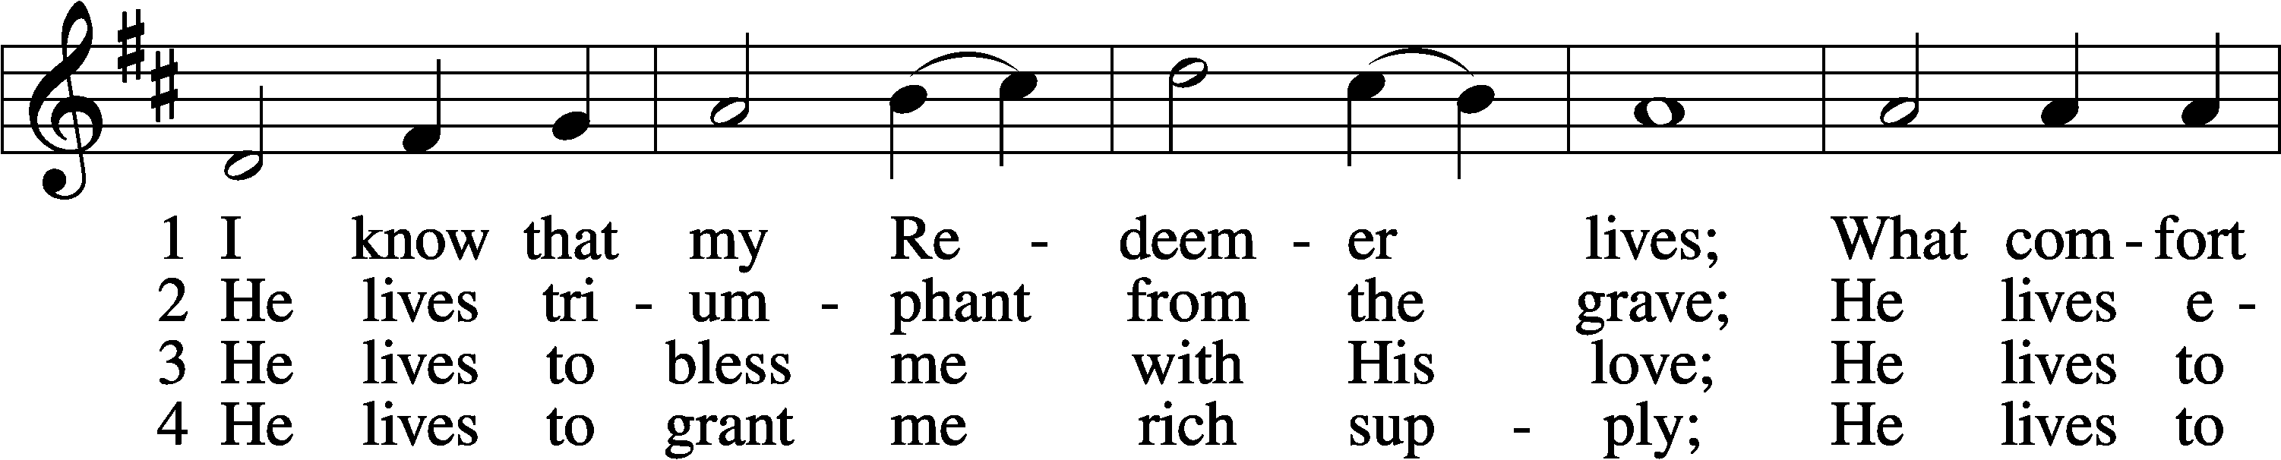
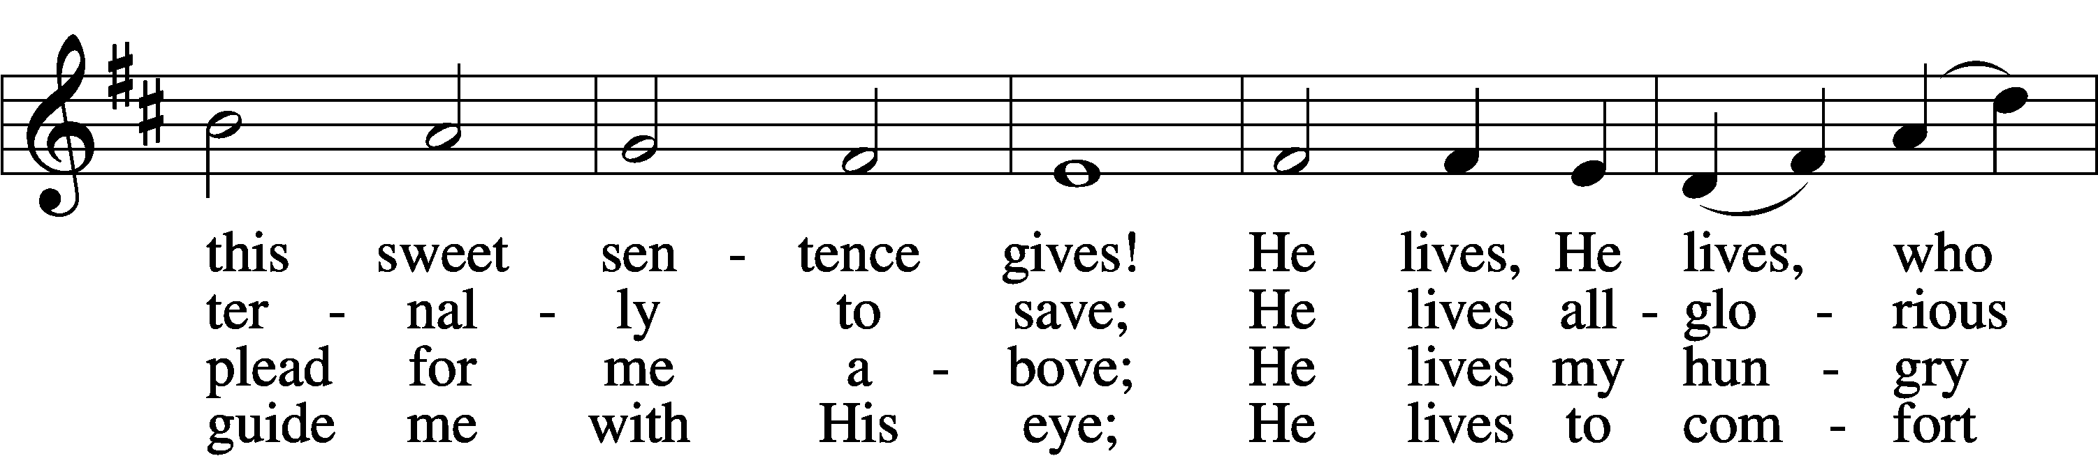
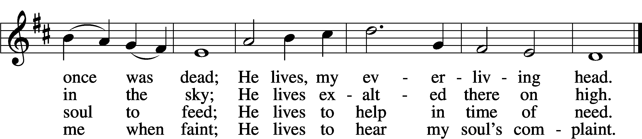
5 He lives to silence all my fears;
He lives to wipe away my tears;
He lives to calm my troubled heart;
He lives all blessings to impart.

6 He lives, my kind, wise, heav’nly friend;
He lives and loves me to the end;
He lives, and while He lives, I’ll sing;
He lives, my Prophet, Priest, and King.

7 He lives and grants me daily breath;
He lives, and I shall conquer death;
He lives my mansion to prepare;
He lives to bring me safely there.
8 He lives, all glory to His name!
He lives, my Jesus, still the same;
Oh, the sweet joy this sentence gives:
I know that my Redeemer lives!
Text: Samuel Medley, 1738–99, abr.
Tune: attr. John C. Hatton, d. 1793
Text and tune: Public domain
Stand
The sign of the cross may be made by all in remembrance of their Baptism.
P In the name of the Father and of the T Son and of the Holy Spirit.
C Amen.

P If we say we have no sin, we deceive ourselves, and the truth is not in us.
C But if we confess our sins, God, who is faithful and just, will forgive our sins and cleanse us from all unrighteousness.
Kneel/Stand
Silence for reflection on God’s Word and for self-examination.
P Let us then confess our sins to God our Father.
C Most merciful God, we confess that we are by nature sinful and unclean. We have sinned against You in thought, word, and deed, by what we have done and by what we have left undone. We have not loved You with our whole heart; we have not loved our neighbors as ourselves. We justly deserve Your present and eternal punishment. For the sake of Your Son, Jesus Christ, have mercy on us. Forgive us, renew us, and lead us, so that we may delight in Your will and walk in Your ways to the glory of Your holy name. Amen.
P Almighty God in His mercy has given His Son to die for you and for His sake forgives you all your sins. As a called and ordained servant of Christ, and by His authority, I therefore forgive you all your sins in the name of the Father and of the T Son and of the Holy Spirit.
C Amen.
Stand
PROCESSIONAL HYMN
Jesus Christ Is Risen Today LSB 457
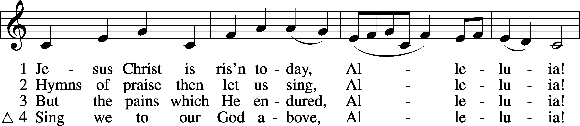
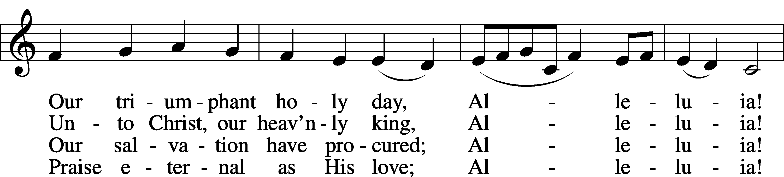
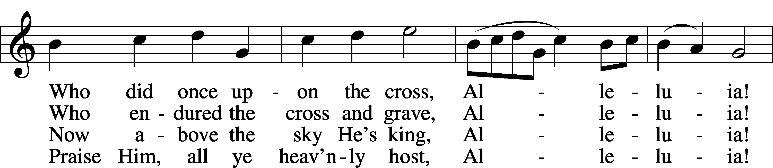
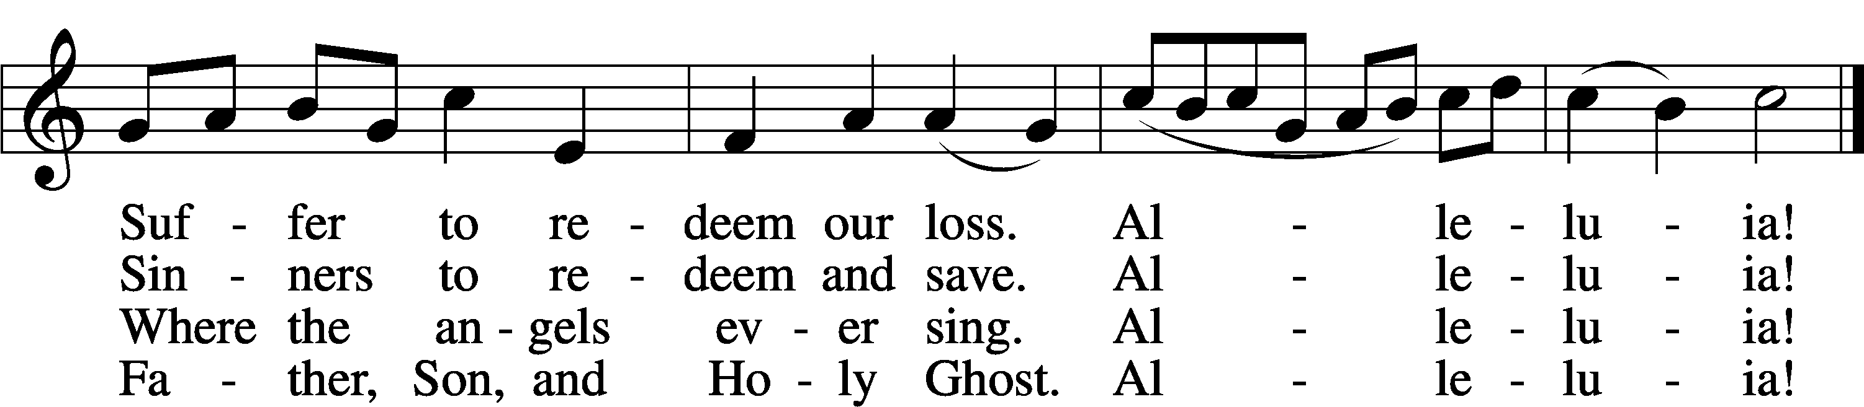
Text: tr. Lyra Davidica, 1708, London, alt.; (sts. 1–3): Latin, 14th cent.; (st. 4): Charles Wesley, 1707–88
Tune: Lyra Davidica, 1708, London
Text and tune: Public domain
Introit
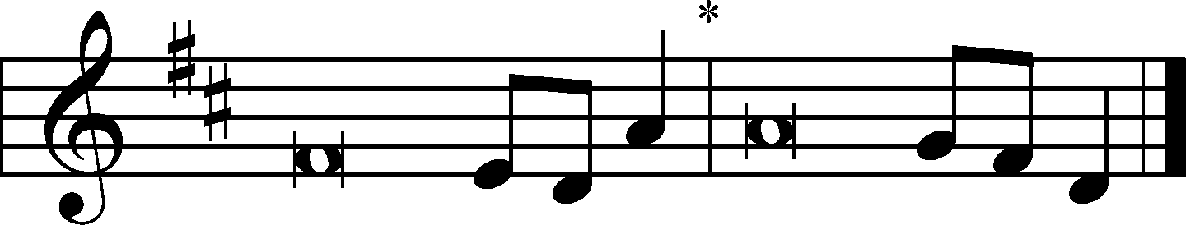
I will sing to the Lord, for he has triumphed | gloriously;*
the horse and his rider he has thrown in- | to the sea.
The Lord is my strength | and my song,*
and he has become my sal- | vation.
Your right hand, O Lord, glorious | in power,*
your right hand, O Lord, shatters the | enemy.
You have led in your steadfast love the people whom you | have redeemed;*
you have guided them by your strength to your ho- | ly abode.
You will bring them in and plant them on your own | mountain,*
the place, O Lord, which you have made for | your abode,
the sanctuary, O Lord, which your hands have es- | tablished.*
The Lord will reign forever and | ever.
Glory be to the Father and | to the Son*
and to the Holy | Spirit;
as it was in the be- | ginning,*
is now, and will be forever. | Amen.
I will sing to the Lord, for he has triumphed | gloriously;*
the horse and his rider he has thrown in- | to the sea.
Kyrie LSB 152
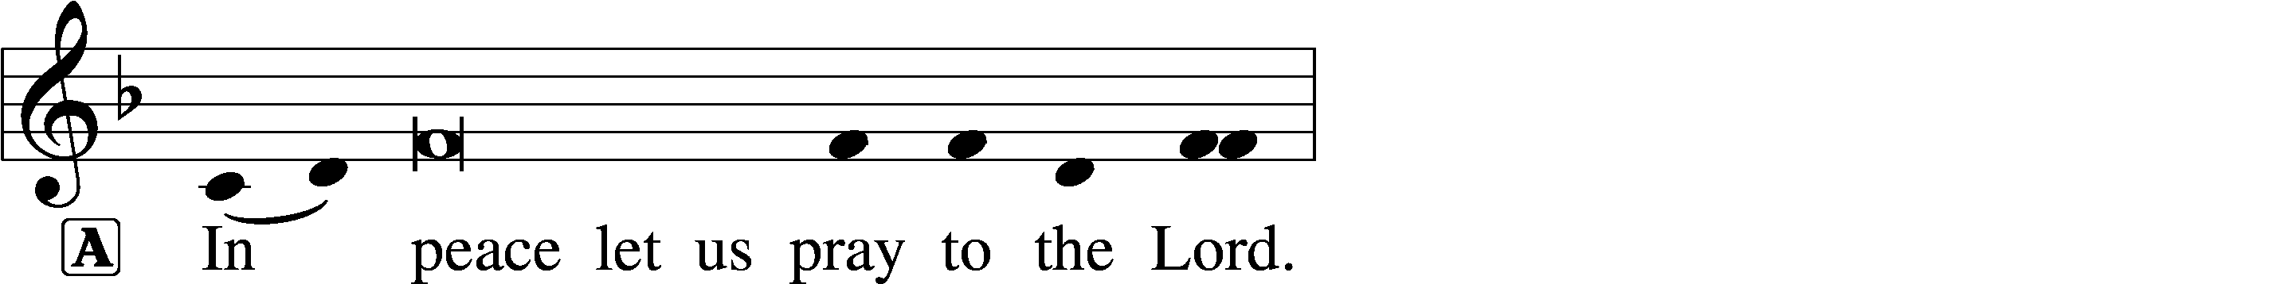
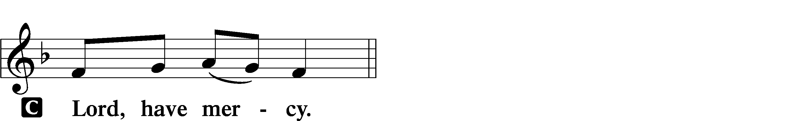
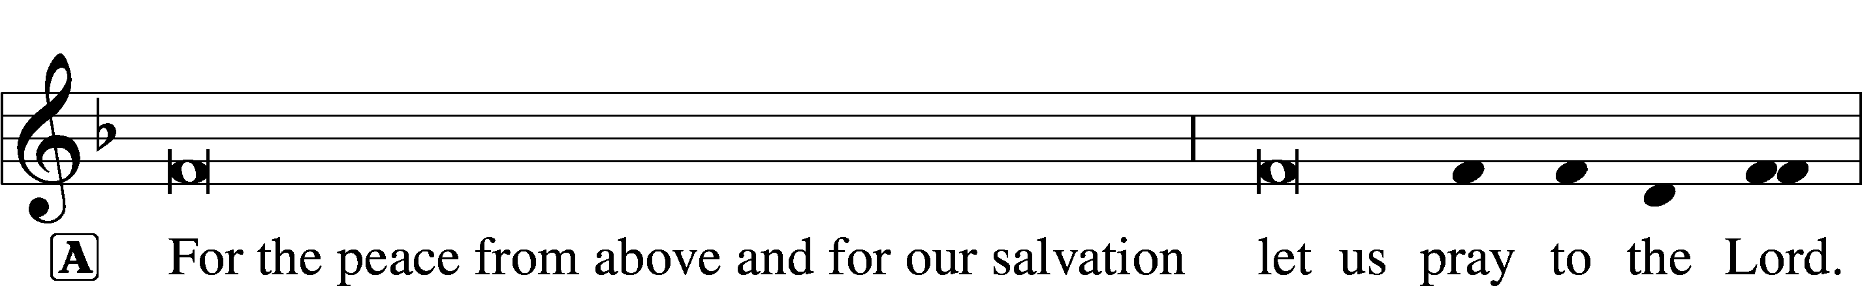
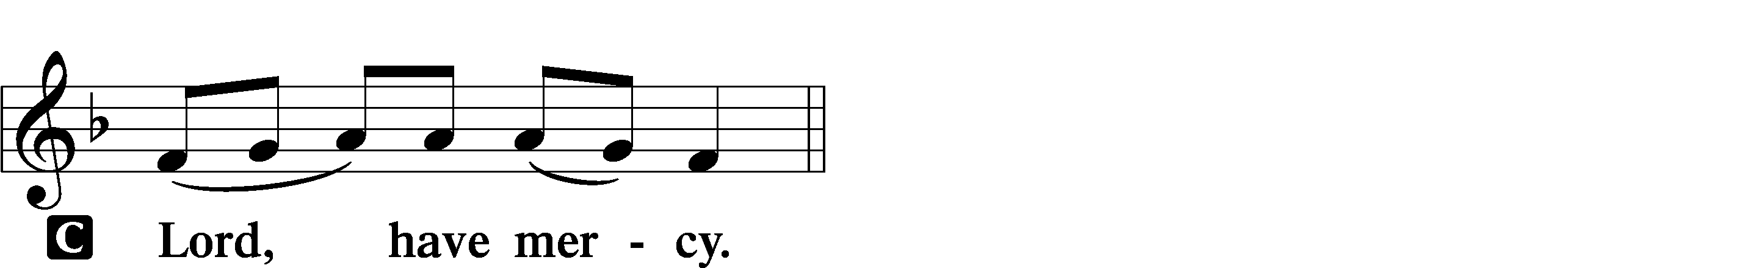
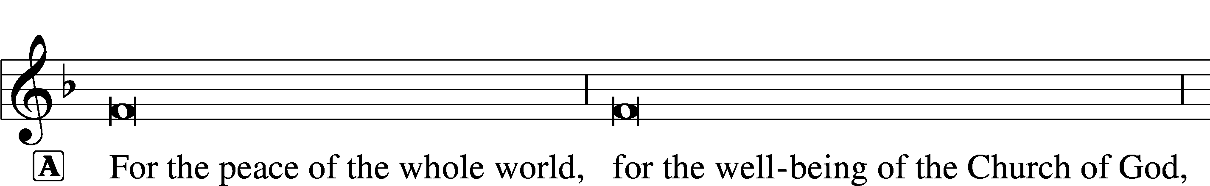
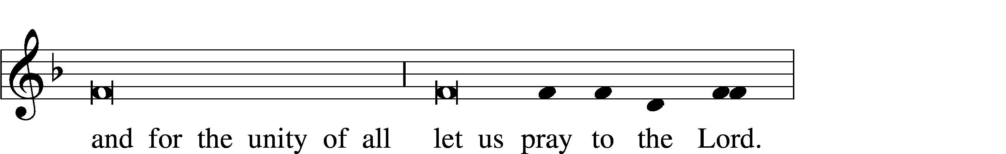
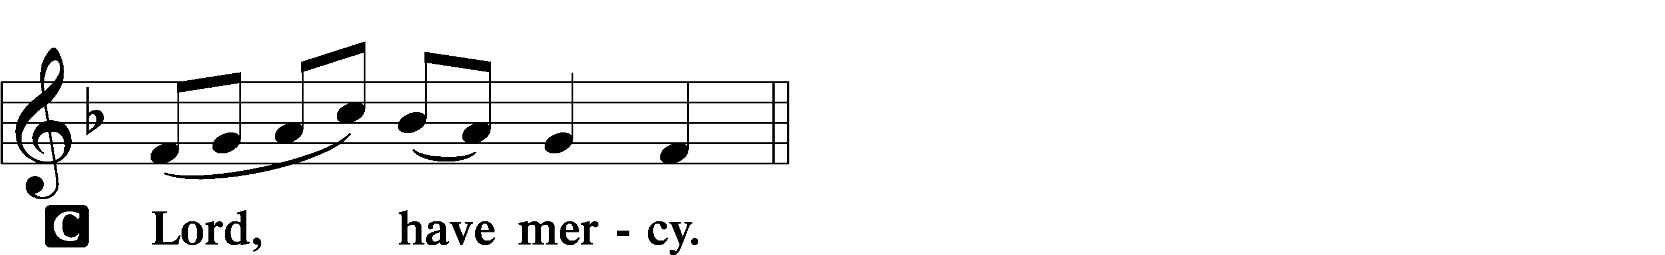
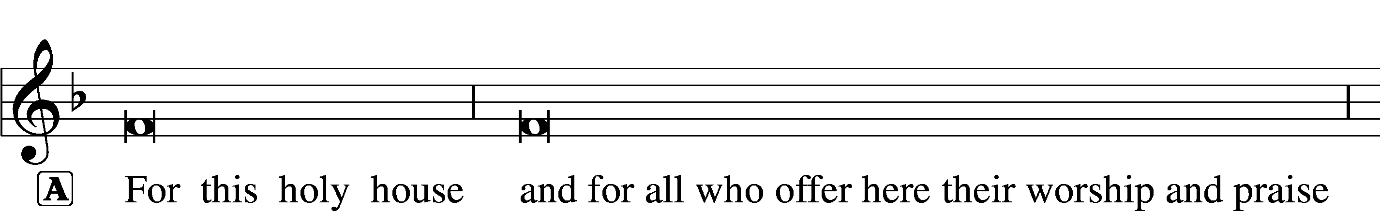
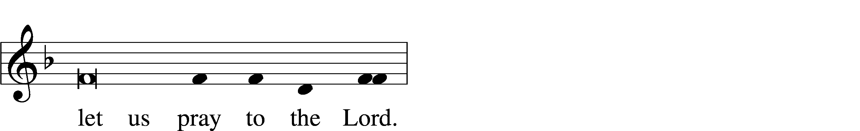
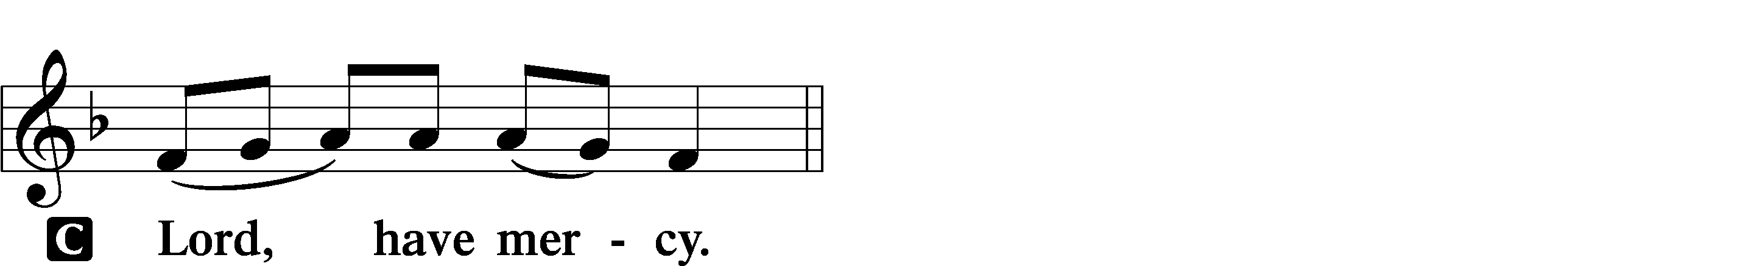
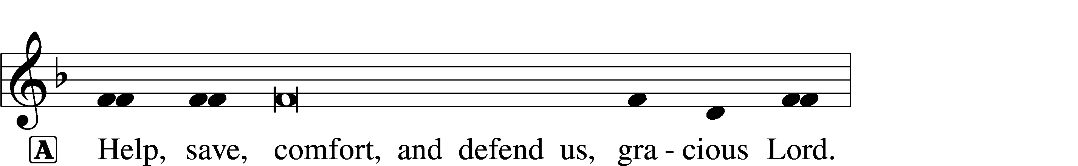


This Is the Feast LSB 155
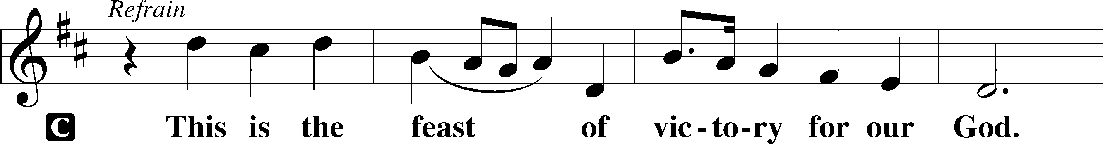
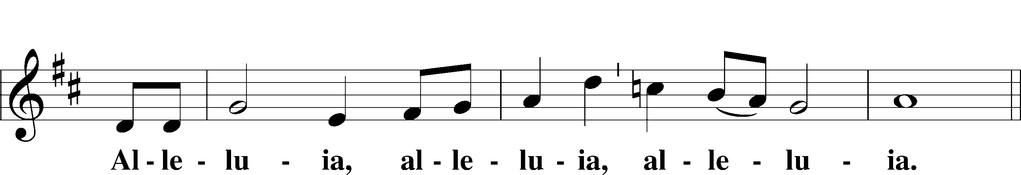
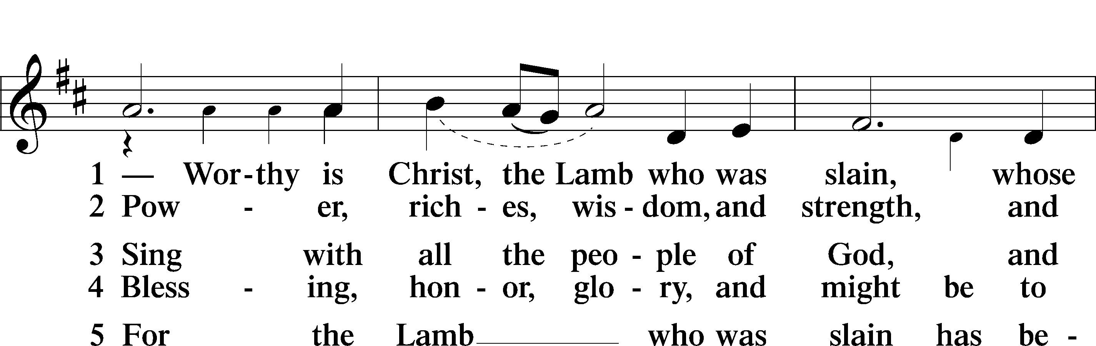
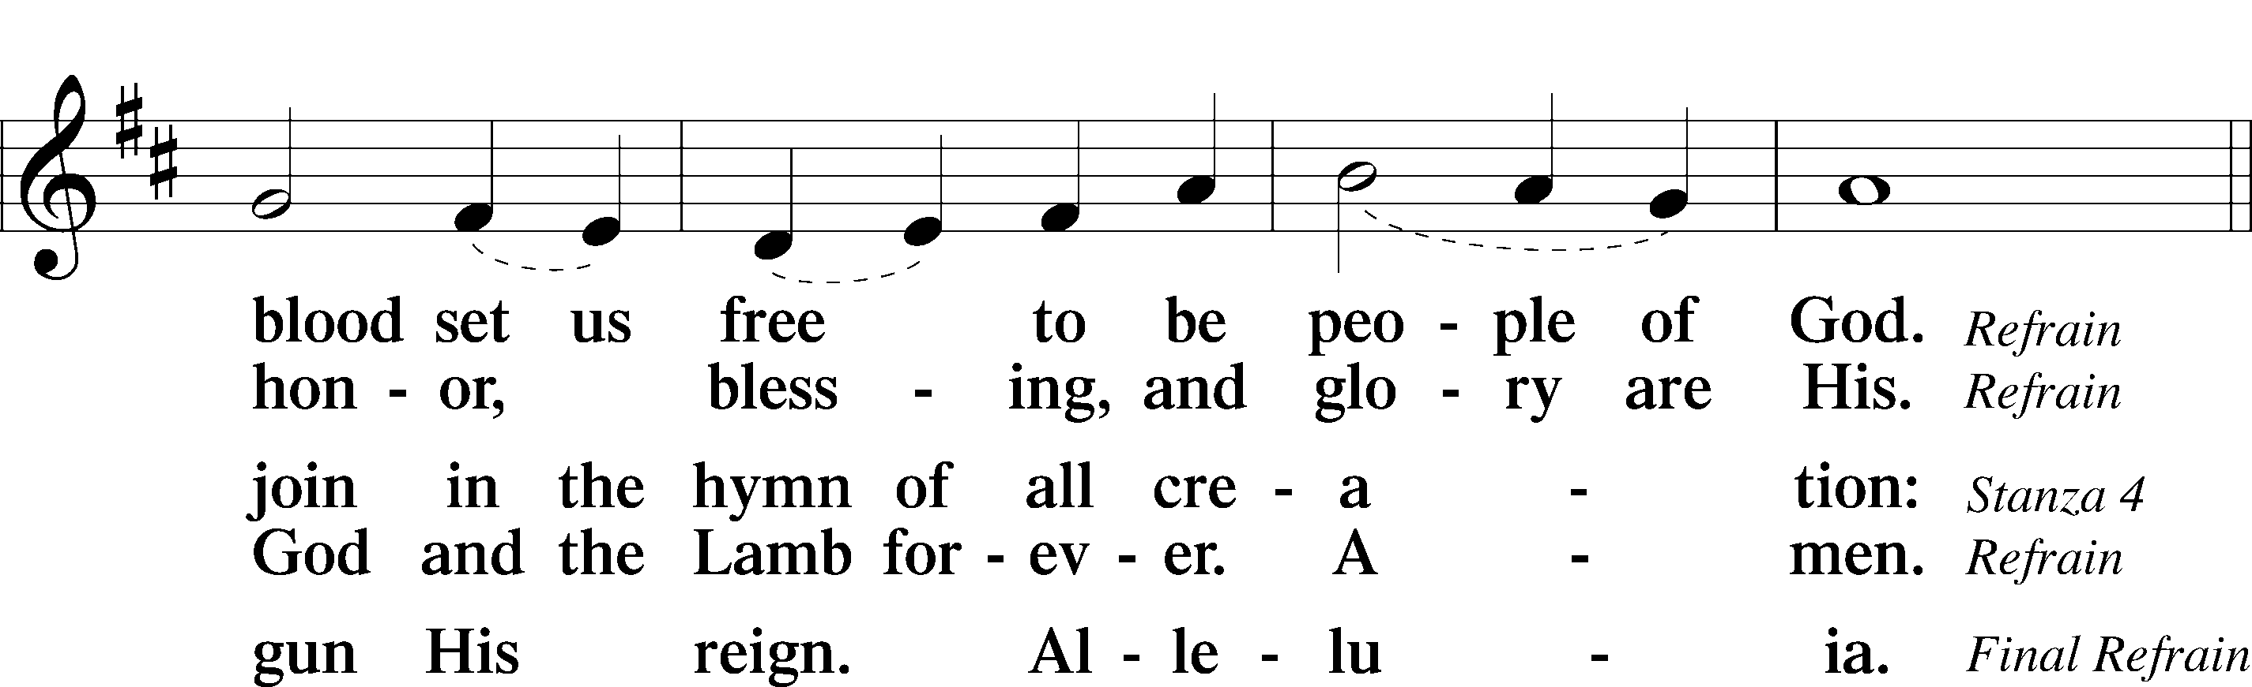
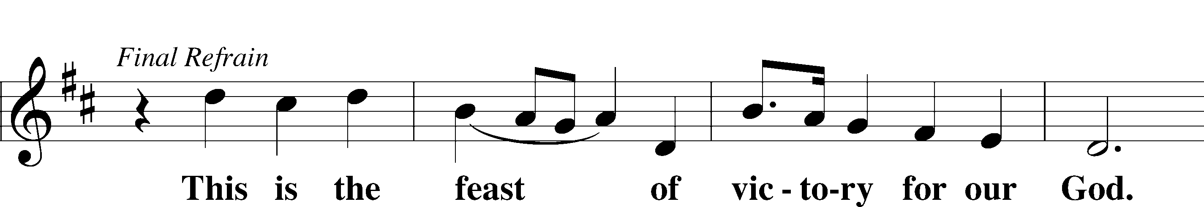
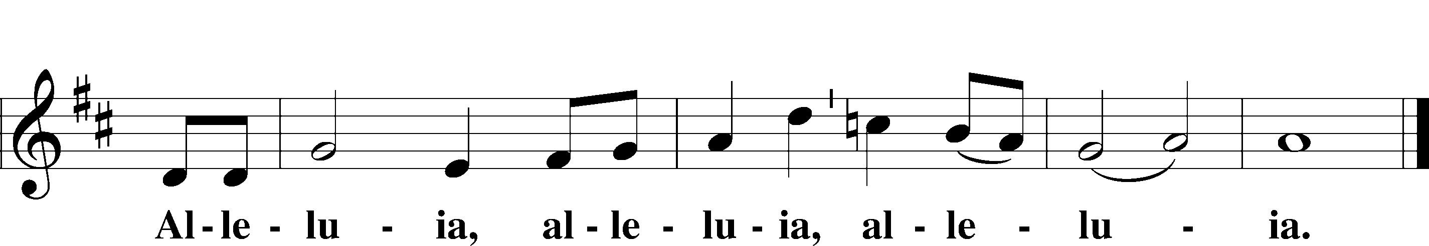

Salutation and Collect of the Day
P The Lord be with you.
C And also with you.

P Let us pray.
Almighty God the Father, through Your only-begotten Son, Jesus Christ, You have overcome death and opened the gate of everlasting life to us. Grant that we, who celebrate with joy the day of our Lord’s resurrection, may be raised from the death of sin by Your life-giving Spirit; through Jesus Christ, our Lord, who lives and reigns with You and the Holy Spirit, one God, now and forever.
C Amen.
Sit
Old Testament Reading Jeremiah 31:1–6
1“At that time, declares the Lord, I will be the God of all the clans of Israel, and they shall be my people.”
2Thus says the Lord:
“The people who survived the sword
found grace in the wilderness;
when Israel sought for rest,
3the Lord appeared to him from far away.
I have loved you with an everlasting love;
therefore I have continued my faithfulness to you.
4Again I will build you, and you shall be built,
O virgin Israel!
Again you shall adorn yourself with tambourines
and shall go forth in the dance of the merrymakers.
5Again you shall plant vineyards
on the mountains of Samaria;
the planters shall plant
and shall enjoy the fruit.
6For there shall be a day when watchmen will call
in the hill country of Ephraim:
‘Arise, and let us go up to Zion,
to the Lord our God.’”
A This is the Word of the Lord.
C Thanks be to God.
Thank you Jesus for the Blood Courney Johnson
Epistle Colossians 3:1–4
1If then you have been raised with Christ, seek the things that are above, where Christ is, seated at the right hand of God. 2Set your minds on things that are above, not on things that are on earth. 3For you have died, and your life is hidden with Christ in God. 4When Christ who is your life appears, then you also will appear with him in glory.
A This is the Word of the Lord.
C Thanks be to God.
Stand
Gospel Processional
Thy Strong Word LSB 578 sts. 1–3
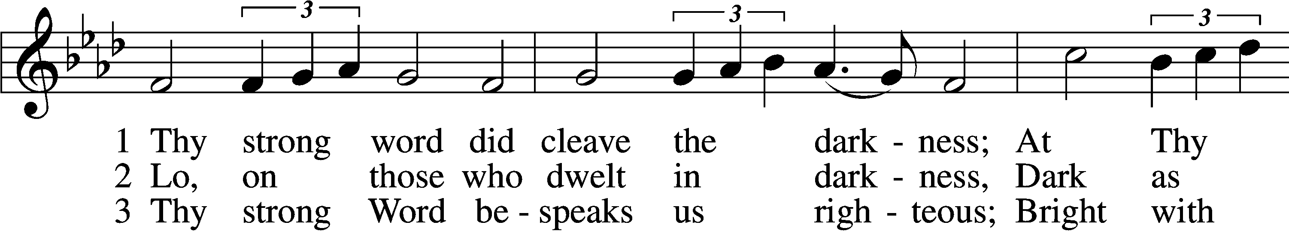
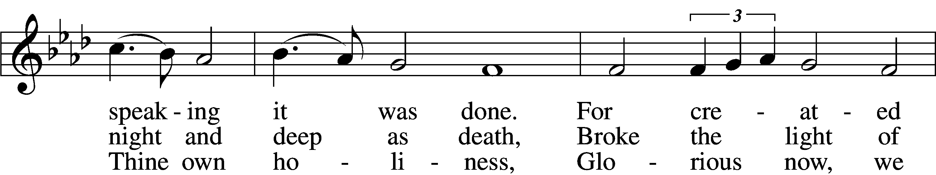
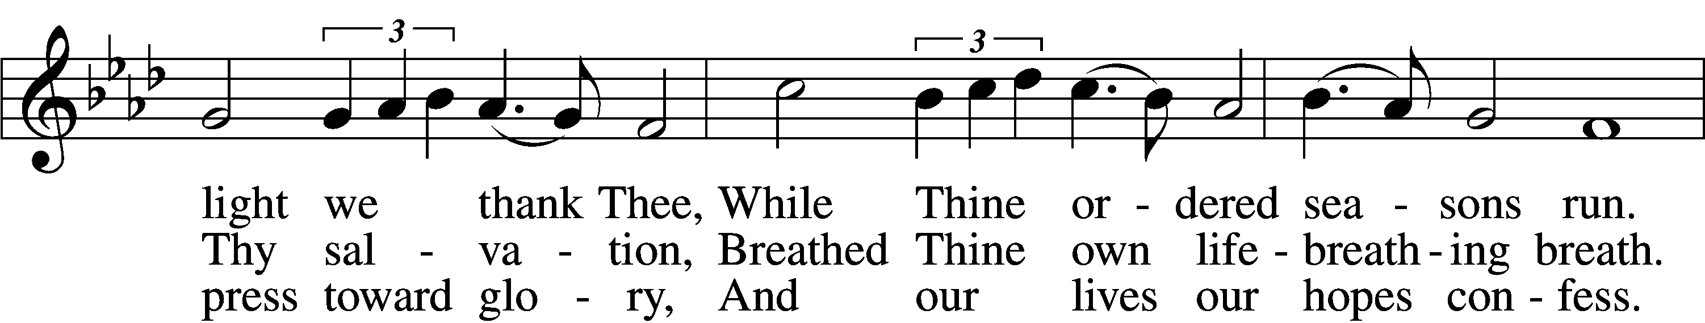
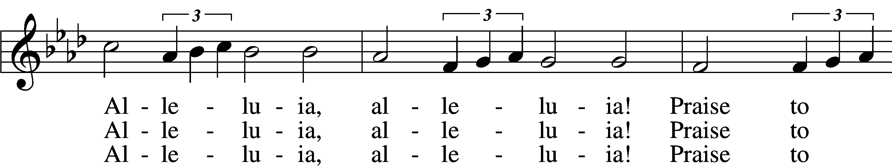
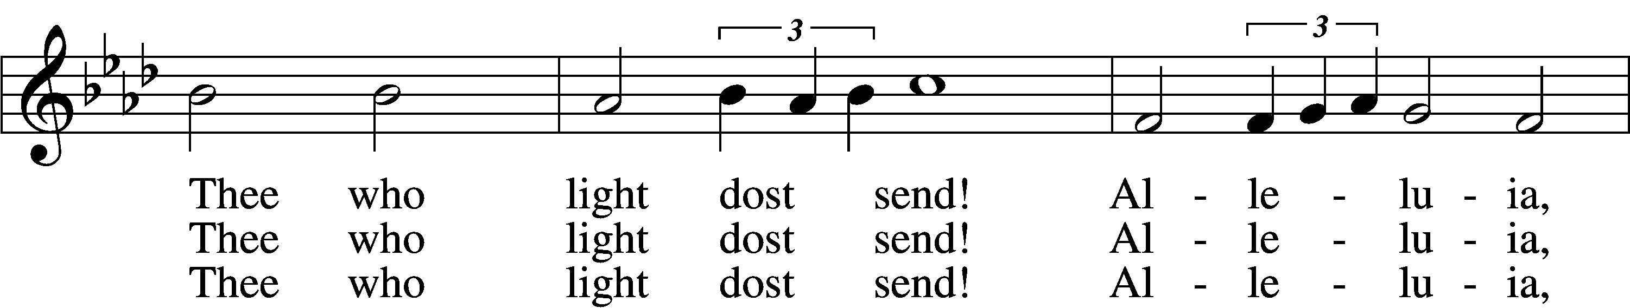
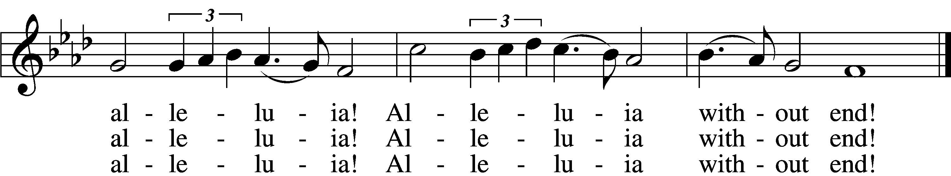
Text: Martin H. Franzmann, 1907–76
Tune: Thomas J. Williams, 1869–1944
Text: © 1969 Concordia Publishing House. Used by permission: LSB Hymn License no. 110000945
Tune: Public domain
Holy Gospel Matthew 28:1–10
P The Holy Gospel according to St. Matthew, the twenty-eighth chapter.
C Glory to You, O Lord.
1Now after the Sabbath, toward the dawn of the first day of the week, Mary Magdalene and the other Mary went to see the tomb. 2And behold, there was a great earthquake, for an angel of the Lord descended from heaven and came and rolled back the stone and sat on it. 3His appearance was like lightning, and his clothing white as snow. 4And for fear of him the guards trembled and became like dead men. 5But the angel said to the women, “Do not be afraid, for I know that you seek Jesus who was crucified. 6He is not here, for he has risen, as he said. Come, see the place where he lay. 7Then go quickly and tell his disciples that he has risen from the dead, and behold, he is going before you to Galilee; there you will see him. See, I have told you.” 8So they departed quickly from the tomb with fear and great joy, and ran to tell his disciples. 9And behold, Jesus met them and said, “Greetings!” And they came up and took hold of his feet and worshiped him. 10Then Jesus said to them, “Do not be afraid; go and tell my brothers to go to Galilee, and there they will see me.”
P This is the Gospel of the Lord.
C Praise to You, O Christ.
Thy Strong Word LSB 578 sts. 4–6
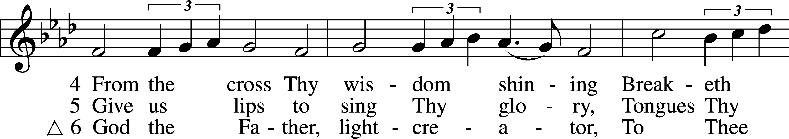
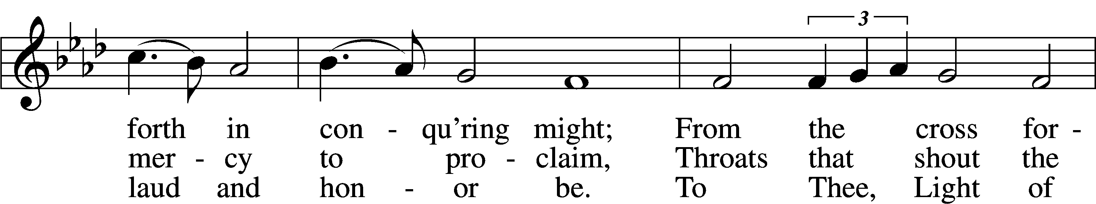
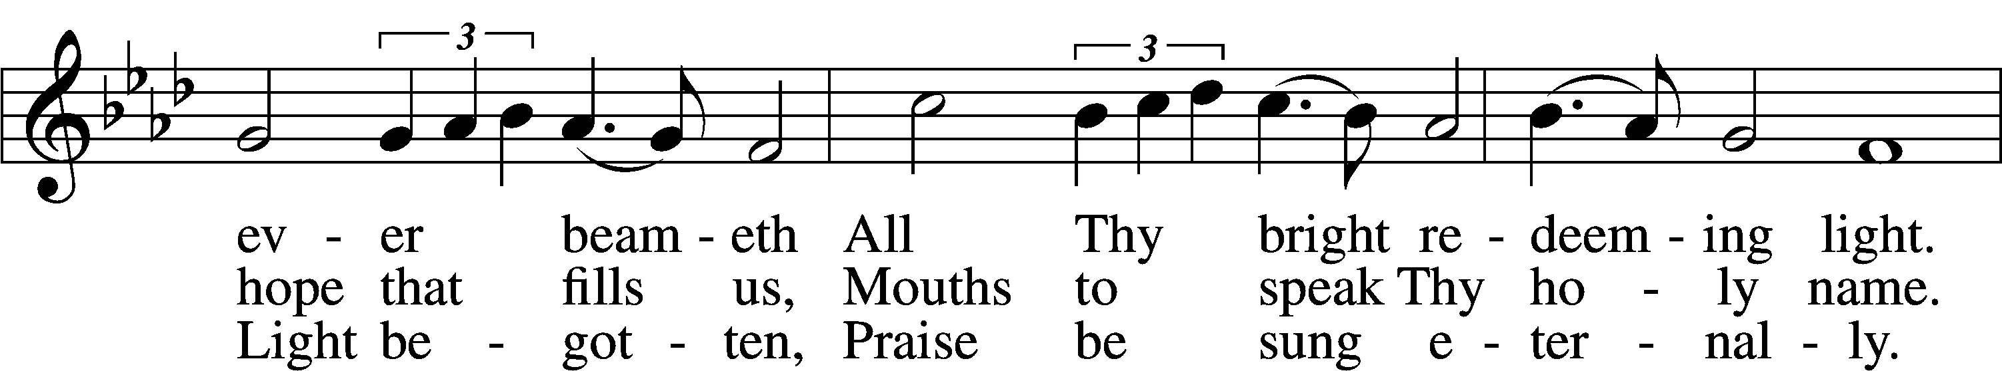
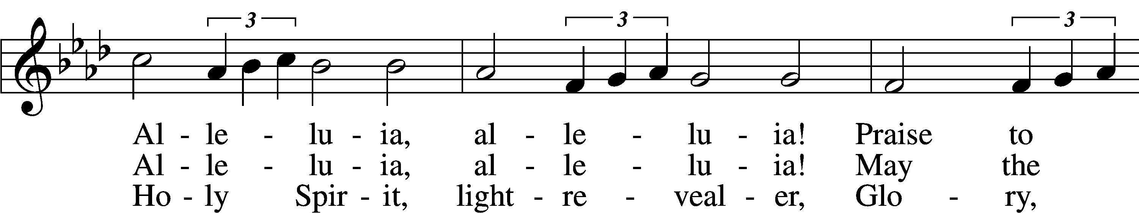
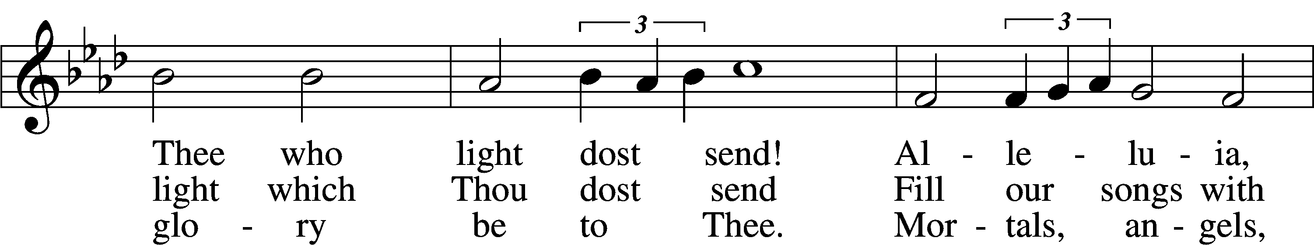
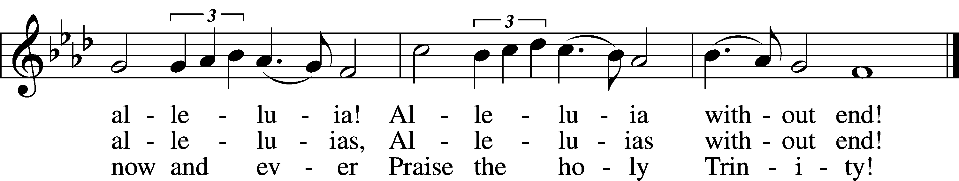
Text: Martin H. Franzmann, 1907–76
Tune: Thomas J. Williams, 1869–1944
Text: © 1969 Concordia Publishing House. Used by permission: LSB Hymn License no. 110000945
Tune: Public domain

Sit

Children's Message
Christ Jesus Lay in Death’s Strong Bands LSB 458
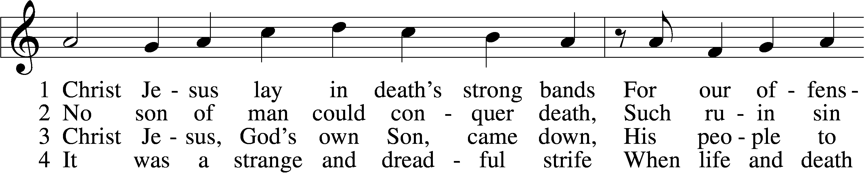
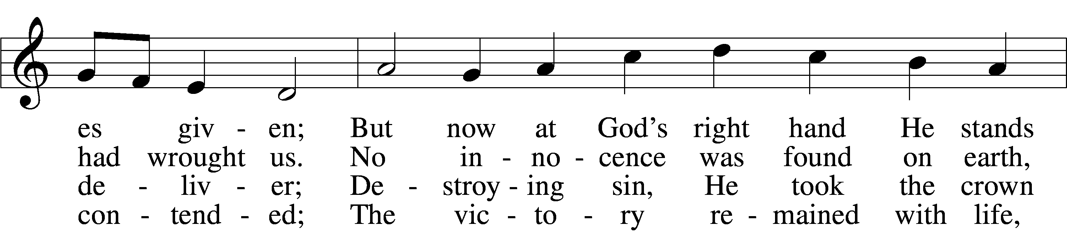
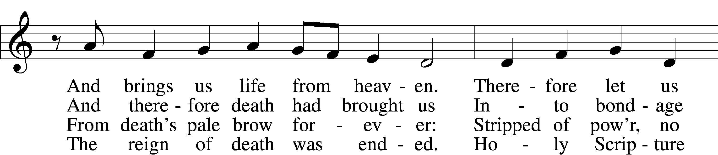
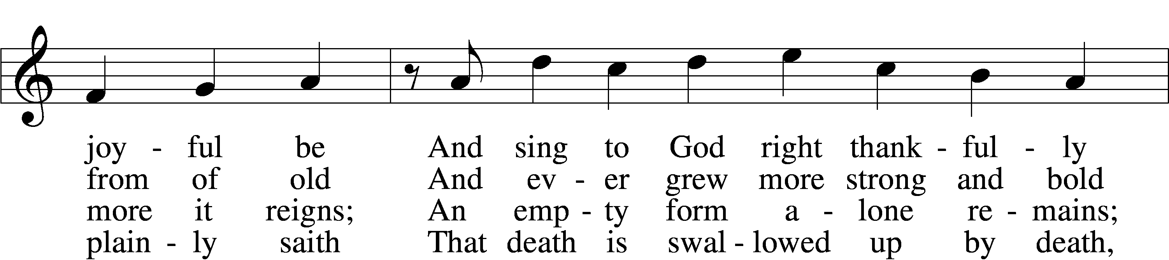
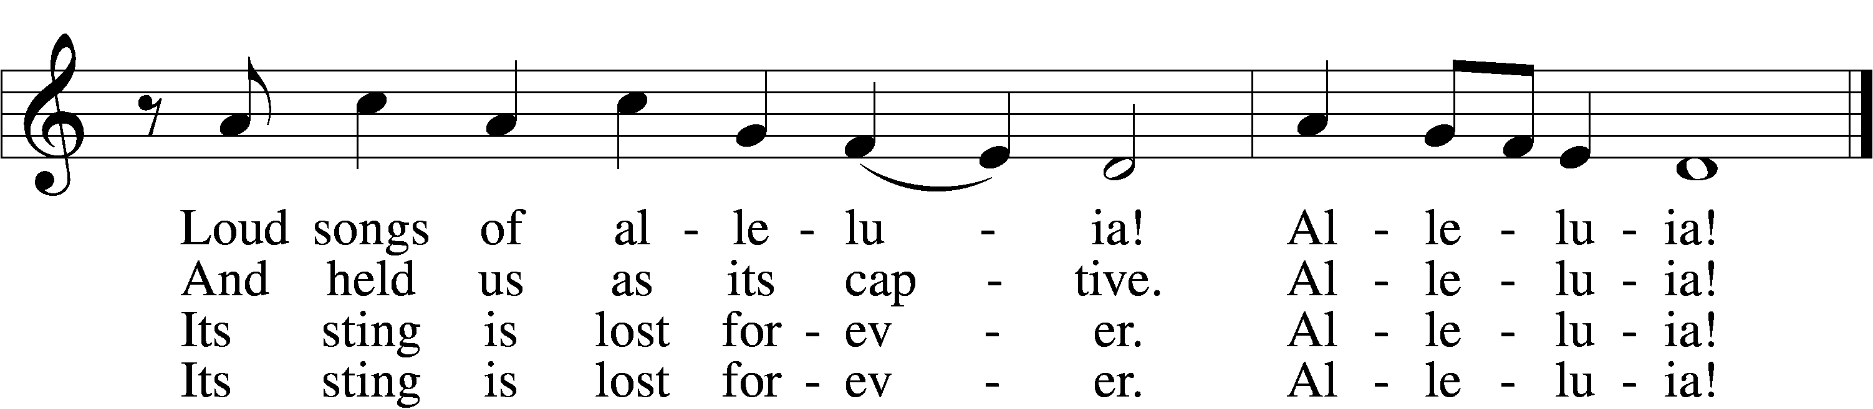
5 Here our true Paschal Lamb we see,
Whom God so freely gave us;
He died on the accursèd tree—
So strong His love—to save us.
See, His blood now marks our door;
Faith points to it; death passes o’er,
And Satan cannot harm us.
Alleluia!
6 So let us keep the festival
To which the Lord invites us;
Christ is Himself the joy of all,
The sun that warms and lights us.
Now His grace to us imparts
Eternal sunshine to our hearts;
The night of sin is ended.
Alleluia!
7 Then let us feast this Easter Day
On Christ, the bread of heaven;
The Word of grace has purged away
The old and evil leaven.
Christ alone our souls will feed;
He is our meat and drink indeed;
Faith lives upon no other!
Alleluia!
Text: Martin Luther, 1483–1546; tr. Richard Massie, 1800–87, alt.
Tune: Geystliche gesangk Buchleyn, 1524, Wittenberg, ed. Johann Walter
Text and tune: Public domain
Sermon
Stand
Nicene Creed
C I believe in one God,
the Father Almighty,
maker of heaven and earth
and of all things visible and invisible.

And in one Lord Jesus Christ,
the only-begotten Son of God,
begotten of His Father before all worlds,
God of God, Light of Light,
very God of very God,
begotten, not made,
being of one substance with the Father,
by whom all things were made;
who for us men and for our salvation came down from heaven
and was incarnate by the Holy Spirit of the virgin Mary
and was made man;
and was crucified also for us under Pontius Pilate.
He suffered and was buried.
And the third day He rose again according to the Scriptures
and ascended into heaven
and sits at the right hand of the Father.
And He will come again with glory to judge both the living and the dead,
whose kingdom will have no end.

And I believe in the Holy Spirit,
the Lord and giver of life,
who proceeds from the Father and the Son,
who with the Father and the Son together is worshiped and glorified,
who spoke by the prophets.
And I believe in one holy Christian and apostolic Church,
I acknowledge one Baptism for the remission of sins,
and I look for the resurrection of the dead
and the life T of the world to come. Amen.

Prayer of the Church
Sit
Offering
Stand
Offertory LSB 159
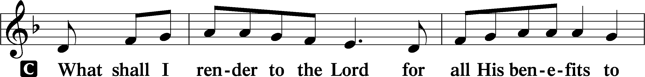
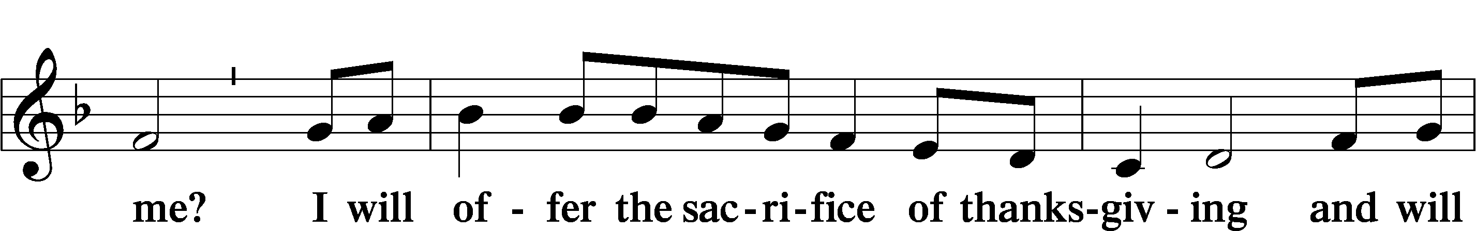
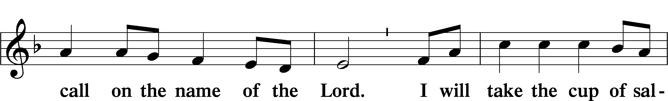
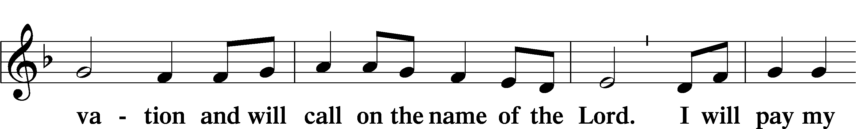
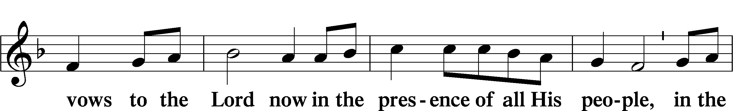
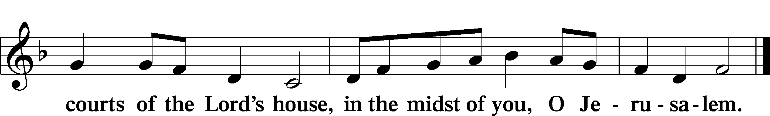
Service of the Sacrament
Preface LSB 160
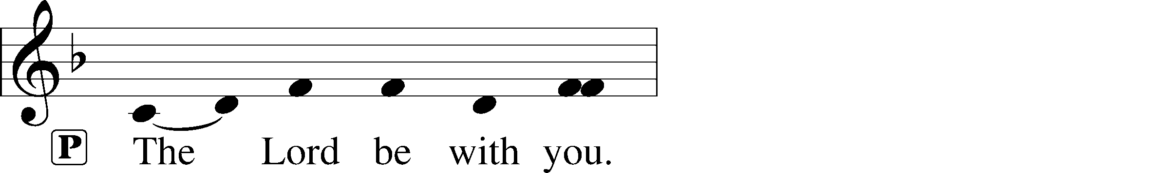
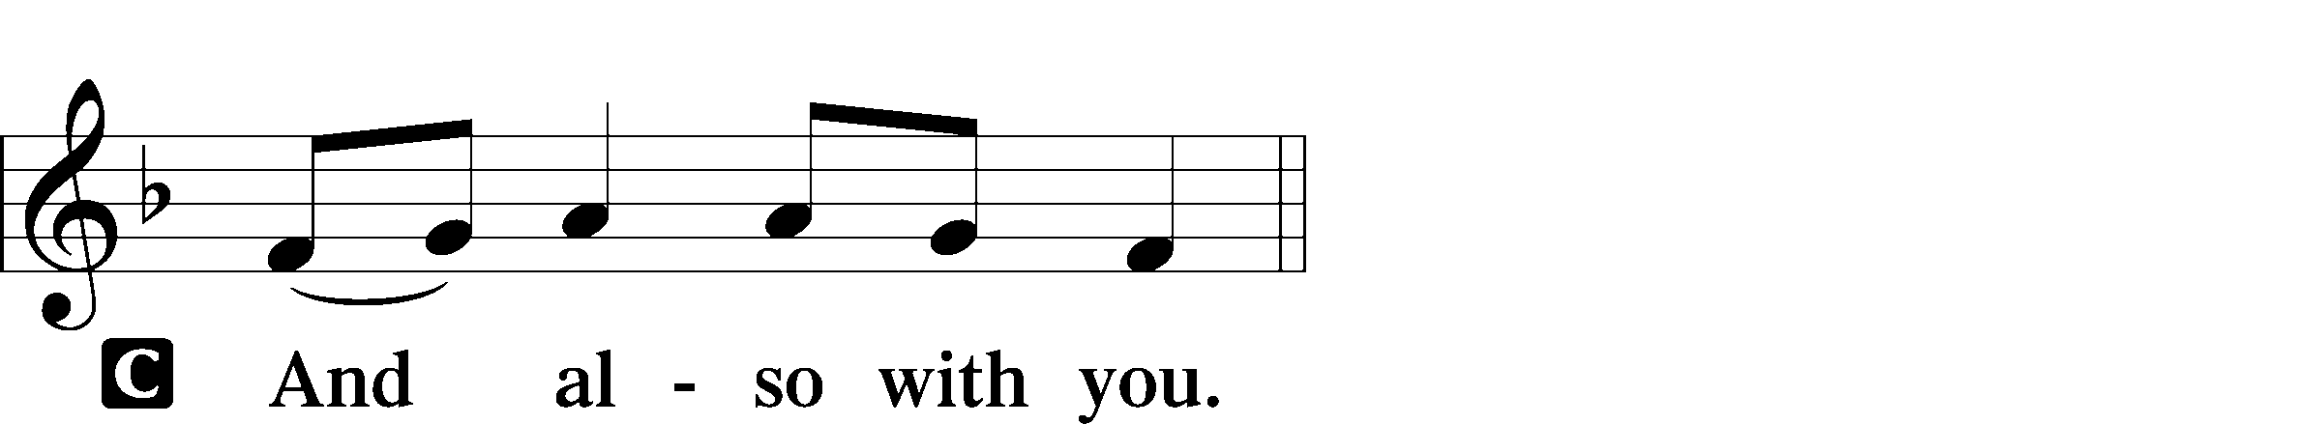
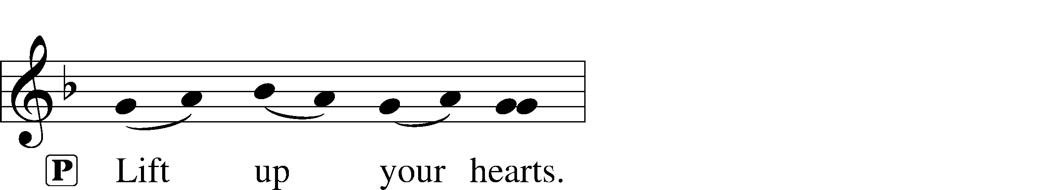

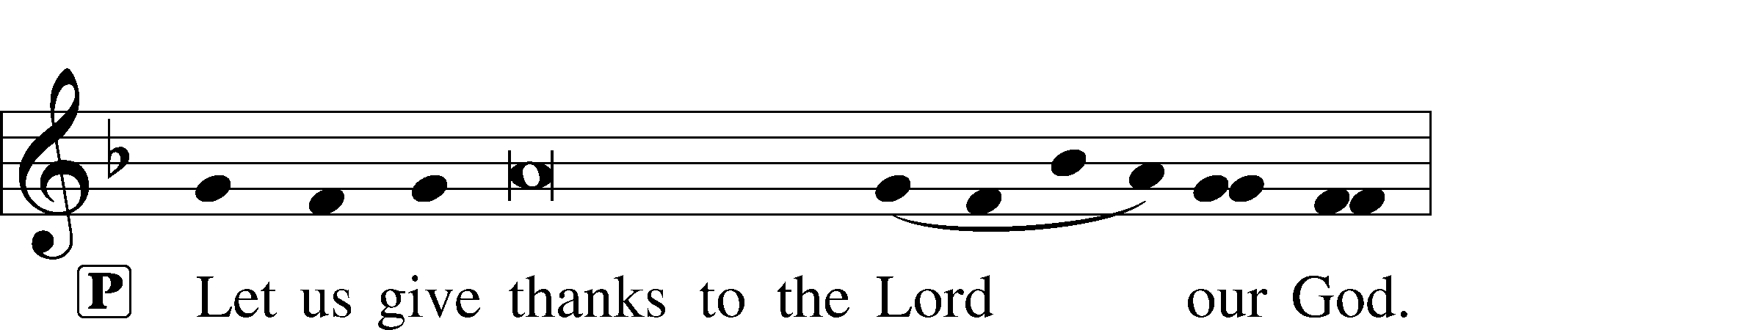
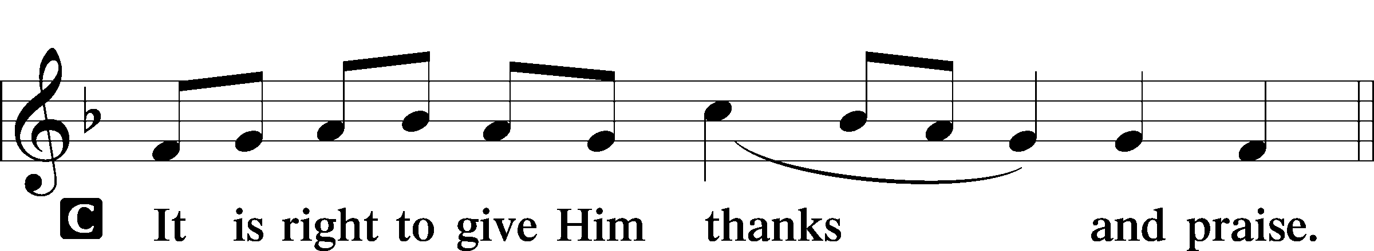
P It is truly good, right, and salutary that we should at all times and in all places give thanks to You, holy Lord, almighty Father, everlasting God. And most especially are we bound to praise You on this day for the glorious resurrection of Your Son, Jesus Christ, the very Paschal Lamb, who was sacrificed for us and bore the sins of the world. By His dying He has destroyed death, and by His rising again He has restored to us everlasting life. Therefore with Mary Magdalene, Peter and John, and with all the witnesses of the resurrection, with angels and archangels, and with all the company of heaven we laud and magnify Your glorious name, evermore praising You and saying:
Sanctus LSB 161
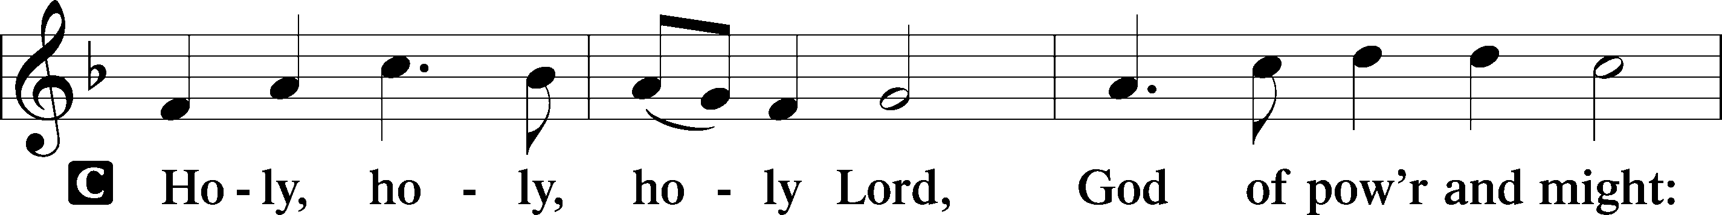
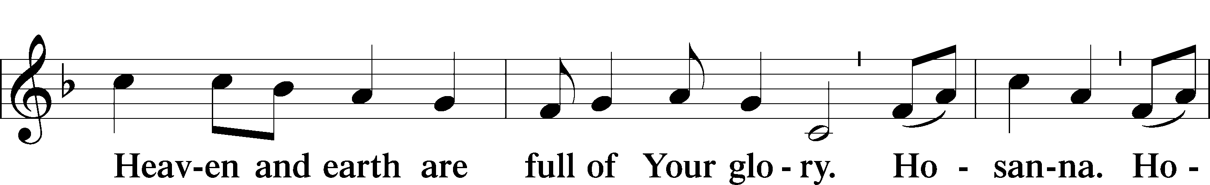
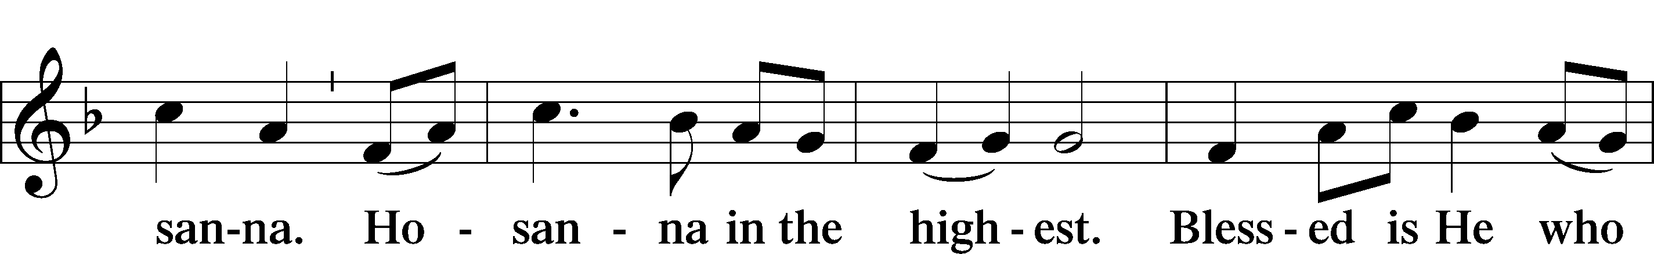
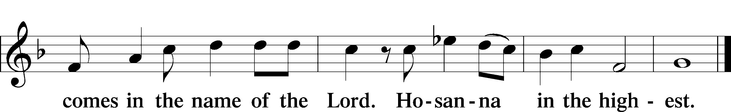
Prayer of Thanksgiving LSB 161
P Blessed are You, Lord of heaven and earth, for You have had mercy on those whom You created and sent Your only-begotten Son into our flesh to bear our sin and be our Savior. With repentant joy we receive the salvation accomplished for us by the all-availing sacrifice of His body and His blood on the cross.

Gathered in the name and the remembrance of Jesus, we beg You, O Lord, to forgive, renew, and strengthen us with Your Word and Spirit. Grant us faithfully to eat His body and drink His blood as He bids us do in His own testament. Gather us together, we pray, from the ends of the earth to celebrate with all the faithful the marriage feast of the Lamb in His kingdom, which has no end. Graciously receive our prayers; deliver and preserve us. To You alone, O Father, be all glory, honor, and worship, with the Son and the Holy Spirit, one God, now and forever.
C Amen.
Lord’s Prayer LSB 162
P Lord, remember us in Your kingdom and teach us to pray:
C Our Father who art in heaven,
hallowed be Thy name,
Thy kingdom come,
Thy will be done on earth
as it is in heaven;
give us this day our daily bread;
and forgive us our trespasses
as we forgive those
who trespass against us;
and lead us not into temptation,
but deliver us from evil.
For Thine is the kingdom
and the power and the glory
forever and ever. Amen.
The Words of Our Lord
P Our Lord Jesus Christ, on the night when He was betrayed, took bread, and when He had given thanks, He broke it and gave it to the disciples and said: “Take, eat; this is My T body, which is given for you. This do in remembrance of Me.”

In the same way also He took the cup after supper, and when He had given thanks, He gave it to them, saying: “Drink of it, all of you; this cup is the new testament in My T blood, which is shed for you for the forgiveness of sins. This do, as often as you drink it, in remembrance of Me.”
Pax Domini LSB 163
P The peace of the Lord be with you always.
C Amen.

Following the prayers, the people may greet one another in the name of the Lord, saying, “Peace be with you,” as a sign of reconciliation and of the unity of the Spirit in the bond of peace (Matt. 5:22–24; Eph. 4:1–3).

Agnus Dei LSB 163
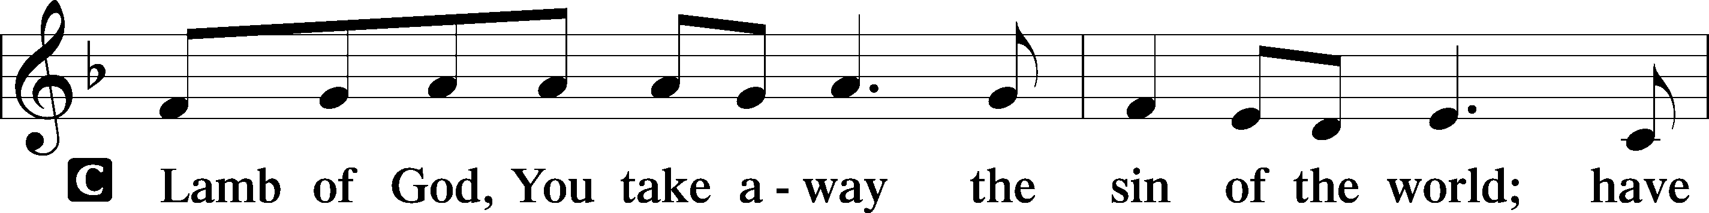
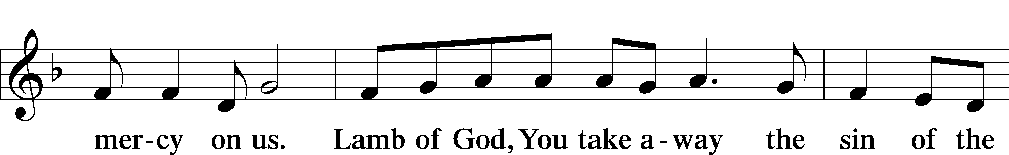
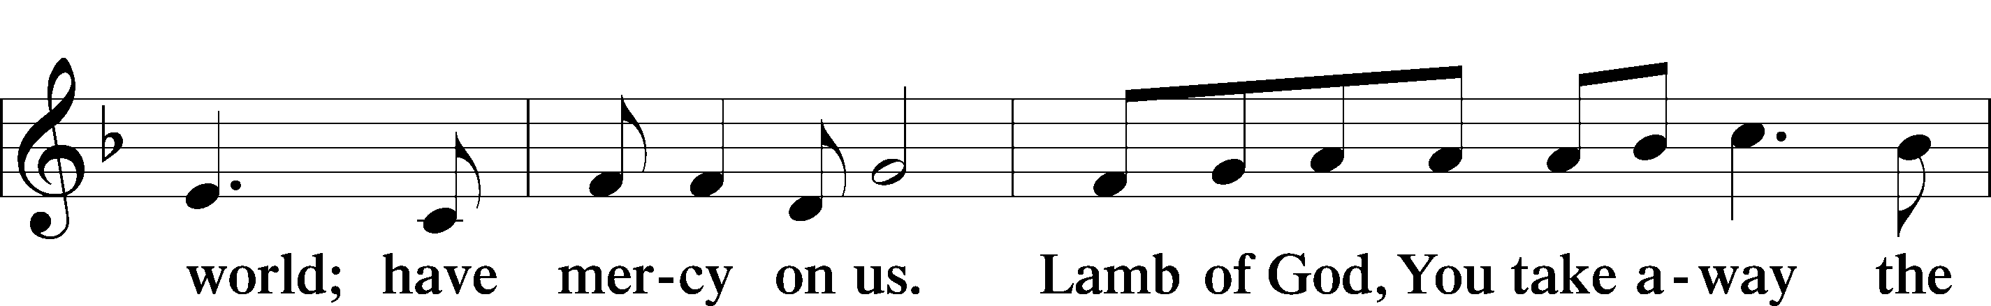
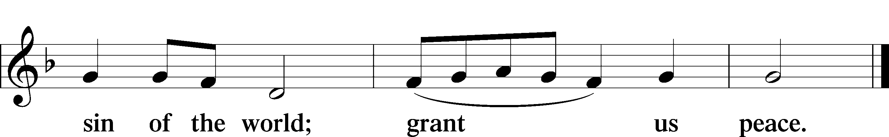
Sit
463 Christ the Lord Is Risen Today; Alleluia
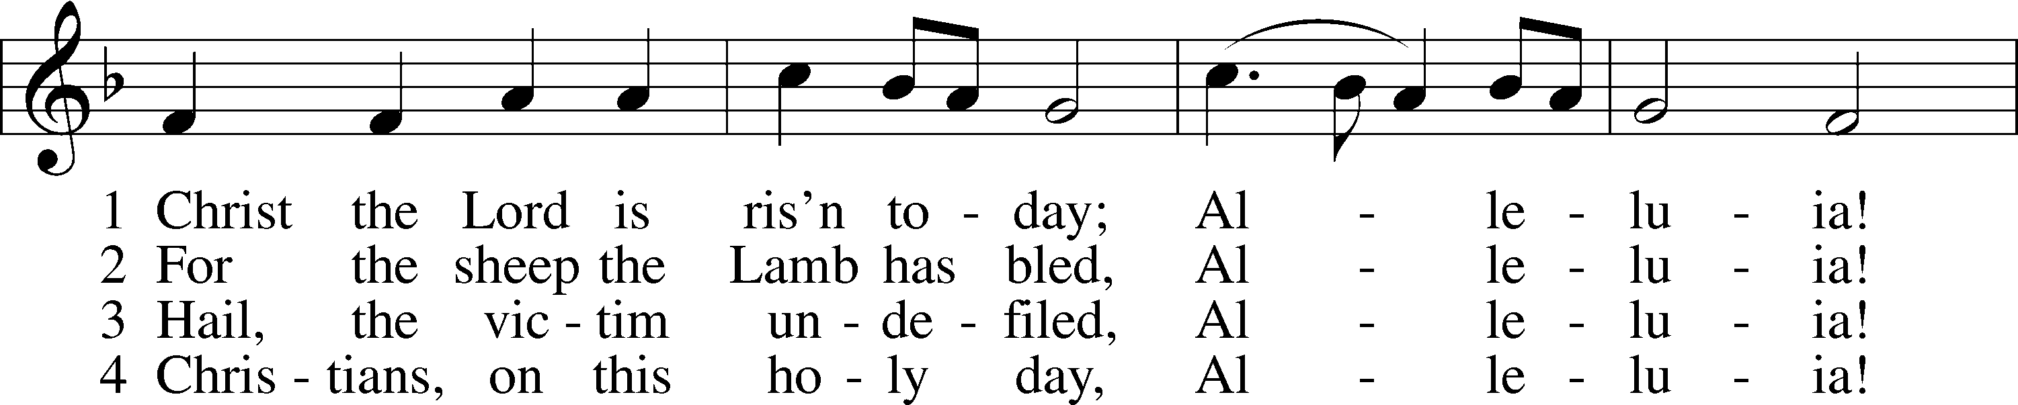
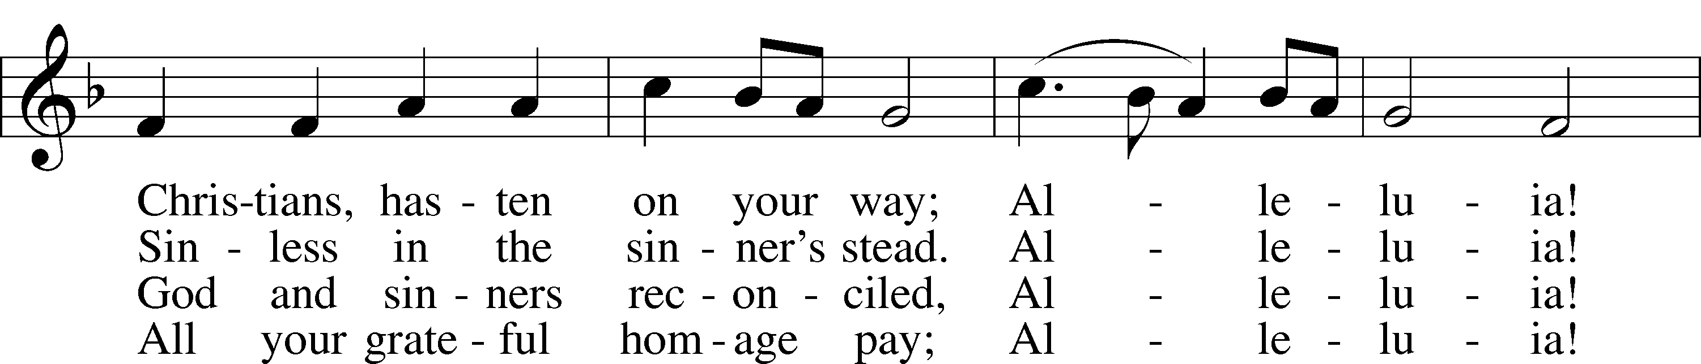
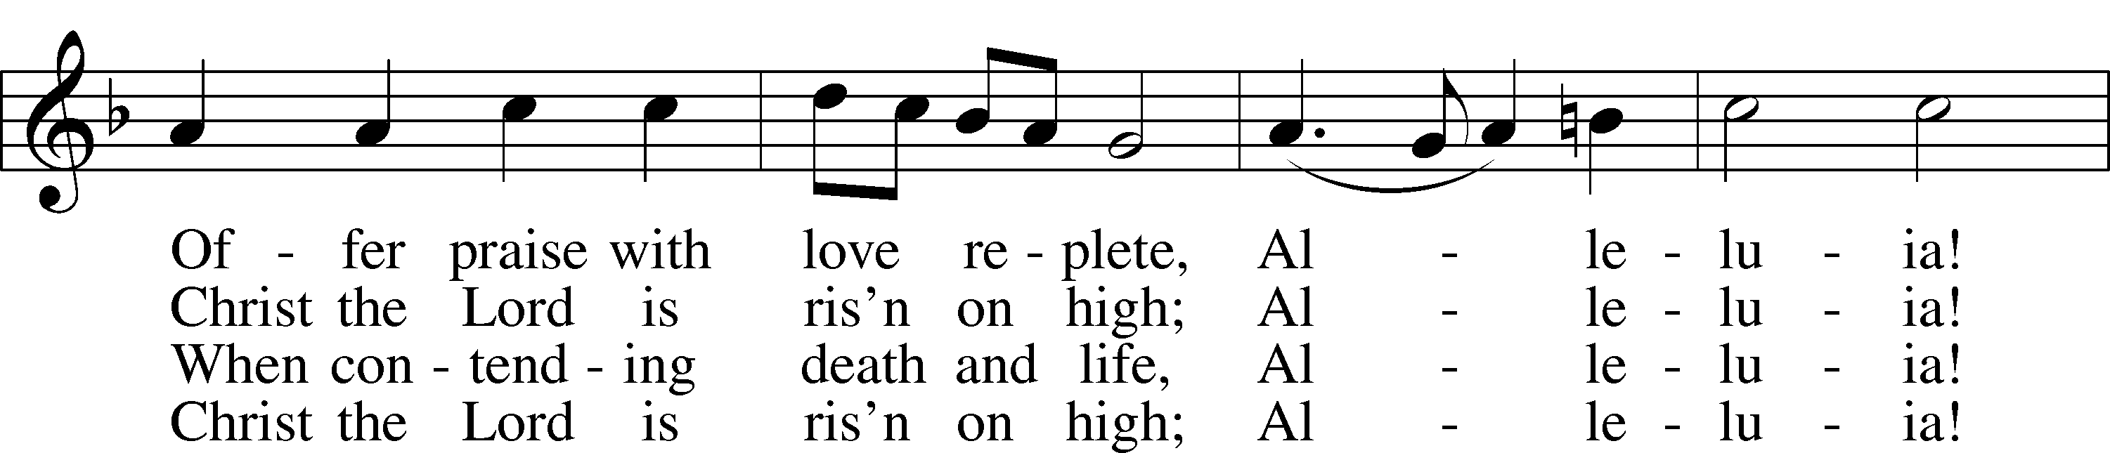
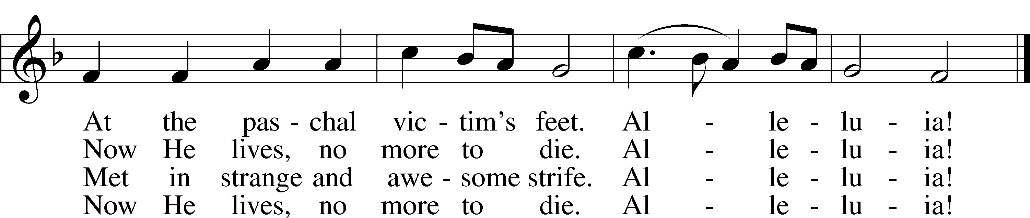
Text: attr. Wipo of Burgundy, d. c. 1050; tr. Jane E. Leeson, 1809–81, alt.
Tune: Robert Williams, c. 1781–1821
Text and tune: Public domain

469 Christ the Lord Is Risen Today
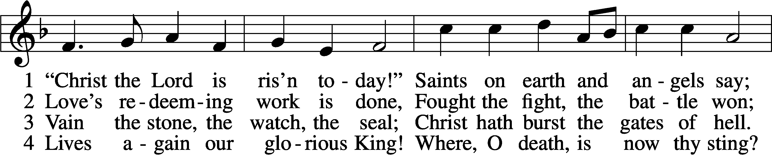
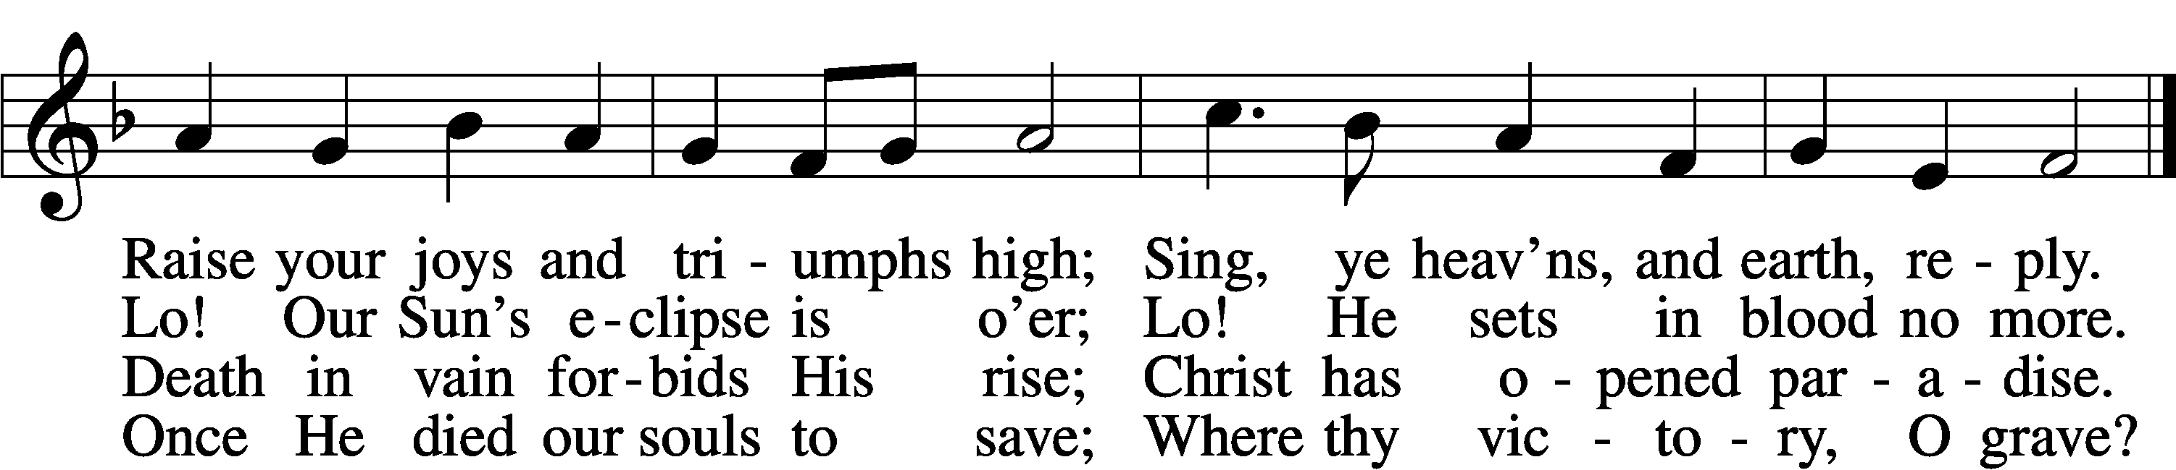

5 Soar we now where Christ has led;
Foll’wing our exalted Head.
Made like Him, like Him we rise;
Ours the cross, the grave, the skies.

6 Hail the Lord of earth and heav’n!
Praise to Thee by both be giv’n!
Thee we greet triumphant now:
Hail, the resurrection, Thou!
Text: Charles Wesley, 1707–88, alt.
Tune: French, 13th cent.
Text and tune: Public domain

Hymn
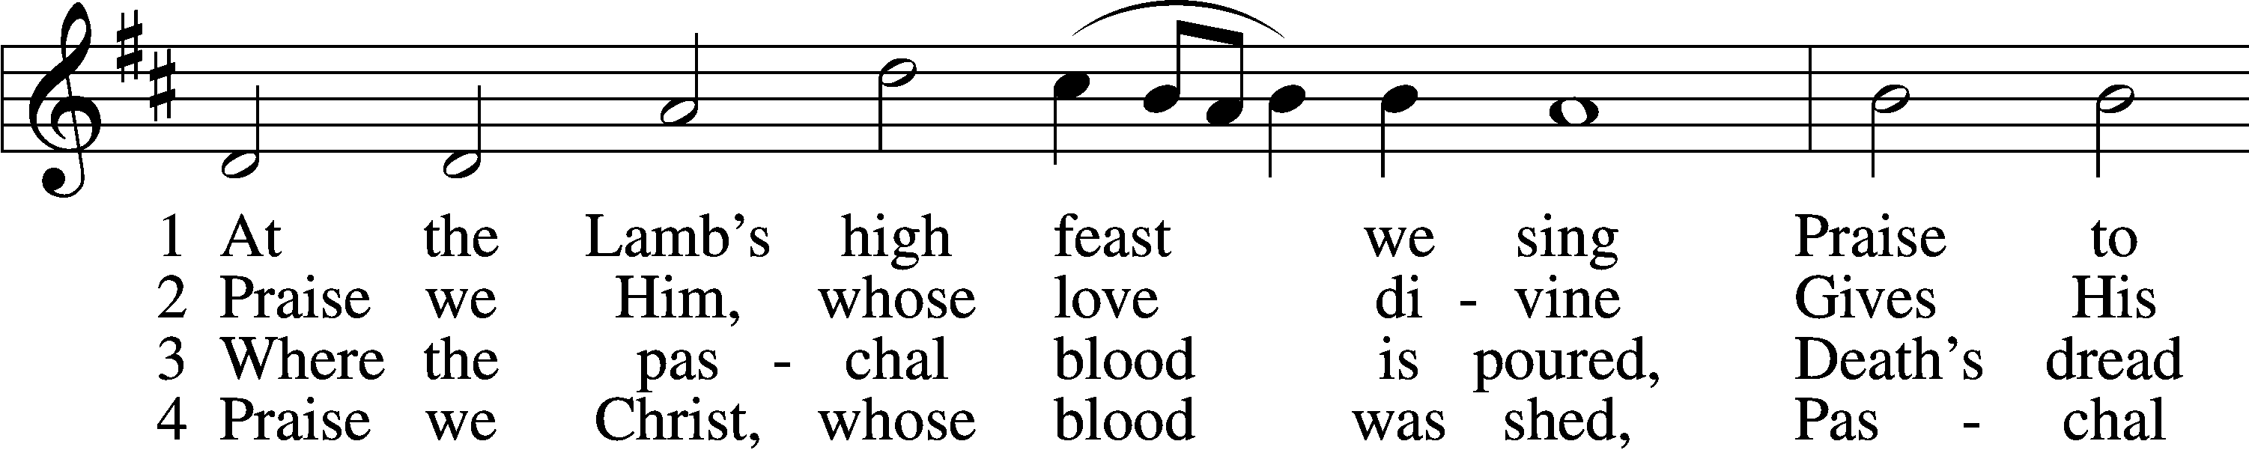
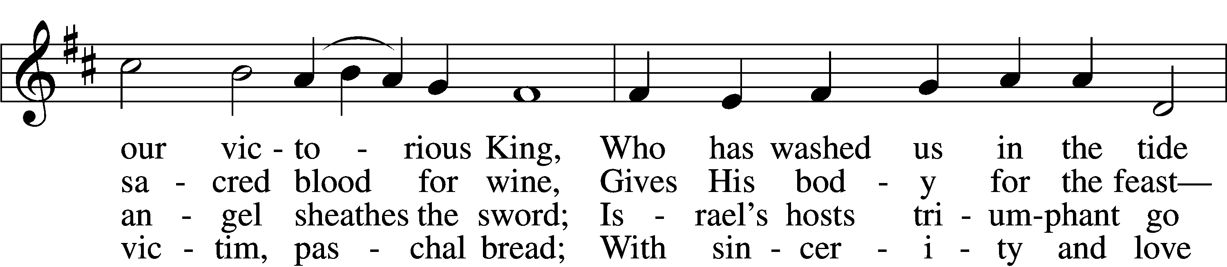
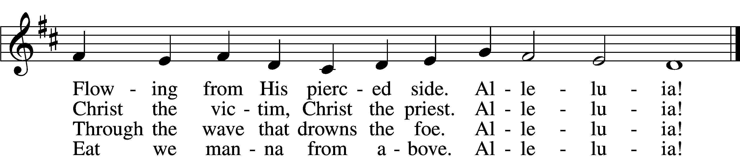

5 Mighty Victim from the sky,
Hell’s fierce pow’rs beneath You lie;
You have conquered in the fight,
You have brought us life and light.
Alleluia!
6 Now no more can death appall,
Now no more the grave enthrall;
You have opened paradise,
And Your saints in You shall rise.
Alleluia!
7 Easter triumph, Easter joy!
This alone can sin destroy;
From sin’s pow’r, Lord, set us free,
Newborn souls in You to be.
Alleluia!

D 8 Father, who the crown shall give,
Savior, by whose death we live,
Spirit, guide through all our days:
Three in One, Your name we praise.
Alleluia!
Text: Latin, c. 5th–10th cent.; tr. Robert Campbell, 1814–68, alt.
Tune: Kirchengeseng, 1566, Ivancice
Text and tune: Public domain
Stand

Thank the Lord LSB 164
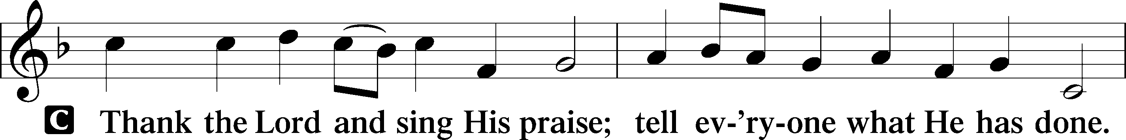
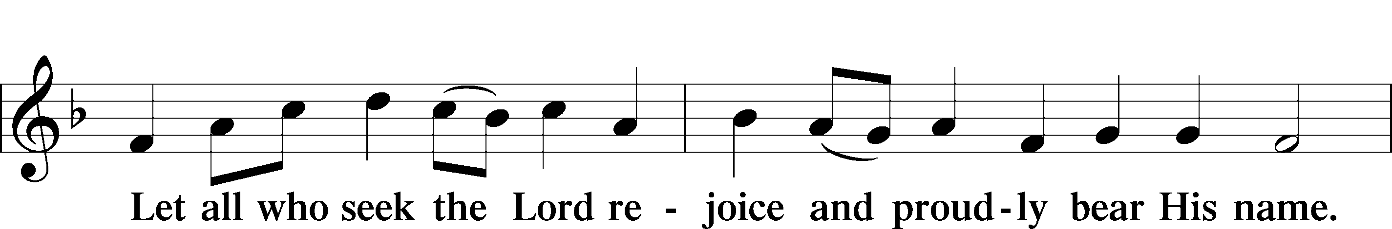
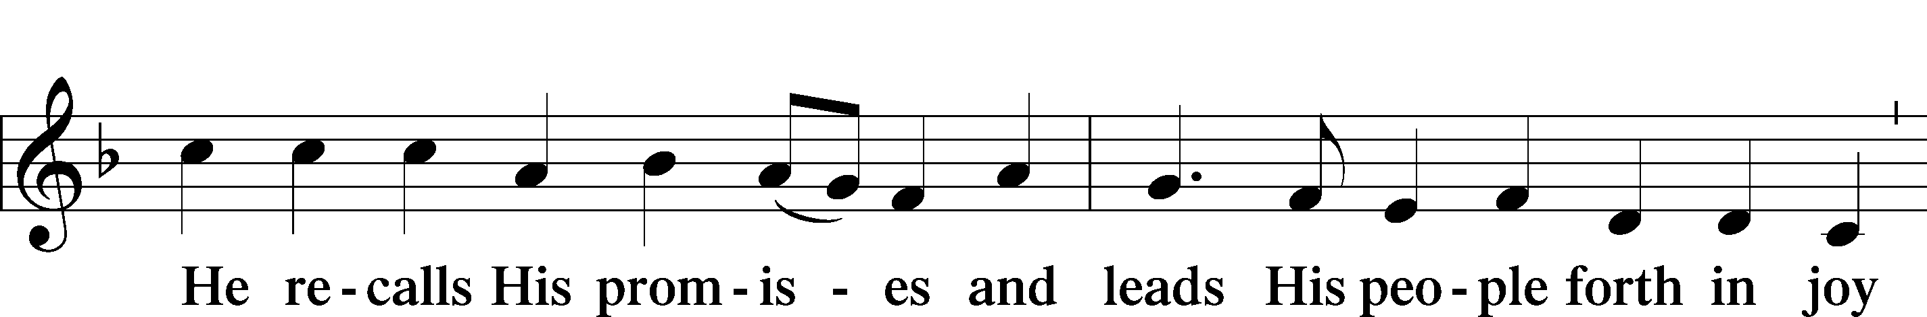
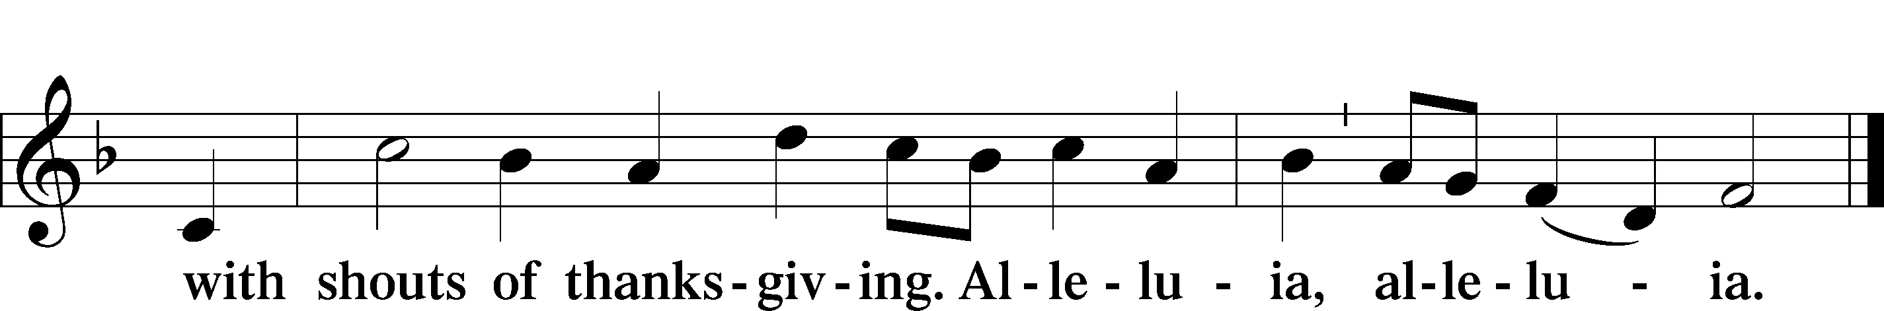
Post-Communion Collect
A Let us pray.
We give thanks to You, almighty God, that You have refreshed us through this salutary gift, and we implore You that of Your mercy You would strengthen us through the same in faith toward You and in fervent love toward one another; through Jesus Christ, Your Son, our Lord, who lives and reigns with You and the Holy Spirit, one God, now and forever.
C Amen.

Benediction LSB 166
P The Lord bless you and keep you.
The Lord make His face shine on you and be gracious to you.
The Lord look upon you with favor and T give you peace.
C Amen.

He’s Risen, He’s Risen LSB 480
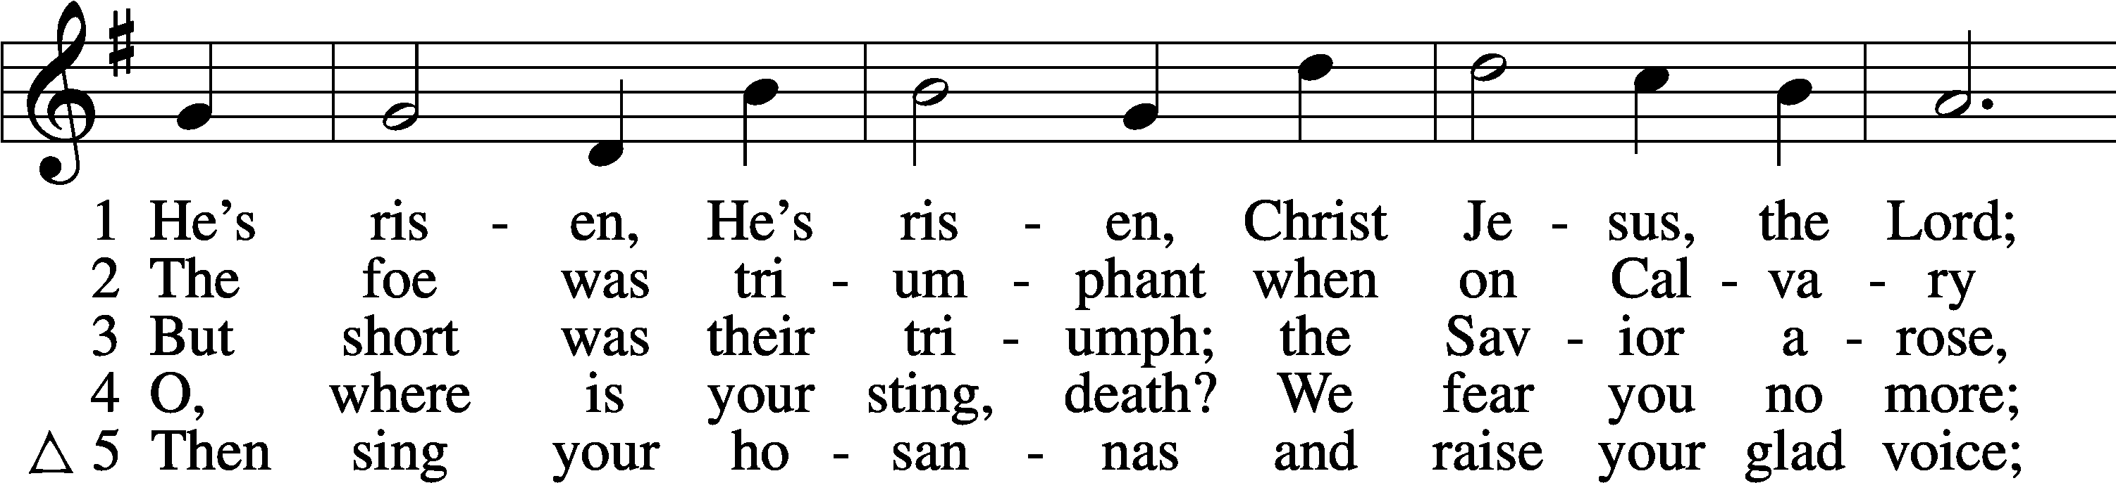
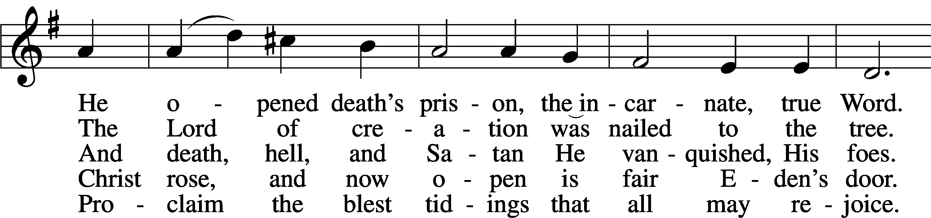
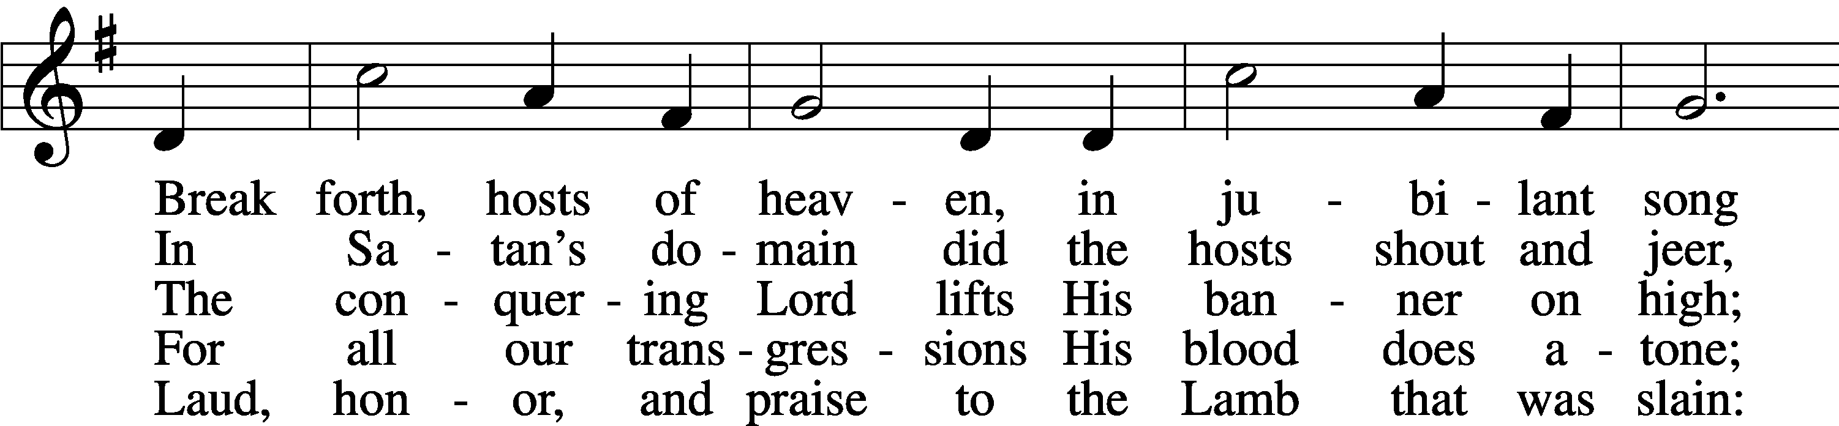
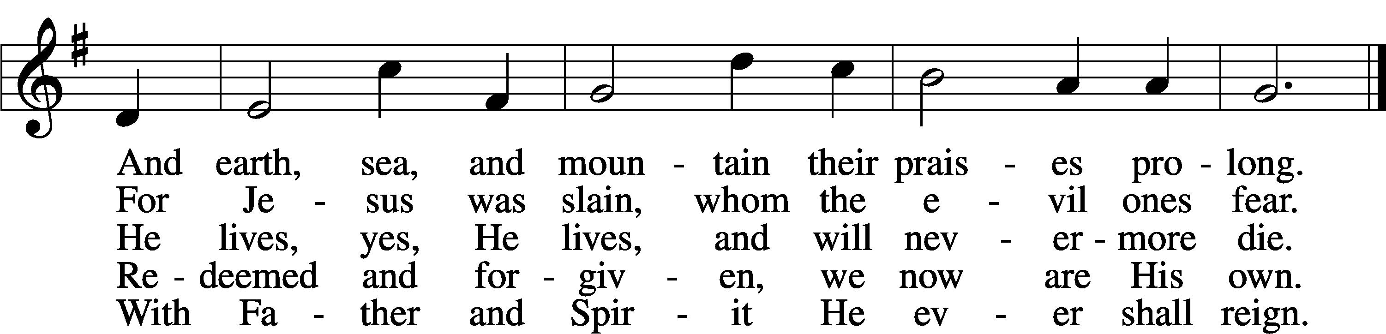
Text: C. F. W. Walther, 1811–87, abr.; tr. Anna M. Meyer, 1867–1941, alt.
Tune: C. F. W. Walther, 1811–87
Text: © 1941 Concordia Publishing House. Used by permission: LSB Hymn License no. 110000945
Tune: Public domain

Acknowledgments
Divine Service, Setting One from Lutheran Service Book
Unless otherwise indicated, Scripture quotations are from the ESV® Bible (The Holy Bible, English Standard Version®), copyright © 2001 by Crossway, a publishing ministry of Good News Publishers. Used by permission. All rights reserved.
Created by Lutheran Service Builder © 2026 Concordia Publishing House.

