The 4th Sunday after Epiphany
Sunday, February 1, 2026


18The word of the cross is folly to those who are perishing, but to us who are being saved it is the power of God. 19For it is written,
“I will destroy the wisdom of the wise,
and the discernment of the discerning I will thwart.” 1st Corinthians 1:18-19

Trinity Lutheran Church
2535 Jefferson Road
Athens, GA 30605

Pastor Timothy P. Davis
Pastor.davis@trinity-athens.org
706-308-7550

Welcome!
We rejoice and give thanks that you are here this morning and pray that the message of the cross of Christ brings comfort to you. If this is your first time worshipping with us please read Trinity’s statement regarding the practice of Holy Communion. Please introduce yourself to the pastor and those sitting around you. Thank you for visiting and please join us again. If you have any questions please reach out to Pastor Davis at 970-630-5191(Text or Voice)

Hearing Aids and Cry Room

Those who have a need for hearing assistance, please speak with the usher. Please be assured that the voices of children are received with delight in our midst. The cry room is located at the back of the church if you desire to use it.

Trinity’s Holy Communion Statement
We rejoice in the celebration of the Lord’s Supper as the Lord Jesus comes to us in an intimate manner. In the Lord’s Supper we receive His true Body and true Blood in, with, and under the bread and wine. Our Lord teaches us in 1 Corinthians 11:28-29, “A man ought to examine himself before he eats of the bread and drinks of the cup. For anyone who eats and drinks without recognizing the body of the Lord eats and drinks judgment on himself.” If this is your confession, please join us in the Lord’s Supper. Alcohol-free wine is available for those who are unable or desire not to receive alcohol. The alcohol-free wine is in the center of the tray.

+ CONFESSION AND ABSOLUTION +
BELL CHOIR (10:00) “Chimings of Great Joy”
LORD, WHOSE LOVE THROUGH HUMBLE SERVICE
LSB 848
(Stand)
(The sign of the cross may be made by all in remembrance of their Baptism.)
INVOCATION
EXHORTATION LSB 151
(Kneel/Stand)
(Silence for reflection on God’s Word and for self-examination.)
CONFESSION OF SINS LSB 151
ABSOLUTION LSB 151
(Stand)
+ SERVICE OF THE WORD +
INTROIT Psalm 1:1–5; antiphon: v. 6

For the Lord knows the way of the | righteous,*
but the way of the wicked will | perish.
Blessèd is the man who walks not in the counsel of the | wicked,*
nor stands in the way of sinners, nor sits in the seat of | scoffers;
but his delight is in the law | of the Lord,*
and on his law he meditates | day and night.
He is like a tree planted by streams of water that yields its fruit in its season, and its leaf does not | wither.*
In all that he does, he | prospers.
The wicked | are not so,*
but are like chaff that the wind | drives away.
Therefore the wicked will not stand in the | judgment,*
nor sinners in the congregation of the | righteous.
Glory be to the Father and | to the Son*
and to the Holy | Spirit;
as it was in the be- | ginning,*
is now, and will be forever. | Amen.
For the Lord knows the way of the | righteous,*
but the way of the wicked will | perish.
KYRIE LSB 152
GLORIA IN EXCELSIS LSB 154
SALUTATION AND COLLECT OF THE DAY
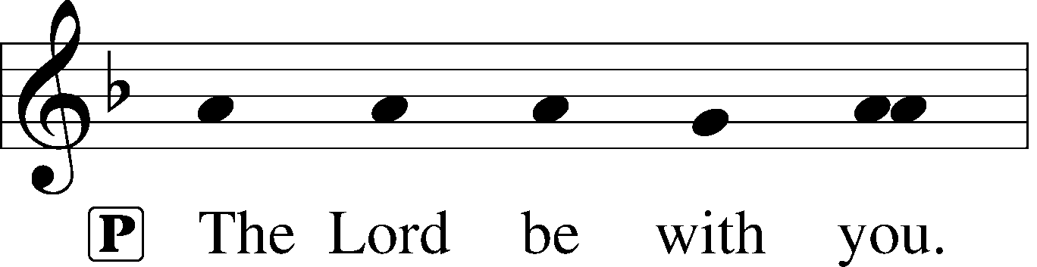
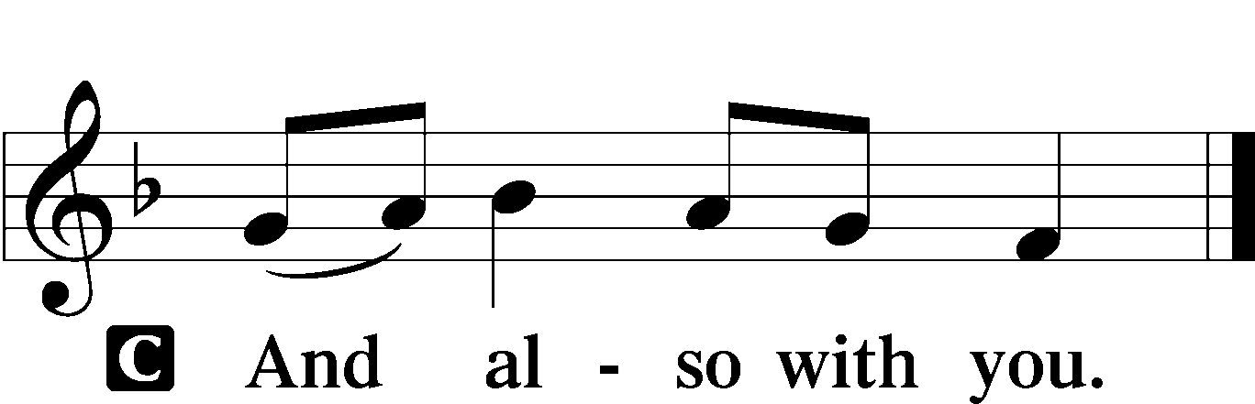

P Let us pray.
Almighty God, You know we live in the midst of so many dangers that in our frailty we cannot stand upright. Grant strength and protection to support us in all dangers and carry us through all temptations; through Jesus Christ, Your Son, our Lord, who lives and reigns with You and the Holy Spirit, one God, now and forever.

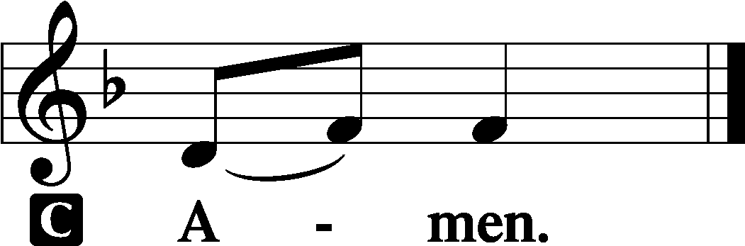
(Sit)
OLD TESTAMENT READING Micah 6:1–8
1Hear what the Lord says:
Arise, plead your case before the mountains,
and let the hills hear your voice.
2Hear, you mountains, the indictment of the Lord,
and you enduring foundations of the earth,
for the Lord has an indictment against his people,
and he will contend with Israel.
3“O my people, what have I done to you?
How have I wearied you? Answer me!
4For I brought you up from the land of Egypt
and redeemed you from the house of slavery,
and I sent before you Moses,
Aaron, and Miriam.
5O my people, remember what Balak king of Moab devised,
and what Balaam the son of Beor answered him,
and what happened from Shittim to Gilgal,
that you may know the saving acts of the Lord.”
6“With what shall I come before the Lord,
and bow myself before God on high?
Shall I come before him with burnt offerings,
with calves a year old?
7Will the Lord be pleased with thousands of rams,
with ten thousands of rivers of oil?
Shall I give my firstborn for my transgression,
the fruit of my body for the sin of my soul?”
8He has told you, O man, what is good;
and what does the Lord require of you
but to do justice, and to love kindness,
and to walk humbly with your God?
A This is the Word of the Lord.
C Thanks be to God.
EPISTLE 1 Corinthians 1:18–31
18The word of the cross is folly to those who are perishing, but to us who are being saved it is the power of God. 19For it is written,
“I will destroy the wisdom of the wise,
and the discernment of the discerning I will thwart.”
20Where is the one who is wise? Where is the scribe? Where is the debater of this age? Has not God made foolish the wisdom of the world? 21For since, in the wisdom of God, the world did not know God through wisdom, it pleased God through the folly of what we preach to save those who believe. 22For Jews demand signs and Greeks seek wisdom, 23but we preach Christ crucified, a stumbling block to Jews and folly to Gentiles, 24but to those who are called, both Jews and Greeks, Christ the power of God and the wisdom of God. 25For the foolishness of God is wiser than men, and the weakness of God is stronger than men.
26For consider your calling, brothers: not many of you were wise according to worldly standards, not many were powerful, not many were of noble birth. 27But God chose what is foolish in the world to shame the wise; God chose what is weak in the world to shame the strong; 28God chose what is low and despised in the world, even things that are not, to bring to nothing things that are, 29so that no human being might boast in the presence of God. 30He is the source of your life in Christ Jesus, whom God made our wisdom and our righteousness and sanctification and redemption. 31Therefore, as it is written, “Let the one who boasts, boast in the Lord.”
A This is the Word of the Lord.
C Thanks be to God.
(Stand)
ALLELUIA AND VERSE LSB 156
HOLY GOSPEL Matthew 5:1–12
P The Holy Gospel according to St. Matthew, the fifth chapter.
C Glory to You, O Lord.

1Seeing the crowds, [Jesus] went up on the mountain, and when he sat down, his disciples came to him.
2And he opened his mouth and taught them, saying:
3“Blessed are the poor in spirit, for theirs is the kingdom of heaven.
4“Blessed are those who mourn, for they shall be comforted.
5“Blessed are the meek, for they shall inherit the earth.
6“Blessed are those who hunger and thirst for righteousness, for they shall be satisfied.
7“Blessed are the merciful, for they shall receive mercy.
8“Blessed are the pure in heart, for they shall see God.
9“Blessed are the peacemakers, for they shall be called sons of God.
10“Blessed are those who are persecuted for righteousness’ sake, for theirs is the kingdom of heaven.
11“Blessed are you when others revile you and persecute you and utter all kinds of evil against you falsely on my account. 12Rejoice and be glad, for your reward is great in heaven, for so they persecuted the prophets who were before you.”
P This is the Gospel of the Lord.
C Praise to You, O Christ.
(Sit)
CHILDREN’S MESSAGE (10:00)
SON OF GOD, ETERNAL SAVIOR LSB 842
SERMON
(Stand)
NICENE CREED
PRAYER OF THE CHURCH
(Sit)
OFFERING
(Stand)
OFFERTORY LSB 159
+ SERVICE OF THE SACRAMENT +
PREFACE LSB 160
P It is truly good, right, and salutary that we should at all times and in all places give thanks to You, holy Lord, almighty Father, everlasting God, through Jesus Christ, our Lord; for what had been hidden from before the foundation of the world You have made known to the nations in Your Son. In Him, being found in the substance of our mortal nature, You have manifested the fullness of Your glory. Therefore with angels and archangels and with all the company of heaven we laud and magnify Your glorious name, evermore praising You and saying:
SANCTUS LSB 161
PRAYER OF THANKSGIVING LSB 161
LORD’S PRAYER LSB 162
THE WORDS OF OUR LORD
PAX DOMINI LSB 163
P The peace of the Lord be with you always.
C Amen.

(Following the prayers, the people may greet one another in the name of the Lord, saying, “Peace be with you,” as a sign of reconciliation and of the unity of the Spirit in the bond of peace (Matt. 5:22–24; Eph. 4:1–3).)
AGNUS DEI LSB 163
(Sit)
I COME, O SAVIOR, TO THY TABLE LSB 618
THY BODY, GIVEN FOR ME, O SAVIOR LSB 619
(Stand)
NUNC DIMITTIS LSB 165
POST-COMMUNION COLLECT
BENEDICTION LSB 166
WHERE CHARITY AND LOVE PREVAIL LSB 845
ACKNOWLEDGMENTS
Divine Service, Setting One from Lutheran Service Book
Unless otherwise indicated, Scripture quotations are from the ESV® Bible (The Holy Bible, English Standard Version®), copyright © 2001 by Crossway, a publishing ministry of Good News Publishers. Used by permission. All rights reserved.
Created by Lutheran Service Builder © 2026 Concordia Publishing House.

A MESSAGE FROM OUR PASTOR
Pastor's Peace
As we work our way through the season of Epiphany, we turn our attention to the ministry and work of Christ as He walks with His disciples. He was always teaching them about His work in restoration and reconciling the world to God. His work on the cross is the final sacrifice for the world's sins. Paul reminds the church at Corinth that the center of his preaching is Christ Crucified. It is a stumbling block to Jews and foolishness to Gentiles. For the people of God, the cross is the gift of salvation.
Pastor
A MESSAGE FROM OUR DISTRICT PRESIDENT
President Rockey and the Executive Staff of the District are excited to partner with you in living as those Compelled by Christ’s Love so that many more may be “added to the number of those being saved. ” (Acts 2:47). Please accept our invitation and join us for our “Circuit-District Partnership Event” Northeast Georgia - Circuit #1 St. Peter Lutheran Church 3460 S. Chestatee Street Dahlonega, GA 30533 March 22, 2026 | 5:30-8:00pm | Dinner Provided. These events are designed to strengthen our partnership, get to know one another and learn more about your District’s Vision and the Ministry Targets. Please see the flyer for more information and sign up in the Gathering Room.
EDUCATIONAL OFFERINGS
Children’s Sunday School 9:00 a.m.-9:45 a.m.
Adult Bible Class 9:00 a.m.-9:40 a.m.
Youth Confirmation Class 11:30 a.m.-12:30 p.m.
Solo Deo Gloria 2nd & 4th Sunday after second service
LWML Saturday, Feb. 7th at 10:00 a.m. in Fellowship Hall.
Tuesday Afternoon Bible Study for Women 2nd and 4th Tuesday of month 11:00-12:00
Tuesday’s Child 2nd & 4th Tuesday 7 p.m. at Malueg home in Watkinsville
Family Bible Study Thursdays 6 p.m.-7p.m. in Fellowship Hall
Raschke’s Fellowship 2nd and 4th Thursday at 7pm at Raschke home in East Athens
Wings and Word Men’s Bible Study one Saturday a month, TBA, 11 a.m. -12:30 p.m .Church Fellowship Hall

