A Call to Action:
Presbyterians Witness in Washington
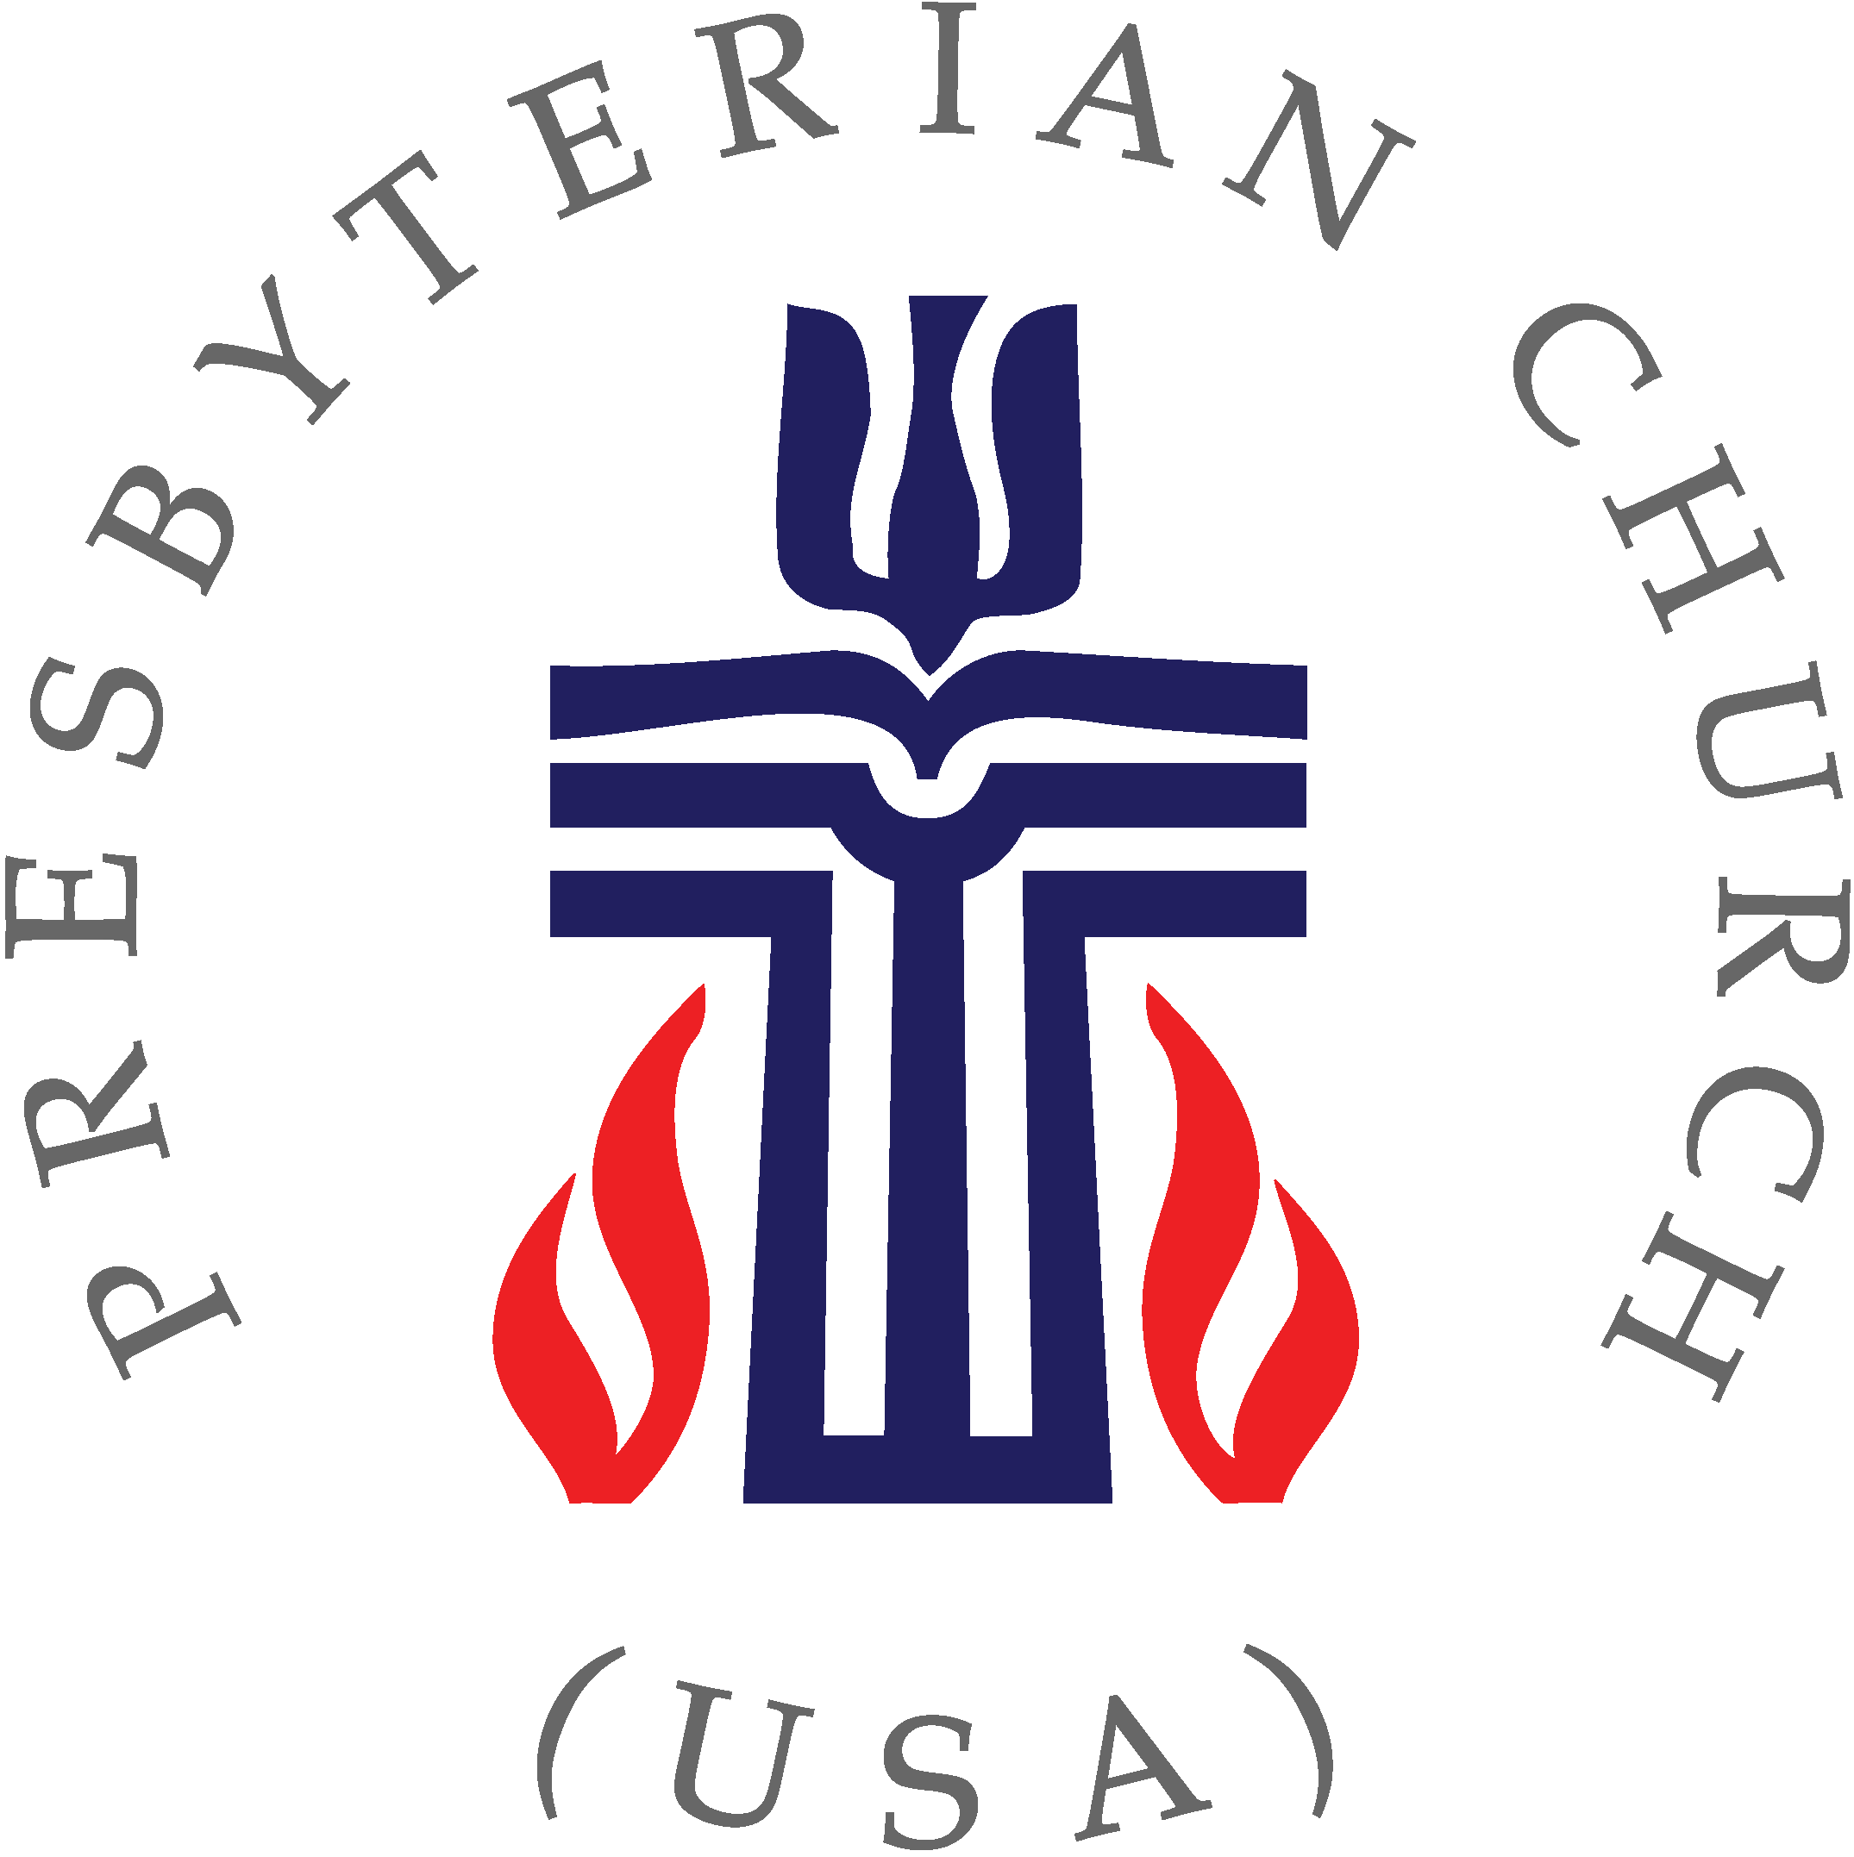

September 12, 2017
Now more than ever your voice is needed in the nation’s capital! As our political leaders move to pass policies that would devastate the most vulnerable – both in our own country and abroad, it is critical that we speak truth to power.

Come to Washington to demand a
Faithful Budget!
9:00: Briefing
11:30: Press Conference
12:30 – 3:30: Meetings with Congressional Offices
3:30: Closing Worship and Debriefing

Click HERE to RSVP
(https://docs.google.com/forms/d/e/1FAIpQLSec_Et8inMR3tlq4wKxF6FlTzRiYr8IwrNS7OYXOTkrjkrkGQ/viewform)
Live Streaming on OPW Facebook page
Save the Date!
Advocacy Training Weekend
April 20-23, 2018
Compassion Peace and Justice Training Day – April 20
Ecumenical Advocacy Days – April 20-23

