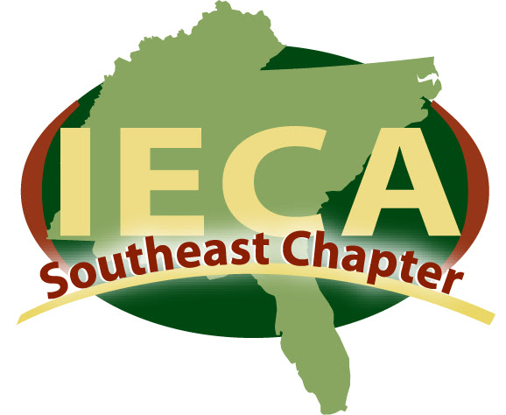

2022 Ted Sherrod Industry Professional Scholarship Application

Purpose:
The purpose of the Ted Sherrod Industry Professional Scholarship is to provide a full conference scholarship for industry professionals to attend the 2022 IECA Annual Conference and Expo from February 15-18. Recipients of the scholarship can use the funds for the full cost of full conference registration. Please fill out the questions below and review/submit the appropriate materials.

Criteria (all applicants must):
- Be an IECA Southeast Chapter member. To join, visit https://www.ieca.org/benefits
- Be an industry professional

Attach:
- Resume
- Documentation of employment in the field of erosion/sedimentation control

Deadlines:
- Submit complete application via email no later than Thursday, January 7, 2022
- Scholarship recipients will be notified no later than Thursday, January 14, 2022

Contact Information:
Name:___________________________________________
Company:________________________________________
Phone:___________________________________________
Email:____________________________________________
Submit information to:
David Snider, Southeast Chapter Vice-President: david@LMES.us
Questions:
(Please answer in space provided, attach additional pages if needed)

Why do you want to attend IECA’s Annual 2022 Conference?

How long have you been an IECA member and what is the biggest benefit you get out of your IECA membership?

How long have you been in the industry and what is one of your most significant professional accomplishments?

