Elizabeth M. Prior is a senior at Auburn University studying civil engineering with a focus in water resources. In high school, she became interested in water resources while completing her Girl Scout Gold Award on assessing Parkerson Mill Creek for chemical and bacteriological parameters with Alabama Water Watch and the Auburn University Water Resources Center. Wanting to continue learning about water resources she decided to study civil engineering at Auburn University since it provided a practical degree that could lead to industry or research. She is an active member of the Auburn University Engineers Without Border chapter, having acted as the water quality specialist and design lead. Through these roles she has traveled to Rwanda twice to test water for E. coli and build a water pipeline for a rural community in Mwendo, Rwanda. She has also worked as a research assistant at the Auburn University Erosion and Sediment Control Testing Facility (AU-ESCTF), while also assisting graduate students in water testing to investigate secondary wastewater spray field breaches in Uniontown, Alabama and stream restoration resiliency in Lanett, Alabama.
Off campus, she has interned with the U.S. Army Corps of Engineers at Fort Carson in Colorado Springs, Colorado. While there, she participated in the development of the 4th Combat Aviation Brigade helicopter hangars and pre-installation assessment for the water distribution system and fire suppression system for Cheyenne Mountain Air Force Base. She interne at Oak Ridge National Laboratory within the environmental sciences division. Her internship focused on constructing a GIS database of fish passageways through dams in North America. She was also chosen to participate in the Texas A&M Costa Rica Research Experience for Undergraduates (REU) funded through the National Science Foundation. Through this REU, she conducted unmanned aerial vehicle (UAV) atmospheric profiling to assess the boundary layer over a montane forest and land development in Costa Rica. Through this research, she became interested in how UAVs could be used in water resources research.
She is currently an Auburn University Undergraduate Research Fellow. Through this funding, she is investigating if total suspended solids and turbidity of a creek can be measured through multispectral imagery taken from an UAV. Testing and sampling have been done at the AU-ESCTF and at a recently restored reach of Moores Creek in Lanett, Alabama. After graduation in August, she will be starting her PhD program at Virginia Tech within the Remote Sensing Interdisciplinary Graduate Education Program and in the Biological Systems Engineering Department. She hopes to continue researching UAV and satellite remote sensing pertaining to water quality and other environmental applications.
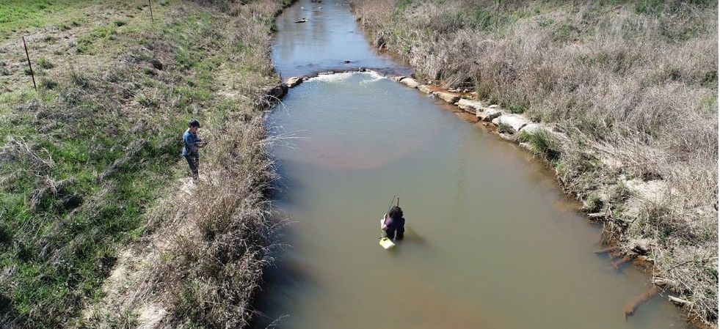
Elizabeth collecting water samples at Moores Creek for undergraduate research study
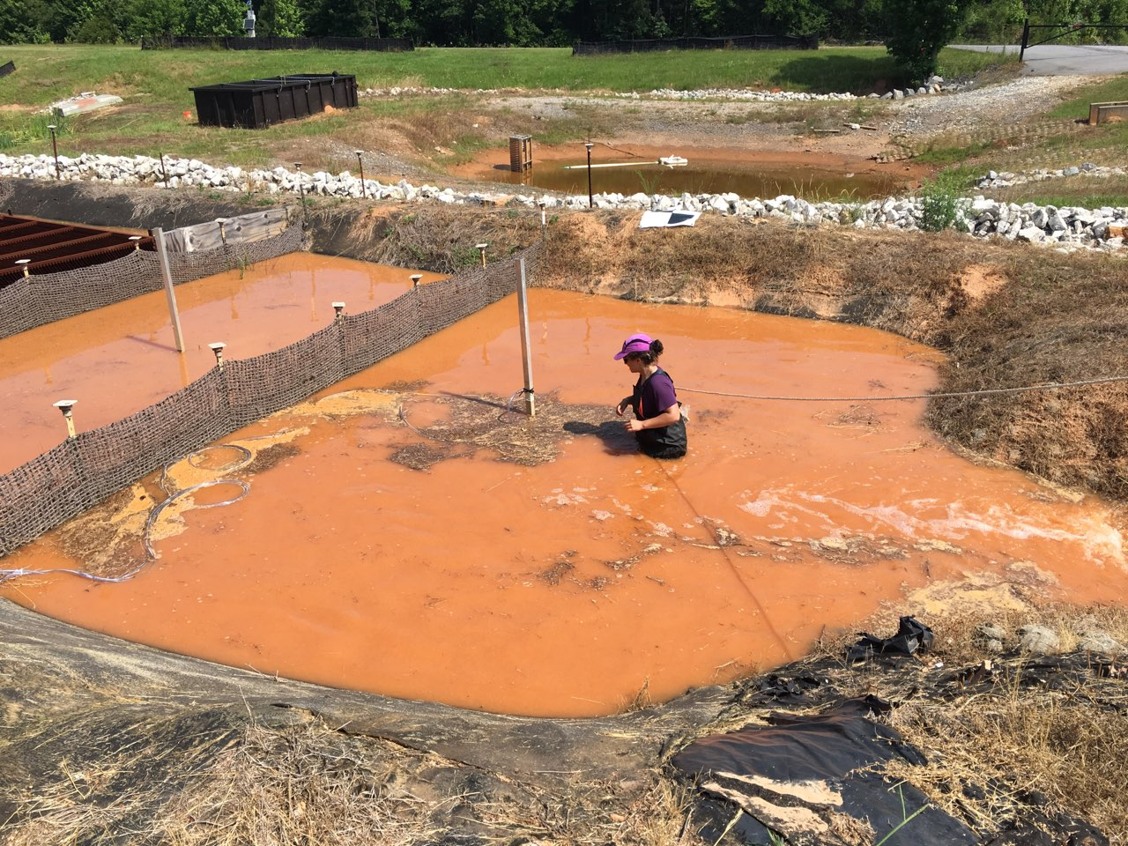
Elizabeth adjusting an automatic water sampler’s intake at the AU-ESCTF during a sediment basin experiment for her undergraduate research study
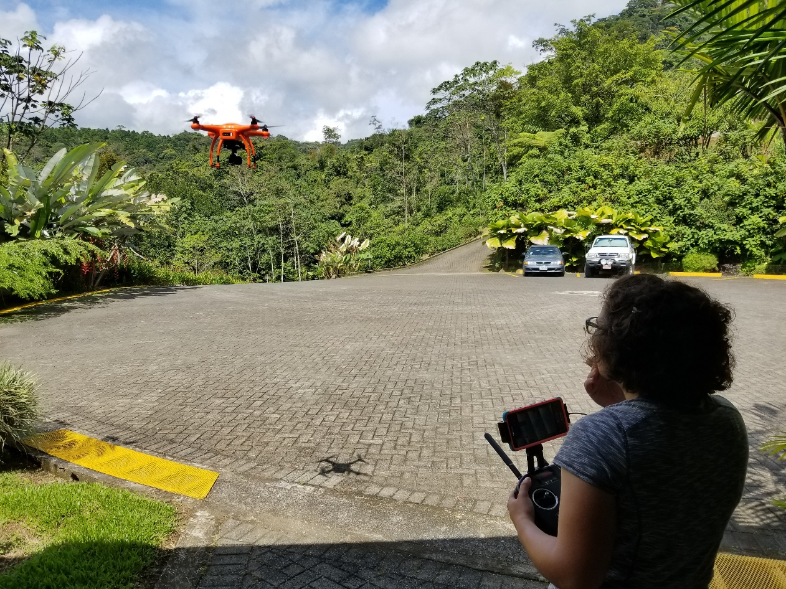
Elizabeth flying a UAV at the Texas A&M Soltis Center in Costa Rica
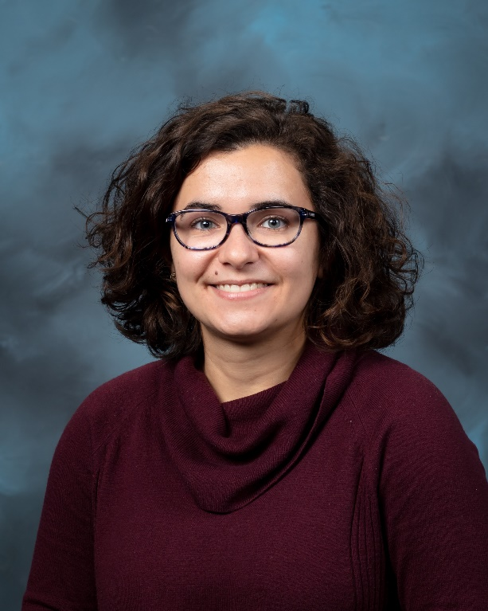
Headshot

