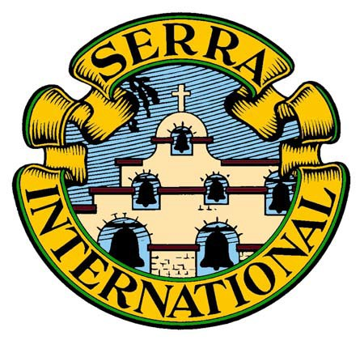

The USA Council of Serra International

About the Programs Committee & Manuals
“Pray, therefore, the Lord of the harvest to send out laborers into his harvest.” (Mt. 9:38)

About the Programs Committee & Manuals

Program Committee of the US Council of Serra International: “The Programs Committee shall study and recommend ways and means to help Serrans to recognize and respond to God’s call to holiness. By promoting fellowship, prayer, and continuing Catholic education, the Programs Committee seeks to better prepare Serrans to fulfill their Christian vocation to service, especially in the Serran mission and ministry. The Vice President of Programs shall be responsible for this committee.” (USA Council Bylaws, Article VI, Section 4)
Invitation to Join the Programs Committee: The committee meets via conference call on the first Monday of each even numbered month at 7:15 pm Central Time. Club Program Vice Presidents are encouraged to join the call as a way to provide input, gain ideas, and become inspired. In addition to club leaders, all Serrans are welcome.

Manual Resources: Your USA Programs Committee has developed two manuals for use by the clubs: Program Manual for Vice Presidents and Meeting Programs—A Call to Holiness. These are presented here in Portable Document Format (PDF). The Adobe Acrobat Reader software is required to view and print PDF files. It is free and can easily be downloaded from the internet.

Programs Vice President Manual: The Programs Vice President Manual is a comprehensive guide for the club Vice President of Programs and his/her committee. Reading through it at the beginning of the year can save a lot of time by not “reinventing the wheel” and will get the club Program Committee off to a solid start. Many additional resources are included therein but if the club finds others, we hope it will share its successes with our USA Council Programs Committee.

Meeting Programs—A Call to Holiness: Serrans are seeking programs directed towards increasing their personal holiness and faith development. Meetings Programs—A Call to Holiness was developed for this purpose. In consists of faith enhancing topics that include: Introductions, biblical readings, prayers, reflections, discussion questions and bibliographies. This manual also outlines the Program Process. These suggested club programs are designed to help the club Programs Vice President and Committee, together with the club Chaplain, in planning the club programs. This topics are designed to assist the presenter in organizing the presentation - be it priest, deacon, religious order member, or Serran. A Suggested Club Program Planning Calendar may be found at the end of this manual.

Other Resources:
The Church Liturgical Calendar & Serran Programs is published along with recommended programs from the Meeting Programs—A Call to Holiness manual with the page numbers referenced. The Programs Committee will maintain the calendar and advance it as we move through the Church year.

Workshop for Training Program Vice Presidents is an effective resource for training Program Vice Presidents at a District Workshop, Convention, or a one-on-one orientation.

We hope you find these suggested program ideas interesting and easy to use. Good programs are invaluable for increasing member awareness of the richness of their Catholic heritage and adding to their personal sanctification, all leading to greater zeal as advocates for priestly and religious vocations.

Additional materials in support of these programs may be found in the Serra Merchandise Catalog. Questions, comments and new program theme ideas are welcome.

