PRIESTHOOD SUNDAY
SUGGESTIONS FOR PARISHES AND SCHOOLS
Compiled by the St. Serra Club of Louisville
Last updated 8/20/26

Priesthood Sunday is a special day set aside for Catholics to thank, affirm and share their love and support for our priests. It is celebrated on the last Sunday of September each year and has been promoted primarily by the USA Council of Serra International (SI) and the Worldwide Marriage Encounter.

Please forward this to the appropriate people in charge of Masses, Prayers of the Faithful, parish bulletins, parish school activities, children’s activities, and youth group activities.

- FOR BULLETINS
  - The week prior to Priesthood Sunday, consider a bulletin announcement like one of the following. Simply copy and paste the one you like.
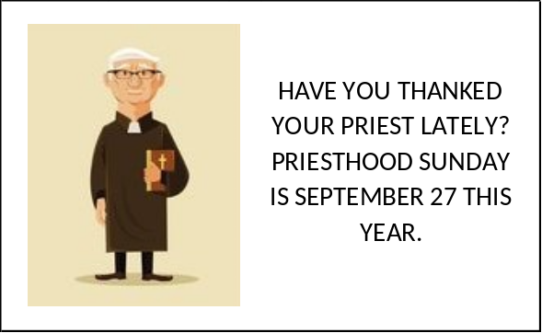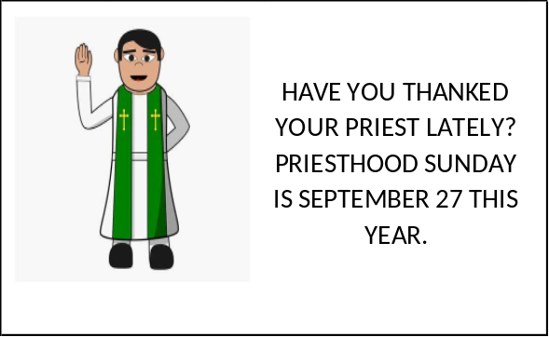

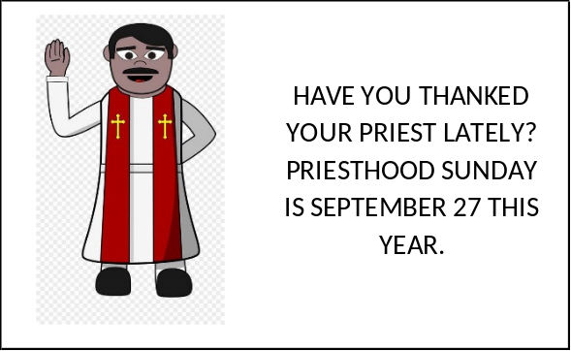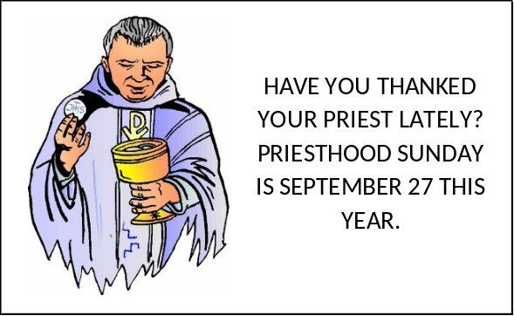

  - On Priesthood Sunday, feature a photo of your pastor and resident priests on the cover of the parish bulletin along with some words of tribute collected from parishioners and a brief bio inside.
  - Include a biography of your priest in the bulletin.
  - See more ideas in part (D) below.

- FOR MASSES
  - Prayers of the Faithful – At Mass, you could use one or more of the following petitions:
    - For all priests who are ordained to serve our Church, that their ministry may be fruitful and appreciated by the people whom they serve, we pray to the Lord.
    - For the gift to our parish, of vocations to the ordained priesthood, that good men may be drawn to love and to serve the People of God, we pray to the Lord.
    - For retired priests, that they may experience God’s abundant love as they walk a new path of prayer and servanthood in retirement, we pray to the Lord.
    - For Father ____________, in his ministry to the faithful of (parish name), that we may affirm, support, and celebrate his gift of service to us, we pray to the Lord.
    - That we may never take the presence of our priests for granted, as we cherish the celebration of the Mass and are nourished by the Eucharist, we pray to the Lord.
    - For all priests who struggle with loneliness, declining health, or loss of mobility, that they may be comforted by the grace of the Holy Spirit, we pray to the Lord.
    - That this parish family may always embrace our priest(s) and sustain his (their) ministry by our love, our constant prayer, and our trust in his leadership, we pray to the Lord.
    - For priests who now sleep in the peace of the resurrection, and for those who may die this year or this day, that God may lead them gently into their eternal reward, we pray to the Lord.
  - Print a special prayer for your priests in the parish bulletin or on cards distributed in the pews. Have the congregation extend their hands over the priests and recite the prayer in unison at the end of the service on Priesthood Sunday. Some of the Prayers of the Faithful above would make good blessings.
  - Coordinate a coffee cake reception following Masses.
  - Have everyone sign a BIG card for your priest. Your parish may be so large that each Mass has its own BIG card.
  - See more ideas in part (D) below.

- FOR SCHOOLS, PARISH CHILDREN, AND YOUTH GROUPS
  - Children could write letters of appreciation to their priest(s).
  - Free greeting cards, which can be printed and completed by individual students, can be found at https://serraspark.org/wp-content/uploads/2019/01/priesthood-sunday-kids-resources.pdf
  - If your parish has a school, part of religion classes leading up to Priesthood Sunday could be devoted to learning about priesthood: for example, the vestments, the priest’s role in the sacraments, etc. Younger children could benefit from free coloring pages found online at
https://www.thecatholickid.com – at the top, click “Free Coloring Pages.”
  - See more ideas in part (D) below.

- MANY MORE IDEAS
Many more ideas can be found at the following websites.
  - For the Serra International recommendations in the Serra Promotion And Resource Kit (S.P.A.R.K.), click
https://serraspark.org/tools-new/priesthood-sunday/ - scroll to the bottom for “Resources.
  - https://saintmichaelusa.org/priesthood/
  - For info from VocationMinistry.com, click
https://vocationministry.com/parish-3/phase-i/#phase-i-2-8
and
https://www.vocationministry.com/vocation-day/vocation-days/priesthood-sunday/
  - Free religious clip art –
https://legacy.diocesan.com/product-category/free-clip-art/
or
https://stock.adobe.com/search/images?k=catholic%20church%20clipart&ef_id=87c286835bab18f21554ec055eafa8c1:G:s&s_kwcid=AL!3085!10!79371205593400!!!!2331170809744468!!506175911!1269937580510905&as_channel=sem&as_campclass=nonbrand&as_campaign=US_CPRO_STOCK_NONBRAND_ROI_CORE_DSA_STOCK_na_CROSS_DSA_na_BNG_EN&as_source=bing&as_camptype=acquisition&sdid=LZ32SSQD&mv=search&mv2=paidsearch&as_audience=core
  - Nineteen ways to let your priest know you appreciate him
https://focusequip.org/19-ways-to-let-your-parish-priest-know-you-appreciate-them/
  - More bulletin announcement ideas
https://serraspark.org/wp-content/uploads/2019/01/Priesthood-Sunday-Bulletin-Announcements.pdf
  - Spiritual Bouquets and prayers
    - https://files.constantcontact.com/c2cd08cd001/b4b98fd4-2d54-4af2-b17e-38a781fd5001.pdf?rdr=true
    - https://files.constantcontact.com/c2cd08cd001/bdcb8e28-d579-4765-b166-7ae9623f75d6.pdf?rdr=true
    - https://files.constantcontact.com/c2cd08cd001/da3718c4-6ed9-4e47-939f-64795beef119.pdf?rdr=true
    - https://files.constantcontact.com/c2cd08cd001/318f59dc-c763-460a-abd0-9c91041fdc9a.pdf?rdr=true
    - https://files.constantcontact.com/c2cd08cd001/79b84cb8-80b8-4b1c-8c6b-2249a4098ee2.pdf?rdr=true
    - https://www.vocationministry.com/parish-resource/parish/phase-ii/prayer/spiritual-bouquets/

- A PRAYER FOR OUR PRIESTS
We thank you, God our Father, for those who have responded to your call of priestly ministry. Accept this prayer on their behalf. Fill your priests with the sure knowledge of your love. Open their hearts to the power and consolation of the Holy Spirit. Lead them to new depths of union with your Son. Increase in them profound faith in the Sacraments they celebrate as they nourish, strengthen and heal us.
Lord Jesus Christ, grant that these, your priests, may inspire us to strive for
holiness by the power of their example, as men of prayer who ponder your word and follow your will.
O Mary, Mother of Christ and our mother, guard with your maternal care these chosen ones, so dear to the Heart of your Son. Intercede for our priests so that, offering the Sacrifice of your Son, they may be conformed more each day to the image of your Son, our Lord and Savior, Jesus Christ. Amen.
St. John Vianney, universal patron of priests, pray for us and our priests.

- SCRIPTURES ON PRIESTS AND THE PRIESTHOOD
  - … like living stones, let yourselves be built into a spiritual house to be a holy priesthood to offer spiritual sacrifices acceptable to God through Jesus Christ. - 1 Peter 2:5
  - Keep watch over yourselves and over the whole flock of which the holy Spirit has appointed you overseers, in which you tend the church of God that he acquired with his own blood. - Acts 20:28
  - … the priest is holy to his God. - Leviticus 21:7
  - I will choose a faithful priest who shall do what I have in heart and mind. I will establish a lasting house for him and he shall serve in the presence of my anointed forever. - 1 Samuel 2:35
  - We have therefore appointed you today to be high priest of your nation; you are to be called the King’s Friend, and you are to look after our interests and preserve friendship with us. - 1 Maccabees 10:20
  - You are a priest forever in the manner of Melchizedek. - Psalm 110:4
  - Honor God and respect the priest; give him his portion as you have been commanded ... - Sirach 7:31
  - For a priest’s lips preserve knowledge, and instruction is to be sought from his mouth, because he is the messenger of the LORD of hosts. - Malachi 2:7
  - The priests ... shall come forward, for the LORD, your God, has chosen them to minister to him and to bless in the name of the LORD ... - Deuteronomy 21:5
  - “We give thanks to God always for all of you, remembering you in our prayers, unceasingly calling to mind your work of faith and labor of love and endurance in hope of our Lord Jesus Christ, before our God and Father, knowing, brothers loved by God, how you were chosen.” - 1 Thessalonians 1:2-4

- THE BEAUTIFUL HANDS OF A PRIEST
We need them in life's early morning,
We need them again at its close;
We feel their warm clasp of friendship,
We see them when tasting life's woes.

At the altar each day we behold them,
And the hands of a king on his throne
Are not equal to them in their greatness;
Their dignity stands all alone.

And when we are tempted and wander
To pathways of shame and sin,
It's the hand of a priest that will absolve us –
Not once, but again and again;

And when we are taking life's partner,
Other hands may prepare us a feast,
But the hand that will bless and unite us
Is the beautiful hand of a priest.

God bless them and keep them all holy
For the Host which their fingers caress.
When can a poor sinner do better
Than to ask Him to guide thee and bless?

When the hour of death comes upon us
May our courage and strength be increased,
By seeing raised over us in anointing
The beautiful hands of a priest. - author unknown

