The Call to Mission!
“By Baptism we share in the priesthood of Christ, in His prophetic and royal mission…” - CCC1268
At Confirmation, we receive the Holy Spirit to strengthen us in our mission.
Eucharistic celebrations renew us for that mission.
What mission is that exactly or to what are we being called to? – A call to holiness! “He who called you is holy, be holy yourself... Be holy because I Am holy”. – 1 Pt. 1: 15
The Apostolic Exhortation of Pope John Paul II (Saint JP II), Christifideles Laici (1988) – underlines every Christian’s call to holiness. “We come to a full sense of the dignity of the lay faithful if we consider the prime and fundamental vocation that the Father assigns to each of them in Jesus Christ through the Holy Spirit: the vocation to holiness, that is, the perfection of charity. Holiness is the greatest testimony of the dignity conferred om a disciple of Christ.”
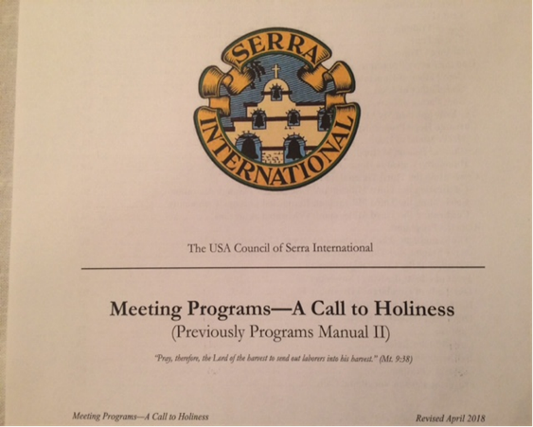
To encourage and sustain every step that we make toward that call to holiness the USA Council of Serra International Program Committee has developed Meeting Programs – A Call to Holiness. The programs are designed to help the club Programs Vice-President together with the Chaplain and President in planning the club programs. Each program topic has an outline which can easily be presented either by your priest, deacon, religious order member, or fellow Serran.

If your club has not utilized the Meeting Programs, you may consider starting with this proposed glide path:
- Prayer: A Path to Vocational Call. Prayer is necessary to discern a vocation, the very act of praying leads to who God created us to be. Pages 82 to 85.
- God the Father Programs. Offer a good in sight and reflection to knowing God as Father of humankind, Father of Jesus, and Father of Love. Pages 35 to 40.
- The Holy Spirit in My Life. Answer the question – how does the Holy Spirit work in my life? Pages 41 to 43.
- Christian Hope Programs. Present Mary as a model of hope through whom we all experience our call to holiness. The Church as the beacon of hope reminds us of our responsibility to spread hope by making visible the love of God in the world. Pages 44 to 49.
- The Beatitudes. Understanding the structure and wisdom of the Beatitudes is to grasp an understanding of blessedness or holiness. Pages 77 to 79.
- Mission and Ministry Programs. We put skin on the lessons learned from the previous five topics. By integrating them in the mission and ministry of Jesus, of the Church, of priesthood, religious life, and mission and ministry of Serra International, and a Serran. Pages 6 to 20.
The Meeting Programs include Liturgical Programs from Advent to Ordinary times that your club can use to enter more deeply into the beauty of each liturgical season. Pages 21 to 32.
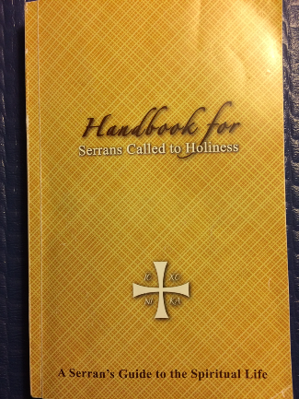
Another good source of meeting programs is the Handbook for Serans Called to Holiness.
In pages 25 to 26 is the Five Biblical Steps on how to Grow in being One with Jesus is a great start in perusing this Serran’s guide to the spiritual life.

The goals and objectives of USAC Programs Committee are to:
- Prepare meeting programs like A Call to Holiness
- Retain membership through information, formation, and fellowship
- Offer program materials that are…
- God centered to enhance our own call to holiness and communion
- Review, or re-align program materials as needed to meet membership needs
- Always forward thinking to be…
- Mission driven and…
- Service oriented to support Vocations, Membership, Communication, and Leadership pillars.
Here is another call for you – join the Programs Committee! If interested give us a phone call, text, or e-mail:
- Betty Ramirez-Lara - Vice-President 956-683-5706 / bettyuseusa@gmail.com
- John Osterhart - Chair 616-245-1893 / ejost1@att.net
- Katie Radford - Member 816-520-2154 / katieradford@comcast.net
- Barbara Meehan - Member 901-836-7475 / brmeehan37@gmail.com
- Morie Ratuiste - Member 509-845-6995 / kgrmamacfc@aol.com
Siempre Adelante, nunca retroceder. May God grant us the grace to always go forward, never back for His glory!
Through Jesus with Mary, and Joseph.

