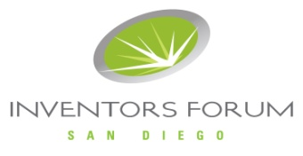

SDIF 2018 INVENTION CONTEST
Entry Form
Please return completed form to: sdif.contest@gmail.com

Thank you for entering SDIF 2018 Invention Contest and showing us the future!
One category: Best New Consumer Product
Finalists will be offered tables to exhibit for free!

Name:____________________________________

Email:____________________________________

Invention name:___________________________

Area:_________________________________

Patent status:_________________________________

Brief description:_______________________________________________
_____________________________________________________________

The following describes the Terms & Conditions for the competition:
NOTE: All entries must be Patented or Patent Pending!

Date: Thursday, October 11th

Entry Fee: $20
Either pay at September 13th meeting or send check payable to SDIF and mail to:
SDIF
1195 Linda Vista Dr. Ste C
San Marcos, CA 92078

Location: AMN Healthcare Inc.
Del Mar Heights
12400 High Bluff Drive,
San Diego, CA 92130

Time: 6:30PM - 9:00PM – Please plan on arriving by 6:00 PM.

Time Allotted: 8 minutes. Inventors should plan on presenting for around 5 minutes and answering some audience questions during the remaining minutes.

I accept these Terms and Conditions: ____________________________

Date:______________

