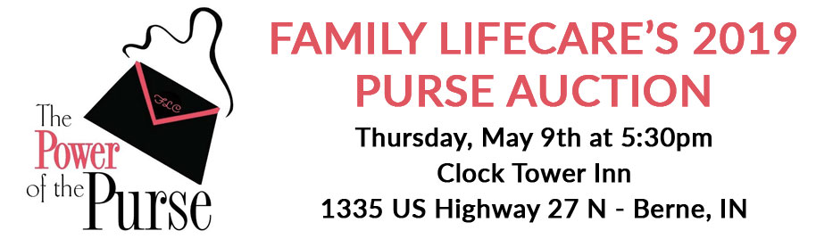

**[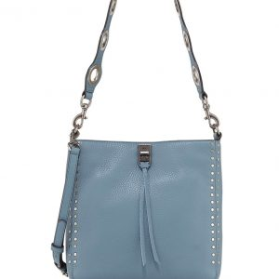](https://familylifecarein.org/product/p3-rebecca-minkoff-darren-small-feed-deerskin-leather-crossbody-bag/)Contact Family LifeCare 1-800-355-2817 or visit** [**www.FamilyLifeCareIN.org**](http://www.FamilyLifeCareIN.org) **to RSVP.**

[[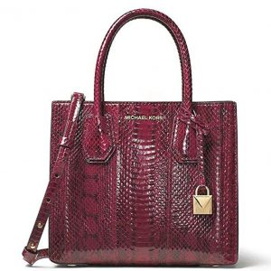](https://familylifecarein.org/product/p2-michael-michael-kors-mercer-medium-snakeskin-crossbody/)[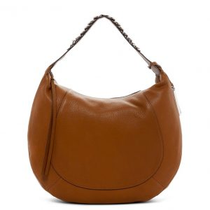](https://familylifecarein.org/product/p1-vince-camuto-cayle-leather-hobo-bag/)](https://familylifecarein.org/product/p2-michael-michael-kors-mercer-medium-snakeskin-crossbody/)

[P3 – Rebecca Minkoff – Darren Small Feed Deerskin Leather Crossbody Bag](https://familylifecarein.org/product/p8-coach-coach-x-selena-gomez-bond-colorblock-leather-bag/)

[P1 – Vince Camuto – Cayle Leather Hobo Bag](https://familylifecarein.org/product/p8-coach-coach-x-selena-gomez-bond-colorblock-leather-bag/)

[P2 – Michael Kors – Mercer Medium Snakeskin Crossbody](https://familylifecarein.org/product/p8-coach-coach-x-selena-gomez-bond-colorblock-leather-bag/)

[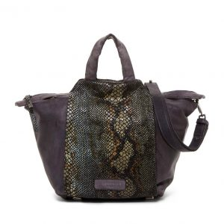](https://familylifecarein.org/product/p4-liebeskind-berlin-baraka-tumbled-snake-print-leather-top-handle-bag/)[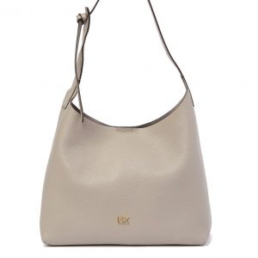](https://familylifecarein.org/product/p5-michael-michael-kors-junie-medium-leather-hobo-bag/)

[[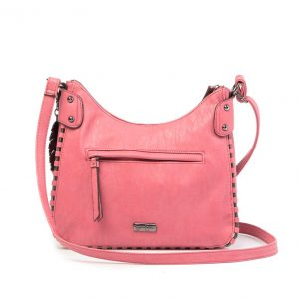](https://familylifecarein.org/product/p6-jessica-simpson-selena-crossbody/)](https://familylifecarein.org/product/p9-cole-haan-esme-leather-bucket-bag/)

[P5 – Michael Kors – Junie Medium Leather Hobo Bag](https://familylifecarein.org/product/p11-marc-jacobs-empire-city-messenger-leather-crossbody-bag/)

[P6 – Jessica Simpson – Selena Crossbody](https://familylifecarein.org/product/p11-marc-jacobs-empire-city-messenger-leather-crossbody-bag/)

[P4 – Liebeskind Berlin – Baraka Tumbled Snake Print Leather Top Handle Bag](https://familylifecarein.org/product/p11-marc-jacobs-empire-city-messenger-leather-crossbody-bag/)

[[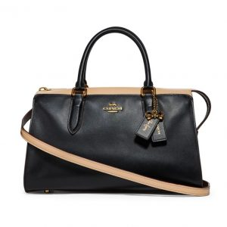](https://familylifecarein.org/product/p8-coach-coach-x-selena-gomez-bond-colorblock-leather-bag/)[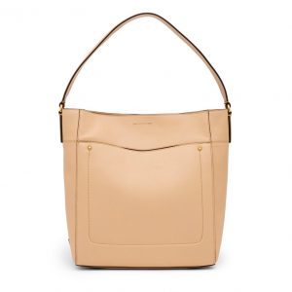](https://familylifecarein.org/product/p9-cole-haan-esme-leather-bucket-bag/)[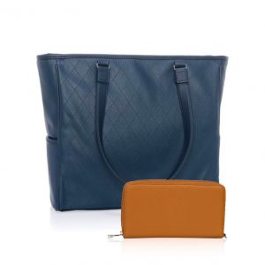](https://familylifecarein.org/product/p7-thirty-one-cindy-tote-ltd/)[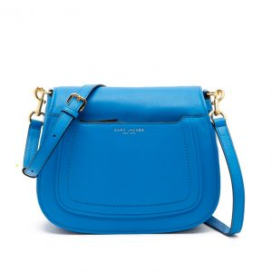](https://familylifecarein.org/product/p11-marc-jacobs-empire-city-messenger-leather-crossbody-bag/)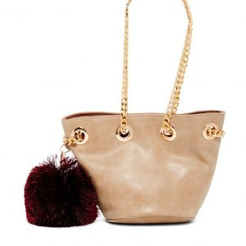](https://familylifecarein.org/product/p11-marc-jacobs-empire-city-messenger-leather-crossbody-bag/)

[P7 – Thirty-One – Cindy Tote Ltd with wallet](https://familylifecarein.org/product/p11-marc-jacobs-empire-city-messenger-leather-crossbody-bag/)

P8 – COACH – Selena Gomez Colorblock Leather Bag

P9 – Cole Haan – Esme Leather Bucket Bag

P10 – Deux Lux – Kiki Mini Bucket Bag

P11 – Marc Jacobs – Empire City Messenger Leather Crossbody Bag