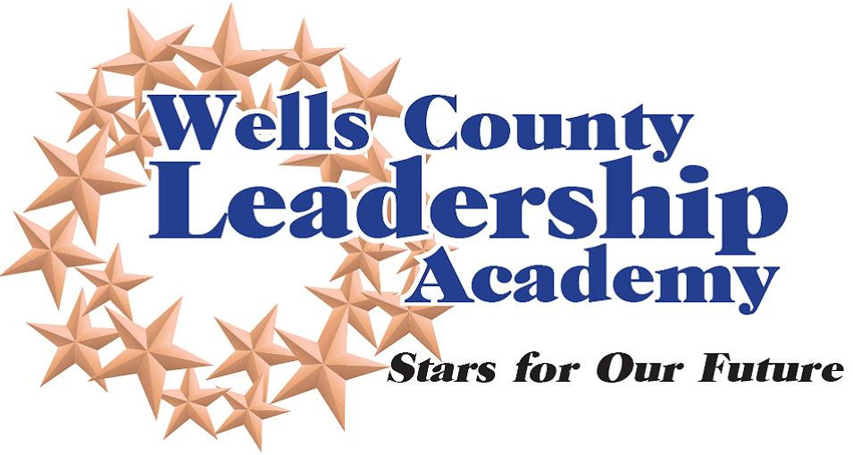

Our mission: The Wells County Leadership Academy will develop, cultivate and enhance

leadership skills for individuals in our community.
2021-2022 Year

Application for Participation
WCLA Level 1
Cost: $700
Instructions:
- Please complete each section in full
- Print in black ink or type
- Limit answers to space provided
- Send completed applications by June 11, 2021 to:
Wells County Leadership Academy, c/o Wells County Chamber of Commerce
211 W. Water St., Bluffton, IN 46714

Acceptance notification letters will be mailed the week of July 26, 2021.

Personal Data
Name Mr. Ms. ____________________________________________________________
Address ________________________________________________________________________
Phone (h) E-mail Address (h) _________________________________________
Cell Number: __________________________________________________________________________
Years of work or residency in Current County _____________________________________________

Employment
Employer Occupation _______________________________________
Address ________________________________________________________________________
Phone (w) E-mail Address (w) __________________________________
Name of immediate supervisor _______________________________________________________

Education
Highest level of education: High School College Some College

Community Involvement
Please list organizations in which you are involved, your responsibilities, and the length of time you have participated.
If you are not currently involved in community activities, please list areas of interest.
_____________________________________________________________________________________
_____________________________________________________________________________________
______________________________________________________________________________

What do you consider to be your most meaningful community service responsibility to date?
_____________________________________________________________________________________
_____________________________________________________________________________________
______________________________________________________________________________

General Information
What do you hope to gain from participation in WCLA and how do you expect to utilize your experience?
_____________________________________________________________________________________
_____________________________________________________________________________________
______________________________________________________________________________

Check the category which best describes the area in which you presently work/serve:
Corporate/Large Business Law Education
Finance Government Healthcare
Small Business Community/Non-profit Other

Scholarship Availability
Corporate and community support makes it possible for the WCLA to offer a limited number of partial scholarships. These are generally for partial tuition and awarded to those most in need. Acceptance into the program is not dependent upon source of tuition.

For individuals in an Agriculture related industry, there is a special scholarship that may be available.

All scholarship applications are available upon request. Please contact Erin Prible at eprible@wellscoc.com or
(260) 824-0510 for further information.

Commitment
Attendance at each session is imperative to the successful completion of the WCLA. Participants who accrue more than two absences must meet with the Facilitator, who will make a determination regarding the participant’s ability to successfully complete the program. The WCLA (session one) will commence on September 8, 2021. No tuition refunds will be granted following September start date. If selected as a participant, I agree to attend the program sessions, complete assignments as required and participate in any project. WCLA Level 1 will meet the second Wednesday of each month (September – May) from 8 a.m. – 12 p.m.

Signature Date ____________________________

Business or Organization Commitment (if applicable)
This candidate has my full support to participate in WCLA. I am aware of the time commitment involved, as well as the financial obligation. The WCLA (session one) will commence on September 8, 2021. No tuition refunds will be granted following that date.

Signature ____________ Date ______________________
Name ____________ Title ______________________
Company/Organization ___________________________________________________________________
Supervisor Email Address _________________________________________________________________

Level 1 of the Wells County Leadership Academy contains six Habitudes plus supplementary sessions to further enhance learning. An additional six Habitudes and other topics are continued in Level 2.

