U.S. Manufacturing Is in Retreat and Trump’s Tariffs Aren’t Helping
Levies on imports were supposed to bring back a golden age of U.S. manufacturing. They haven’t worked, so far.
By David Uberti
Feb. 2, 2026 9:00 pm ET
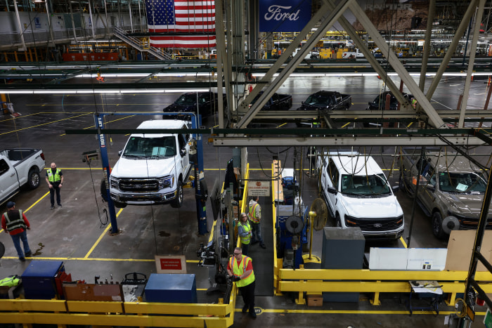Auto and chip makers have cut tens of thousands of workers over the past year. Evelyn Hockstein/Reuters
The manufacturing boom President Trump promised would usher in a golden age for America is going in reverse. After years of economic interventions by the Trump and Biden administrations, fewer Americans work in manufacturing than any point since the pandemic ended.
Manufacturers shed workers in each of the eight months after Trump unveiled “Liberation Day” tariffs, according to federal figures, extending a contraction that has seen more than 200,000 roles disappear since 2023.
An index of factory activity tracked by the Institute for Supply Management shrunk in 26 straight months through December, but showed a January uptick in new orders and production that surprised analysts. The Census Bureau estimates that manufacturing construction spending, which surged with Biden-era funding for chips and renewable energy, fell in each of Trump’s first nine months in office.
The gradual slowdown is in some ways a continuation of decadeslong trends that pulled factory jobs overseas and helped empty out Midwestern cities. In an industry where capital plans and construction timelines extend years into the future, turnarounds also don’t happen overnight.
In November, the Federal Reserve slashed estimates for overall U.S. output since the pandemic in an annual revision to metrics for industrial production.
“We never got all the way back” from the pandemic, said Josh Lehner, a U.S. economist at SGH Macro Advisors.
While auto and chip makers have cut tens of thousands of workers over the past year, stable layoff rates across the sector suggest that the jobs pullback is gradual.
Lehner and other economists also say there are signs output has stabilized, if not inched higher, though gains in efficiency could limit the number of new jobs. A White House spokesman noted that manufacturing productivity ticked upward in recent quarters and that workers’ wage hikes outpaced inflation over the past year.
In the long term, tariffs could achieve their desired effect of making some manufacturers more competitive with overseas producers. Economists believe lower interest rates and deregulation could also provide support. But in the shorter run, tariffs have boosted many companies’ costs on materials sourced abroad, pushing firms that buy foreign parts to raise prices or scramble for supplies.
The White House’s stop-and-start policymaking—Trump threatened new tariffs on Europe, Canada and South Korea in recent weeks—has also led to what many executives view as a lost year for investment. The possibility the Supreme Court could nullify some import taxes has added to the uncertainty.
At the same time, China and others have continued pumping out exports despite tariffs, pushing down prices in global markets where U.S. manufacturers are struggling to compete.
“There’s very little in our product portfolio that has benefited from tariffs,” said H.O. Woltz III, chief executive of North Carolina-based Insteel Industries.
With tariffs on foreign steel doubled to 50% this year, Insteel has increasingly struggled to get from U.S. suppliers the metal it shapes into wire that reinforces concrete infrastructure, such as the Gordie Howe bridge, a major trade crossing that will soon connect Detroit to Canada. Instead, Insteel has at times turned to tariffed imports from Algeria, India and elsewhere when there weren’t enough American supplies to go around.
“Our growth today could be compromised by the dearth of [domestic] raw material available to us,” Woltz said.
In the trucking industry, a yearslong postpandemic slide has dinged firms such as metal-component maker NN. The Charlotte, N.C.,-based company, which runs 23 plants in six countries, trimmed its U.S. workforce in recent years to compete with low-cost factories abroad, as well as in response to slowing growth in electric-vehicle demand.
CEO Harold Bevis believes tariffs will ultimately benefit NN by curbing Chinese competition for precision parts that appear in steering systems, audiovisual controls and more. But meanwhile, import taxes have helped push up costs for steel and aluminum, adding to pressures from soaring market prices for the gold and silver NN uses in some products.
That has squeezed how much cash the firm has to invest in new, potentially lucrative sectors such as data centers and electrical equipment.
“So you take a hit,” Bevis said. NN is trying to recoup costs by raising prices in subsequent orders.
Bevis said business has accelerated while Ford and GM, which recently took multibillion-dollar write-downs on their EV businesses, have pushed for domestic parts. As NN evaluates where to expand manufacturing for the auto business, Bevis warned places such as Michigan and Massachusetts are still a hard sell compared with Mexico, where many products remain tariff-free through a trade deal.
Investing to supply the auto market in China—home to three NN factories—is also a safer bet than building out its footprint stateside.
Pointing to that country’s parallel push to consolidate auto supply chains within its borders, Bevis said, “They are doing it at a way faster pace than the U.S.”
Trump has taken other measures to try to jump-start the manufacturing sector. He muscled trading partners such as Japan and South Korea into deals that include pledges to invest hundreds of billions in the U.S. Firms such as Apple, TSMC and AstraZeneca have announced massive projects that could create thousands of manufacturing jobs.
Administration officials say the long-term vision is to make industries self-sufficient. The timeline for investments is often years, muddling the near-term outlook for manufacturing.
“I don’t know when all of this money is going to kick in,” Trump said in a December interview with The Wall Street Journal.
Analysts say that new investments will likely focus on the robotic tools and artificial-intelligence components that have captivated Wall Street, meaning a surge in new, permanent factory jobs is less likely. Some sectors of the economy are also still lagging behind after years of elevated inflation and borrowing costs, which has rippled down to certain types of manufacturing.
“If people aren’t buying houses, they aren’t buying furniture,” said Meganne Wecker, CEO of Skyline Furniture Manufacturing outside of Chicago.
Skyline, a family owned business since 1946, was early to e-commerce and began sourcing metals supplies domestically in 2018.
But tariffs still hit hardwood from Vietnam and textiles from India and China. Prices rose. Wecker doesn’t fear direct impacts on Skyline so much as she does weakened suppliers and retailers.
“The whole industry is sort of fragile,” she said of the furniture sector, adding that tariff uncertainty has dampened the outlook for new domestic production. “I don’t know anyone who is confident putting that investment in to maybe only make it a couple years.”
Some investors believe interest-rate cuts and stimulative fiscal policy should help the economy grow faster this year.
“The biggest factor overall in how manufacturing is doing is how our economy is doing. There’s no getting away from that,” said Scott Paul, president of the Alliance for American Manufacturing, which supports tariffs on steel and many Chinese products. “It’s way too early to tell what the new normal is because we’ve just exited the roller-coaster ride.”

