Mexico’s Tariff Overhaul Creates Opportunities for US Plastics
According to Plastics Industry Association Chief Economist Perc Pineda, PhD, the country’s new tariff regime reshapes trade dynamics, offering US plastics manufacturers a chance to expand market share.

David Hutton
January 16, 2026
4 Min Read
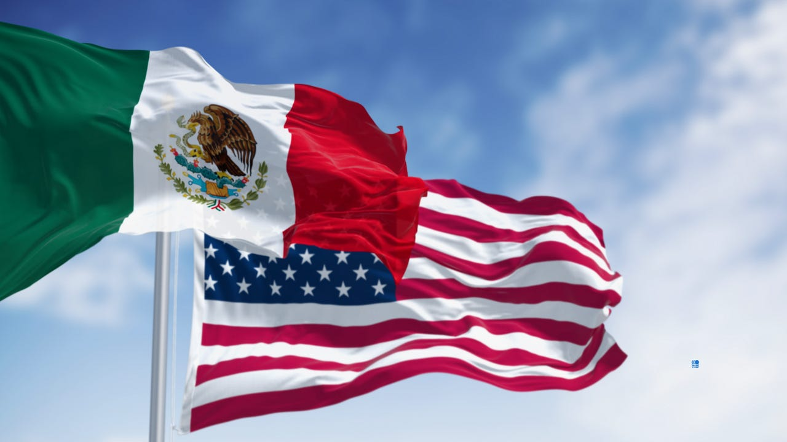
US firms must navigate rules of origin and supply chain shifts to capitalize on Mexico’s tariff changes.rarrarorro/iStock via Getty Images
At a Glance
- US plastics industry gains $11.6 billion trade surplus with Mexico despite policy shifts.
- Mexico raises tariffs up to 35% on 79 plastic products from countries lacking trade agreements.
- American manufacturers must reassess supply chains to comply with USMCA rules of origin.
Mexico's recent overhaul of its tariff policy is reshaping the dynamics of the US plastics industry's largest export market, presenting both lucrative opportunities and significant challenges.
As US manufacturers navigate this shifting landscape, the potential for trade diversion toward free trade agreement (FTA) partners under the USMCA offers a critical chance to expand market share, while compliance with rules of origin and supply chain adjustments will be essential to mitigate risks.
The Plastics Industry Association (PLASTICS) Chief Economist, Perc Pineda, PhD, has released a new economic analysis highlighting the resilience of the US–Mexico plastics trade relationship and assessing how recent changes in Mexico's tariff policies could affect US plastics exports.
"The United States recorded another plastics trade surplus with Mexico in 2024, totaling $11.6B," Pineda wrote. "By category, the surplus consisted of $7.92B in resins, $3.2B in plastic products, and $239.2M and $282.5M in machinery and molds, respectively."
Trade surplus
Over the past decade, the plastics trade surplus has ranged from $8.3B to $11.6B.
"However, recent changes in Mexico's trade and tariff policies present both opportunities and challenges for the US plastics industry," Pineda noted.
Mexico remains the largest export market for the US plastics industry, accounting for 26% of total US plastics exports in 2024, including resins, products, machinery, and molds. Pineda noted that over the past decade, this share has remained stable, fluctuating between 24% and 27%. In 2024, the United States recorded a plastics trade surplus with Mexico totaling $11.6 billion, comprising $7.92 billion in resins, $3.2 billion in plastic products, and $239.2 million and $282.5 million in machinery and molds, respectively.
However, recent changes in Mexico's trade and tariff policies present both opportunities and challenges for US plastics manufacturers.
Effective January 1, 2026, Mexico implemented a new tariff regime targeting imports from countries without FTAs. Pineda noted the policy, approved by Congress and administered by the Ministry of Economy, raises import duties — up to 35% — across more than 1,400 product categories, including plastics, automotive, steel, textiles, and consumer goods.
This measure aims to protect employment in trade-exposed industries, increase domestic value added, and support broader industrial development goals. While the US, Mexico, and Canada benefit from free trade under the US-Mexico-Canada Agreement (USMCA), the new tariffs impact non-FTA countries significantly.
Plastics among affected categories
Among the affected categories, 79 are plastic products identified in Mexico's Harmonized Tariff Schedule (HTS). Of these, Pineda noted that 31 products face tariffs of 25%, and five are subject to 35%. US exports of these products to Mexico totaled $10.8B in 2024, while Mexico imported $18.7B of these products overall.
Moreover, according to Pineda, the United States accounted for 57.6% of Mexico's imports of these plastic products, with imports from non-FTA countries — led by China — making up 24.5% of the total. Mexico's 14 FTAs, covering over 50 countries, ensure that imports from FTA partners, including the US, Canada, and the European Union, account for 75.5% of the affected plastic products.
The higher tariffs on non-FTA imports create opportunities for US plastics manufacturers to expand their market share in Mexico. With $4.6B worth of plastic products imported from non-FTA countries, trade diversion toward FTA partners, particularly the US, is likely. Pineda pointed out that US firms can leverage USMCA preferences, proximity, and existing customer relationships to capture business from higher-cost suppliers. This is especially true for products facing tariffs of 15% or more.
Challenges remain
However, challenges persist. US manufacturers exporting to Mexico from offshore facilities in non-FTA countries may face higher tariffs, as duties are assessed based on the country of origin where substantial transformation occurs. This underscores the importance of reassessing export strategies, supply chains, and rules-of-origin compliance to ensure eligibility for preferential treatment under USMCA.
Mexico's tariff shift offers a clear window of opportunity for US plastics companies to act decisively. While the policy may be temporary, Pineda explained that timely engagement could lead to lasting market share expansion and a stronger position in the United States' most important export market for plastics.
Taken together, Pineda noted that Mexico's tariff shift creates a clear window of opportunity for US plastics companies to act decisively.
"While the policy may be temporary, the potential gains are real: timely engagement could translate into lasting market share expansion and a stronger long-term position in the United States' most important export market for plastics," Pineda concluded.

