

Dear Chuck:

Today marks a historic moment for the plastics industry.

We’re excited to announce that the Plastics Industry Association (PLASTICS) and the Society of Plastics Engineers (SPE) are coming together to form a unified organization—one that represents the full plastics value chain, from molecule to marketplace.

Under an agreement approved by both Boards of Directors, SPE will become a division of PLASTICS starting January 2026. This integration brings together two storied organizations with complementary strengths to create a stronger, more impactful voice for the industry.

🎥 Watch the video message from PLASTICS President & CEO Matt Seaholm as he shares the vision behind this exciting merger and what it means for our future:

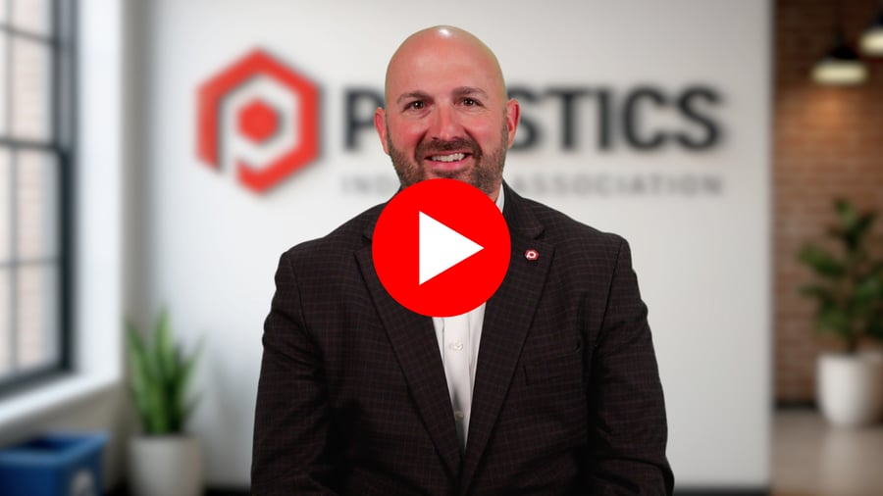

Why it matters:
- Better Together: This merger is built on a shared belief that we are better together. By combining SPE’s technical expertise with PLASTICS’ advocacy reach, we’re creating new opportunities for collaboration, innovation, and influence.
- Enhanced Member Value: Expect deeper technical education, expanded workforce development, and more meaningful connections across the industry.
- Unified Vision: From students to corporate leaders, this integration supports every facet of the plastics value chain.
We’re committed to a thoughtful and disciplined process, with the goal of finalizing the agreement by year-end. To support this transition, SPE CEO Pat Farrey will join PLASTICS as Executive Vice President, SPE, and Chief Integration Officer, ensuring continuity and leadership.

We’ve launched a landing page with additional information and answers to key questions, which will be updated as the integration progresses.

We are better together. And the future of plastics is brighter because of it.

Matt Seaholm
President and CEO
Plastics Industry Association
plasticsindustry.org

