South Korea sets up fund to support auto parts makers
Selected Hyundai suppliers to get financial support following US import tariffs.
August 21, 2025
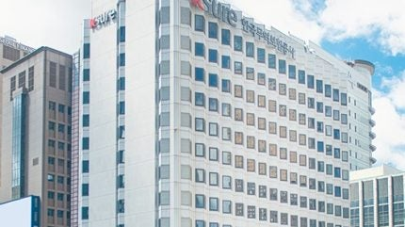
K-Sure’s headquarters in Seoul.
South Korean state-owned Korea Trade Insurance Corporation (K-Sure), with the support of Hyundai Motor Group (HMG) and Hana Bank, has launched a new KRW 630 billion (US$ 450 million) fund to provide financial support to the country’s automotive component manufacturers, following the recent introduction of import tariffs in the US.
The launch event in Asan was attended by South Korea’s Trade, Industry and Energy Minister, Kim Jung-kwan; K-Sure’s CEO Jang Young-jin; HMG’s President Sung Kim; and Hana Bank’s CEO Lee Ho-sung.
The aim of the programme is to provide financial support to domestic component suppliers of Hyundai Motor and Kia Corporation that are facing declining sales following the recent introduction of import duties in the US. Hana Bank has contributed KRW 30 billion to the fund, while HMG has made available KRW10 billion won.

