January 16, 2026

Re: Polystyrene Price Increase Effective February 1, 2026

Dear Valued Customer:

Americas Styrenics LLC will increase the transaction price for all grades of polystyrene by $0.03/lb effective February 1, 2026.

Your Americas Styrenics Account Executive will be in contact with you to discuss this price increase and to answer any questions you may have. We genuinely appreciate your business and thank you for the opportunity to supply your polystyrene requirements.

Sincerely,
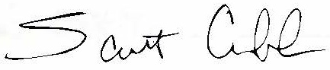

Scott Cobb
Polystyrene Product Director

