SABIC further optimizes its portfolio for long-term sustainable growth, divests its European Petrochemical (EP) business and its Engineering Thermoplastics (ETP) business in the Americas and Europe
08/01/2026
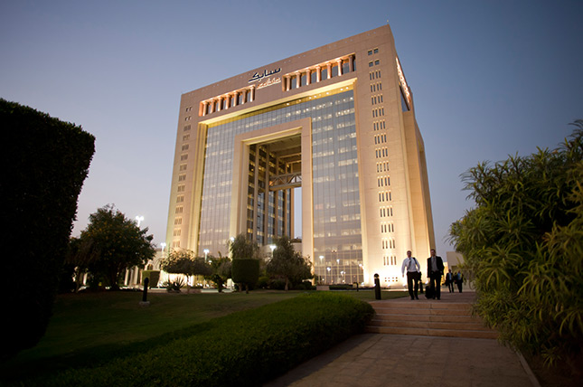
Home > News & Media > Latest News > SABIC further optimizes its portfolio for long-term...

The Saudi Basic Industries Corporation (SABIC) today announced the signing of two strategic transactions to divest its European Petrochemicals (EP) business to AEQUITA and its Engineering Thermoplastics (ETP) business in the Americas and Europe to MUTARES, for a total combined enterprise value of $950 million.
These transactions represent significant steps in the advancement of SABIC’s strategy and constitute a core component of its broader portfolio optimization program. The divestments together establish a strong foundation for future profitable growth and reinforce the Company’s long-term strategic positioning for maximum value add.
These efforts are a continuation of SABIC’s plans to improve returns, focus on high margin markets and products where we have clear competitive advantage, recycle capital to higher-return opportunities and improve free cash flow, whilst continuing to serve its global customers and maximize shareholder value. Additionally, these transactions do not impact the technology and innovation focus and commitment that SABIC has for its customers.
Commenting on the transactions, Chairman of the Board of Directors of SABIC Khalid H. Al-Dabbagh, said: “The Board endeavored to achieve these transactions, which represent a significant milestone in the execution of our strategy to further optimize our portfolio and maximize shareholder value by enhancing the Company’s cash generation capacity and achieving the highest possible return on our global businesses”.
Abdulrahman Al-Fageeh, Chief Executive Officer of SABIC, said: “These transactions represent a continuation of our Portfolio Optimization Program, which started in 2022 and included previous actions, such as the divestment of Functional Forms, Hadeed and Alba. This strategic approach allows us to actively reshape our portfolio and sharpen our focus on areas where SABIC has clear and sustainable competitive advantages in a rapidly changing landscape”.
“I am pleased that both AEQUITA and MUTARES will work with us in the future to ensure that we continue to serve our global customers in a seamless manner,” Al-Fageeh also stated.
Salah Al-Hareky, Chief Financial Officer of SABIC, said: “These transactions are a clear demonstration of our disciplined approach and decisive execution regarding capital allocation and active portfolio management. By unlocking value to fund higher-return opportunities, we are improving the quality and efficiency of our capital employed and enhancing the group’s ROCE over time. Together, these actions position SABIC to deliver sustainable returns and create value for our shareholders.”
These transactions reposition SABIC for longer-term success by refocusing financial resources and management attention towards growth areas where the Company has clear competitive advantages.
The divestments are expected to enhance SABIC’s performance, including through increasing overall EBITDA margins, improving free cash flow generation, and supporting higher return on capital employed (ROCE), enabling the Company to optimize capital and align its profitability aspirations with a value-accretive portfolio.
Importantly, both transactions will allow SABIC to maintain strategic access for its products through exports to both Europe and the Americas, which remain priority markets for the Company. Furthermore, SABIC’s leadership in global research, and advanced technology and innovation will be preserved, supporting effective customer service and sustainable growth.
SABIC, alongside the buyers, will maintain business continuity, customer service excellence, and the highest standards of safety, reliability and compliance throughout the transition and beyond for both divestments. In this context, SABIC is committed to ensuring a seamless separation, minimizing disruption to ongoing operations, and preserving strong relationships with all stakeholders, including customers.
Completion of these transactions is subject to customary closing conditions and regulatory approvals, including employee consultation where relevant.
Transaction: European Petrochemicals business
SABIC has agreed to sell its European Petrochemicals (EP) business to AEQUITA for an enterprise value of $500 million.
SABIC’s EP business produces and markets various products: ethylene, propylene, low- and high-density polyethylene (LDPE, LLDPE, and HDPE), polypropylene (PP), and value-added polymer compounds, and manages a number of manufacturing sites, including in Teesside, the United Kingdom; Geleen, the Netherlands; Gelsenkirchen, Germany; and Genk, Belgium.
Dr.-Ing. Axel Geuer, President & Co-CEO of AEQUITA, said: “This transaction represents a further step in the expansion of our European chemicals platform. The assets are highly synergistic with the olefins and polyolefins business we recently acquired from LYB; with complementary markets, infrastructure and operational capabilities, we see substantial potential to realize synergies and drive operational improvements across both businesses. Under AEQUITA’s active ownership model, our focus will be on supporting the teams on the ground, ensuring a seamless integration, and building a scaled, competitive platform positioned for long-term, sustainable value creation.”
Transaction: Engineering Thermoplastics business
SABIC has also agreed to sell its regional Engineering Thermoplastics (ETP) business in the Americas and Europe to MUTARES for an enterprise value of $450 million, in addition to an agreed earn-out mechanism that could generate further value to SABIC based on the business’ free cash flow generation over the next four years, as well as in the event of a future sale of the business by MUTARES.
SABIC’s Americas and European ETP business produces polycarbonate (PC), polybutylene terephthalate (PBT), and acrylonitrile butadiene styrene (ABS) resin and compounds, and manages manufacturing sites, including in Mt. Vernon, Ottawa, Bay St. Louis and Burkville, United States; Tampico, Mexico; Campinas, Brazil; Cartagena, Spain; and Bergen op Zoom, the Netherlands.
Robin Laik, co-Founder and CEO of MUTARES, said: “The Engineering Thermoplastics (ETP) business in the Americas and Europe has a highly skilled workforce and strong customer relationships. Under focused ownership, our priority is to ensure continuity, support employees through the transition, and unlock the full potential of our asset base as a standalone ETP platform.”
Transaction Advisors
SABIC was advised by Goldman Sachs (Financial Advisor – EP transaction); J.P. Morgan (Financial Advisor – ETP transaction); Lazard (Independent Financial Advisor); KPMG (Accounting, Carve-Out and Tax Advisor); and A&O Shearman (Legal Advisor).
Cautionary Statement
This press release contains forward-looking statements relating to matters that are not historical facts. These statements are based on current expectations, estimates, projections and assumptions of SABIC’s management and information available as of the date hereof. Forward-looking statements are subject to known and unknown risks, uncertainties and other factors that may cause actual results, performance or developments to differ materially from those expressed or implied. There can be no assurance that any forward-looking statements will be realized. Forward-looking statements speak only as of the date they are made, and SABIC undertakes no obligation to update or revise any such statements, except as required by applicable law.

