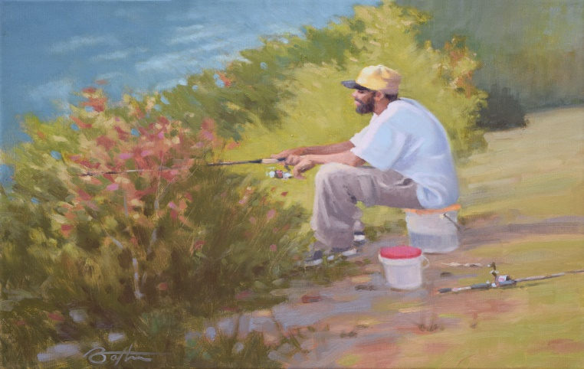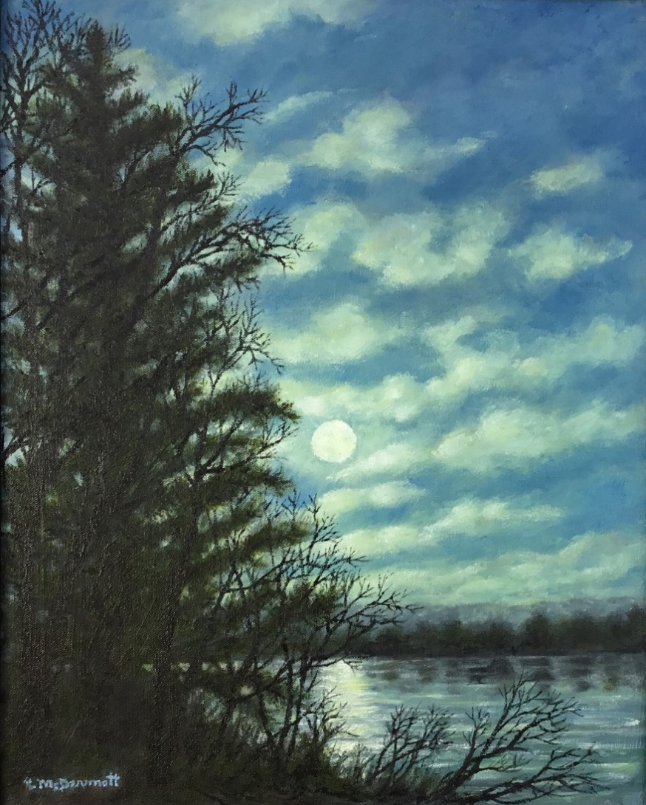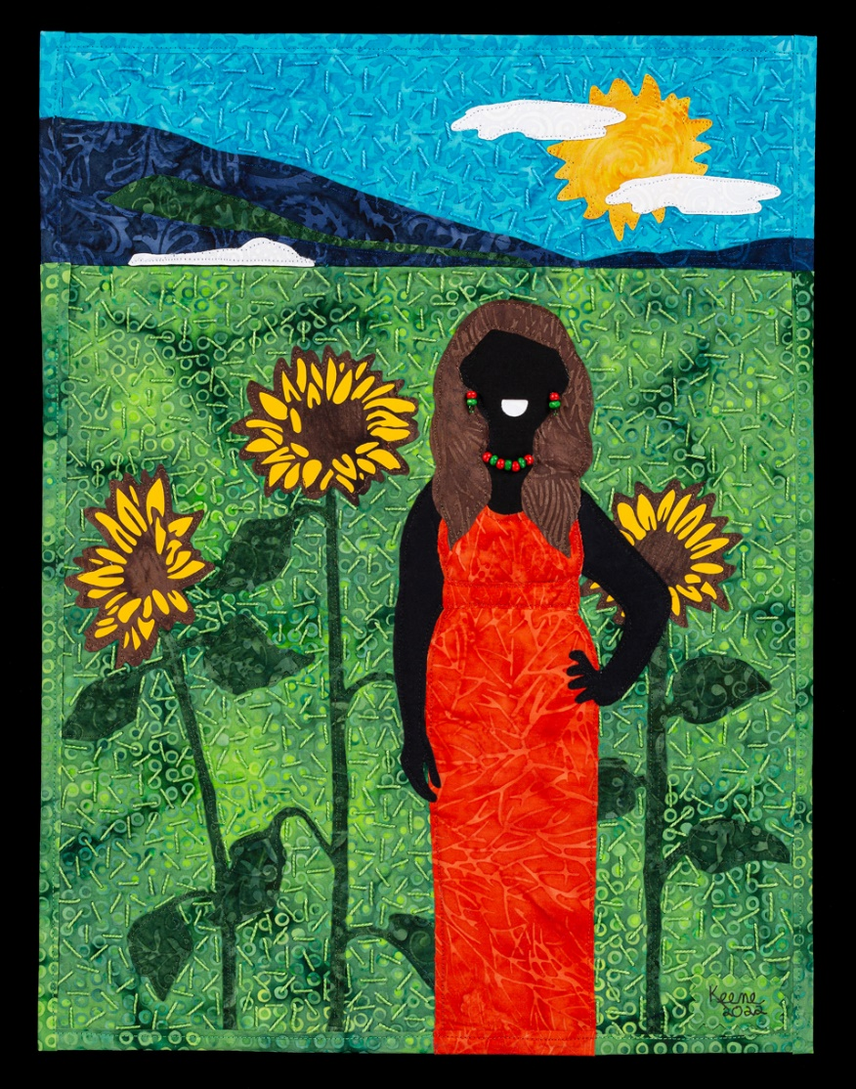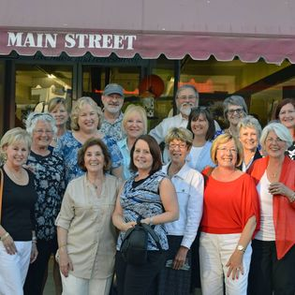
Art Gallery Address and Hours
Monday 10am – 4pm
Tuesday 10am - 4pm
Wednesday CLOSED
Thursday 10am – 4pm
Friday 10am – 4pm
Saturday CLOSED
Sunday CLOSED

Union County Arts Council

presents works by
The Catawba River Art Guild
January 15 – February 28
Public reception, January 20, 6pm – 8pm

