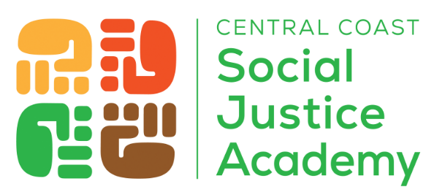

2026 Community Organizer of the Year Award

Nomination Form

The Community Organizer of the Year Award was established to honor and recognize the courageous and impactful work of professional community organizers.Two awards of $2,500 will be conferred – one for Ventura County and one for Santa Barbara County. The cash award will be provided directly to the organizer for personal use – not to their organization.

What is a community organizer? Community organizers develop grassroots leaders, help residents recognize their own power, and identify leadership roles for people to step into during campaigns for social change.

Nominations are welcomed from other fellow community organizers, co-workers, civic leaders, nonprofit Board members, grassroots leaders, and others with direct knowledge of the candidate’s exceptional organizing work. Winners will be selected by a committee of former community organizers. The award ceremony will take place on June 12, 2026.

DEADLINE FOR NOMINATIONS: THURSDAY, MARCH 19, 2026

Qualifications: | Nominees must:  - Be serving or employed as a community organizer in Ventura or Santa Barbara counties.  - Have been a community organizer for a minimum of three years.  - Demonstrate a distinguished track record of active, meaningful policy campaigns and of developing grassroots leaders.
Nominee Contact Information | Nominee:  Job Title:  Organization:  Email Address:  Phone Number  County served:  # of years doing community organizing work:
Nominator Contact Information | Person recommending nominee:  Job Title:  Organization:  Email Address:  Phone Number:  County served:
#1 | Tell us how the community organizer excelled in recruiting and engaging community members, and developing community leaders. (Use as much space as needed)
#2 | Describe the impacts the community organizer had on their community, including any campaigns and policy wins. (Use as much space as needed)
#3 | Anything else you would like to share about the individual you are nominating?

Please email this completed form to: jovita@mccunefoundation.org

The Central Coast Social Justice Academy, launched in 2024, is a ten-month program that empowers staff from social justice organizations in Ventura and Santa Barbara Counties. It enhances their movement-building skills, leadership, and local networks. This program aims to cultivate effective advocates for social justice in our region.
www.socialjusticeacademy.org

