Sleep in Heavenly Peace-TX Houston NW 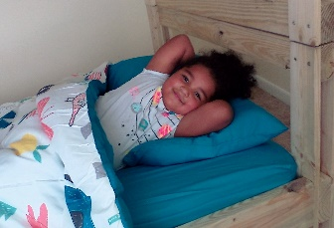
No Kid Sleeps on the Floor in Our Town
A local chapter of the non-profit, all-volunteer organization, Sleep in Heavenly Peace (SHP), was established by Chamber member, Gary Akin. SHP’s dedicated volunteers build, assemble and deliver bunk or single beds, free of charge, to homes with kids (3 to 17) who have no beds of their own.
SHP partners with organizations, such as churches, businesses and individuals, to build the beds at events called Build Days at its build shop on the campus of TheMET Church on Jones Road.
Since its first Build, in mid-August, SHP-TX Houston NW, has built and delivered 60+ cargo style beds, complete with all new bedding, to kids who were sleeping on the floor, on air mattresses, couches, with a sibling or parent. Scheduled Build Days will increase that number to 100 by the end of December.
Akin is actively seeking sponsored Team Builds. Sponsor organizations can participate in building as many bunkbeds, at a cost of $275 each (complete with all new bedding), as they choose and involve their employees, members, volunteers in a special Build Day. Children as young as seven are welcome to come with parents; there are several areas in the build process where they can participate.
Sleep in Heavenly Peace was founded in Kimberly, Idaho in 2012. The organization has grown steadily since its beginning and numbers 115 chapters in 39 states throughout the U.S.
Through the wonderful efforts of volunteers and generous donations of funds and bedding, SHP is fulfilling its mission: No Kid Sleeps on the Floor in our Town!

Gary Akin, President
SHP TX-Houston NW
832-326-3678
gary.akin@shpbeds.org

