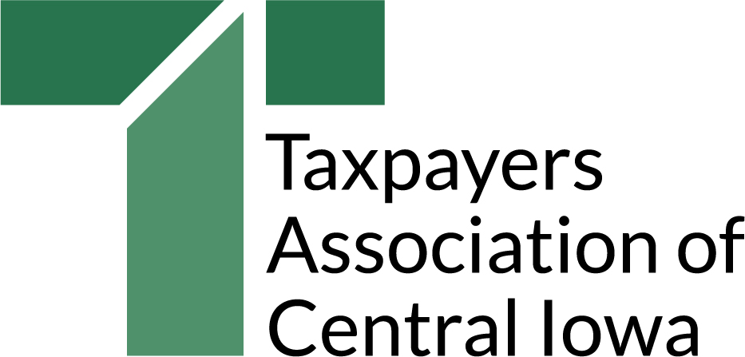
September 2018

Dear Mayors, Council Members and Managers:

For nearly 100 years the Taxpayers Association of Central Iowa has supported local governments as they strive to obtain the best value for every tax dollar. We have worked with many cities on collaborative endeavors and have observed as local governments have developed their own best practices.

As our region competes to attract, retain, and grow workers, we know our prospects are increasingly dependent on our ability to offer the range and quality of services that today’s residents and businesses expect, within a competitive tax structure. One of the benefits of the Taxpayers Association is its ability to see across the jurisdictions and analyze what practices seem to be working best to get the best results from limited property tax dollars.

To that end, we are kicking off a new initiative to highlight, share, and encourage the broad adoption of best practices in local government efficiency. While we anticipate bringing the initiative to most, if not all the municipalities in central Iowa, we begin this fall with Des Moines and West Des Moines. Our long-term involvement with local governments in central Iowa provides a good lens through which we have identified a short list of best practices in cities.

The attached summary and checklist outline the practices we believe demonstrate the best opportunities, over the long term, for cities to maximize value for the local tax dollar.

We invite you to review the descriptions, and be prepared during the budget development cycle to discuss the ways in which your city demonstrates these and other best practices. We will be looking for the best examples to feature on our website and recognize at our annual meeting, but we also invite you to submit your own examples as candidates for the In the Public Interest Award.

We are excited to become even more engaged in the great work that is happening across central Iowa. Working together, our local governments can become even more of an asset as we seek to attract and retain workers to our metro area.

Sincerely yours,
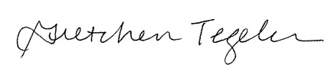
Gretchen Tegeler, President

