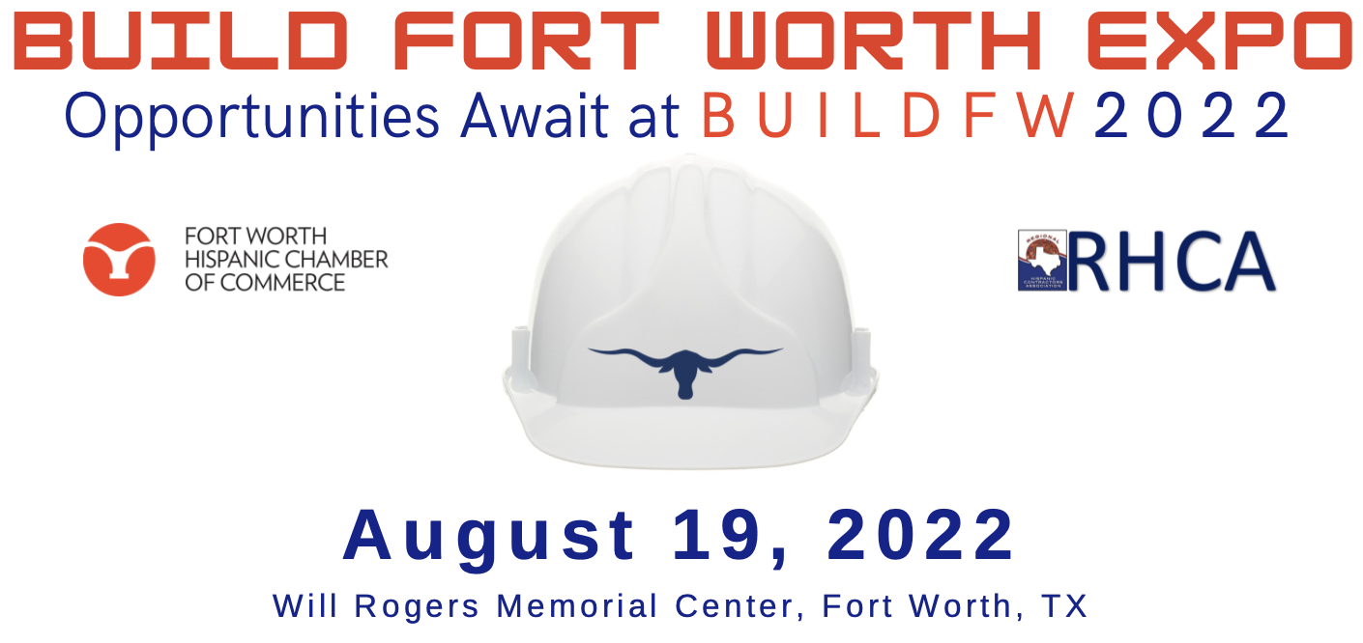

Over 100 Exhibitors including Hispanic Contractors and Business Equity Firms, DFW public and private entities will be showcased at the 5th Annual Build Fort Worth Expo. MWDBE’s are invited to network and learn about upcoming project opportunities.

Over 100 Exhibitors  Hispanic Contractors  Business Equity Firms  DFW Public & Private Entities | 8:00 AM- 8:30 AM  8:30 AM- 9:30 AM  9:30 AM - 12:30 PM  12:00 PM - 1:00 PM | Schedule  Registration | Coffee & Networking  Reception and Ribbon Cutting  EXPO  “Power Hour Networking Mixer”  FWHCC & RHCA Members and Sponsors ONLY

2022 Build Fort Worth – Partnership Levels

Presenting Partner $10,000
- Presenting Partner recognition from Podium
- 20x20 Exhibitor Space (priority prime location – two 8ft tables/two chairs)
- 16 Admission Tickets (opportunity to invite clients, subs, and team members)
- Five (5) complimentary “MWDBE Exhibitor” spaces (invite your subs to participate and exhibit as your guest)
- Opportunity to provide welcome remarks Ribbon Cutting Ceremony (Senior Executive)
- Promo video feature during expo (30 second) due August 1, 2022, format MP4
- Presenting Partner logo inclusion on digital program cover
- Presenting Partner logo inclusion recognition on all marketing/promotional material (social media, registration page, Event Banner, and flyer)
- Dedicated social media sponsorship feature (individualize post)
- Professional company photo taken during event to showcase participation
- Access to FWHCC & RHCA Member “Power Hour Networking Mixer”

Gold Partner $7,500
- 10x10 Exhibitor Space (prime location – two 8ft tables/two chairs)
- 12 Admission Tickets (opportunity to invite clients, subs, and team members)
- Four (4) complimentary “MWDBE Exhibitor” spaces (invite your subs to participate and exhibit as your guest)
- Partner recognition from Podium
- Logo inclusion on digital program partner’s page
- Included on social media recognitions of event partners
- Logo inclusion recognition on all marketing/promotional material (social media, registration page, and flyer)
- Social media partnership feature
- Professional company photo taken during event to showcase participation
- Access to FWHCC & RHCA Member “Power Hour Networking Mixer”

Silver Partner $5,000
- 10x10 Exhibitor Space (prime location – two 8ft tables/two chairs)
- 10 Admission Tickets (opportunity to invite clients, subs, and team members)
- Two (2) complimentary “MWDBE Exhibitor” spaces (invite your subs to participate and exhibit as your guest)
- Partner recognition from Podium
- Logo inclusion on digital program partner’s page
- Included on social media recognitions of event s partners
- Logo inclusion recognition on all marketing/promotional material (social media, registration page, and flyer)
- Professional company photo taken during event to showcase participation
- Access to FWHCC & RHCA Member “Power Hour Networking Mixer”

Bronze Partner $3,500
- Exhibitor Table (one 8ft table/two chairs)
- 8 Admission Tickets (opportunity to invite clients, subs, and team members)
- Partner recognition from Podium
- Logo inclusion on digital program partner’s page
- Included on social media recognitions of event partners
- Access to FWHCC & RHCA Member “Power Hour Networking Mixer”

Reception Partner $3,000
- Exhibitor Table (one 8ft table/two chairs)
- 6 Admission Tickets (opportunity to invite clients, subs, and team members)
- Logo inclusion on digital program partner’s page
- Included on social media recognitions of event partners
- Access to FWHCC & RHCA Member “Power Hour Networking Mixer”

2022 Build Fort Worth – Partnership Levels continue

General Contractor/Corporate Exhibitor $2,500
- Exhibitor Table (one 8ft table/two chairs)
- 4 Admission Tickets (opportunity to invite clients, subs, and team members)
- Logo inclusion on digital program exhibitor’s page
- Access to FWHCC & RHCA Member “Power Hour Networking Mixer”

Government Agency Exhibitor $1,500
- Exhibitor Table (one 8ft table/two chairs)
- 2 Admission Tickets

Small Business / MWDBE Exhibitor (Non-Members) $1,000
- Exhibitor Table (one 8ft table/two chairs)
- 2 Admission Tickets

Small Business / MWDBE Exhibitor (FWHCC/RHCA Members in good standing) $1,000 | $500 early bird ends Dec 1, 2021
- Exhibitor Table (one 8ft table/two chairs)
- 2 Admission Tickets

Individual Admission Tickets $100 | $50 early bird ends Dec 1, 2021
- 1 General Admission Ticket (includes Power Hour lunch)

--------------------------------------------------------------------------------------------------------------------------------------------

Commitment Form:

Company

Representative Name Title

Phone/Cell Email

Partnership Level:

[ ] Presenting Partner $10,000 [ ] Gold Partner $7,500 [ ] Silver Partner $5,000

[ ] Bronze Partner $3,500 [ ] Reception Partner $3,000

Payment:

[ ] Invoice [ ] Credit Card

FWHCC Contact: Anette Landeros | 817-625-5411 | Anette.landeros@fwhcc.org

RHCA Contact: Yolanda Tafoya | 972-786-0909 | yolanda@reigonalhca.org

