Superior National Forest
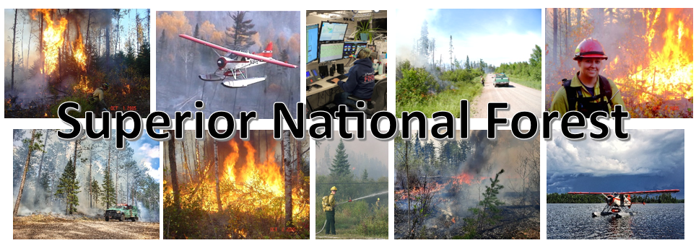

Vacancy Announcement
GS-0462-08/09 Forestry Technician
“Airtanker Base Manager”
Ely, MN
Opens February 7, 2024, and closes February 16, 2024

The Superior National Forest is filling a GS-0462-08/09 Forestry Technician, Airtanker Base Manager position in Ely, MN.

Apply in USAJOBS between February 7, 2024, and February 16, 2024. Please apply by close of business 2/16/24, or sooner.

Vacancy Announcement Number: 24-FIRE-P3GVA-AIRTNK-89DH

About the Position
This position serves as an Airtanker Base Manager. Responsibilities include: management of an aerial retardant base in support of wildland fire suppression activities; management and administration of assigned contracts as Contracting Officers Representative and/or Project Inspector; oversight and support to various types of aircraft assigned to the base; and management of the airtanker base and Ely seaplane base facilities.
This is a covered secondary position description under the provisions of 5USC 8336 (c) and 8412 (d). Ninety (90) days of experience as a primary/rigorous wildland firefighter or equivalent experience outside federal employment as a basic qualification requirement for this position. This position has been approved for Secondary Firefighter Retirement Coverage under CSRS and FERS by USDA on 8/2/2013, A2.
In accordance with USDA Department Regulation 4430-792-2, this position is a Testing Designated Position (TDP) under the USDA Drug Free Workplace Program and subject to pre-employment drug testing. All applicants selected for this position will be required to submit to a urinalysis to screen for illegal drug use prior to appointment. Incumbents of this position will be required to submit to a urinalysis on an ongoing random basis, after appointment as directed.
Incumbent is required to have and maintain Incident Qualification and Certification System (IQCS) qualifications as an Airtanker Base Manager (ATBM).
Major Duties
- Directs and oversees the activities at an airtanker base in support of wildland fire suppression and will assist at the Ely Seaplane Base as needed. (approximately 20% of time)
- Serves as an expert in aviation safety and retardant aircraft limitations.
- Applies multi-agency policy, agreements and protocols to ensure effective interagency aviation operations.
- Responsible for the overall efficiency, safety and security of ground and aviation operations.
- Serves as the principal point of contact with public affairs, airport management and various federal, state, and local entities, pertaining to aviation operations at the base.
- Oversees the planning, scheduling and monitoring of all flights and resources assigned to the airtanker base.
- Determines flight information such as location, heading, radio contacts, frequencies and possible hazards.
- Disseminates information to tactical aircraft. Provides local aircraft traffic conditions that may affect operations and safety.
- Oversees mixing and loading of retardant chemicals to ensure that individual aircraft weight limitations are not exceeded.
- Responsible for retardant quality assurance standards.
- Serves as an expert in the administration of aviation and retardant contracts to ensure conformance to contract specifications.
- Performs day to day administration of contracts.
- Completes and maintains reports and records of aircraft retardant use; completes daily flight invoices and contract daily diaries.
- Signs for receipt of services and recommends payment approval/disapproval and provides documentation of contractor claims.
- Manages data input into computerized records relating to aircraft use and payment, scheduling, incident and accident reports and information necessary to obtain desired results of aviation computer programs.
- Processes payment documents for contract aviation/retardant services. Utilizes computer-based applications for program support.
- Responsible for planning and directing maintenance activities to assure that base buildings, grounds, and equipment are maintained to ensure a safe work environment.
- Reviews and approves requisitions, purchases, repairs, and servicing of equipment at the facility.
- Assists in establishing local environmental protocols in support of aviation operations.
- Ensures preparation of base operation and safety plans. May participate in budget planning.
Ben Roy at Benjamin.roy@usda.gov would be glad to provide additional information on this position, the schedule, and the community.

Locations
The Superior National Forest is located in the northeast tip of Minnesota and is sandwiched between Lake Superior and the Canadian border. One third of its three million acres contains the Boundary Waters Canoe Area Wilderness (BWCAW). The National Forest has over 2,000 lakes, 3,400 miles of streams, hosts 27 Forest Service campgrounds, nine Minnesota DNR campgrounds, 2,200 developed campsites within the BWCAW, and 254 back country campsites outside the Wilderness. These camping areas provide quick access to 354 fishing lakes, 162 public boat landings, 29 picnic areas, 400 miles of designated hiking trails, 450 miles of groomed cross-country ski trails, and over 1500 miles of canoe routes through the BWCAW. Additional information regarding the Superior National Forest can be found at: http://www.fs.usda.gov/superior/
Ely, Minnesota is located in the heart of the Boundary Waters Canoe Area Wilderness (BWCAW). It has a population of around 3,500 year-round residents and the town includes a vibrant local arts community and a community theater. There are numerous churches, a newly remodeled K-12 school, as well as several restaurants and gift shops. Ely is the home to the International Wolf Center and the North American Bear Center. There are also many recreation opportunities such as golf, a hockey arena, and athletic fields. Outdoor recreation activities abound in and out of Ely, including fishing, hunting, cross country skiing, hiking, boating, canoeing and snowmobiling. You are within minutes of any outdoor adventure. Ely hosts a hospital and clinic Essentia Health-Ely Clinic as well as the Vermillion Campus for Minnesota North College. Vermilion - Minnesota North * Additional information regarding Ely can be found at: City of Ely, http://www.ely.org, and http://elyminnesota.com.
If this position is not filled non-competitively a vacancy announcement for will be posted in USAJobs. Individuals wishing to apply must first create an on-line profile in USA Jobs and upload a customized resume to ensure proper documentation of duties and accomplishments that are directly related to this position. You can create a search in USA Jobs that will notify you jobs are posted.
Tips on writing a Federal resume and applying for Federal jobs can be found on the USAJobs Channel
Thank you for your interest.
The USDA is an equal opportunity provider, employer, and lender.

