VACANCY ANNOUNCEMENTS
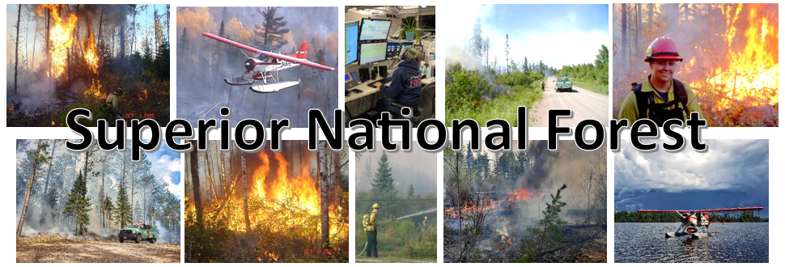

The Superior National Forest is advertising to fill four fire positions; located in Grand Marais and Tofte, Minnesota. These openings are varying grade and experience levels from engine crew to assistant engine captain. Please view the announcements for qualifications and apply through USAJOBS. These positions are all permanent, full time (year-round) positions.

These positions will open in USAJOBS on

February 7 and are open until February 16, 2024.

Please apply by close of business on February 16, 2024.

Forestry Technician FEO (Fire Engine Operator) GS-o462-06/07

Two Positions:
One position is located in Grand Marais and one position is located at the Seagull Guard Station.

Vacancy Announcement #: 24-FIRE-P3GVA-FEOH-67DH
This position is categorized as an Assistant Fire Engine Operator and applicants must meet IFPM qualifications for this position which includes being qualified, as a minimum, FFT1 and additional required training S-290. This position is a lead wildland firefighter on a type 6 engine. These positions are target-grade GS-7.

Forestry Technician (Fire) GS-0462-03/04/05 FT

Vacancy Announcement #:
Wildland Fire Apprentice Program: 24-FIRE-P3GVA-WFAP-345DH
Forestry Technician Senior Fire Fighter: 24-FIRE-P3GVA-FFTR-34DH
Forestry Technician (SRFF): 24-FIRE-P3GVA-ENGSRFF-45DH

The position is located on a wildland fire crew/engine. The primary purpose of this position is to perform wildland firefighting work. The crew performs work directly related to wildland fire suppression and control activities including suppression, preparedness, prevention, monitoring, and hazardous fuels reduction. May also perform duties in other fuels related or ecosystem restoration projects.
Two positions:
One position is located on the engine located at the Tofte Ranger District and one position is located on the engine located at Seagull Guard Station (for the summer/fall months).

These positions are target-grade GS-5. Please read the job announcement and apply where you qualify. If you have no previous firefighting experience, apply to the apprentice announcement. If you have questions, please contact one of the supervisors listed below for more explanation.

For more information regarding the positions:
Grand Marais: Brandon Rea at brandon.rea@usda.gov
Tofte: Justin O’Brien at justin.obrien@usda.gov
Seagull Guard Station: Darin Smith at darin.smith2@usda.gov

They would be glad to provide additional information on the positions and the community.

This notification is being circulated to inform prospective applicants of this opportunity.

You will apply through USAJOBS.GOV to announcement numbers listed above for each position.

Individuals wishing to apply must first create an on-line profile in USA Jobs and upload a customized resume to ensure proper documentation of duties and accomplishments that are directly related to this position. You can create a search in USA Jobs that will notify you jobs are posted.

Tips on writing a Federal resume and applying for Federal jobs can be found on the USAJobs Channel

The Superior National Forest is located in the northeast tip of Minnesota and is sandwiched between Lake Superior and the Canadian border. One third of its three million acres contains the Boundary Waters Canoe Area Wilderness (BWCAW). The National Forest has over 2,000 lakes, 3,400 miles of streams, hosts 27 Forest Service campgrounds, nine Minnesota DNR campgrounds, 2,200 developed campsites within the BWCAW, and 254 back country campsites outside the Wilderness. These camping areas provide quick access to 354 fishing lakes, 162 public boat landings, 29 picnic areas, 400 miles of designated hiking trails, 450 miles of groomed cross-country ski trails, and over 1500 miles of canoe routes through the BWCAW. Additional information regarding the Superior National Forest can be found at: http://www.fs.usda.gov/superior/
Grand Marais is a small picturesque town on the shore of Lake Superior, and is on the eastern edge of the Superior National Forest. It has a year-round population of approximately 1250, and is the county seat of Cook County. The town has long been influenced by tourism, being located near the internationally known natural attraction of the largest fresh water lake in the world, as well as the BWCAW, which is the most visited wilderness area in the nation. It is a modern population center with grocery stores, gas stations, restaurants, outfitters, lodging, hardware and variety stores, gift and souvenir shops, library, city and county services, and medical facilities, and to complement the natural attractions; a vibrant arts community. More information on Grand Marais, Minnesota can be found at: www.boreal.org/ , www.grandmaraismn.com, www.silverbay.com, www.exploreminnesota.com
Tofte, Minnesota is a small, picturesque town on the shore of Lake Superior with a population of about 200. It is home to a bank, a Lutheran Church, resorts and restaurants, a grocery store, a gas station and a couple of gift shops. There is an elementary school (grades 1-5) with the remaining grades at a larger school in Grand Marais. Tofte is located between the communities of Silver Bay and Grand Marais. There are limited opportunities for home purchase or rental. More information on Tofte, Minnesota can be found at: www.boreal.org/ , https://www.ci.grand-marais.mn.us/ , www.silverbay.com/ , www.exploreminnesota.com/

Thank you for your interest.
The USDA is an equal opportunity provider, employer, and lender.

