Superior & Chippewa National Forests

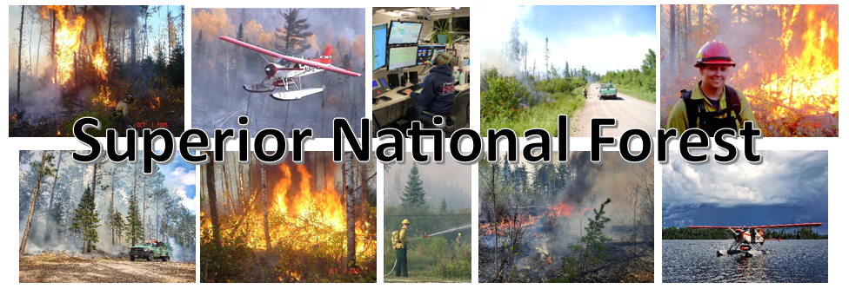
Vacancy Announcement
GS-301-11/12 Forest Assistant Fire Management Officer
In Grand Rapids, MN
Opens February 7, 2024, and closes February 16, 2024

The Superior National Forest is filling a GS-301-11/12 Forest Assistant Fire Management Officer in Grand Rapids, Minnesota. This position will assist both the Chippewa and Superior National Forests in fire leadership and program management and will serve as a member of the Chippewa Leadership team.

Apply in USAJOBS between
February 7, 2024, and February 16, 2024.
Please apply by close of business 2/16/24, or sooner.

Vacancy Announcement #: 24-FIRE-P3GVA-AFMOH-1112DH

ABOUT THE POSITION: The position is established on a Forest Service Unit. The incumbent serves as a Forest Assistant Fire Management Officer (FAFMO) with responsibility for assisting the FFMO to provide leadership and program direction for the unit’s fire and aviation management program. In the absence of the immediate supervisor, the incumbent serves as the acting FFMO.
The incumbent is responsible to assist with coordinating the development of short and long-range fire management programs, fire management activities on the unit, and integrating the unit’s fire management program with other disciplines and interagency partners to achieve goals consistent with the Federal Wildland Fire Policy and agency manual direction. The incumbent provides leadership, coordination, and direction for the administration of the fire suppression; detection and prevention programs; dispatching services; fuels/vegetation management; aviation management; and the integration of fire and aviation management plans and activities with other resources including urban interface/intermix, watershed, range, ecosystem management, and recreation.
This position is categorized as a High Complexity Forest Assistant Fire Management Officer (FAFMO) position that is subject to the Forest Service Fire Program Management (FS-FPM) Standard and Guide, as designated by the W.O. Fire and Aviation Management. The FS-FPM minimum qualification standards (MQS) for this position must be met prior to entrance into the position as a condition of hire. Refer to the Forest Service FS-FPM Standard Position Description Crosswalk for a full description of the MQS.
This is a covered secondary position description under the provisions of 5USC 8336 (c) and 8412 (d). Ninety (90) days of experience as a primary/rigorous wildland firefighter or equivalent experience outside federal employment as a basic qualification requirement for this position. This position is approved for secondary firefighter coverage under CSRS and FERS by USDA on 10-28-11, B2.
In accordance with USDA Department Regulation 4430-792-2, this position is a Testing Designated Position (TDP) under the USDA Drug Free Workplace Program and subject to pre-employment drug testing. All applicants selected for this position will be required to submit to a urinalysis to screen for illegal drug use prior to appointment. Incumbents of this position will be required to submit to a urinalysis on an ongoing random basis, after appointment as directed.
MAJOR DUTIES may include:
- Provides administrative supervision to a group of highly skilled subordinate fire program managers and specialists.
- Performs the administrative and human resource management functions relative to the staff supervised.
- Assists the Forest Fire Management Officer (FFMO) in directing a fire management program with a high complexity level.
- Assists the FFMO in directing all aspects of the unit’s fire and aviation management program.
- Coordinates the collection and analysis of data for appraisal of Forest fire damage and for the collection of evidence in fire trespass cases.
- Is responsible for ensuring that a well-coordinated fire training program is maintained on the unit.
- Coordinates the development of the unit’s annual fire management budget to assure balance in organization at varying levels of funding, and recommends changes to the FFMO as appropriate.
- May serve as the Contracting Officers Representative (COR) on fire and aviation contracts for the forest.
- Coordinates and negotiates the development of local operating plans to implement cooperative fire protection agreements with other federal, tribal, state, local agencies, and private industry.
- Reviews and evaluates fire management plans for technical soundness and adequacy in accordance with regional and national policies.
- Assists in coordinating complex operations with cooperating agencies on serious incidents and all phases of the fire and aviation management planning on the Unit.
- Negotiates complicated cooperative suppression agreements and resolves difficult and controversial public relations problems.
- Develops and recommends alternative fire suppression strategies by taking into consideration total values at risk and cost effectiveness.
- Coordinates suppression action on large, complex wildland fires.
- Provides advice and counsel to Line Officers on the development of strategies and appropriate course of actions for all incidents.
- Is responsible for coordinating complex operations with cooperating agencies on large fires with great potential for damage to resources and improvements and high risk to human safety.
- Serves as Duty Officer/POC for the unit during periods of fire activity.
- Provides leadership and program oversight to the unit’s aviation program and may serve as the Forest Aviation Officer when the unit does not have one assigned.
- Is responsible for the preparation of contract specifications and inspections for rotor and fixed wing aircraft.
- Provides program oversight to the unit or interagency Dispatch Center.

Nick Petrack at Nicholas.petrack@usda.gov would be glad to provide additional information on this position, the schedule, and the community.

Locations
The Chippewa National Forest is located in north central Minnesota, approximately 200 miles northwest of Minneapolis/St. Paul, and encompasses about 1.6 million acres which includes approximately 666,600 acres of checkerboard ownership with other public, private, and tribal lands interspersed. The Forest Supervisor’s office is located in Cass Lake, MN, with district offices in Blackduck, Deer River and Walker. The Forest was the first National Forest established east of the Mississippi River in 1908 and has a rich cultural history spanning at least 10,000 years including pre-European contact sites, logging camps, and Ojibwe and Euroamerican homesteads. Over 40% of the Forest is within the Leech Lake Indian Reservation and forest employees coordinate and consult closely with the Leech Lake Band of Ojibwe.
Water is very abundant on the National Forest and includes the Mississippi River headwaters region along with over 1300 lakes, 923 miles of rivers and streams, and 400,000 acres of wetlands providing world class fishing opportunities to visitors. Mixed northern conifer and hardwoods blanket the rolling uplands of the Chippewa. Recreation opportunities abound with canoeing, camping, boating, swimming, hiking, biking, horseback riding, cross-country skiing, snowmobiling and scenic drives throughout the area. For further information about the Forest, see our website: https://www.fs.usda.gov/Chippewa
The Superior National Forest is located in the northeast tip of Minnesota and is sandwiched between Lake Superior and the Canadian border. One third of its three million acres contains the Boundary Waters Canoe Area Wilderness (BWCAW). The National Forest has over 2,000 lakes, 3,400 miles of streams, hosts 27 Forest Service campgrounds, nine Minnesota DNR campgrounds, 2,200 developed campsites within the BWCAW, and 254 back country campsites outside the Wilderness. These camping areas provide quick access to 354 fishing lakes, 162 public boat landings, 29 picnic areas, 400 miles of designated hiking trails, 450 miles of groomed cross-country ski trails, and over 1500 miles of canoe routes through the BWCAW. Additional information regarding the Superior National Forest can be found at: http://www.fs.usda.gov/superior/
Grand Rapids, Minnesota is a major regional trade center, boasting one of the highest per capita annual retail sales figures of any city in the state. Large national retailers, such as Target, Walmart and Home Depot have found profitability in Grand Rapids, while the prosperous central business district of the community supports small specialty shops and service providers. Grand Rapids is also home to Itasca Community College, a higher learning institution that has provided exceptional training and educational opportunities for thousands of students throughout its history. More information about Grand Rapids Minnesota can be found at: http://www.grandmn.com and www.dted.state.mn.us.
If this position is not filled non-competitively a vacancy announcement for will be posted in USAJobs. Individuals wishing to apply must first create an on-line profile in USA Jobs and upload a customized resume to ensure proper documentation of duties and accomplishments that are directly related to this position. You can create a search in USA Jobs that will notify you jobs are posted.
Tips on writing a Federal resume and applying for Federal jobs can be found on the USAJobs Channel
Thank you for your interest.
The USDA is an equal opportunity provider, employer, and lender.

