Superior National Forest
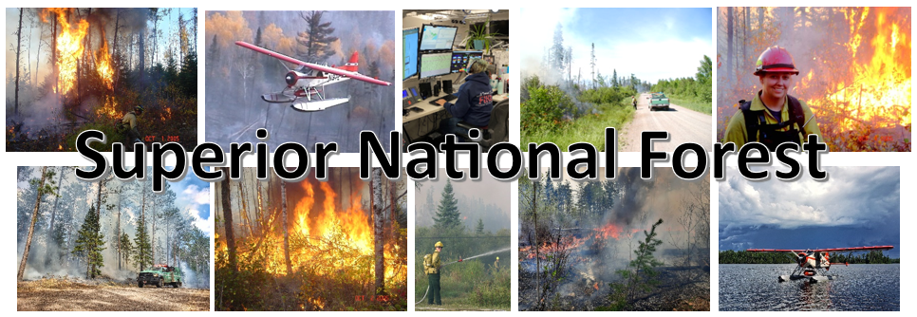
Vacancy Announcement

GS-0462-08/09 Forestry Technician (Fire)
Vacancy #: 24-FIRE-P3GVA-DFUELS-89DH

or a

GS-0401-09 Fire Management Specialist
Vacancy #: 24-FIRE-P3R9-FFUELM-9DH

Located in Cook, Ely, or Aurora, MN
Please select all the duty locations you would consider.

Opens February 7, 2024, and closes February 16, 2024

Apply in USAJOBS between February 7, 2024, and February 16, 2024. Please apply by close of business 2/16/24, or sooner.

Vacancy Announcement Number:
This is a standard wildland fire management position description intended for use in the USDA Forest Service. The incumbent serves in a key fire management position in a field fire management organization as a Fire Management Specialist (Prescribed Fire and Fuels)
The incumbent has program responsibility for prescribed fire, fuels management, smoke management, and wildland fire use planning. The incumbent provides professional advice and assistance to meet resource management objectives with prescribed fire and/or wildland fire use.
MAJOR DUTIES
Provides oversight for a moderate complexity fuels management planning.
Provides professional expertise in the development and implementation of multiple resource objectives.
Develops fuels treatment alternatives to support management decisions while adhering to applicable laws, regulations, policies, and guidelines.
Evaluates individual fuels treatments as well as the effectiveness of the assigned program and makes recommendations for improvement.
Coordinates with the next higher organizational level, other agencies, cooperators, and stakeholders to develop interagency fuels strategies.
Represents the organization in multi-agency fuels management activities.
Maintains awareness of technological developments in wildland fire science and related disciplines.
Collects information through a variety of methods, including field surveys, computer modeling, and specific literature searches.
Stays abreast of state-of-the-art computer modeling software and scientific methods to support fire use, air quality, and fuel treatment planning and applications.
Serves as a member of an interdisciplinary team planning, developing, and implementing land management plans, compliance documents, and agreements.
Provides assistance to other resource program managers in the design of fuels management prescriptions and implementation plans.
Develops, reviews and monitors fuels management plans.
Works closely with other resource specialists to integrate vegetation management project designs in fuels program direction.
Implements and administers prescribed fire activities, wildland fire use, and fuels management activities to ensure targets are achieved, management objectives are met and mitigation measures are adequate.
Monitors fire behavior, evaluates fire effects, identifies potential problems and takes appropriate action.
Provides information on fuels management methods to enhance, restore. and protect ecosystems.
Participates in the development, review, and modification of the fire management plan.
Develops, reviews and monitors fuels management plans.
Works closely with other resource specialists to integrate vegetation management project designs in fuels program direction.
May serve as a Contracting Officer's Representative (COR) on fuels management contracts and may be responsible for the preparation of contract specifications and performance measures.
Tony Harding at Anthony.harding@usda.gov would be glad to provide additional information on this position, the schedule, and the community.

Locations
The Superior National Forest is located in the northeast tip of Minnesota and is sandwiched between Lake Superior and the Canadian border. One third of its three million acres contains the Boundary Waters Canoe Area Wilderness (BWCAW). The National Forest has over 2,000 lakes, 3,400 miles of streams, hosts 27 Forest Service campgrounds, nine Minnesota DNR campgrounds, 2,200 developed campsites within the BWCAW, and 254 back country campsites outside the Wilderness. These camping areas provide quick access to 354 fishing lakes, 162 public boat landings, 29 picnic areas, 400 miles of designated hiking trails, 450 miles of groomed cross-country ski trails, and over 1500 miles of canoe routes through the BWCAW. Additional information regarding the Superior National Forest can be found at: http://www.fs.usda.gov/superior/
Aurora, Minnesota is 60 miles north of Duluth, Minnesota. Five other small cities are located within 20 miles of Aurora. Surrounding rural communities also provide opportunities for housing outside Aurora. The local economy is based primarily on taconite mining. Tourism is also important, including income from all-season visitors. Outdoor recreational opportunities include deer and small-game hunting, snowmobiling, downhill and cross-country skiing, biking and hiking. Lakes and rivers for fishing, boating, canoeing and swimming are located within close proximity to all communities. There are numerous golf courses in the area, in addition to Giants Ridge Golf and Ski resort which is located within five miles of Aurora. Health care facilities in Aurora and Virginia include a hospital and a clinic. The K-12 public school system in Aurora and Virginia provide a curriculum including college level courses. A community college is located in Eveleth/Virginia. Many area churches serve various faiths. More information on Aurora, Minnesota can be found at: http://www.aurora-mn.com/
Cook Minnesota has a population of 622. It is a full-service community with a hospital, medical/dental clinic, K-12 school, five churches, public and school libraries, three banking institutions, fire department, airport, one grocery store, hardware store, two new and used car dealerships, furniture store, movie theatre, sporting goods store, drug store, restaurants, and other local businesses. Area recreational opportunities cover a broad spectrum: swimming, boating, hunting, fishing, snowmobile use, cross country skiing, golfing, and more. More information on Cook Minnesota can be found at: www.cookminnesota.com and www.cookmn.us.
Ely, Minnesota is located in the heart of the Boundary Waters Canoe Area Wilderness (BWCAW). It has a population of around 3,500 year-round residents and the town includes a vibrant local arts community and a community theater. There are numerous churches, a newly remodeled K-12 school, as well as several restaurants and gift shops. Ely is the home to the International Wolf Center and the North American Bear Center. There are also many recreation opportunities such as golf, a hockey arena, and athletic fields. Outdoor recreation activities abound in and out of Ely, including fishing, hunting, cross country skiing, hiking, boating, canoeing and snowmobiling. You are within minutes of any outdoor adventure. Ely hosts a hospital and clinic Essentia Health-Ely Clinic as well as the Vermillion Campus for Minnesota North College. Vermilion - Minnesota North * Additional information regarding Ely can be found at: City of Ely, http://www.ely.org, and http://elyminnesota.com.
If this position is not filled non-competitively a vacancy announcement for will be posted in USAJobs. Individuals wishing to apply must first create an on-line profile in USA Jobs and upload a customized resume to ensure proper documentation of duties and accomplishments that are directly related to this position. You can create a search in USA Jobs that will notify you jobs are posted.
Tips on writing a Federal resume and applying for Federal jobs can be found on the USAJobs Channel
Thank you for your interest.
The USDA is an equal opportunity provider, employer, and lender.

