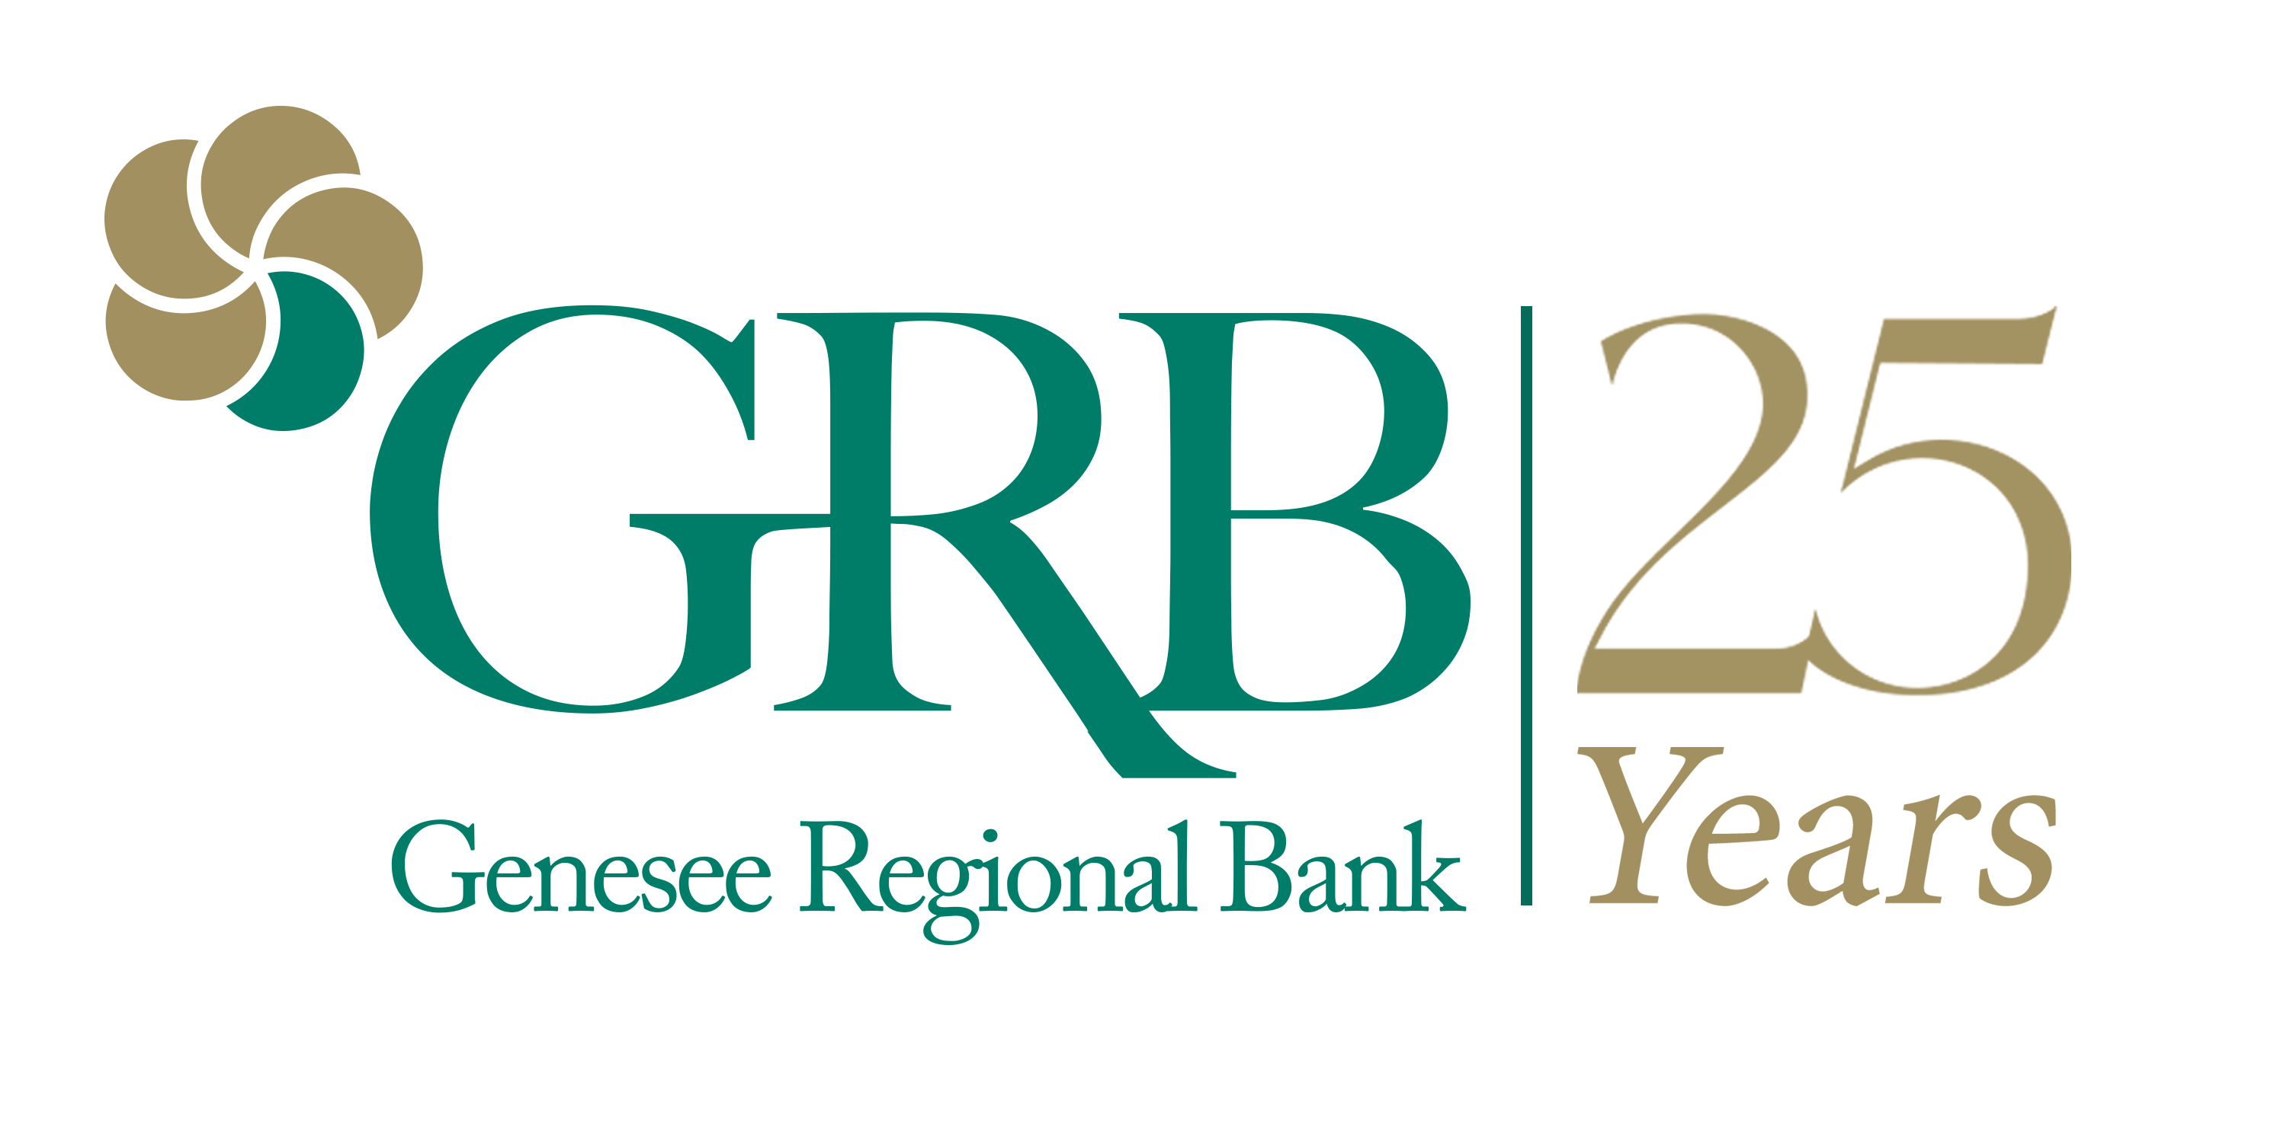
CONTACT
Stacey Michaels, Marketing Director
Genesee Regional Bank
585-249-1540
smmichaels@grbbank.com

FOR IMMEDIATE RELEASE

Genesee Regional Bank Recognized by
S&P Global Market Intelligence as One of the Country’s
Best-performing Community Banks in 2020

Rochester, NY. Genesee Regional Bank (GRB), a locally owned and operated bank specializing in business banking, personal banking, and home mortgages, has been recognized by S&P Global Market Intelligence as one of the “Best-performing Community Banks for 2020” for banks up to $3 billion in assets. Ranked at no. 23, GRB is the only New York state community bank on the nationwide list.

To determine the ranking, S&P calculated scores for more than 4,000 financial institutions on six weighted metrics: pre-tax return on tangible common equity, efficiency ratio, net interest margin, operating revenue growth, leverage ratio and nonperforming assets and loans 90 days past due as a percentage of total assets, and the net of the Paycheck Protection Program (PPP) loans. GRB performed well in all categories, delivering an efficiency ratio of 46.03%, keeping non-performing assets to 0.30% as a percent of total assets, and delivering a return on tangible common equity of 25.83%.

“In a year filled with so much uncertainty, we are proud that GRB was able to maintain its stability, make significant gains in efficiency, and serve the local community as one of the region’s leading SBA PPP loan providers,” said GRB President and CEO Philip L. Pecora. “Our previous years’ investments in technology and ability to develop a committed, high-performing workforce allowed us to respond quickly to the PPP program and simultaneously move forward with other lending activities, deposit growth, and support a record-breaking year for our residential mortgage team.”

"Despite going through a challenging year filled with economic uncertainty, we have seen community banks and credit unions play a significant role in their regional markets, providing support and essential services needed in their local communities. I'm thrilled to see these community banks and credit unions thrive in a challenging time and proud to recognize these top performing local financial institutions in our annual rankings," said Jimmy Pittenger, Senior Director of Financial Institutions at S&P Global Market Intelligence.

Pecora points out that it was the bank’s strong relationships with its customers that provided the foundation for fully leveraging its technology infrastructure and shifting to a remote work environment for more than 70% of the bank’s employees.

“We take pride in being the kind of banking partner that knows its customers intimately and proactively works with them to face challenges and take advantage of new opportunities,” said Pecora. “In an environment like 2020, those relationships were critical. Even though things were changing for us and for our customers on a daily basis, they knew we were focused on doing the right thing for them, for our employees and for this community.”

In addition to processing PPP loans for 575 small businesses, 2020 also brought GRB a number of other achievements: earning Emerald Award status from the U.S. Small Business Administration (SBA) and being the top SBA lender in the Rochester region, being named to the “Rochester Chamber Top 100” list of fastest-growing privately owned companies, and being recognized as one of the “Best Companies to Work for in New York” by the Society for Human Resource Management. The bank was also a leading purchase mortgage bank lender in the region and was recently named a top residential mortgage refinance provider by Expertise.com.

“We were well-positioned in 2020 to fulfill the rapidly changing needs of our customers and still provide opportunities for our employees and shareholders,” said Pecora. “We know that strength will be needed in 2021 as we continue to support the recovery efforts of the small businesses and community members in the Rochester region.”

Read the full S&P report.

# # #

About Genesee Regional Bank
Established in 1996, Genesee Regional Bank (GRB) is celebrating its 25th anniversary in 2021. The genesis of two successful businessmen, E. Philip Saunders and Dan Gullace, GRB was created with a vision of re-establishing a community bank presence and helping small businesses grow in the Rochester area. From this vision has emerged not only a successful financial institution, but one known for being a trusted advisor to its small business clients in a wide range of industries. The 2013 addition of enhanced mortgage services brought yet another critical service to the bank’s customers and the local community. With loan decisions made right here in Rochester, GRB's residential mortgage team has grown rapidly and is now one of the leading mortgage lenders in the region.

GRB has demonstrated consistent growth throughout its history, increasing its asset size to more than $800 million in 2021. The bank currently employs more than 140 people in the Rochester region. www.GRBbank.com

