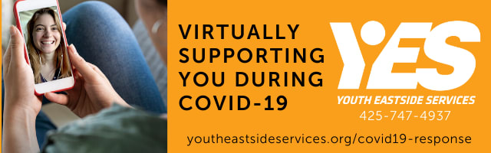

LW Community--Would you like support with the challenges of dealing with being at home, stress, vaping, family conflicts, substance use, loneliness, irritability, or are you worried about a family member or friend’s drug/alcohol/vape use?
If you want help and can benefit from brief drop-in counseling or consultation, you can easily connect with our Youth Eastside Services (YES) Counselor, Andrea Frost. Just use her drop-in office hours on Zoom on Tuesdays or Wednesdays or email her at andreaf@youtheastsideservices.org. She is our Substance Abuse Prevention Intervention Specialist (PI) and is here to support you.
YES PI Services Offered with Andrea:

Drop-in counseling/consultation hours are available to students, parents/caregivers and teachers/staff.
- To register, please click on a link below for Tuesday or Wednesday. You will then receive an email with information on how to join the virtual meeting. Sessions are approximately 15 minutes each and if you want to, we can talk about setting up another time for a longer future visit.
  - Tuesdays 10:00am-11:30am
  - Wednesdays 11:00am-12:30pm
Substance Use & Prevention Support Groups for Students
To register contact your school counselor, call or email Andrea at 425-747-4937 x2721 or andreaf@youtheastsideservices.org
*Recovery Group on Wednesdays 1:00-2:00pm
- For students who are working toward or are in recovery from substance use. Learn healthy coping skills and tools, along with mindfulness strategies on how to support present and future goals of not using substances. Ongoing group, can join at any time.
*Affected Others Group on Wednesdays 2:30-3:30pm
- For students who are affected by others’ substance use (family or friends). Confidential space to explore and express feelings, build community and reduce feelings of isolation. Also a space to feel empowered and have fun. Ongoing group, can join at any time.
*Quit Vaping Now Group on Wednesdays 4:00-5:00pm
- For students who want to work towards not using nicotine products of any kind. Building motivation to quit by recognizing triggers, learning mindfulness strategies to reduce stress, and creating steps for success with realistic goals. 4 week series, ongoing group, can join at any time.

Free Virtual Drug & Alcohol Education Class:
Held on a Saturday of each month from 9:30am-12:30pm is YES’ virtual Alcohol Drug Education Class. This is a great way for parents and students (12-19 y.o.) to attend together to gain information on the dangers of current substance abuse trends, effects of substances on the developing body and brain (including the dangers of mixing substances), along with where to turn for help with substance abuse & mental health issues. Students will also gain tools and skills to make more informed decisions for their futures. Go to https://www.youtheastsideservices.org/services/school-based-services/ to register for this FREE educational opportunity for parents and students to attend together. Next class dates are March 27, April 24, May 22 & June 19. All classes are no cost to families, on Saturdays, and run virtually from 9:30am – 12:30pm. Thank you for spreading the word about this important resource! Questions? Contact Andrea Frost at 425-747-4937 x2721 or andreaf@youtheastsideservices.org

Click here to watch Andrea’s introduction video.

