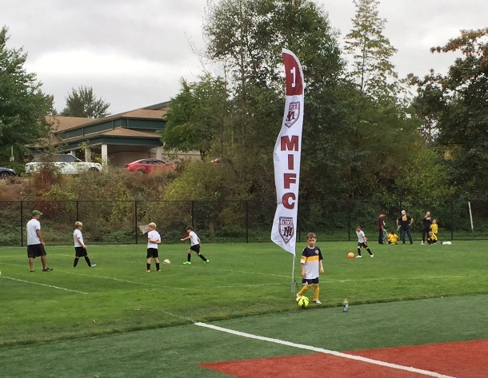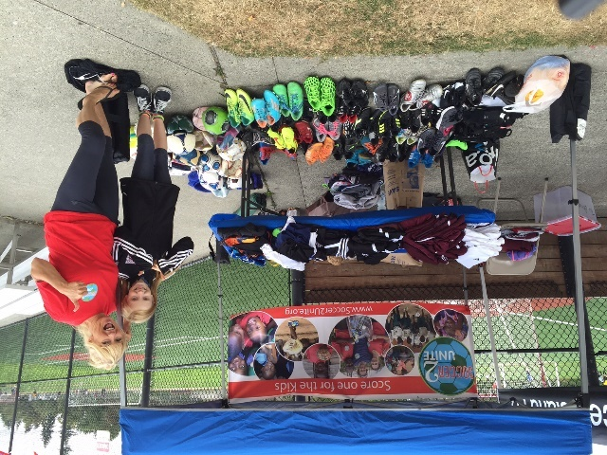
2016 EYSA Pre-Season Recreational Jamboree for U8-9-10 year-olds
Saturday August 27th dawned cool and overcast as the 2016 Eastside Youth Soccer Association (EYSA) Recreational Jamboree kicked off at the South Mercer playfields. With nearly 40 U8-10 teams from Bellevue, Issaquah, Lake Hills, Newport Hills and Mercer Island participating, it was sure to be a fun day despite the grey skies.
Not only was the jamboree a chance for the players to get some game experience before the regular season starts on September 10th, but Mercer Island FC VP of Referees Ken Robertson was able to get recently certified youth referees some game experience under the watchful eyes of experienced referee mentors. Robertson commented, “After their classroom course, these new referees really need some game experience to feel ready for the fall season. This pre-season jamboree is the perfect way for them to get that experience.”
EYSA Jamboree Coordinator Kendra Allori said “This is the second year we’ve done an association wide jamboree for our younger teams and we think it was a big success. Of course, there are always things we can improve on, but we think this is a fun way for our coaches and players to get some game experience before the start of the season”.
Again this year, Suzanne Fortune and her Soccer2Unite charity was on-site to collect used soccer equipment – balls, shoes, shin guards, shorts and jerseys for children in Uganda. Suzanne will be traveling to Uganda in October to distribute the equipment to kids at orphanages and schools. If you’d like to learn more about Suzanne’s work and how you can support her, check out her website at http://www.soccer2unite.org/ or her Facebook page at Soccer 2 Unite. Mercer Island FC is proud to partner with Suzanne and support her efforts to equip aspiring soccer players in Uganda.

