MIFC/EYSA Partner with Sounders FC to Launch a New Coach and Player Development Program
Beta Program Brings World-Class Development Techniques to Youth Recreational Soccer

In August, Mercer Island FC and the Seattle Sounders FC announced a new first-of-its-kind coach and player development program to support recreational youth teams and coaches. The program, which debuted in beta form for the fall 2016 recreational season, aims to provide MIFC and our fellow Eastside Youth Soccer Association (EYSA) recreational clubs (Bellevue FC, Issaquah FC, Lake Hills Soccer Club, and Newport FC) with enhanced and cutting-edge plans and systems for coach development support, player development curriculum, playing philosophy, player development programs (already offered by Sounders Youth Development Camps) and weekly technical direction (to be provided by Sounders trained Technical Directors).

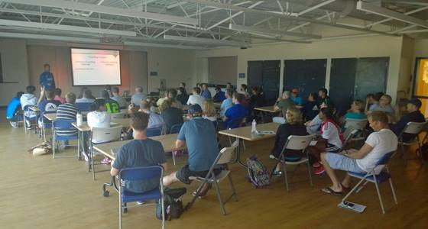
This program had been under discussion for the past year and aims to replicate across EYSA some of the recent player development successes of Mercer Island FC. With a player development focused curriculum MIFC pioneered and implemented several years ago, we have produced a number of players who started in our recreational programs and have gone on to play with top level Regional Club teams such as Eastside FC, the Sounders Academy and other elite programming including Elite Player Development/US National Team pools. On August 22, nearly 70 coaches from across EYSA came to the Mercer Island Boys & Girls Club to get educated on the curriculum and roll-out plan.

"We believe there is a substantial opportunity in providing education and resources to youth players and coaches," said Sounders FC Academy Director Marc Nicholls. "This is a previously unsupported frontier that has the potential to substantially accelerate and enhance the youth soccer product
--- we aspire to a high level of efficiency in the way we improve the development of youth coaches and, even more importantly, players."

The new program has provided coaches with a weekly session plan, videos and coaching development topics. There have also been free coach's education clinics (available to all EYSA Recreational coaches) that have supported and educated coaches on the season's session plans, playing philosophy and suggested tactical references.

"With 80% of our country's players playing in this youth and recreational demographic, there is an enormous opportunity to better develop players. One need only look at a country like Iceland, where they can develop competitive global teams with a population size of 340,000 people. Or, on a much smaller scale, Mercer Island with only 20,000 people, to realize that there is so much room to raise the bar," said MIFC VP of Coach and Player Development Aaron Byers. "This program is all about continuing to get better, raising the bar, and never stopping the soccer learning process."

