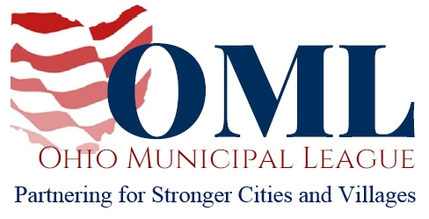

TESTIMONY TO THE SENATE WAYS AND MEANS COMMITTEE

PROPONENT TESTIMONY

SB 121

November 19, 2019

Chair Roegner, Vice Chair Blessing, Ranking Member Williams, and members of the Senate Ways and Means Committee, my name is Ashley Brewster and I am the Director of Communications for the Ohio Municipal League. On behalf of our 750 members, thank you for the opportunity to testify in support of SB 212.
SB 212 would allow a municipality to designate part of its jurisdiction as a Neighborhood Development Area (NDA) and thereby authorize the developers or owners of newly-constructed single-family homes within the NDA to apply for either full or partial exemption for property taxes.
If this exemption is applied to single-family homes under construction, it begins the year after construction starts and ends within the first year of the home becoming occupied. If a newly-occupied single-family home could have qualified for this exemption, a new homeowner can apply for the exemption and if granted, it would begin the first year after the home’s initial occupation and last for ten years. Additionally, owners renovating a single-family home within an NDA could apply for an incremental value exemption for five years.
When designating an NDA, the bill stipulates that a municipal ordinance must mandate proof that the NDA would encourage either the construction or renovation of single-family homes that wouldn’t otherwise take place as well as an explanation of how the NDA will improve the overall quality of life for the community and generate additional property tax revenues after the exemptions expire.
SB 212 provides municipalities a permissive tool to incentivize development and revitalization within its neighborhoods. Cities and villages would be able to use this tool as a means of “placemaking”, creating neighborhoods that attract the upcoming younger workforce and thereby attract businesses to their communities. By encouraging economic development and job creation, a municipality would benefit from increased revenue generation that would further enable the delivery of quality services Ohio businesses and its citizens deserve.
We want to thank Sen. Schuring for recognizing the need for this legislation. Thank you for your consideration, and we urge for your favorable passage of this bill. I would be happy to try to answer any questions you may have.

