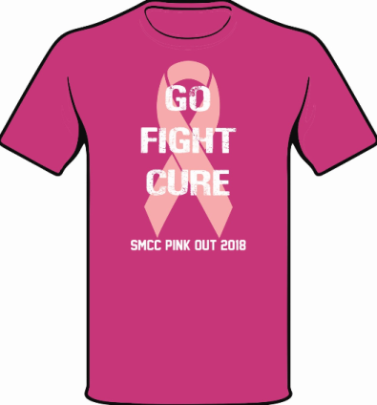

Join us Saturday October 6th as the Panthers take on Gibsonburg at 7:00pm. Game is sponsored by:
Firelands Regional Medical Center.
Get your official 2018 Pink-Out Tee and unite together in support of breast cancer awareness and prevention.
Please completely fill out and detach the bottom of the form and return back to school along with your payment by Friday September 7th. 50% of the profits will be donated to NBCF; a foundation for providing mammograms for women in need. Tee-shirts are $15 each; please make checks payable to Panther Cheerleading. No cash please.
- - - - - - - - - - - - - - - - - - - - - - - - - - - - - - - - - - - - - - - -
Youth SM Quantity_____ Adult SM Quantity_____
Youth LG Quantity_____ Adult MD Quantity_____
Youth XL Quantity_____ Adult LG Quantity_____
Adult XS Quantity_____ Adult XL Quantity_____
Adult 2XL Quantity_____
Name__________________________________________ Phone____________________
Email___________________________________________ Total Payment_____________
- Send home with Student
Student Name ___________________________Teacher___________________________
- Pick-up at development office Friday Oct. 5th 7:30am-3:00pm

