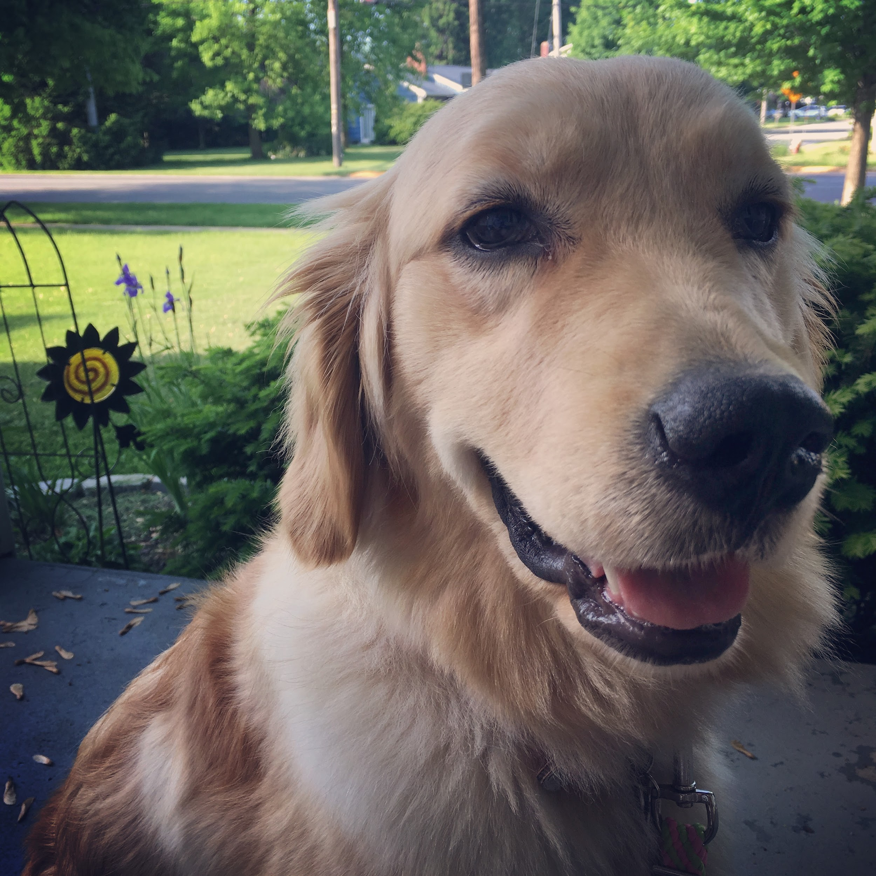
Dear Panther Families,

The administration and staff of Sandusky Central Catholic School is happy to announce our newest addition, Zahara, our facility dog. Zahara is an 18 month old Golden Retriever who was donated by two Panther families and was trained by Freedom Paws Assistance Dogs in Marysville, Ohio. She is excited and ready to meet all students at SCCS!

Zahara is available to all students who wish to seek her for comfort, calm, or even to say a quick hello! Zahara will be based out of the Counseling Office, which is on the main floor of the Jefferson Building. She will be walking the hall and visiting classrooms with Miss Howman, so students will have plenty of opportunities to visit with her.

Some students may be allergic or fearful of dogs, and Miss Howman would like to know if this impacts your child. Miss Howman will work with families who need special consideration when working with and around Zahara. If there is a concern regarding Zahara and your child, please reach out to Miss Howman at mhowman@sanduskycc.org or 419-626-1892 ext. 226.

