

March 17, 2026

The Honorable Pilar Schiavo
California State Assembly
1021 O Street, Suite 4140
Sacramento, CA 95814

SUBJECT: AB 2021 (SCHIAVO) CALIFORNIA CONSUMER PRIVACY ACT OF 2018: WHISTLEBLOWER COMPLAINTS
OPPOSE– AS INTRODUCED FEBRUARY 17, 2026

Dear Assemblymember Schiavo:

The California Chamber of Commerce respectfully OPPOSES your AB 2021 (Schiavo) as introduced February 17, 2026, as a COST DRIVER because it expressly incentivizes individuals to bring claims of California Consumer Privacy Act (CCPA) violations, effectively deputizing employees and consumers as private attorneys enforcing the CCPA under the promise of a financial bounty. In doing so, the bill not only encourages opportunistic litigation over technical or immaterial violations—diverting resources away from meaningful privacy compliance efforts and toward defending bounty-driven claims—but also circumvents the calibrated limits the Legislature and voters placed on private enforcement and undermines a deliberate enforcement structure which reserves public enforcement authority over non–data breach CCPA violations to the Attorney General (AG) and the California Privacy Protection Agency (CPPA). We strongly believe that far more good could be achieved on behalf of Californians if those funds were invested in things like education and compliance guidance for businesses.
Deputizing employees and consumers to bring forth claims of violations under the promise of a financial bounty causes more harm than good for a law that is rife with vagueness
AB 2021 seeks to enact a statute exclusively for reporting violations of the CCPA, a relatively new law that is rife with vagueness and heavily dependent on implementing regulations to give it meaning.
To illustrate this point, several CCPA rights are based on “reasonable expectations” of “an average consumer” or the “reasonable anticipations” of “the consumer”, as is one of the thresholds determining if a business is even subject to the CCPA. For example:
- Civ. Code Sec. 1798.121(a) grants a consumer the right to direct a business that collects PI to limit the use of the consumers’ sensitive PI to that use which is necessary to perform the services or provide the goods “reasonably expected” by “an average consumer”.
- Civ. Code Sec. 1798.105(d)(1) details that the right of deletion does not apply to information needed to complete a transaction for which the PI was collected, to fulfill the terms of a warranty or product recall “conducted in accordance with federal law”, or to provide a good or service either requested by the consumer or “reasonably anticipated by the consumer” “within the context of a business’ ongoing relationship with the consumer”.
- Civ. Code Sec. 1798.140(d)(2) expands application of the CCPA to any entity that controls or is controlled by a business that meets one of the threshold determining if a business is subject to the CCPA if it shares common branding with the business and with whom the business shares consumers’ PI, where common branding is a shared name, service mark or trademark that “the average consumer” would understand that two or more entities are commonly owned.
Creating a special, one-off whistleblower statute for a single law pertaining to personal rights not only sets a poor precedent but also risks confusion and frustration. Consumers and employees may not know which companies are “covered businesses” for purposes of the CCPA or fully understand the nuances of the rights and exemptions built into this complex law. This confusion could very well lead to a flood of claims to the Agency under the enticing promise of a monetary reward, without any of procedural safeguards normally provided by courts against frivolous claims.
Again, current law covers whistleblowing activities associated with privacy violations under the CCPA because there is a robust body of existing law that governs whistleblower protection covering employees who report violations of state/federal laws, rules, or regulations. (See Labor Code Section 1102.5.) While existing laws may even allow courts to award damages to whistleblowers, those awards are made under the discretion of a judge, not offered up front as an incentive for employees to seek out potential violations as volunteer “bounty hunters” for the Privacy Agency. AB 2021 therefore risks setting a poor and dangerous precedent inviting confusion among employees and consumers and overwhelming the Agency with claims lacking the procedural safeguards normally applied by courts, ultimately diverting limited resources away from meaningful privacy compliance efforts.
Anti-retaliation protections already exist under the CCPA
Not only do whistleblower and anti-retaliation protections already exist under existing law, the CCPA itself prohibits retaliation against individuals for exercising their CCPA rights. Civil Code Section 1798.125 clearly states that a business shall not discriminate against a consumer because the consumer exercised any of their rights under the act which, as amended by Proposition 24, includes retaliating against an employee, applicate for employment, or independent contractor for exercising their rights under this act.
AB 2021 creates a PAGA-like enforcement dynamic within the CCPA enforcement structure and blurs the lines between public enforcement and private litigation
Although AB 2021 specifies that “a decision by the agency to take administrative enforcement action based on information contained in a whistleblower’s complaint does not confer a private right of action …or permit the whistleblower to bring a claim on behalf of the agency or state”, the bill would nonetheless create a PAGA-like enforcement dynamic by financially incentivizing individuals to act as de facto private enforcers by seeking out and reporting alleged violations to regulators. This is especially true because it even allows for the monetary award where the business settles a claim- meaning claimants and their attorney have little incentive to determine whether the claim is actually meritorious.
It is worth remembering that, with both with the passage of AB 375 (Chau & Hertzberg, Ch. 55, Stats. 2018) and the subsequent approval of Proposition 24 by voters, the CCPA was deliberately crafted to be enforced by public entities – the AG, and later both the AG and the CPPA – except in the limited circumstances of data breaches under Civil Code Section 1798.150. This intentional enforcement structure reflected significant operational changes that businesses would need to undertake to comply with these new privacy rights, as well as challenges posed by the statute’s inherent vagueness.
AB 2021 would, for the first time, introduce enforcement with the active assistance of whistleblowers and their attorneys in exchange for financial gain. For example, Proposed Section 1798.199.101 states that while the attorney shall not represent the agency in connection with any administrative enforcement action based on information contained in a whistleblower complaint, they “may provide as much assistance as the agency determines is appropriate to advance the investigation or litigation of the administrative enforcement action.” In addition, Proposed Section 1798.199.103(b)(8) goes so far as to prohibit any award to whistleblower who is not represented by an attorney.
This structure raises significant concerns. Conditioning awards for identifying grounds to bring public enforcement action based on attorney representation blurs the line between public enforcement and private litigation while simultaneously creating incentives for attorneys and advocacy organizations to recruit individuals to bring claims that the whistleblower might not have otherwise pursued in their own right. In turn, this risks the potential development of a cottage industry around identifying and advancing whistleblower complaints.
In effect, AB 2021 risks importing elements of a PAGA-like enforcement model into the CCPA framework despite the Legislature’s and voters’ deliberate decision to rely primarily on public enforcement. Doing so on the heels of PAGA-reform in this state, is particularly troubling, as outlined below.
Even without a financial incentive, the Agency reports thousands of complaints each year
It is worth noting that the Privacy Agency’s Enforcement Division has previously found that as of August 2025 there had been roughly 8,000 CCPA consumer complaints. That number was up from less than 4,000 in December in 2024, as outlined in their graph below [see Agenda Item 4 - Enforcement Update, p. 4 [as of Mar. 17, 2026]. That is without the promise of any sort of financial incentive to bring forth complaints. These numbers will only multiply under the PAGA-like dynamic created by this bill, with the added incentive of a bounty.
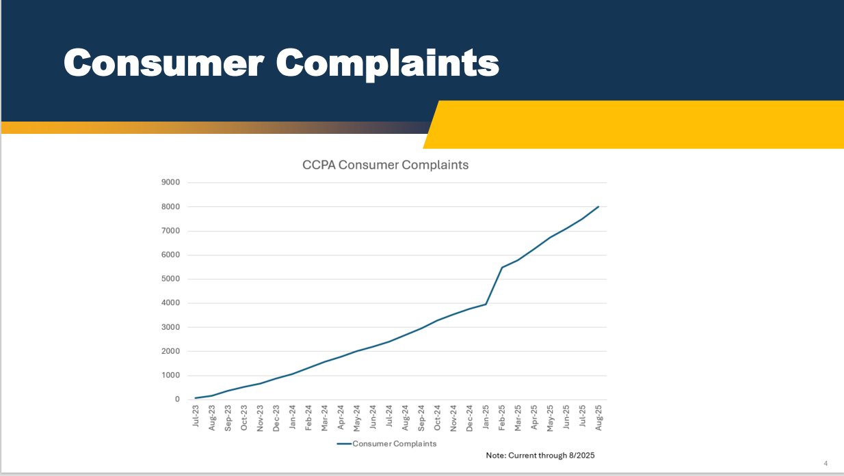
However well-intentioned and sincere the current Agency may be about weeding through complaints to pursue only meritorious ones, decisions to not pursue claims for minor or technical violations brought forth in a system set up for whistleblowers, and specifically those represented by legal representation, are virtually guaranteed result in demands for the addition of a private right of action as an enforcement mechanism when frustration invariably builds at a time when companies are still asking for compliance guidance and bearing the enormous – and vastly underappreciated costs – of coming into compliance with recent Agency regulations. These are deeply personal rights that the average consumer or employee who feels they have a meritorious claim are not going to like seeing get foreclosed upon by lack of Agency action in the exercise of discretion.
PAGA and other enforcement regimes demonstrate the risks of bounty-style enforcement
One prime example of a deputized enforcement mechanism that was subject to years of abuse is PAGA. Thousands of notices are filed every year, many of which are boilerplate and used simply to leverage a settlement. Companies are under “enormous pressure” to settle claims “regardless of the validity of those claims.” [See Assembly Appropriations Analysis for SB 646 (Hertzberg).] Alleged violations are often technical in nature and, like AB 2021, there is no requirement that the complainant actually experienced any harm. Even after the 2024 PAGA Reforms, the Labor and Workforce Development Agency is continuing to have to work to get that cottage industry under control through letters to law firms that continue to file hundreds of boilerplate cases and new regulations proposing to tag certain attorneys as high-frequency litigants or vexatious litigants. Those regulations even propose creating an entirely new PAGA notice form to try to slow down firms from copying and pasting boilerplate claims.
ADA litigation is another good example. Unlike federal law, California law offers a $4,000 penalty for violations of the Unruh Civil Rights Act, which can be triggered by alleging a violation of the ADA. A cottage industry of attorneys has weaponized that penalty structure for minor violations of the ADA, targeting both small and large businesses. Unfortunately, wherever there is a financial incentive to file claims under the promise of collecting a penalty, it generates a cottage industry that overwhelms the system with claims, often where there is no real harm to the plaintiff.
Ultimately, we do not believe that the inclusion of a whistleblower incentive into CCPA is appropriate or directly comparable to the whistleblower statutes relied upon to help enforce the California False Claims Act or federal securities or tax law that rely on whistleblower incentives to expose concealed misconduct. Those regimes address inherently hidden violations—such as fraud or tax evasion—where critical information is uniquely held by insiders and cannot be feasibly detected by regulators absent whistleblower disclosures. By contrast, the CCPA governs ongoing data practices within a comprehensive regulatory framework overseen by the CPPA, where compliance is subject to audits, investigations, and consumer complaints. While some aspects of data processing may not be fully visible to the public, CCPA violations are not typically predicated on the kind of intentional, covert misconduct that necessitates whistleblower-driven enforcement.
Similarly, the policy behind the False Claims Act is that, in order to avoid bad actors defrauding the government, you must incentivize whistleblowers to come forward. Without such incentives, there is no law enforcement or agency which can sufficiently oversee every state contract and compliance with them. In contrast, the CCPA is an incredibly complicated and continually evolving legal framework that has an entire agency dedicated to the enforcement of personal data privacy rights and — as evidenced above — the Agency already receives thousands of reports of alleged violations by people concerned that their rights have been violated. California law has not traditionally relied on whistleblower-style bounty mechanisms to enforce personal rights of this kind. Layering financial incentives onto this framework risks distorting enforcement priorities, encouraging opportunistic or high-volume claims untethered from concrete harm, and undermining the role of the designated regulatory authority as illustrated by the well-documented challenges associated with PAGA enforcement.
For these reasons we must OPPOSE your AB 2021 (Schiavo).
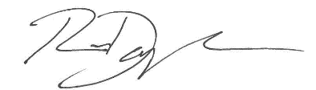
Sincerely,

Ronak Daylami
Policy Advocate

cc: Legislative Affairs, Office of the Governor

RD:ldl

Even the Privacy Agency’s estimated costs for compliance in their 2025 rulemaking recognized that small businesses face initial costs of $6,058 to $38,225 and annual ongoing costs of $16,377. The typical business will see initial costs that go up to $65,312, with annual costs of $20,431. These are not insignificant by any means, yet based on our own judgment and experience, vastly lower than what the actual cost will be to businesses. See Economic and Fiscal Impact Statement (Regulations and Orders), p. 2.
See the LWDA’s recently proposed regulations and Initial Statement of Reasons detailing decades of abuse of PAGA by a cottage industry of law firms, available here: Rulemaking: Labor Code Private Attorneys General Act of 2004 | LWDA
In San Francisco alone, two plaintiffs were responsible for filing 1,000 lawsuits against small businesses: SF’s Chinatown Businesses Hit with Lawsuits by Prolific ADA Plaintiffs – NBC Bay Area

