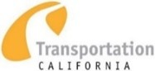
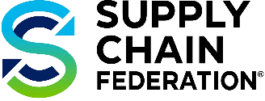
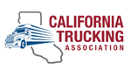


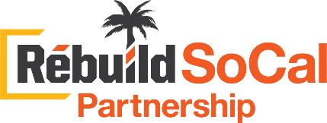




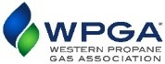
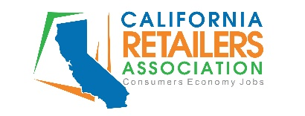
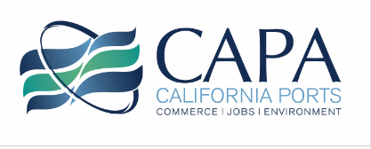

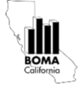
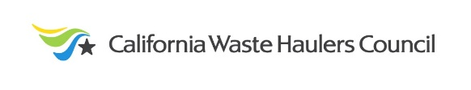

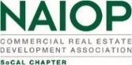
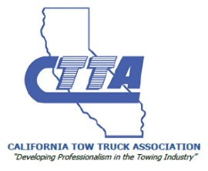





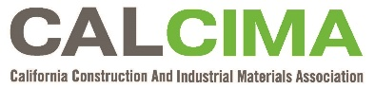

March x, 2026
The Honorable Robert Garcia
California State Assembly
RE: AB-1777 (Garcia) Air pollution: indirect sources - OPPOSE
Asm. Garcia,
The undersigned 24 organizations strongly OPPOSE AB1777. AB1777 would represent one of the largest expansions of the California Air Resources Board’s regulatory authority in history, increase cost of living for Californians, stall improvement of our State’s infrastructure and ignore decades of air quality improvement.
History of Indirect Source Review
The Federal Clean Air Act (CAA) generally divides regulatory responsibility as follows:
- The Federal Environmental Protection Agency (EPA) sets mobile source emission standards for sources such as cars, trucks, ships and locomotives. States are preempted from setting their owns standards, except California upon receipt of a waiver from EPA.
- States out of attainment with National Ambient Air Quality Standards are responsible for regulating stationary sources, including the issuance of permits for major new sources and imposing control measures.
This framework has governed air regulation for more than fifty years and has driven dramatic improvements in air quality.
“Indirect Source Review” (ISR) was included in the 1977 amendments to the Federal Clean Air Act. ISR involves the facility-by-facility review of the construction of new facilities that attract or produce vehicle trips, but do not themselves emit pollutants. By monitoring the location of these facilities, a fully implemented ISR permit program approximates land use regulation.
“Indirect source” is defined in the Clean Air Act as follows:
“a facility, building, structure, installation, real property, road, or highway which attracts, or may attract, mobile sources of pollution. Such term includes parking lots, parking garages, and other facilities subject to any measure for management of parking supply (within the meaning of subsection (c)(2)(D)(ii)), including regulation of existing off-street parking but such term does not include new or existing on-street parking. Direct emissions sources or facilities at, within, or associated with, any indirect source shall not be deemed indirect sources for the purpose of this paragraph.”
ISR as a regulatory tool has largely remained dormant since 1977 as innovative stationary and mobile source control techniques have drastically cut emissions. This is partly due to the fact that increasingly stringent mobile and station source regulations were achieving substantial emission reductions.
Policies such as SB 375 (Steinberg, 2008) directly addressed the land use-emissions nexus by encouraging transit oriented and infill development via Sustainable Community Strategies.
However, in recent years, the South Coast Air Quality Management District (SCAQMD) has pursued a suite of ISRs which have blurred the nearly fifty-year division of regulatory authority between EPA, the California Air Resources Board and local air districts.
These adopted and proposed rules include:
- Rule 2305 – WAIRE Program
  - Requires operators of existing warehouses above 100,000 square feet to take actions or pay fees to mitigate emissions from visiting trucks.
- Rule 2306 – Railyard ISR
  - Operators of railyards must meet declining NOx targets for all visiting locomotives and drayage trucks.
These rules bear little resemblance to Indirect Source Review as contemplated by the Clean Air Act, rather, functionally operating as an authorization to write nearly any expansive rule requiring stationary facility operators to control, subsidize, or pay for emissions from independently regulated mobile sources.
AB1777 Expands CARB Regulatory Authority
AB 1777 erroneously states that it’s provisions granting CARB the authority to regulate indirect sources “is declaratory of, and does not constitute a change in, existing law.”
We rely on no greater source than CARB itself. From a February 10th article in Politico:
State law already allows regional air quality districts to establish rules for indirect sources…CARB officials say it’s unclear, however, if the agency has the same regulatory power.
CARB Does Not Need More Regulatory Authority
AB 1777 would grant CARB broad new authority to regulate facilities based on emissions from vehicles and equipment they do not own, operate, or directly control.
This effectively erodes the long-standing boundary between:
- Federal mobile-source authority;
- State mobile-source authority (via waiver); and State and local stationary source authority.
Under its existing authority, CARB and local air districts have imposed the nation’s strictest regulations on nearly every stationary and mobile source operating in the State. AB 1777 would represent one of the largest expansions of California’s regulatory regime in history, allowing CARB to adopt redundant, costly measures for sources that are already tightly, directly regulated by existing rules. Worse, this expansion of the regulatory state would be of dubious benefit towards the State’s clean air goals. For example, the Biden EPA gave California no emission reduction credit for Rule 2305.
ISRs have been proven to be ineffective as an emission reduction strategy. A recent study conducted by Ramboll found that the South Coast Air Quality Management District’s (SCAQMD) Rule Warehouse ISR has failed to produce meaningful emission reductions and has been significantly more costly than projected.
The study’s conclusions can be summarized as:
- The WAIRE program has had negligible additional effect on emissions. Emission reductions around freight facilities have resulted from the Truck and Bus Rule, Low Carbon Fuel Standard and early adoption of near-zero emission trucks certified to CARB’s pre-2022 model year optional low NOx standard of 0.02 g/bhp-hr.
- WAIRE Program compliance costs were likely 2.4-9.4 times higher than assumed by the SCAQMD.
- The WAIRE program is functionally serving as a tax on the supply chain, with an estimated 80% of future compliance being achieved through mitigation fees.
AB1777 Will Increase California’s Cost of Living, Stall Infrastructure Projects, Snarl Supply Chains, and Disrupt Vital Industries
California is experiencing an affordability crisis. AB1777 would exacerbate this crisis by adding another layer of regulation upon already regulated sources. Nearly every good and service Californians consume would be impacted. Projects to improve our state’s infrastructure could be held up indefinitely. For the reasons outlined in this letter, the undersigned organizations must strongly OPPOSE AB1777.

“The Clean Air Act and Indirect Source Review: 1970-1991” UCLA Journal of Environmental Law and Policy (1992) https://escholarship.org/content/qt71q986z0/qt71q986z0.pdf?t=mv7w31#:~:text=%22Indirect%20source%20review%22%20(ISR,do%20not%20themselves%20emit%20pollutants.
https://www.federalregister.gov/documents/2024/09/11/2024-20349/air-plan-approval-california-south-coast-air-quality-management-district

