
2017

Distracted Driver Prevention
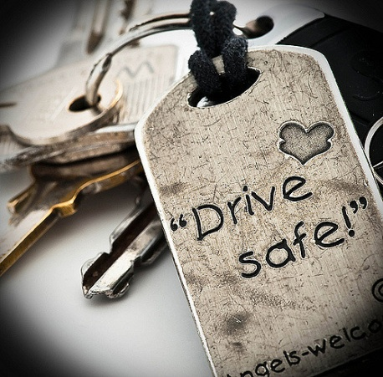
Challenge
NYMIR Resources
Sample Resolution
Certificate of Completion
 Nationally, distracted driving has been the leading cause of motor vehicle crashes. In 2014, the Official U.S. Government website for Distracted Driving reported that 3,179 people were killed and 431,000 injured in moving vehicle accidents. In 2014, NYMIR’s vehicle claims totaled $5.7 mm of which 72% or $4.1 mm were as a result of a distraction while driving. NYMIR’s 24 years of vehicular accident claim costs total $5.9 mm of which 39.7 mm or 66% were as a result of distracted driving. Substantial financial consequences from distracted driving incidents can be suffered by your municipality. Employee injuries which increase costs of workers’ compensation insurance and can incur overtime expenses for hired help, equipment repair and downtime as well as, rental costs can follow. In addition, injuries to the public and their property create negative publicity for your municipality, as well as, liability claims that can increase your insurance premiums.
NYMIR is challenging you to initiate a safe driving program to raise awareness of the danger of activities that create distractions and cause drivers to lose focus behind the wheel. Implementing a safe driver training program, every two years, for employees who operate municipal vehicles or equipment or their personal vehicle on behalf of your municipality, is a productive start. Driver Policies can be adopted, reviewed for enforcement, and evaluated and updated when necessary. NYMIR provides a variety of resources to assist you in this endeavor. Our Fleet Safety Handbook is on the website, www.nymir.org; our Risk Management staff can provide Train-the- Trainer programs; or you can sponsor a seminar instructed by our staff at your municipality. Take the pledge today! Check out nymir.org or call our NYMIR Risk Management Department for various training opportunities. Send a photo of your staff attending a training session and we’ll post it on our NYMIR Facebook recognizing their commitment to safety while operating your vehicles in their community.
Included is a list of resources NYMIR can provide, a sample resolution for you to modify to suit your needs, and a Certificate to recognize an employees’ successful completion of a Driver Safety program.

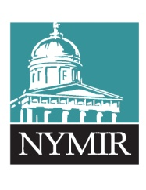
NYMIR Resources & More for Safe Driving Practices
nymir.org
Distracted Driving Webinar – Our NYMIR Loss Control Specialist reviews the multitude of activities that cause drivers to lose focus behind the wheel.
American Safety Council Defensive Driving Course - $19.95 (6 hour course)
This course provides drivers with the techniques and knowledge to stay safe on the roads. This course aims to minimize the risks associated with operating a motor vehicle.
Night Time Driving Video- Traffic Control Technician, Mark Loveless, addresses the various factors that challenge our night time driving and strategies to overcome those challenges.
Fleet Safety Handbook- Sample driver policies, maintenance checklists, and best practices are included.
Classroom Training
NYMIR Risk Management staff provides Train –the-Trainer instruction for Distracted Driving classes to prepare your own employees as instructors.
Distracted Driver Training provided by NYMIR Risk Management staff at your municipality.
Regional Training Seminars Available
Drive to Survive – Techniques used by crash investigators, the class is designed to provide a better understanding of various important practices essential for safe driving. Training focus for heavy/commercial vehicle operators or police, fire, and emergency vehicle drivers is available.
Safety During Snow & Ice Removal Operations- The focus of this workshop is to review the safety aspects of Snow and Ice Removal Operations with those involved to reduce the potential for losses due to accidents and equipment breakdowns.
Important and Beneficial Links
Current NY Law regarding Distracted Driving: http://www.safeny.ny.gov/phon-vt.htm
Driving while Distracted Laws in NY: http://www.safeny.ny.gov/phon-ndx.htm
PSA Videos:
https://www.youtube.com/watch?v=VztOISZxeaw
https://www.youtube.com/watch?v=w5_MJuMgAxs
Posters:
https://www.distraction.gov/downloads/pdfs/adult-final-poster-4_v2.pdf
https://www.distraction.gov/downloads/pdfs/adult-final-poster-3_v2.pdf
(Contact Susan O’Rorke- 518-292-0057 for more information on the above resources)

SAMPLE RESOLUTION

Resolution: Employee Distracted Driver Training

Date

WHEREAS, the ___________________ recognizes the dangers associated with distracted driving which often results in injuries to employees, damage to municipal property and personal injury and property damage to others;
WHEREAS, the _____________________ is committed to the safety of its employees, residents and the general public along with reducing the costs associated with automobile accidents such in higher insurance premiums, down time for equipment repairs, over time pay, and reduction in services to residents.
THEREFORE BE IT RESOLVED, that the ________ will require all municipal employees who drive a municipal vehicle or drive their own vehicle on behalf of __________ to participate in Distracted Driving Training every two years.
BE IT FURTHER RESOLVED, that the Town will use the free resources provided by its insurance carrier, NYMIR, to provide this training. (other resources may be used outside of the NYMIR program). The _______ will appoint ____________ as the instructor(s) for this training.
BE IT FURTHER RESOLVED, that ______ will notify NYMIR upon the completion of the Distracted Driving Program by its employees.

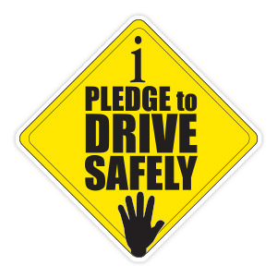

The New York Municipal Insurance Reciprocal
And {MUNICIPALITY} Recognize

{ATTENDEES NAME}
Commitment to Safe Driving
Through completion of (Distracted Driver Training/ Defensive Driving)
On {DATE}

_______________________ _____________________
Supervisor/Mayor/Administrator Risk Management Department

