

**Conquest Boys Club**

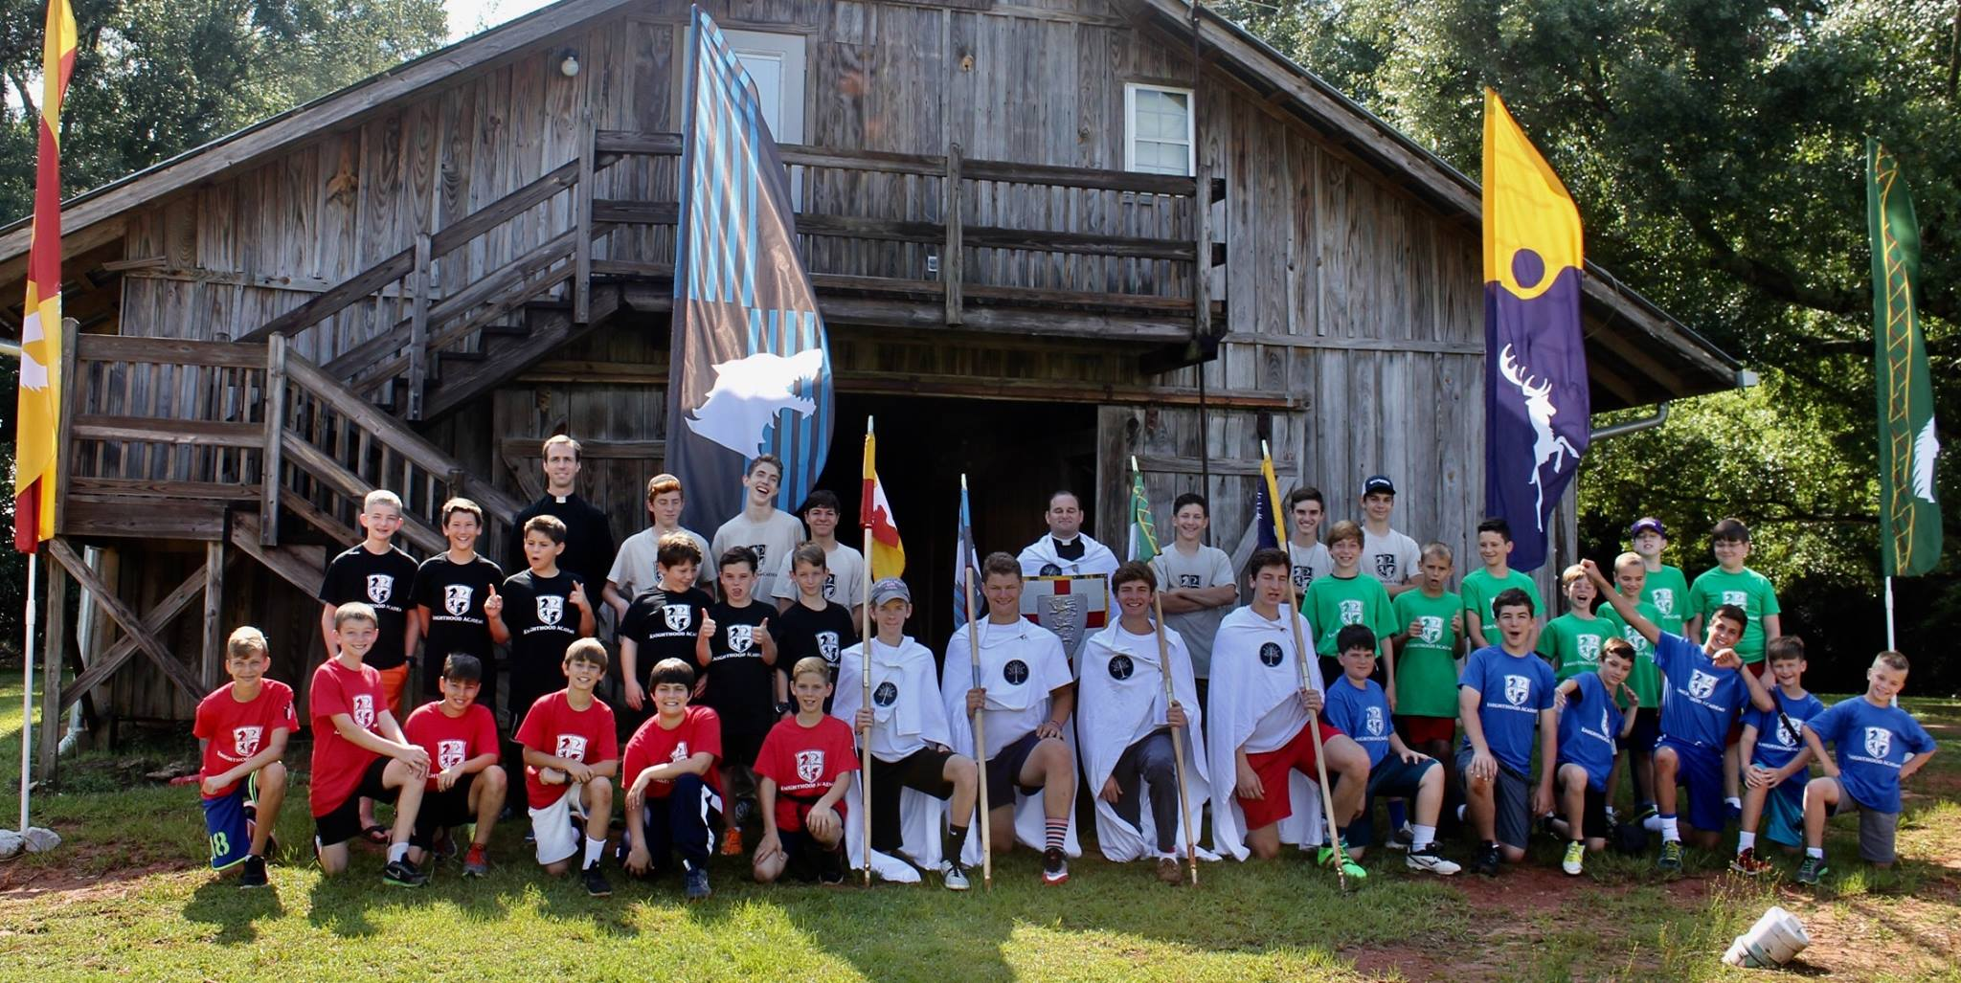

For Boys in 5th - 8th Grade

**Conquest is a 100% Catholic Youth Ministry program for boys and girls in 5th – 12th grade to grow in knowledge of their Catholic faith, friendship with Christ, and make a difference and positive impact on their families, friends and in the world around them. Conquest helps boys answer question the world poses today. What does it mean to be a good friend? How should I treat others? It is run by adult mentors and youth team leaders who act as role models. Every meeting is has sports and fun activities designed to build virtue and leadership skills.**

Where : MBS school

When: 6pm-7:45 Weekly - Starts September 10th

Who: all boys 5th-8th grade

For more information visit [www.conquestyouthministry.com](http://www.conquestyouthministry.com) or [www.conquestbr.org](http://www.conquestbr.org) or

call or text Mitch Leger at 225-284-7580

https://conquestyouthministry.com