

Hormel Foods Corporation Position Vacancies in The Following Areas:
All Positions are listed with the requisition (req) number that is included on the website.
Example:
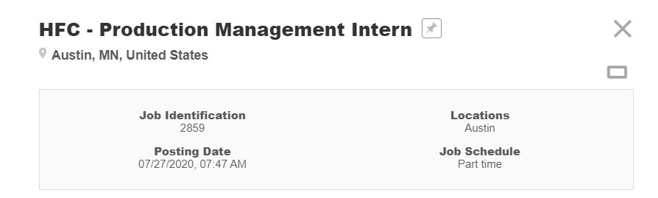

To verify open positions, go to: hormelfoods.com/careers

- #20225 – Human Resources Intern – austin, MN
https://ekkh.fa.us2.oraclecloud.com/hcmUI/CandidateExperience/en/sites/CX_2002/job/20225/?utm_medium=jobshare
- #20227 – Corporate communications Intern – AUstin, MN
https://ekkh.fa.us2.oraclecloud.com/hcmUI/CandidateExperience/en/sites/CX_2002/job/20227/?utm_medium=jobshare

- #20229 – planters marketing intern – Chicago, IL
https://ekkh.fa.us2.oraclecloud.com/hcmUI/CandidateExperience/en/sites/CX_2002/job/20229/?utm_medium=jobshare
- #20231 – Accounting & FInance Intern – Austin, MN
https://ekkh.fa.us2.oraclecloud.com/hcmUI/CandidateExperience/en/sites/CX_2002/job/20231/?utm_medium=jobshare
- #20234 – Data Analyst Intern – Austin, MN
https://ekkh.fa.us2.oraclecloud.com/hcmUI/CandidateExperience/en/sites/CX_2002/job/20234/?utm_medium=jobshare
- #20236 – Packaging engineering intern/coop – Austin MN
https://ekkh.fa.us2.oraclecloud.com/hcmUI/CandidateExperience/en/sites/CX_2002/job/20236/?utm_medium=jobshare
- #20243 – category development analyst Intern – Austin, MN
https://ekkh.fa.us2.oraclecloud.com/hcmUI/CandidateExperience/en/sites/CX_2002/job/20243/?utm_medium=jobshare
- #20246 – Quality Control/Assurance Intern – multiple Locations
https://ekkh.fa.us2.oraclecloud.com/hcmUI/CandidateExperience/en/sites/CX_2002/job/20246/?utm_medium=jobshare
- #20247 – Industrial engineering intern/coop – Multiple Locations
https://ekkh.fa.us2.oraclecloud.com/hcmUI/CandidateExperience/en/sites/CX_2002/job/20247/?utm_medium=jobshare
- #20248 – Plant/maintenance engineering intern/coop – Multiple Locations
https://ekkh.fa.us2.oraclecloud.com/hcmUI/CandidateExperience/en/sites/CX_2002/job/20248/?utm_medium=jobshare

- #20249 – Production ManagemenT InTern – Multiple Locations
https://ekkh.fa.us2.oraclecloud.com/hcmUI/CandidateExperience/en/sites/CX_2002/job/20249/?utm_medium=jobshare
- #20250 – Sales Intern (various locations)
https://ekkh.fa.us2.oraclecloud.com/hcmUI/CandidateExperience/en/sites/CX_2002/job/20250/?utm_medium=jobshare
- #20251 – marketing Intern – Austin, MN
https://ekkh.fa.us2.oraclecloud.com/hcmUI/CandidateExperience/en/sites/CX_2002/job/20251/?utm_medium=jobshare
- #20252 – Product Development intern – Austin, Willmar, or Hayward, CA – Hormel Corp/Jennie-O/Columbus
https://ekkh.fa.us2.oraclecloud.com/hcmUI/CandidateExperience/en/sites/CX_2002/job/20252/?utm_medium=jobshare
- #20257 – Consumer Innovation intern – Austin, MN
https://ekkh.fa.us2.oraclecloud.com/hcmUI/CandidateExperience/en/sites/CX_2002/job/20257/?utm_medium=jobshare
- #20258 – Consumer insights Intern – Austin, MN
https://ekkh.fa.us2.oraclecloud.com/hcmUI/CandidateExperience/en/sites/CX_2002/job/20258/?utm_medium=jobshare
- #20260 – Justin’s marketing intern – Boulder, CO
https://ekkh.fa.us2.oraclecloud.com/hcmUI/CandidateExperience/en/sites/CX_2002/job/20260/?utm_medium=jobshare
- #20531 – Supply Chain intern – Applegate – Bridgewater, NK
https://ekkh.fa.us2.oraclecloud.com/hcmUI/CandidateExperience/en/sites/CX_2002/job/20531/?utm_medium=jobshare
- #20534 – Supply Chain intern – Austin or willmar, mn
https://ekkh.fa.us2.oraclecloud.com/hcmUI/CandidateExperience/en/sites/CX_2002/job/20534/?utm_medium=jobshare
- #20645 – Category Development Analyst CO-Op (St. Joseph’s University)
https://ekkh.fa.us2.oraclecloud.com/hcmUI/CandidateExperience/en/sites/CX_2002/job/20645/?utm_medium=jobshare
- #20664 – Corporate Development Intern – Austin, MN
https://ekkh.fa.us2.oraclecloud.com/hcmUI/CandidateExperience/en/sites/CX_2002/job/20664/?utm_medium=jobshare

Please note: Open positions may be filled by the time you receive your interview packets and conduct interviews.

