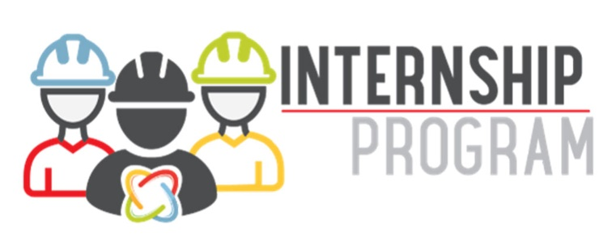
- 10 weeks of challenging, hands-on work experience in a production facility or our corporate office.
- Mentoring and coaching by a cultural ambassador and technical expert within your facility.
- Interacting with our company’s senior leadership team.
- Building industry relationships with company leaders and other interns.
- Rotating through various departments and business functions for plant operations interns.
- Variety of locations still open in beef, pork, and poultry- please visit our website to explore more.
Dates: May 20 – July 26, 2024
Click to see past internship projects.
Click a department below to apply:
- Accounting/Finance
- Human Resources
- IT
- JBS Ops
- Pilgrim's Live Ops
- Maintenance
- Pilgrim's Ops
- ​​​​​​​Quality Assurance
- Rendering
- Sales

